Youngjune Kim

Lab 6 out of lab

Part A

1. 
2. x is first initialized as 0. i is initialized as 1 to use as counter for loop. The loop runs t till i<=3 which means it will run 3 times.

In the first iteration, s = 1, in the second s = 4, in the third s = 9.

In the first iteration x = 1, in the second x = 5, in the third x = 14.

i is incremented by 1.

x is printed at the end with 14 as its value.

Part B

1. 

Part C

1. 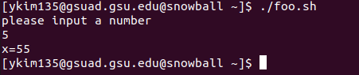

Part D

1. public class foo {

public static void main(String args[])

int x = 0, i = 1, s;

while (i<=3) {

s = i\*I;

x = s+x;

i++;

}

System.out.println (“x=” + x);

}

}

Part E

1. 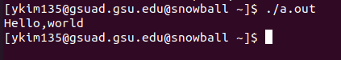
2. hello file is generated after the command
3. 