Youngjune Kim

Lab 7 out of lab

Part 1

1. 

#include <stdio.h>

int main (void)

{

int i, j;

char arr[13], ph[12];

printf("Enter phone number [(999)999-9999]: ");

scanf ("%s", arr);

j = 0;

for (i = 0; i < 13; i++)

{

if (arr[i] != '(' && arr[i] != ')')

{

ph[j]=arr[i];

j++;

}

else if (arr[i] == ')')

{

ph[j]='-';

j++;

}

}

printf ("You entered %s\n", ph);

return 0;

}

1. 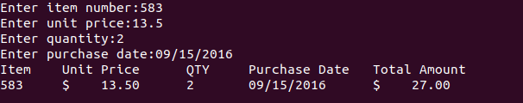

#include <stdio.h>

int main()

{

int item_number;

double unit_price;

int quantity;

char purchase_date[12];

printf("Enter item number:");

scanf("%d", &item_number);

printf("Enter unit price:");

scanf("%lf", &unit_price);

printf("Enter quantity:");

scanf("%d", &quantity);

printf("Enter purchase date:");

scanf("%s", purchase_date);

printf("Item\tUnit Price\tQTY\tPurchase Date\tTotal Amount\n");

printf("%d\t$%9.2lf\t%d\t%s\t$%9.2lf\n\n", item_number, unit_price, quantity, purchase_date, unit_price * quantity);

return 0;

}