Youngjune Kim

Post Lab 8

Part 1

4) break 6

5) run

6)

|  |  |  |  |  |
| --- | --- | --- | --- | --- |
|  | 1st iteration | 2nd iteration | 3rd iteration | 4th iteration |
| num | 112 | 11 | 1 | 0 |
| rev_num | 5 | 52 | 521 | 5211 |

8) Function foo is used to reverse the initial number.

Part 2

1. Line 5: the variable *space* needs to be initialized.
2. Line 11: The \n command requires ‘ ‘.
3. 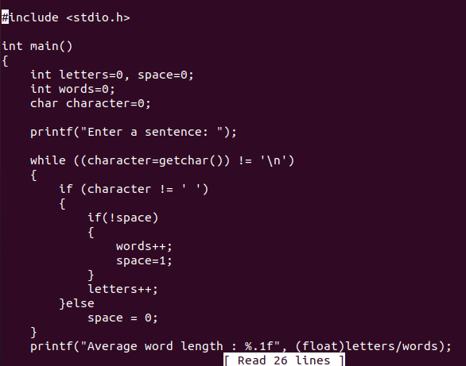The type needs to be printed in the printf statement. (float)