Youngjune Kim

Lab 9 – Post Lab

Part 1

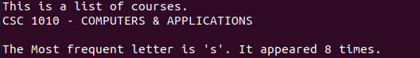

Part 2

1. 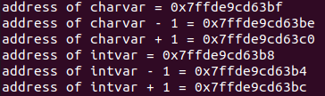
2. #include <stdio.h>

int main()

{

char charvar=’\0’;

printf(“address of charvar = %p\n”. (void \*) (&charvar));

printf(“address of charvar – 1 = %p\n”. (void \*) (&charvar - 1));

printf(“address of charvar + 1 = %p\n”. (void \*) (&charvar + 1));

int intvar = 1;

printf(“address of intvar = %p\n”. (void \*) (&intvar));

printf(“address of intvar - 1 = %p\n”. (void \*) (&intvar - 1));

printf(“address of intvar + 1 = %p\n”. (void \*) (&intvar + 1));

}

1. intvar is declared as int while charvar is declared as char. integer takes 4 bytes while character only takes 1 byte.

Part 3

1. 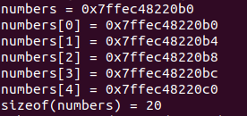
2. The addresses are the same.
3. 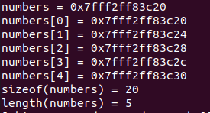printf(“length(numbers) = %lu\n”, sizeof(numbers)/sizeof(numbers[0]));