* **WHAT IS FLUTTER?**

Flutter is a mobile app SDK ([software development kit](https://www.forbes.com/sites/forbestechcouncil/2021/04/07/how-the-api-and-sdk-revolutions-transform-software-development/?sh=59ca7b136563)) for building high-performance, high-fidelity apps for iOS and Android. With powerful graphics and animation libraries, the Flutter framework makes it easy to build user interfaces that react smoothly in response to touch.

Flutter is built on the Dart programming language and provides a fast development workflow with hot reloading, so you can quickly iterate on your code.

* **HOW FLUTTER WORKS?**

The term **Flutter** refers to two major things/concepts

1. Flutter SDK
2. Flutter Framework

* **Flutter SDK:** is a collection of tools that allows you to build any kind of app for android & iOS platform in one codebase.
* **Flutter Framework:** Basically it provides all the predefined widgets/widget library, utility functions & packages.

And the compilation task is done by Flutter SDK.

[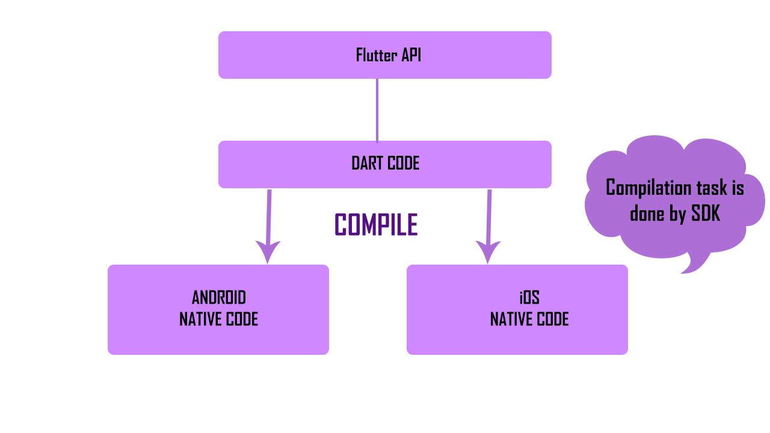](https://i.stack.imgur.com/rykjW.png)

Flutter doesn't use any kind of web view or native controls of the operating system. Instead flutter uses its own high performance rendering engine (Skia), to draw widgets.

And the high performance is mainly guaranteed by two points.

* Dart Language
* Own engine to render/draw widgets

JIT & AOT refer to the way the program runs, and the programming language isn't strongly related. And some languages support JIT and AOT together, Ex: Java, Python.

**First time - Compiled -> intermediate byte code**

**Later -> byte code will be directly executed**

**The DART runtime and compiler also support a combination of two key features - JIT & AOT.**

* **WHY WE USE FLUTTER INSTEAD OF USING NATIVE PLATFORMS?**
* It is easier to maintain and update hybrid apps than native applications.
* Flutter uses proprietary visual, structural, platform, and interactive widgets. These widgets are built-in UI components that replace native platform components.
* There is no interconnecting bridge for initiating interactions with the device’s native components. Hence, interactions with native components are faster, improving the overall performance of the application.
* Flutter also supports many hardware acceleration features, such as Skia, which improve the app's performance.

|  |  |  |
| --- | --- | --- |
| **Feature** | **React Native** | **Flutter** |
| **User Interface** | External UI kits, more UI options | Pre-built widgets, lesser UI customizations |
| **Performance** | Comparatively slower | Fast as it avoids bridges of JavaScript. |
| **Documentation** | Disorganized | Simple and streamlined |