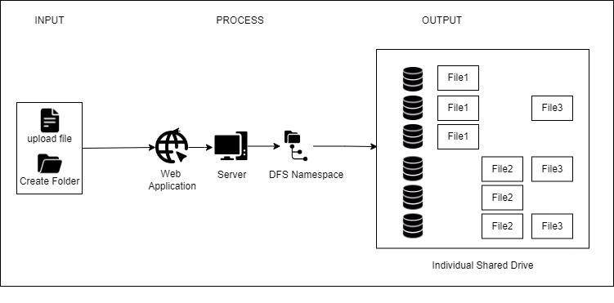

Figure 3.1 Conceptual Framework