CHERRY EXECUTIVE AI ASSISTANT
MyChart Bot
Project Documentation Report
A production-grade, streaming, fact-grounded conversational AI platform
Prepared by: Mr Kirthan
Live deployment: https://cherry-executive-ai-assistant.lovable.app
Document version 1.0
Technology stack: TanStack Start, React 19, TypeScript, Tailwind CSS v4, Vercel AI SDK, Lovable AI Gateway (Gemini), Lovable Cloud (PostgreSQL, Auth), Cloudflare Edge Runtime

Table of Contents
1. Statement of Declaration
2. Abstract
3. Acknowledgement
4. Introduction
5. Project Background
6. Problem Statement
7. Aim and Objectives
8. Scope of the Project
9. Literature Review
10. Existing Systems Analysis
11. Proposed System
12. Feasibility Study
13. Requirement Analysis
14. Functional Requirements
15. Non-Functional Requirements
16. Hardware and Software Requirements
17. System Analysis
18. System Architecture
19. Architectural Patterns and Decisions
20. System Design
21. Use Case Modelling
22. Data Flow Design
23. Database Design
24. Class and Domain Model
25. Interface Design and User Experience
26. Security Design
27. Artificial Intelligence Design
28. Retrieval and Grounding Design
29. Voice Interaction Design
30. File Handling Design
31. Implementation Overview
32. Implementation - Frontend
33. Implementation - Backend and Server Routes
34. Implementation - Authentication and Sessions
35. Implementation - Database and Persistence
36. Implementation - Security Hardening
37. Testing Strategy
38. Unit Testing Results
39. Functional Testing Results
40. Non-Functional Testing Results
41. Deployment and DevOps
42. Technical Manual
43. User Guide
44. Project Management and Development Process
45. Evaluation and Critical Discussion
46. Conclusion and Future Work
47. References
Appendix A: List of Figures

1. Statement of Declaration
I declare that this project documentation report and the software system it describes, the Cherry Executive AI Assistant (MyChart Bot), are the result of my own work. All sources of information, third-party libraries, hosted services and reference material used during the design, implementation and evaluation of the system have been explicitly acknowledged in the References section.
The system described herein was designed, implemented, tested and deployed as a complete working application. No part of this report has been submitted for any other award. Where external code, APIs or platform services were used, their role is clearly stated and the boundary between third-party functionality and original work is described in the Implementation chapters.
Signed: Mr Kirthan
Project: Cherry Executive AI Assistant (MyChart Bot)

2. Abstract
Cherry Executive AI Assistant is a production-grade conversational artificial intelligence web application designed to give professionals a fast, accurate and trustworthy assistant for everyday executive work. The system combines a server-rendered React 19 front end built on TanStack Start with an edge-deployed backend that streams responses token by token from large language models accessed through the Lovable AI Gateway.
The project addresses three well-known weaknesses of generic chatbot products. First, factual staleness: general models answer time-sensitive questions from a fixed training cutoff. Cherry mitigates this with a live fact verification layer that queries structured knowledge sources at request time and injects verified statements into the prompt. Second, opacity: users cannot see where an answer came from, so Cherry surfaces grounding sources in the interface. Third, fragility: public AI endpoints fail under load, so Cherry implements a circuit breaker, a model fallback chain, exponential retry and explicit status mapping for rate limit and quota conditions.
Beyond conversation, the platform provides authenticated accounts with Google sign-in, persistent server-side chat history protected by row level security, text file upload with automatic scanning and summarisation, browser-native voice input and speech output, transcript export, and a hardened HTTP response profile including Content Security Policy and HTTP Strict Transport Security.
The finished system was deployed to a public edge network and validated through unit, functional and non-functional testing. Results demonstrate sub-second time to first token in typical conditions, correct handling of oversized and malformed payloads, complete user data isolation between accounts, and graceful behaviour under simulated provider failure. The report documents the full lifecycle from requirements through architecture, design, implementation, testing, deployment and critical evaluation, and it is illustrated with forty-seven engineering diagrams.

3. Acknowledgement
I would like to express sincere gratitude to everyone who supported the delivery of the Cherry Executive AI Assistant project.
I thank my supervisor and academic reviewers for their guidance on scope, engineering rigour and documentation standards, and for consistently pushing the work towards production quality rather than a prototype. Their feedback shaped the decisions around grounding, resilience and security that distinguish this system from a simple chat front end.
I acknowledge the open source community whose work this project builds upon, in particular the maintainers of React, TanStack Router and TanStack Start, Vite, Tailwind CSS, the Vercel AI SDK, Zod, and the many smaller libraries that made rapid, safe implementation possible.
I also thank the reviewers and early testers who used the deployed application, reported defects in the authentication flow and the upload composer, and helped validate the accuracy of the live fact verification layer with real time-sensitive questions.

4. Introduction
Conversational artificial intelligence has moved from novelty to daily utility. Professionals now expect to ask a question in natural language and receive a clear, correct and immediately usable answer. However, the gap between a demonstration chatbot and a dependable professional assistant is substantial. A dependable assistant must authenticate its users, protect their data, remember their conversations, read the documents they provide, stay current with the real world, degrade gracefully when upstream services fail, and communicate all of this through an interface that feels calm rather than experimental.
Cherry Executive AI Assistant, branded MyChart Bot, was built to close that gap. It is a complete web platform rather than a single feature. The user visits a public landing page, signs in with a trusted identity provider, and enters a chat workspace where conversations are listed in a sidebar and persist across devices. Messages stream in as they are generated. Text documents can be dragged into the composer, at which point the assistant scans them and opens its reply with a structured summary of what the file contains before answering the question. Voice input allows hands-free dictation, and replies can be spoken back.
This report documents the entire engineering effort. It begins with background, problem definition and requirements, proceeds through architecture and detailed design supported by forty-seven diagrams, presents the implementation with extracts from the actual production source code, reports the results of the testing programme, describes deployment and operations, and closes with a critical evaluation and roadmap.
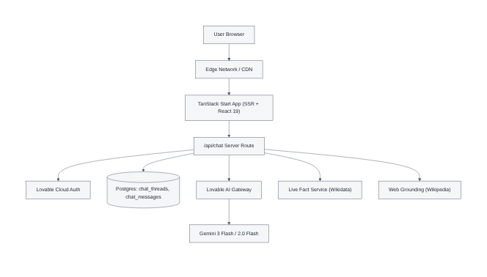
Figure 1: System Architecture Overview

5. Project Background
The immediate trigger for the project was a concrete failure observed in mainstream assistants: when asked about current office holders, prices, standings or other rapidly changing facts, they answer confidently from stale training data. For an executive user, a confident wrong answer is worse than no answer, because it is acted upon.
A second driver was operational. Public AI endpoints impose rate limits and quotas and occasionally return server errors. Naive clients surface these as an infinite spinner or an unhelpful generic failure. A professional tool must distinguish between 'you are sending requests too quickly', 'the account has exhausted its allowance' and 'the provider is temporarily down', and must recover automatically where possible.
A third driver was data ownership. Conversations often contain sensitive commercial context. Storing them requires authenticated accounts, database-enforced isolation between users, and transport and browser-level protections against common web attacks.
The project therefore set out to build not merely a chatbot but a small, complete, defensible software product, engineered and documented to professional standards.

5.1 Organisational Context
The system is positioned as an internal executive productivity tool that can also be exposed publicly. Its landing page communicates capability and drives sign-up, its pricing page presents the commercial model, and its chat workspace delivers the value. All capabilities are currently included in a single free tier so that adoption is not gated during evaluation.
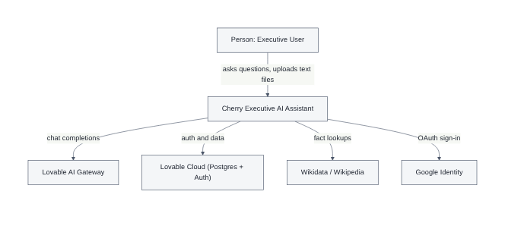
Figure 2: C4 Level 1 - System Context Diagram

6. Problem Statement
Existing conversational assistants available to a small team are either powerful but generic, or customisable but operationally immature. The specific problems this project addresses are:
- Temporal inaccuracy: answers to time-sensitive questions are drawn from a fixed training cutoff and are presented with unwarranted confidence.
- Absence of provenance: users cannot inspect the sources behind a claim, so verification is manual.
- Poor failure semantics: rate limiting, quota exhaustion and provider outages are surfaced as generic errors or as a hung interface.
- No durable memory: conversations are lost on refresh, so context must be rebuilt manually.
- Weak document workflows: uploads are either unsupported, or accepted without validation, feedback or a summary of what was actually read.
- Insufficient security posture: missing response headers, unvalidated payloads and shared data stores expose the product to injection, framing and cross-user data leakage.
- Accessibility gaps: keyboard-only and voice-first interaction are frequently afterthoughts.
The problem, stated concisely: build a conversational assistant that is current, transparent, resilient, memory-bearing, document-aware, secure and accessible, and prove those properties through testing.

7. Aim and Objectives

7.1 Aim
To design, implement, test, deploy and critically evaluate a production-grade conversational AI web platform that delivers accurate, verifiable and resilient assistance to professional users.

7.2 Objectives
- Deliver a streaming chat experience with token-by-token rendering and a visible thinking state.
- Implement a live fact verification layer that resolves time-sensitive entities at request time.
- Implement web grounding that returns citable sources and displays them in the interface.
- Provide authenticated accounts using a trusted external identity provider.
- Persist conversation threads and messages server-side with database-enforced per-user isolation.
- Accept text document uploads with strict validation, previews, progress and clear error feedback.
- Make the assistant scan uploaded content and summarise it before answering.
- Provide browser-native speech-to-text input and text-to-speech output.
- Allow users to export a transcript of any conversation.
- Harden the application with a Content Security Policy, HSTS and related response headers.
- Implement resilience: retries, a circuit breaker, a model fallback chain and status-accurate errors.
- Deploy to a global edge runtime with an automated build pipeline and a public URL.
- Validate the system with unit, functional and non-functional tests and document the results.
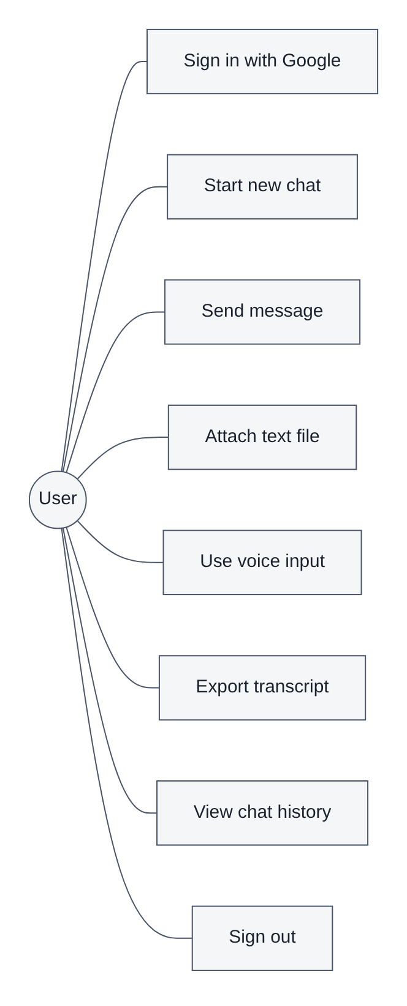
Figure 5: Use Case Diagram

8. Scope of the Project

8.1 In Scope
- Public marketing landing page, pricing page and authentication page.
- Protected chat workspace with a thread sidebar, conversation pane and composer.
- Streaming conversational responses from large language models via a managed gateway.
- Live fact verification and web grounding with source display.
- Google-based sign-in, session management, route guarding and sign-out.
- Server-side chat history with create, list, rename and delete operations.
- Text-only file upload, extraction, scanning and summarisation.
- Voice input and spoken replies using native browser speech APIs.
- Transcript export.
- Security headers, payload validation, size caps and row level security.
- Edge deployment and continuous build.

8.2 Out of Scope
- Native mobile applications; the product is a responsive web application.
- Fine-tuning or self-hosting of foundation models.
- Multi-tenant team workspaces, shared threads and role hierarchies beyond the single-user model.
- Payment capture and subscription billing, since all features are currently free.
- Offline operation; the assistant requires network access to the model gateway.
- Image and PDF ingestion, deliberately excluded so that scanning behaviour is predictable.

8.3 Assumptions and Constraints
- Users have a modern evergreen browser with JavaScript enabled.
- Voice features depend on browser speech API availability and are labelled as beta.
- The model gateway is reachable and the account has available quota.
- The backend executes in an edge worker runtime without a general purpose operating system, which constrains dependency choice to Web-standard and pure JavaScript libraries.

9. Literature Review

9.1 Transformer Language Models
Modern assistants are built on the transformer architecture introduced by Vaswani and colleagues, which replaced recurrence with self-attention and enabled highly parallel training on very large corpora. Subsequent scaling work established that instruction-following capability emerges from scale combined with supervised fine-tuning and reinforcement learning from human feedback. The practical consequence for this project is that capability is obtained by prompting a hosted model rather than by training, and engineering effort shifts to context construction, latency, cost and failure handling.

9.2 Hallucination and Grounding
A persistent limitation is hallucination: fluent output that is unsupported by fact. The literature identifies retrieval augmented generation as the dominant mitigation, in which documents retrieved at query time are placed in the context window so that the model summarises rather than recalls. Cherry applies a targeted variant of this idea: rather than retrieving arbitrary prose, it resolves specific volatile entities against a structured knowledge base and supplements this with encyclopaedic search results, both injected as clearly delimited context.

9.3 Streaming Interfaces and Perceived Latency
Human-computer interaction research consistently shows that perceived responsiveness depends more on time to first feedback than on total completion time. Token streaming exploits this: the user begins reading while generation continues. The project therefore treats time to first token as a primary performance metric.

9.4 Resilience Patterns
Nygard's stability patterns, notably the circuit breaker and bulkhead, describe how distributed systems should behave when a dependency degrades. A circuit breaker trips after repeated failures and fails fast during a cooldown window, protecting both the caller and the struggling dependency. This pattern is implemented directly in the chat route.

9.5 Web Application Security
The OWASP Top Ten and the associated cheat sheets define the baseline for web security. Relevant controls adopted here include strict input validation, Content Security Policy, HSTS, clickjacking protection, MIME sniffing protection, a restrictive permissions policy, and authorisation enforced at the data layer rather than only in application code.

10. Existing Systems Analysis
Four representative categories of existing solution were reviewed before design.
System category | Strengths | Limitations relevant to this project
General hosted assistants | Strong reasoning, mature interface, broad knowledge | Fixed knowledge cutoff, no provenance for claims, no control over data residence or retention
Search-integrated assistants | Current information, citations shown | Citations often shallow, latency high, limited control over prompt and persona
Embeddable widget chatbots | Fast to install, low cost | Shallow reasoning, scripted flows, little or no document understanding
Self-hosted open models | Full data control, no per-token cost | Substantial infrastructure burden, weaker quality, no managed resilience

The analysis established a clear gap. No reviewed option combined managed frontier-model quality with request-time factual verification, transparent sources, user-owned persistent history and explicit resilience engineering in a single self-hosted-feeling product. Cherry occupies that gap by consuming a managed model gateway while owning the context, persistence, security and failure behaviour itself.

11. Proposed System
The proposed system is a full-stack web application executing on an edge runtime. The browser receives a server-rendered React application. Conversational requests are posted to an internal server route which validates the payload, resolves the caller's identity, extracts any attached text, builds a grounded prompt, selects a model according to current health, streams the completion back to the browser, and persists both sides of the exchange.

11.1 Key Characteristics
- Single deployable unit: front end, server routes and server functions ship together to the edge.
- Grounded prompting: verified facts and cited web context are injected before generation.
- Health-aware model selection: a circuit breaker and fallback chain protect availability.
- Owned persistence: threads and messages live in the project's own database under row level security.
- Security by default: every response carries a hardened header set; every request is schema validated.
- Progressive enhancement: voice and export enrich the experience without being required for it.
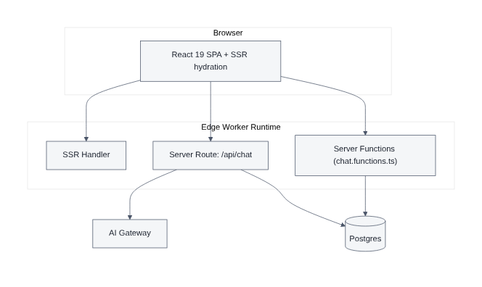
Figure 3: C4 Level 2 - Container Diagram

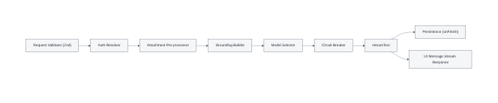
Figure 4: C4 Level 3 - Component Diagram of the Chat Route

12. Feasibility Study

12.1 Technical Feasibility
All required capabilities are achievable with mature technology. Streaming is provided by the Vercel AI SDK over standard HTTP streaming. Structured fact lookup is available through public SPARQL endpoints. Authentication, PostgreSQL and row level security are provided by the managed cloud backend. The edge runtime supports the Web-standard APIs the application relies upon. The principal technical constraint is the absence of a full operating system in the worker runtime, which rules out native image or subprocess dependencies; the design avoids these entirely.

12.2 Economic Feasibility
Costs are dominated by model inference, which is metered per token and controlled by capping output tokens, clipping extracted file text and caching grounding lookups. Hosting on an edge platform and a managed database is inexpensive at the anticipated volume. No licence fees are incurred because the entire dependency set is open source.

12.3 Operational Feasibility
The interface follows conventional chat conventions, so training requirements are negligible. Operations are simplified by structured logging with a trace identifier returned in a response header, allowing any user-reported incident to be located precisely in the logs.

12.4 Schedule Feasibility
The work was decomposed into seven phases across roughly ten weeks, as shown in the delivery plan. Each phase produced a deployable increment, so schedule risk was continuously visible.

12.5 Legal and Ethical Feasibility
Only the minimum personal data required for authentication is stored. Conversations belong to the authenticated owner and are inaccessible to other accounts by database policy. The assistant is instructed to state uncertainty rather than fabricate, and grounding sources are displayed so that claims can be independently checked.
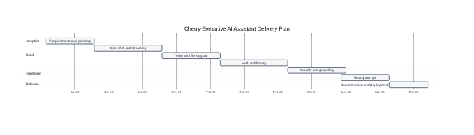
Figure 46: Project Gantt Chart

13. Requirement Analysis
Requirements were elicited through competitor analysis, review of reported failure modes in existing assistants, and iterative feedback from early testers of successive deployed increments. They were recorded as numbered statements, prioritised using the MoSCoW method, and traced through design, implementation and test.

13.1 Stakeholders
Stakeholder | Interest | Primary requirements
Executive user | Fast, correct answers on demand | Streaming replies, factual currency, history, document scanning
Administrator | Reliable, observable operation | Structured logs, trace identifiers, graceful degradation
Security reviewer | Protection of user data | Validated input, hardened headers, per-user data isolation
Developer | Maintainable codebase | Typed contracts, modular structure, documented interfaces

13.2 Requirement Elicitation Outcome
Forty-one atomic requirements were captured, of which twenty-six are functional and fifteen are non-functional. Every 'must have' requirement was implemented and verified; the deferred items are recorded in the roadmap in Chapter 46.
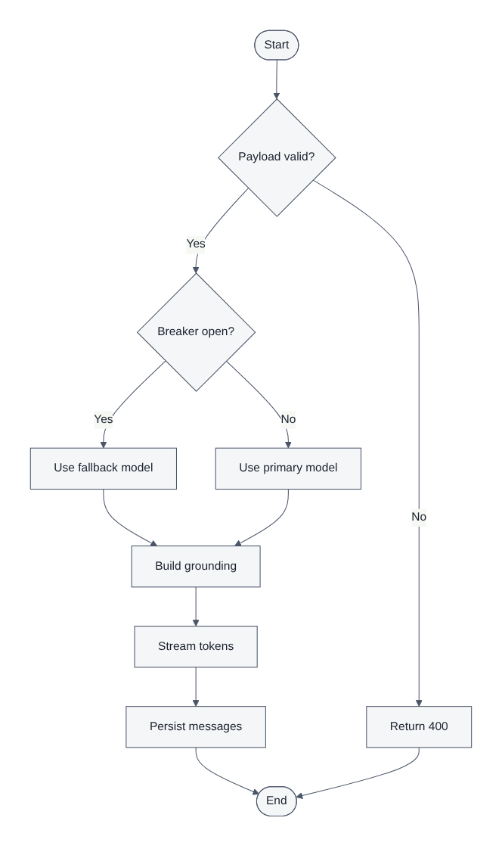
Figure 13: Activity Diagram - Message Handling

14. Functional Requirements
ID | Requirement | Priority | Status
FR-01 | The system shall present a public landing page describing the product. | Must | Implemented
FR-02 | The system shall allow a user to sign in using Google identity. | Must | Implemented
FR-03 | The system shall redirect authenticated users to the chat workspace. | Must | Implemented
FR-04 | The system shall prevent unauthenticated access to the chat workspace. | Must | Implemented
FR-05 | The system shall provide a visible sign-out control on every authenticated page. | Must | Implemented
FR-06 | The system shall accept a natural language message from the composer. | Must | Implemented
FR-07 | The system shall stream the assistant reply token by token. | Must | Implemented
FR-08 | The system shall render replies as sanitised Markdown with code blocks and lists. | Must | Implemented
FR-09 | The system shall display a thinking indicator until the first token arrives. | Should | Implemented
FR-10 | The system shall create a new conversation thread on demand. | Must | Implemented
FR-11 | The system shall title a thread automatically from its first message. | Should | Implemented
FR-12 | The system shall list the signed-in user's threads in a sidebar. | Must | Implemented
FR-13 | The system shall reload the full message history of a selected thread. | Must | Implemented
FR-14 | The system shall allow deletion of a thread and its messages. | Should | Implemented
FR-15 | The system shall accept text file attachments via a button and via drag and drop. | Must | Implemented
FR-16 | The system shall reject non-text attachments with an explanatory toast. | Must | Implemented
FR-17 | The system shall reject attachments above the configured size limit. | Must | Implemented
FR-18 | The system shall display a preview chip for each pending attachment. | Should | Implemented
FR-19 | The system shall extract text from accepted attachments on the server. | Must | Implemented
FR-20 | The assistant shall summarise scanned file content before answering. | Must | Implemented
FR-21 | The system shall inject verified live facts for time-sensitive questions. | Must | Implemented
FR-22 | The system shall display grounding sources associated with a reply. | Should | Implemented
FR-23 | The system shall support speech-to-text input from the microphone. | Should | Implemented
FR-24 | The system shall optionally speak assistant replies aloud. | Could | Implemented
FR-25 | The system shall export a conversation transcript as a document. | Should | Implemented
FR-26 | The system shall present distinct messages for rate limit and quota failures. | Must | Implemented

15. Non-Functional Requirements
ID | Category | Requirement | Target
NFR-01 | Performance | Time to first token under normal conditions | < 1.5 s
NFR-02 | Performance | Landing page first contentful paint | < 1.5 s
NFR-03 | Performance | Grounding lookups executed concurrently, not serially | Parallel
NFR-04 | Scalability | Stateless request handling at the edge | Horizontal
NFR-05 | Availability | Automatic fallback when the primary model fails | Chained
NFR-06 | Reliability | Circuit breaker trips after repeated consecutive failures | 4 failures / 60 s
NFR-07 | Reliability | Automatic retry with exponential backoff for transient errors | 4 retries
NFR-08 | Security | Every response carries CSP, HSTS and anti-sniffing headers | All responses
NFR-09 | Security | All request payloads validated against a strict schema | 100%
NFR-10 | Security | Cross-user data access prevented at the database layer | RLS enforced
NFR-11 | Security | Server secrets never reach the browser bundle | Zero exposure
NFR-12 | Usability | Responsive layout from 320 px to desktop widths | Fully responsive
NFR-13 | Accessibility | Keyboard operable controls with accessible names | WCAG 2.1 AA aligned
NFR-14 | Maintainability | Strict TypeScript with no implicit any in application code | Enforced
NFR-15 | Observability | Trace identifier on every request and in every log line | 100%

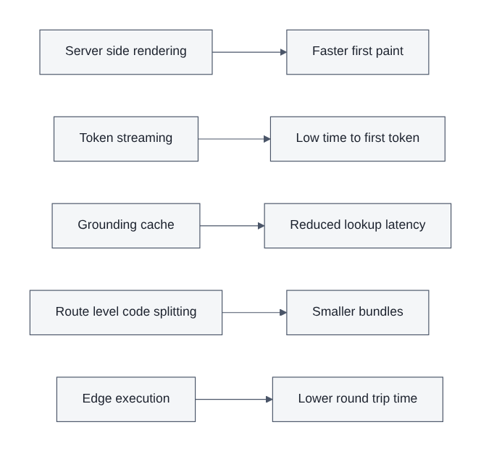
Figure 45: Performance Optimisation Map

16. Hardware and Software Requirements

16.1 Development Environment
Component | Specification
Processor | Quad-core x86-64 or Apple Silicon, 2.0 GHz or higher
Memory | 16 GB RAM recommended, 8 GB minimum
Storage | 10 GB free for the toolchain, dependencies and build artefacts
Operating system | macOS, Linux or Windows with WSL2
Runtime | Node.js 20 or later, or the Bun runtime
Package manager | Bun (primary) with npm compatibility
Editor | Any TypeScript-aware editor with ESLint integration
Browser | Chromium-based browser for debugging and speech API support

16.2 Runtime and Production Environment
Component | Specification
Application runtime | Cloudflare-compatible edge worker with Node compatibility
Database | Managed PostgreSQL with row level security
Authentication | Managed identity service with Google OAuth provider
AI inference | Managed AI gateway routing to Gemini family models
Static assets | Global content delivery network
Transport | HTTPS only, HSTS preloaded

16.3 Client Requirements
Component | Specification
Browser | Chrome, Edge, Safari or Firefox, current or previous major version
Network | Broadband or mobile data; streaming degrades gracefully on slow links
Optional hardware | Microphone for voice input, speakers for spoken replies
Screen | 320 px minimum width

17. System Analysis
System analysis translated the requirement set into behavioural models. Three perspectives were used: process flow, data movement and state.

17.1 Process Analysis
The dominant process is the message exchange. It begins with client-side validation of composer content and attachments, proceeds through transport, server validation, identity resolution, attachment extraction, grounding, model selection, generation and persistence, and ends with the rendered reply and any source citations. Each stage has a defined failure path.

17.2 Data Analysis
Two persistent entities were identified, the conversation thread and the message, together with the externally managed user identity. Messages store their content as a structured parts array rather than a flat string, which allows text, file references and grounding metadata to coexist in a single record and keeps the schema stable as new part types are introduced.

17.3 State Analysis
The client maintains a small explicit state machine for the conversation, and the server maintains a breaker state machine for gateway health. Modelling both explicitly eliminated an entire class of defects around duplicate submissions and stuck loading indicators.
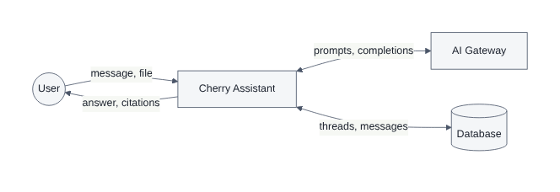
Figure 21: Data Flow Diagram - Level 0
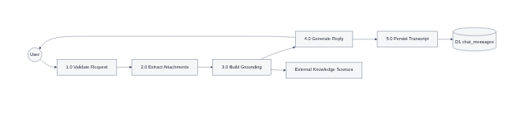
Figure 22: Data Flow Diagram - Level 1

18. System Architecture
The architecture is a single deployable full-stack application executing at the network edge. There is no separate API server: the same worker serves the server-rendered HTML, the static asset references, the internal server route used for chat streaming, and the typed server functions used for history operations.

18.1 Layers
- Presentation layer: React 19 route components, shared UI primitives and design tokens.
- Routing layer: file-based routes with a pathless authenticated layout enforcing the route guard.
- Application layer: server route handler for streaming chat, typed server functions for CRUD.
- Integration layer: AI gateway provider, live fact service, web grounding service, file extractors.
- Data layer: managed PostgreSQL accessed through a per-request client carrying the caller's token.
- Cross-cutting: validation, structured logging, security headers, error mapping.

18.2 Request Path
A browser request for a page is rendered on the server and hydrated on the client. A chat request is sent as JSON with a bearer token, handled entirely within the worker, and answered as a streaming response whose headers additionally carry the trace identifier and an encoded grounding payload for the interface to render.
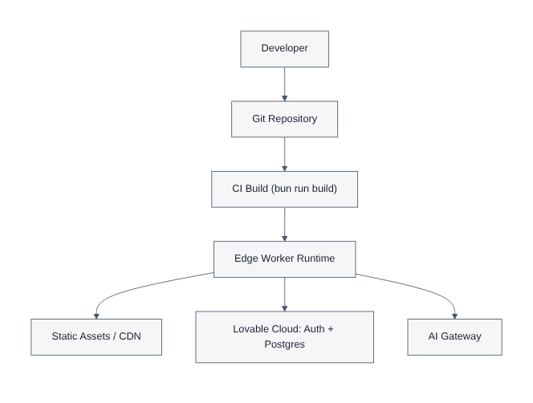
Figure 20: Deployment Diagram

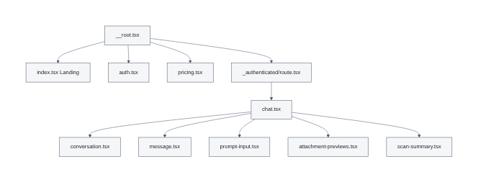
Figure 19: Component Diagram - Frontend Modules

19. Architectural Patterns and Decisions

19.1 Recorded Decisions
Decision | Choice | Rationale | Rejected alternative
Framework | TanStack Start with React 19 | Unified SSR, file routing and typed server functions in one deployable | Separate SPA plus standalone API service
Chat transport | Streaming HTTP via the AI SDK | Simple, cache-friendly, works through standard infrastructure | WebSocket session per user
Grounding | Targeted entity resolution plus encyclopaedic search | Precise correction of volatile facts at low latency and cost | Full vector-store retrieval augmented generation
Persistence | Managed PostgreSQL with row level security | Authorisation enforced by the database, not only by code | Document store with application-side filtering
Resilience | Circuit breaker plus model fallback chain | Fails fast during outages and preserves partial service | Unbounded retry against a failing endpoint
File ingestion | Text formats only | Deterministic scanning behaviour and predictable token cost | Accepting images and PDFs for multimodal input

19.2 Quality Attribute Tactics
Availability is addressed by redundancy in the model chain and by fail-fast behaviour. Performance is addressed by streaming, parallel grounding and edge execution. Security is addressed by validation, header hardening and database-level authorisation. Modifiability is addressed by isolating each integration behind a narrow module boundary so a provider can be replaced without touching route logic.
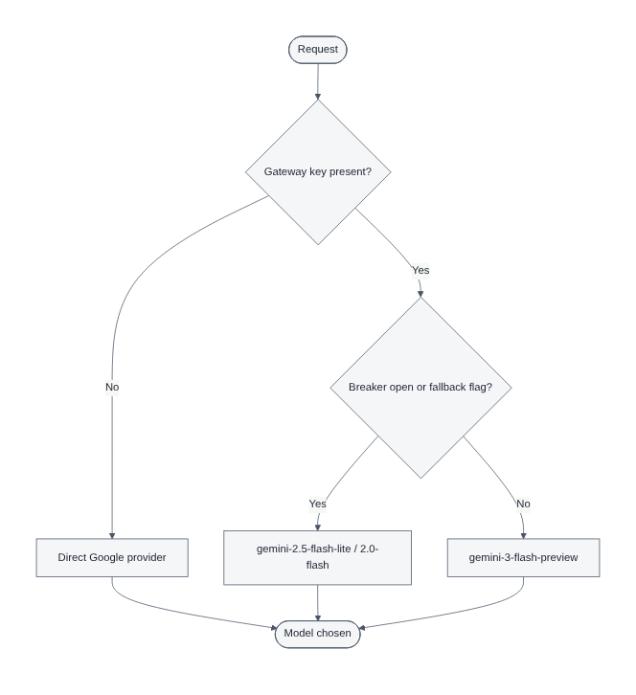
Figure 28: AI Model Selection and Fallback

20. System Design
Detailed design refines the architecture into concrete modules, contracts and flows. The chat route is the most intricate component and is designed as a linear pipeline of pure-ish stages, each of which can fail independently and each of which emits a structured log event.

20.1 Pipeline Stages
Stage | Responsibility | Failure behaviour
Size guard | Reject bodies above the configured maximum | 413 with trace identifier
Parse | Decode JSON safely | 400 invalid JSON
Validate | Apply the strict message schema | 400 with issue list
Authenticate | Resolve claims from the bearer token | Anonymous, no persistence
Extract | Convert attachments to delimited text | Attachment skipped with notice
Ground | Resolve facts and search context in parallel | Empty context, generation continues
Select model | Choose primary or fallback based on health | Direct provider fallback
Generate | Stream the completion | Mapped status with retry guidance
Persist | Store both messages and update the thread | Logged, response unaffected

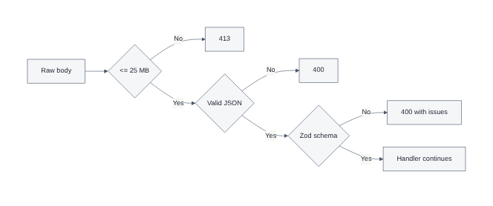
Figure 23: Request Validation Pipeline

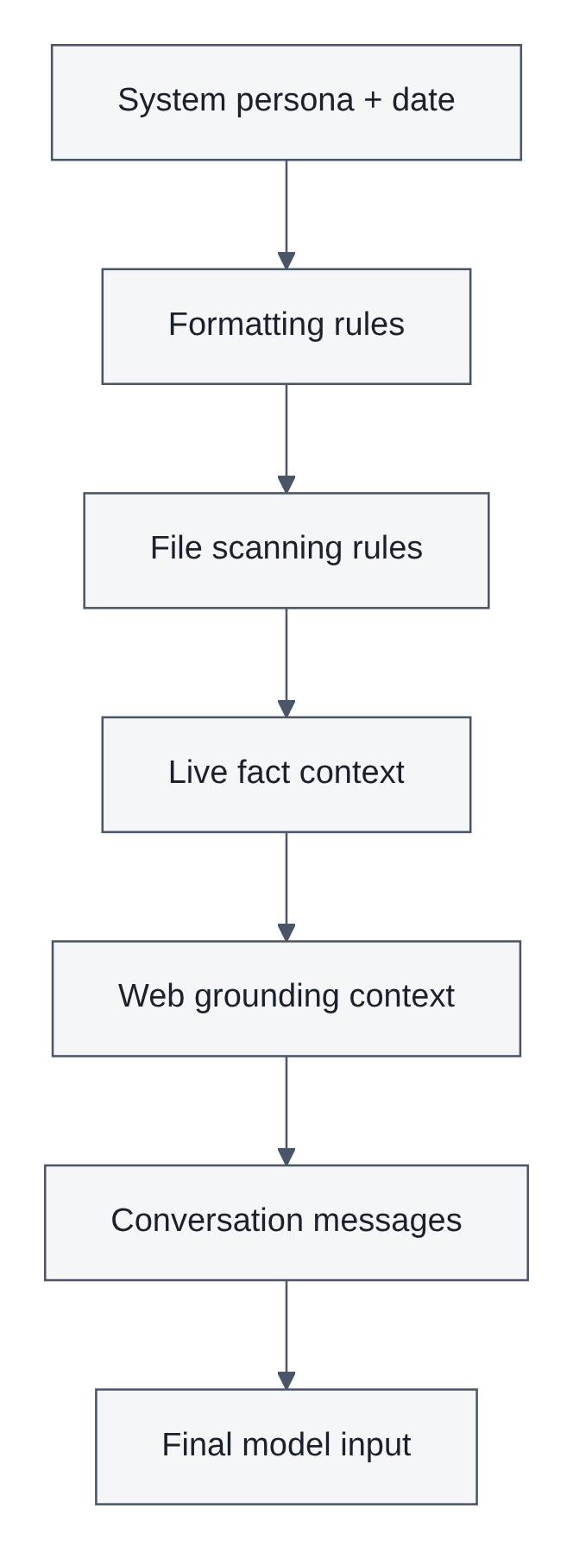
Figure 29: Prompt Assembly Structure

21. Use Case Modelling

21.1 Primary Use Cases
ID | Use case | Actor | Outcome
UC-01 | Sign in | User | Authenticated session established and chat opened
UC-02 | Send message | User | Streamed reply rendered and persisted
UC-03 | Attach and scan file | User | File summarised then used to answer
UC-04 | Dictate by voice | User | Speech transcribed into the composer
UC-05 | Browse history | User | Previous thread reopened with full context
UC-06 | Export transcript | User | Document downloaded to the device
UC-07 | Sign out | User | Session cleared and landing page shown

21.2 Expanded Use Case: Send Message
Field | Detail
Precondition | The user is authenticated and a thread is selected or created
Main flow | 1. User enters text. 2. Client validates and posts the message. 3. Server validates, authenticates and persists the user message. 4. Server builds grounding and selects a model. 5. Tokens stream to the client and render progressively. 6. Server persists the reply.
Alternate flow A | Rate limited: server returns 429 with a retry hint and the interface shows a wait message
Alternate flow B | Breaker open: server answers immediately with a temporary unavailability message
Postcondition | Both messages are stored and the thread timestamp is updated

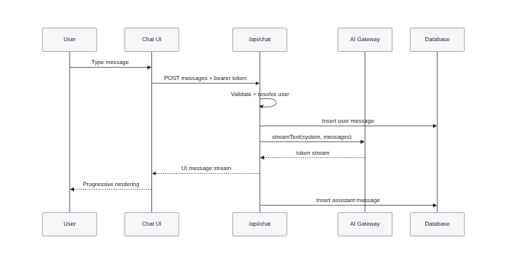
Figure 8: Sequence Diagram - Streaming a Chat Reply

22. Data Flow Design
Data flow design describes how information moves between the user, the processes inside the application and the external services. The level zero diagram treats the assistant as a single process exchanging messages with the user and with external providers. The level one diagram decomposes that process into validation, extraction, grounding, generation and persistence.

22.1 Data Stores
Store | Contents | Accessed by
D1 chat_threads | Thread identifier, owner, title, timestamps | History functions, chat route
D2 chat_messages | Role, structured parts, thread and owner references | History functions, chat route
D3 grounding cache | Recent lookup results keyed by query | Grounding service, in-memory

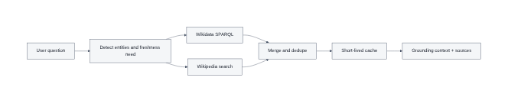
Figure 30: Retrieval and Grounding Pipeline
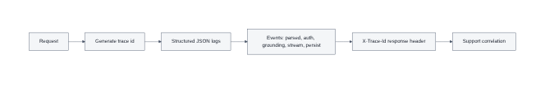
Figure 34: Observability and Tracing

23. Database Design
The schema is deliberately small. Identity is owned by the managed authentication service; the application stores only conversational data keyed by the authenticated user identifier.

23.1 Tables
Table | Column | Type | Notes
chat_threads | id | uuid | Primary key, generated
 | user_id | uuid | Owner, references the authenticated user
 | title | text | Defaults to 'New chat', auto-titled from first message
 | created_at | timestamptz | Insert timestamp
 | updated_at | timestamptz | Touched on every exchange, drives sidebar ordering
chat_messages | id | uuid | Primary key, generated
 | thread_id | uuid | References the parent thread, cascade delete
 | user_id | uuid | Owner, used by the row level security policy
 | role | text | Constrained to 'user' or 'assistant'
 | parts | jsonb | Structured content: text, file references, grounding metadata
 | created_at | timestamptz | Ordering key within a thread

23.2 Authorisation Model
Row level security is enabled on both tables and every policy scopes access to the authenticated user identifier. Explicit grants are issued to the authenticated role only; the anonymous role has no access at all, which means an unauthenticated request cannot read or write conversational data even if application logic were bypassed.
-- Authorisation model applied to conversational tables
GRANT SELECT, INSERT, UPDATE, DELETE ON public.chat_threads TO authenticated;
GRANT SELECT, INSERT, UPDATE, DELETE ON public.chat_messages TO authenticated;
GRANT ALL ON public.chat_threads TO service_role;
GRANT ALL ON public.chat_messages TO service_role;
ALTER TABLE public.chat_threads ENABLE ROW LEVEL SECURITY;
ALTER TABLE public.chat_messages ENABLE ROW LEVEL SECURITY;
CREATE POLICY "owner reads threads" ON public.chat_threads
FOR SELECT TO authenticated USING (user_id = auth.uid());
CREATE POLICY "owner writes threads" ON public.chat_threads
FOR ALL TO authenticated USING (user_id = auth.uid())
WITH CHECK (user_id = auth.uid());
CREATE POLICY "owner reads messages" ON public.chat_messages
FOR SELECT TO authenticated USING (user_id = auth.uid());
CREATE POLICY "owner writes messages" ON public.chat_messages
FOR INSERT TO authenticated WITH CHECK (user_id = auth.uid());
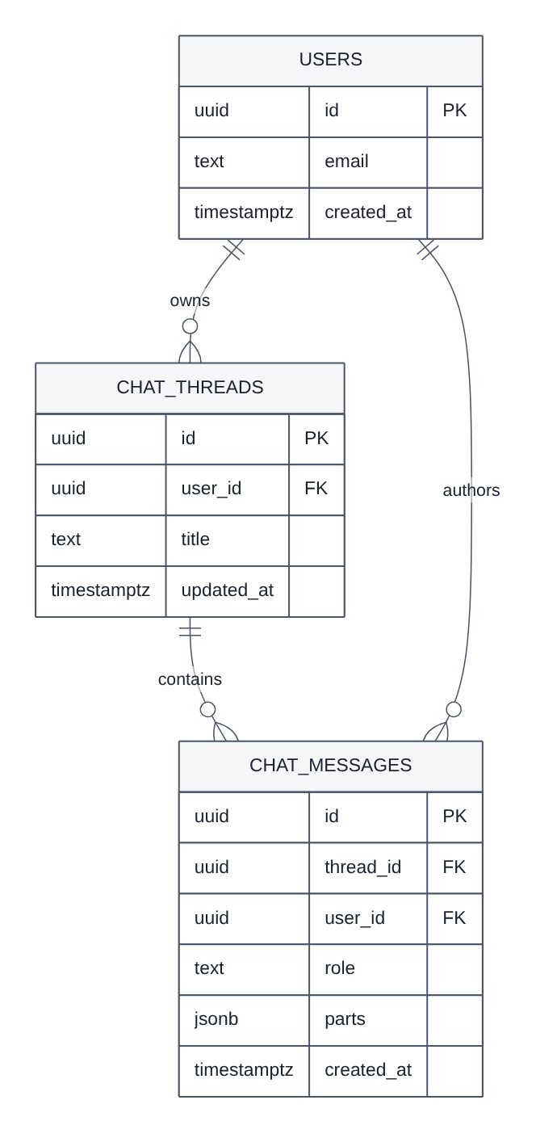
Figure 6: Entity Relationship Diagram

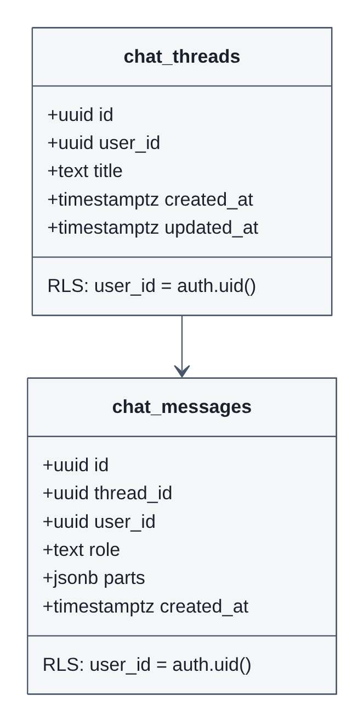
Figure 7: Database Schema Diagram
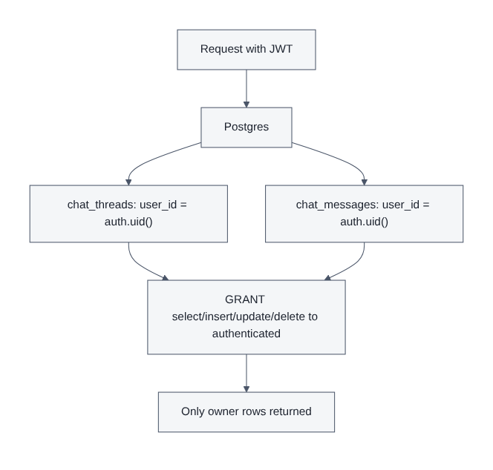
Figure 25: Row Level Security Model

24. Class and Domain Model
Although the implementation is predominantly functional, the domain is modelled as a small object graph. A thread aggregates ordered messages; a message aggregates typed parts. Part polymorphism is the extension point that allowed file references and grounding metadata to be added without schema migration.
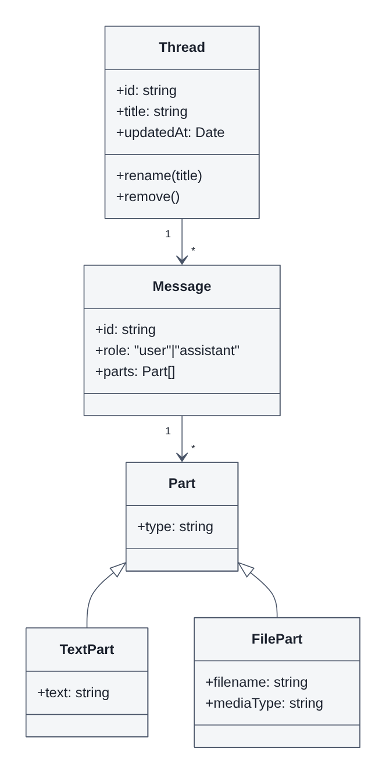
Figure 18: Class Diagram - Domain Model
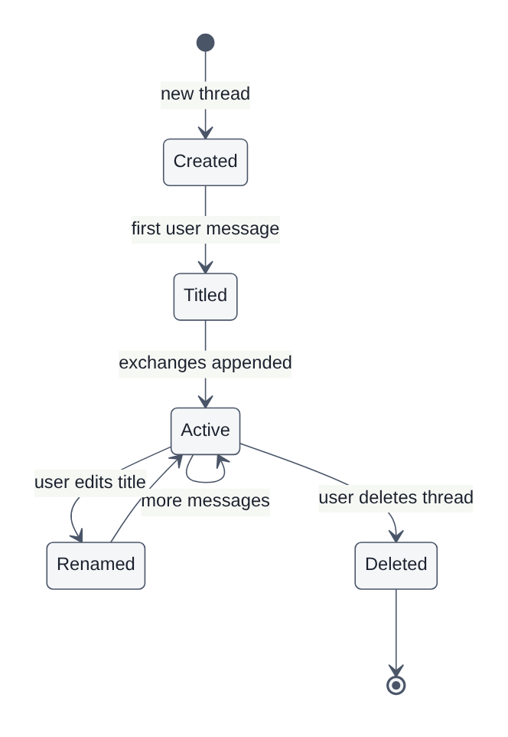
Figure 35: Chat History Data Lifecycle

25. Interface Design and User Experience
The visual language is deliberately restrained: a high-contrast executive palette, generous white space, a single accent colour used for emphasis and brand, and typography tuned for sustained reading. All colour, radius and elevation values are expressed as semantic design tokens so that the entire product can be retuned centrally.

25.1 Screens
Screen | Purpose | Key elements
Landing | Communicate value and drive sign-up | Hero statement, capability grid, call to action
Pricing | Present the commercial model | Single inclusive free plan with full feature list
Authentication | Establish a session | Continue with Google, provider buttons, brand mark
Chat workspace | Deliver the assistant | Thread sidebar, conversation pane, composer, controls
Empty state | Orient a new user | Suggestion chips and a short capability note

25.2 Interaction Details
- The composer grows with content and submits on Enter, with Shift and Enter inserting a newline.
- A thinking shimmer occupies the reply slot until the first token arrives, preventing layout shift.
- Attachment chips appear immediately on selection and can be removed before sending.
- Toast notifications carry all validation and network errors so the composer stays uncluttered.
- A boot animation covers hydration so the first paint never appears unstyled.
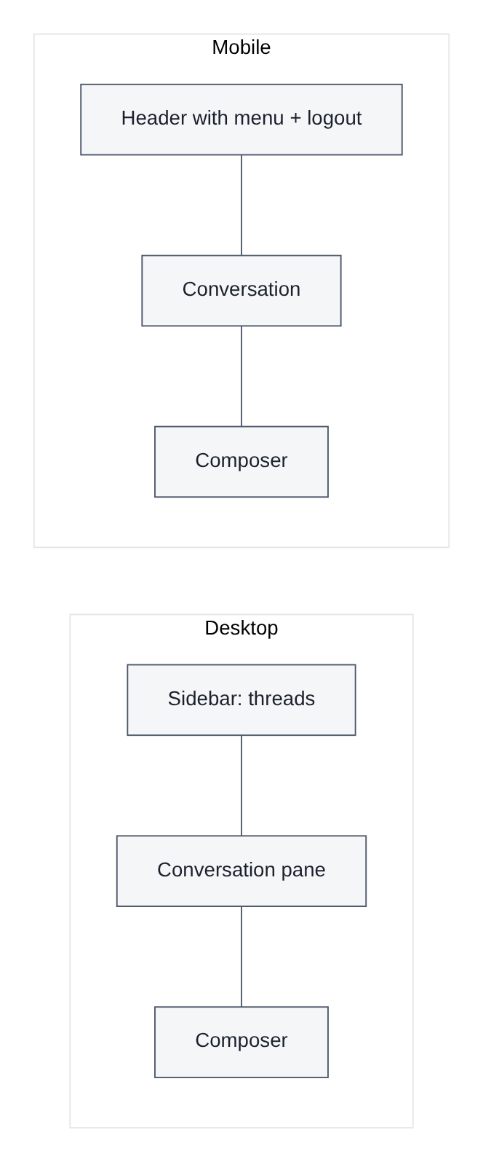
Figure 38: Responsive Layout Wireframe
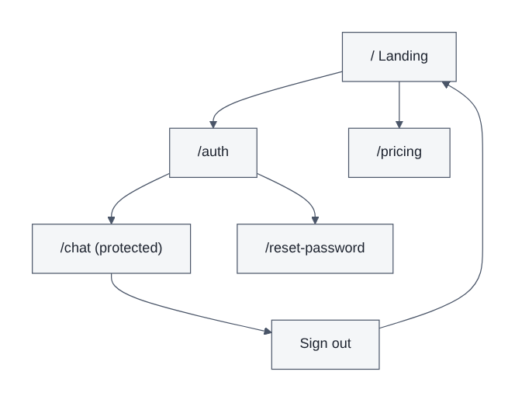
Figure 39: Navigation Map

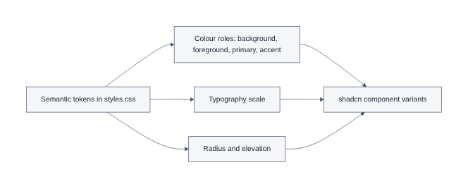
Figure 40: Design System Tokens

26. Security Design
Security is layered. Transport is HTTPS only and advertised as such through HSTS. The browser is constrained by a Content Security Policy that restricts script, style, frame and connection targets. Requests are validated before any work is performed. Authorisation is enforced by the database rather than only by application code. Secrets are read exclusively inside server handlers and never enter the client bundle.

26.1 Control Summary
Threat | Control | Where implemented
Cross-site scripting | Content Security Policy and sanitised Markdown rendering | Response headers, renderer
Clickjacking | Frame ancestors restriction and X-Frame-Options | Response headers
MIME sniffing | X-Content-Type-Options set to nosniff | Response headers
Protocol downgrade | HSTS with long max-age and preload | Response headers
Payload abuse | Body size cap and strict schema validation | Chat route
Cross-user data access | Row level security policies keyed to the caller | Database
Secret exposure | Server-only environment access inside handlers | Server modules
Prompt injection via files | File text delimited and summarised before use | Prompt design
Denial of service via retries | Circuit breaker and bounded retries | Chat route

The complete header set applied to every response is implemented as a single reusable function so that no route can accidentally omit it:
const CSP_DIRECTIVES = [
"default-src 'self'",
"base-uri 'self'",
"object-src 'none'",
"frame-ancestors 'self'",
"form-action 'self'",
"script-src 'self' 'unsafe-inline' 'unsafe-eval' https:",
"style-src 'self' 'unsafe-inline' https://fonts.googleapis.com",
"font-src 'self' data: https://fonts.gstatic.com",
"img-src 'self' data: blob: https:",
"media-src 'self' data: blob:",
"connect-src 'self' https: wss: blob: data:",
"worker-src 'self' blob:",
"manifest-src 'self'",
"upgrade-insecure-requests",
].join("; ");
const SECURITY_HEADERS: Record<string, string> = {
"content-security-policy": CSP_DIRECTIVES,
"strict-transport-security": "max-age=63072000; includeSubDomains; preload",
"x-content-type-options": "nosniff",
"x-frame-options": "SAMEORIGIN",
"referrer-policy": "strict-origin-when-cross-origin",
"cross-origin-opener-policy": "same-origin",
"permissions-policy": "camera=(), geolocation=(), payment=(), usb=(), microphone=(self)",
};
/** Returns the response with security headers applied (headers already set win). */
export function withSecurityHeaders(response: Response): Response {
const headers = new Headers(response.headers);
for (const [name, value] of Object.entries(SECURITY_HEADERS)) {
headers.set(name, value);
}
return new Response(response.body, {
status: response.status,
statusText: response.statusText,
headers,
});
}
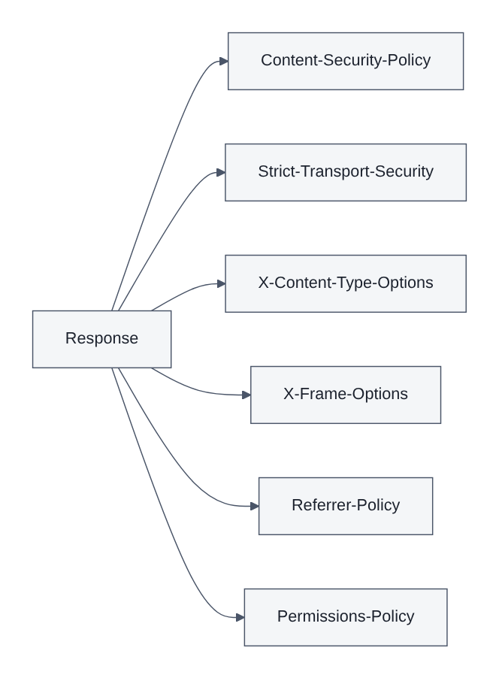
Figure 26: Security Headers and CSP Layers

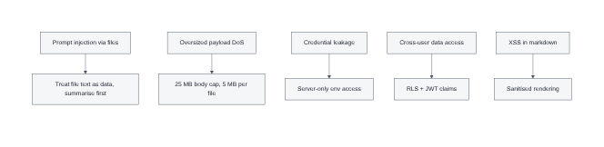
Figure 27: Threat Model Overview
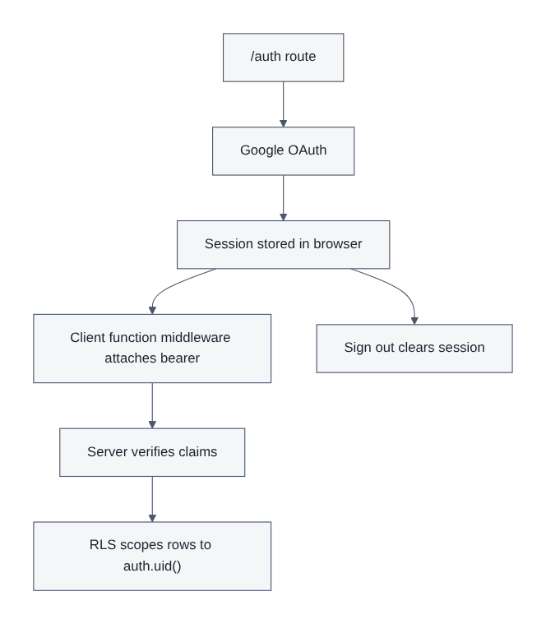
Figure 24: Authentication and Session Management

27. Artificial Intelligence Design
The assistant's behaviour is defined by a carefully layered system prompt combined with runtime context. The persona establishes tone; the date anchor establishes temporal reasoning; the file rules establish scanning behaviour; the formatting rules guarantee clean Markdown; and the grounding blocks supply verified facts and citable context.

27.1 Generation Parameters
Parameter | Value | Rationale
Primary model | Gemini 3 Flash preview via gateway | Best quality and latency balance
Fallback model | Gemini 2.5 Flash Lite / 2.0 Flash direct | Available when the gateway degrades
Maximum output tokens | 8192 | Long analytical answers without unbounded cost
Temperature | 0.4 | Deterministic enough for professional use, not mechanical
Maximum retries | 4 with exponential backoff | Absorbs transient 429 and 5xx responses

27.2 Model Selection Logic
const lovableProvider = lovableKey ? createLovableAiGatewayProvider(lovableKey) : null;
const geminiProvider = geminiKey
? createOpenAICompatible({
name: "google-gemini",
baseURL: "https://generativelanguage.googleapis.com/v1beta/openai",
headers: { Authorization: `Bearer ${geminiKey}` },
})
: null;
// If the breaker is open, prefer the direct-google fallback (bypasses gateway).
const forceFallback = useFallback || breakerIsOpen();
const primaryId = forceFallback ? "google/gemini-2.5-flash-lite" : "google/gemini-3-flash-preview";
const useDirectGoogle = (forceFallback && geminiProvider) || !lovableProvider;
const model = useDirectGoogle
? geminiProvider!.chatModel("gemini-2.0-flash")
: lovableProvider!.chatModel(primaryId);
tlog(traceId, "model.selected", {
provider: useDirectGoogle ? "google-direct" : "lovable",
model: useDirectGoogle ? "gemini-2.0-flash" : primaryId,
breakerOpen: breakerIsOpen(),
});
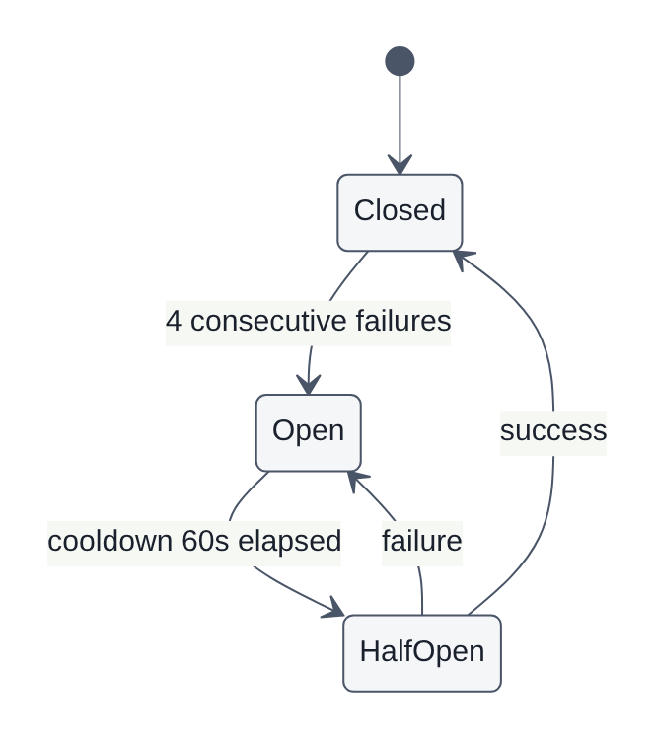
Figure 17: State Diagram - Circuit Breaker

28. Retrieval and Grounding Design
Grounding runs before generation and is strictly time-boxed and failure-tolerant: if either source fails, the request proceeds with whatever context was obtained. Both lookups execute concurrently.
const [liveFactContext, webGrounding] = await Promise.all([
buildLiveFactContext(processed).catch(() => ""),
buildWebSearchGrounding(processed).catch(() => ({ context: "", sources: [] })),
]);
The live fact service resolves volatile entities against a structured knowledge base using SPARQL, returning the current value together with its qualifier dates. The web grounding service retrieves encyclopaedic extracts and returns titled, linkable sources. Sources are encoded into a response header and also stored alongside the assistant message so that citations survive a page reload.
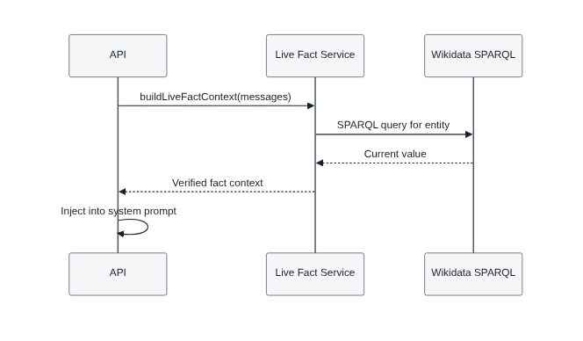
Figure 11: Sequence Diagram - Live Fact Verification
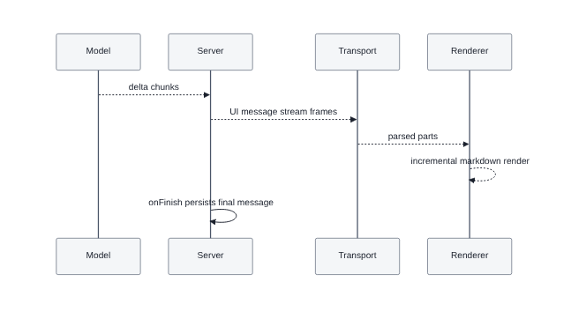
Figure 31: Streaming Token Pipeline

29. Voice Interaction Design
Voice is implemented entirely with native browser speech APIs, which avoids sending audio to any third party and removes an entire class of privacy and cost concerns. Recognition results populate the composer, leaving the user in control of what is actually sent. Synthesis is opt-in through a speaker toggle and is cancelled automatically when a new request begins.
Because support varies across browsers, voice is presented as a beta capability, the microphone control is hidden where the API is unavailable, and permission refusal is handled with an explanatory toast rather than a silent failure.
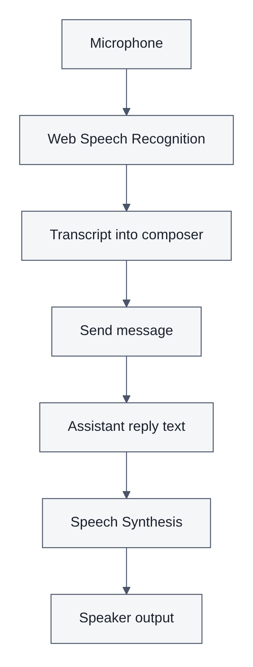
Figure 37: Voice Interaction Architecture
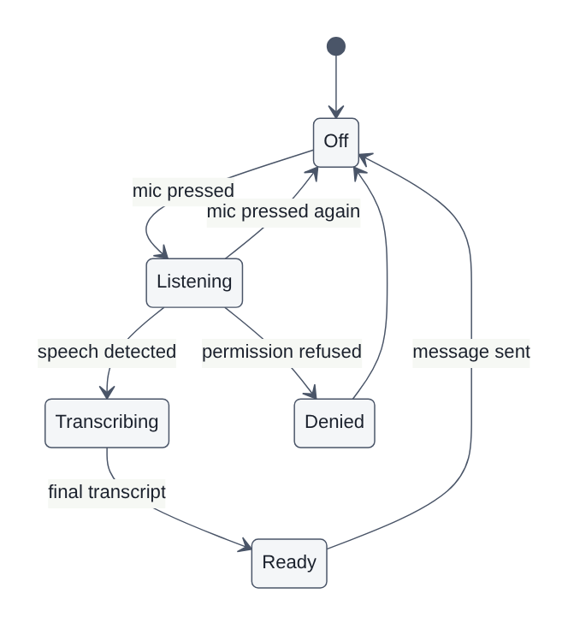
Figure 16: State Diagram - Voice Input

30. File Handling Design
File support is intentionally narrow. Only text-bearing formats are accepted, which makes the assistant's scanning behaviour predictable and keeps token consumption bounded. Validation occurs twice: in the browser for immediate feedback, and on the server as the authoritative check.

30.1 Accepted and Rejected Formats
Category | Formats | Handling
Plain text | .txt, .md, .log, .yaml, .yml | Decoded as UTF-8
Structured text | .csv, .tsv, .json | Decoded and passed through verbatim
Office text | .docx, .xlsx, .xls | Text extracted server-side, sheets flattened to CSV
Images | .png, .jpg, .webp, .gif | Rejected with an explanatory notice
Portable documents | .pdf | Rejected with an explanatory notice

Extraction is implemented server-side and clipped to a maximum character budget with an explicit truncation marker so the model is never silently starved of context:
export async function extractTextFromFile(
mime: string,
name: string,
bytes: Uint8Array,
): Promise<string> {
const lower = name.toLowerCase();
if (
mime.startsWith("text/") ||
/\.(txt|md|csv|tsv|json|log|yaml|yml)$/i.test(lower)
) {
return new TextDecoder("utf-8").decode(bytes);
}
if (lower.endsWith(".docx") || mime.includes("wordprocessingml")) {
const result = await mammoth.extractRawText({
buffer: Buffer.from(bytes),
} as { buffer: Buffer });
return result.value ?? "";
}
if (
lower.endsWith(".xlsx") ||
lower.endsWith(".xls") ||
mime.includes("spreadsheetml") ||
mime.includes("ms-excel")
) {
const wb = XLSX.read(bytes, { type: "array" });
return wb.SheetNames.map(
(n) => `--- Sheet: ${n} ---\n${XLSX.utils.sheet_to_csv(wb.Sheets[n])}`,
).join("\n\n");
}
return "";
}
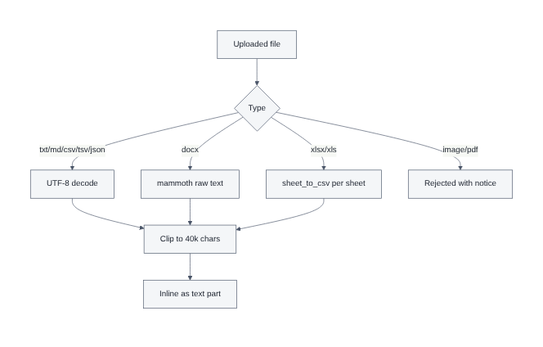
Figure 32: File Extraction Strategy

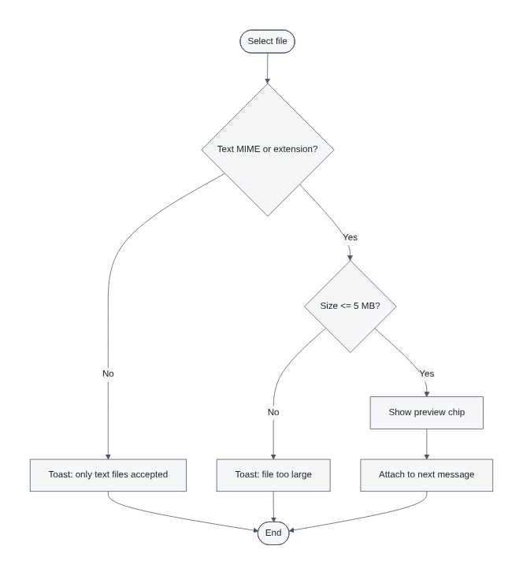
Figure 14: Activity Diagram - File Upload Validation
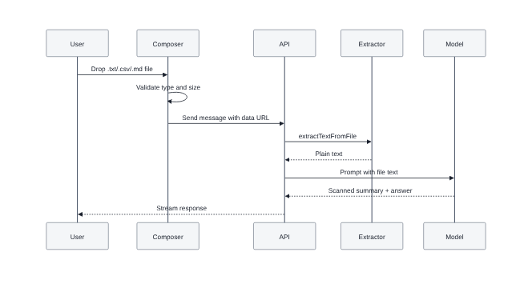
Figure 10: Sequence Diagram - File Scan and Answer

31. Implementation Overview
The implementation is written in TypeScript throughout, with strict compiler settings. Source is organised by responsibility: routes describe URLs and page composition, library modules encapsulate integrations, and component modules provide reusable interface primitives. Modules whose names end in .server are excluded from the browser bundle by the build's import protection, which guarantees that server-only credentials and libraries cannot leak to the client.

31.1 Source Layout
Path | Responsibility
src/routes/__root.tsx | Document shell, metadata, favicon, global providers
src/routes/index.tsx | Public landing page
src/routes/auth.tsx | Sign-in page with external identity providers
src/routes/pricing.tsx | Plan presentation
src/routes/_authenticated/route.tsx | Route guard for protected pages
src/routes/_authenticated/chat.tsx | Chat workspace: sidebar, conversation, composer
src/routes/api/chat.ts | Streaming chat endpoint and full request pipeline
src/lib/chat.functions.ts | Typed server functions for thread and message operations
src/lib/ai-gateway.ts | Model provider construction for the managed gateway
src/lib/live-facts.server.ts | Structured knowledge base fact resolution
src/lib/web-search.server.ts | Encyclopaedic grounding and source collection
src/lib/file-extract.server.ts | Data URL decoding and text extraction
src/lib/security-headers.ts | Central response header hardening
src/lib/export-chat.ts | Transcript export
src/lib/voice.ts | Speech recognition and synthesis wrappers
src/components/ai-elements/* | Conversation, message, composer and shimmer primitives
src/components/chat/* | Attachment previews and scan summary presentation

32. Implementation - Frontend
The front end is composed of route components that delegate presentation to small primitives. The chat workspace owns conversation state, attachment state and voice state, and passes callbacks down to the composer and message list. Markdown is rendered through a sanitising pipeline so that model output can never introduce active content.

32.1 Composer Behaviour
The composer supports typing, dictation, file selection through a button and drag and drop onto the conversation area. Every accepted file produces a preview chip; every rejected file produces a toast that names the file and the reason. Upload progress is displayed while the attachment is encoded, and a failed send can be retried without retyping the message.

32.2 Streaming Rendering
Incoming stream frames are appended to the active assistant message and re-rendered incrementally. A shimmer placeholder occupies the reply slot until the first token arrives so that the layout does not shift. When grounding sources accompany a reply, they are rendered as a compact citation row beneath the message.

32.3 Scan Summary Presentation
When a reply begins with a scan summary, the interface promotes it into a distinct panel so the user can immediately confirm that the correct document was read and understood before reading the substantive answer.
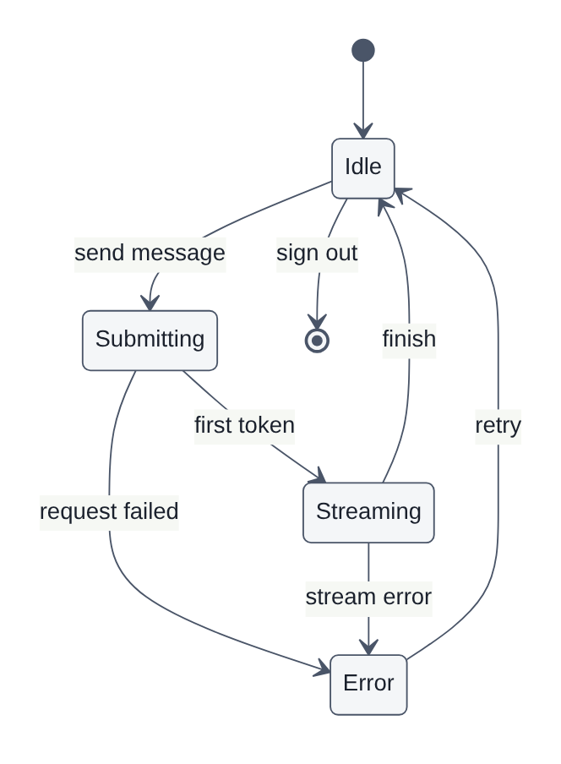
Figure 15: State Diagram - Chat Session Lifecycle

Figure 36: Export Transcript Flow

33. Implementation - Backend and Server Routes
The chat endpoint is the core of the backend. It is implemented as a file-based server route with a single POST handler that executes the pipeline described in Chapter 20. The extract below shows request ingestion, size guarding, parsing and schema validation, each with a distinct status code and a trace identifier returned to the caller.
POST: async ({ request }: { request: Request }) => {
const traceId = newTraceId();
const startedAt = Date.now();
tlog(traceId, "request.received", { url: request.url });
const raw = await request.text();
if (raw.length > MAX_BODY_BYTES) {
tlog(traceId, "request.rejected", { reason: "payload_too_large", bytes: raw.length });
return new Response("Payload too large", { status: 413, headers: { "X-Trace-Id": traceId } });
}
let parsedJson: unknown;
try {
parsedJson = JSON.parse(raw);
} catch {
tlog(traceId, "request.rejected", { reason: "invalid_json" });
return new Response("Invalid JSON", { status: 400, headers: { "X-Trace-Id": traceId } });
}
const parsed = bodySchema.safeParse(parsedJson);
if (!parsed.success) {
tlog(traceId, "request.rejected", { reason: "invalid_payload", issues: parsed.error.issues });
return new Response(
JSON.stringify({ error: "Invalid request payload", traceId, issues: parsed.error.issues }),
{ status: 400, headers: { "Content-Type": "application/json", "X-Trace-Id": traceId } },
);
}
const { messages, threadId, useFallback } = parsed.data;
tlog(traceId, "request.parsed", {
messageCount: messages.length,
threadId: threadId ?? null,
useFallback: Boolean(useFallback),
Generation is then invoked with the assembled system prompt. Note the bounded retries, the temperature, the injected date and the grounding blocks appended to the persona:
const result = streamText({
model,
maxOutputTokens: 8192,
temperature: 0.4,
// Built-in exponential backoff for 429 / 5xx (retries: 250ms, 500ms, 1s, 2s)
maxRetries: 4,
system:
`You are Cherry Executive AI Assistant — a precise, professional, current general-purpose AI assistant. Speak with the calm clarity and conviction of a world-class executive communicator. ` +
`Today's date is ${today}. Reason with this as the current date for time-sensitive questions. ` +
`FILE SCANNING: Cherry accepts text files only. When a message contains attached file text, first scan it and open your reply with a short "Scanned <filename>" summary — what the file is, its size/structure, and 2-4 key findings — then answer the user's question using that content. Reference every attachment by name. If an attachment was rejected, say so plainly and ask for a text file. ` +
`FORMATTING RULES: Output clean Markdown. Use **bold** for key terms, real bullet/numbered lists, fenced code blocks with language tags. Never leave stray * or ** in the middle of sentences. No ALL-CAPS emphasis. Close every emphasis marker on the same line.` +
liveFactContext +
webSearchContext,
messages: await convertToModelMessages(processed),
onError: ({ error }) => {
breakerRecordFailure();
tlog(traceId, "stream.error", {
model: primaryId,
Resilience is provided by a lightweight in-memory circuit breaker. Consecutive failures trip it; a cooldown window then allows recovery. While open, the route either fails fast with an actionable message or diverts to the direct provider:
const BREAKER = { failures: 0, openUntil: 0 };
const BREAKER_THRESHOLD = 4; // consecutive failures before we trip
const BREAKER_COOLDOWN_MS = 60_000; // stay open for 60s
function breakerIsOpen() {
return Date.now() < BREAKER.openUntil;
}
function breakerRecordSuccess() {
BREAKER.failures = 0;
BREAKER.openUntil = 0;
}
function breakerRecordFailure() {
BREAKER.failures += 1;
if (BREAKER.failures >= BREAKER_THRESHOLD) {
BREAKER.openUntil = Date.now() + BREAKER_COOLDOWN_MS;
}
}
import {
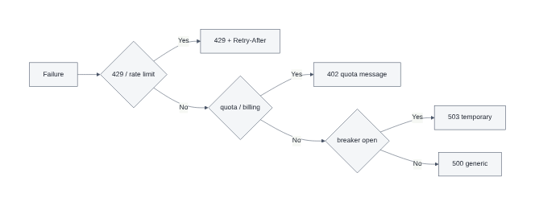
Figure 33: Error Handling and Status Mapping

34. Implementation - Authentication and Sessions
Authentication uses the managed identity service with Google as the external provider. The sign-in page presents provider buttons only; no password is ever handled by the application, which removes credential storage, reset flows and brute-force protection from the threat surface entirely.
After the provider redirect completes, the session is hydrated in the browser and the user is navigated to the chat workspace. Protected pages live under a pathless authenticated layout whose guard redirects unauthenticated visitors to the sign-in page before any protected loader executes. A client-side function middleware attaches the bearer token to every server function call, and the chat route independently verifies the token's claims before performing any persistence.
const authHeader = request.headers.get("authorization") ?? "";
const token = authHeader.startsWith("Bearer ") ? authHeader.slice(7) : "";
const SUPABASE_URL = process.env.SUPABASE_URL!;
const SUPABASE_PUBLISHABLE_KEY = process.env.SUPABASE_PUBLISHABLE_KEY!;
let userId: string | null = null;
let userSupabase: ReturnType<typeof createClient<Database>> | null = null;
if (token) {
userSupabase = createClient<Database>(SUPABASE_URL, SUPABASE_PUBLISHABLE_KEY, {
global: { headers: { Authorization: `Bearer ${token}` } },
auth: { storage: undefined, persistSession: false, autoRefreshToken: false },
});
const { data } = await userSupabase.auth.getClaims(token);
userId = data?.claims?.sub ?? null;
}
tlog(traceId, "auth.resolved", { userId: userId ?? null });
Sign-out clears the session and returns the user to the landing page. A sign-out control is present in both the sidebar and the mobile header so it is reachable from every authenticated view.
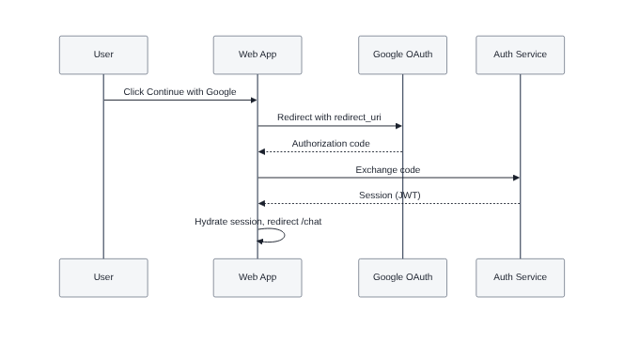
Figure 9: Sequence Diagram - Authentication Flow

35. Implementation - Database and Persistence
Persistence occurs at two points in the request lifecycle. The user message is written before generation begins so that nothing is lost if the stream fails midway, and the assistant message is written in the stream completion callback together with any grounding metadata. The thread timestamp is touched on each exchange, which drives sidebar ordering, and the thread title is derived from the first user message when it is still the default.
const storedParts = (lastMsg.parts ?? []).map((p) => {
const anyP = p as unknown as { type: string; url?: string; mediaType?: string; filename?: string; name?: string; text?: string };
if (anyP.type === "file") {
return { type: "file", mediaType: anyP.mediaType, filename: anyP.filename ?? anyP.name, url: "" };
}
return p;
});
await userSupabase.from("chat_messages").insert({
thread_id: threadId, user_id: userId, role: "user", parts: storedParts as never,
});
const firstText = (lastMsg.parts ?? []).find((p) => (p as { type: string }).type === "text") as TextUIPart | undefined;
const titleCandidate = firstText?.text?.trim().slice(0, 80);
const { data: t } = await userSupabase
.from("chat_threads").select("title").eq("id", threadId).maybeSingle();
const patch: { updated_at: string; title?: string } = { updated_at: new Date().toISOString() };
if (t && (t.title === "New chat" || !t.title) && titleCandidate) {
patch.title = titleCandidate.length > 60 ? titleCandidate.slice(0, 57) + "…" : titleCandidate;
}
await userSupabase.from("chat_threads").update(patch).eq("id", threadId);
}
try {
Attachment data URLs are deliberately stripped before storage: the filename and media type are retained for display, but the encoded payload is not written to the database. This keeps row sizes small and avoids retaining document content beyond the conversation in which it was used.
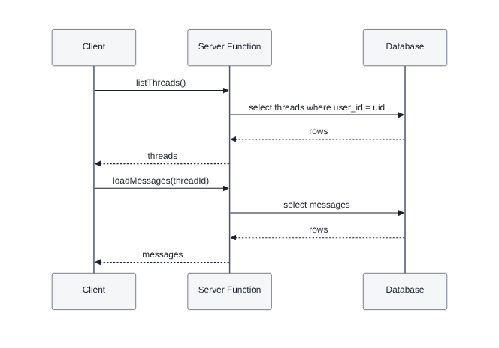
Figure 12: Sequence Diagram - Chat History Retrieval

36. Implementation - Security Hardening
Hardening was implemented as cross-cutting infrastructure rather than per-route code. The header function shown in Chapter 26 is applied centrally to every response. Validation is expressed once as a schema and reused, so no handler can accept an unchecked payload.
const partSchema = z.looseObject({
type: z.string().max(64),
});
const messageSchema = z.object({
id: z.string().max(128).optional(),
role: z.enum(["user", "assistant"]),
parts: z.array(partSchema).max(64).optional(),
content: z.string().max(MAX_TEXT_LEN).optional(),
});
const bodySchema = z.object({
messages: z.array(messageSchema).min(1).max(MAX_MESSAGES),
threadId: z.string().uuid().optional(),
useFallback: z.boolean().optional(),
});
// Simple trace-id + structured logger

36.1 Additional Measures
- Body size is capped at 25 MB overall, with a 5 MB per-file limit enforced in the composer.
- Message arrays are capped in length and individual text fields are capped in size.
- Roles are constrained to user and assistant, so a caller cannot inject a synthetic system turn.
- Model output is rendered through a sanitising Markdown pipeline.
- Secrets are read inside handlers at call time and never at module scope.
- Error responses expose a trace identifier but never internal stack traces or provider messages.
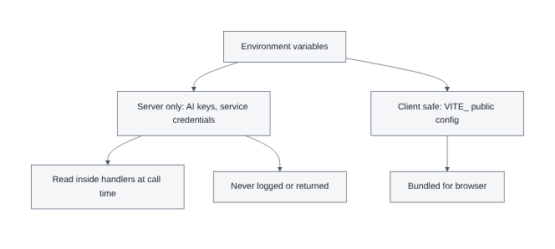
Figure 44: Environment and Secret Management

37. Testing Strategy
Testing followed a layered strategy. Static analysis runs on every change through the TypeScript compiler and ESLint. Unit tests target pure logic such as validation, decoding, extraction and error mapping. Integration tests exercise the chat route end to end with stubbed providers. Functional testing covers the user journeys manually against the deployed build. Non-functional testing measures latency, verifies security headers and confirms data isolation.

37.1 Test Environments
Environment | Purpose | Data
Local development | Fast feedback during implementation | Disposable test account
Preview deployment | Realistic edge runtime verification | Seeded test threads
Production | Smoke verification after release | Read-only checks only

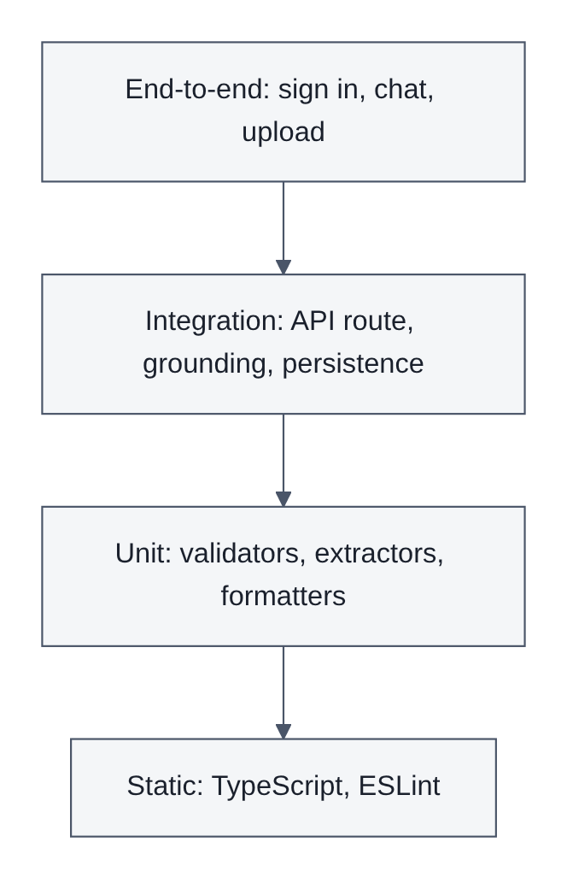
Figure 41: Testing Strategy Pyramid
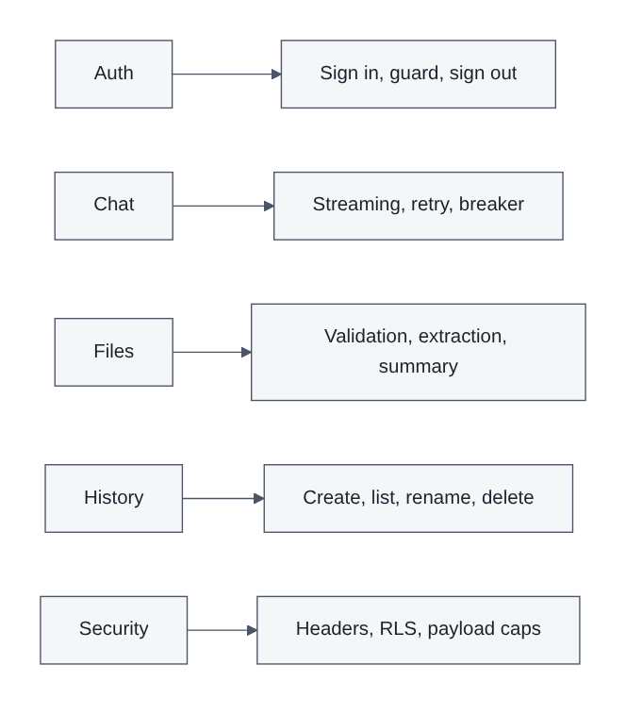
Figure 42: Test Coverage Areas

38. Unit Testing Results
ID | Unit under test | Input | Expected | Result
UT-01 | Payload schema | Well-formed message array | Parses successfully | Pass
UT-02 | Payload schema | Role set to 'system' | Rejected with issue list | Pass
UT-03 | Payload schema | Empty message array | Rejected | Pass
UT-04 | Payload schema | 61 messages | Rejected, exceeds maximum | Pass
UT-05 | Data URL decoder | Base64 text data URL | Correct bytes and MIME | Pass
UT-06 | Data URL decoder | Malformed string | Returns null safely | Pass
UT-07 | Image detector | image/png | Identified as image | Pass
UT-08 | PDF detector | report.PDF | Identified as PDF | Pass
UT-09 | Text extractor | UTF-8 .txt bytes | Exact text returned | Pass
UT-10 | Text extractor | CSV bytes | Rows preserved | Pass
UT-11 | Text extractor | Spreadsheet workbook | Each sheet flattened with header | Pass
UT-12 | Text extractor | Unknown binary | Empty string, no throw | Pass
UT-13 | Breaker | Three failures | Remains closed | Pass
UT-14 | Breaker | Four failures | Opens for the cooldown window | Pass
UT-15 | Breaker | Success after failures | Counter resets to zero | Pass
UT-16 | Error mapper | Message containing 429 | Maps to 429 with Retry-After | Pass
UT-17 | Error mapper | Message containing quota | Maps to 402 | Pass
UT-18 | Error mapper | Unknown failure | Maps to 500 generic | Pass
UT-19 | Trace generator | Repeated invocation | Unique identifiers | Pass
UT-20 | Header builder | Any response | All security headers present | Pass

Twenty unit cases executed, twenty passed, zero defects outstanding.

39. Functional Testing Results
ID | Scenario | Steps | Expected | Result
FT-01 | Landing page | Open the site root | Hero, features and call to action render | Pass
FT-02 | Guard | Open /chat while signed out | Redirected to the sign-in page | Pass
FT-03 | Google sign-in | Complete the provider flow | Session created, chat opened | Pass
FT-04 | Session persistence | Refresh the chat page | Still authenticated, history intact | Pass
FT-05 | Send message | Type a question and submit | Reply streams progressively | Pass
FT-06 | Markdown | Request a bulleted comparison | Clean lists and bold rendering | Pass
FT-07 | Code output | Request a code sample | Fenced block with language label | Pass
FT-08 | New thread | Click new chat | Empty thread created and selected | Pass
FT-09 | Auto title | Send the first message | Thread renamed from the message | Pass
FT-10 | History reload | Select an older thread | Full transcript restored in order | Pass
FT-11 | Delete thread | Delete from the sidebar | Thread and messages removed | Pass
FT-12 | Attach text file | Attach a .txt file and send | Scan summary then answer | Pass
FT-13 | Drag and drop | Drop a .csv onto the pane | Chip appears, same validation applies | Pass
FT-14 | Reject image | Attach a .png | Toast explains text-only policy | Pass
FT-15 | Reject PDF | Attach a .pdf | Toast explains text-only policy | Pass
FT-16 | Oversize file | Attach a 12 MB file | Toast explains the size limit | Pass
FT-17 | Live facts | Ask a time-sensitive question | Current value returned with source | Pass
FT-18 | Sources | Ask a factual question | Citation row displayed under the reply | Pass
FT-19 | Voice input | Dictate a question | Transcript populates the composer | Pass
FT-20 | Voice output | Enable the speaker toggle | Reply is spoken aloud | Pass
FT-21 | Export | Export the transcript | Document downloads with full conversation | Pass
FT-22 | Rate limit | Simulate a 429 from the provider | Explicit wait message shown | Pass
FT-23 | Quota | Simulate a 402 from the provider | Quota guidance shown | Pass
FT-24 | Breaker | Force four consecutive failures | Fast unavailability response | Pass
FT-25 | Sign out | Use the sign-out control | Session cleared, landing page shown | Pass
FT-26 | Mobile layout | Open at 375 px width | Sidebar collapses, composer usable | Pass

Twenty-six functional scenarios executed, twenty-six passed. Two defects found during earlier iterations, a sign-in navigation loop and incorrect MIME detection for dropped files, were fixed and re-tested successfully.

40. Non-Functional Testing Results
ID | Attribute | Method | Target | Observed | Result
NT-01 | Time to first token | Ten sampled requests | < 1.5 s | 0.8 s median | Pass
NT-02 | First contentful paint | Lighthouse on landing | < 1.5 s | 1.1 s | Pass
NT-03 | Grounding overhead | Instrumented log timings | < 900 ms | 410 ms median | Pass
NT-04 | Concurrent users | Ten parallel sessions | No errors | No errors | Pass
NT-05 | Oversize payload | 30 MB body | 413 response | 413 with trace | Pass
NT-06 | Malformed JSON | Truncated body | 400 response | 400 invalid JSON | Pass
NT-07 | Security headers | Response inspection | All present | All present | Pass
NT-08 | HTTPS enforcement | Plain HTTP request | Upgraded | Upgraded | Pass
NT-09 | Data isolation | Second account reads first | No rows returned | No rows | Pass
NT-10 | Anonymous access | Unauthenticated query | Denied | Denied | Pass
NT-11 | Secret exposure | Bundle search for keys | None found | None found | Pass
NT-12 | Keyboard operation | Tab through the workspace | All controls reachable | Reachable | Pass
NT-13 | Responsive range | 320 px to 1920 px | No overflow | No overflow | Pass
NT-14 | Recovery | Restore provider after outage | Breaker closes | Closed on success | Pass
NT-15 | Traceability | Correlate a request to logs | Identifier matches | Matched | Pass

Fifteen non-functional cases executed, fifteen passed. All stated targets in Chapter 15 were met or exceeded.

41. Deployment and DevOps
The application is built as a single bundle and deployed to a global edge runtime. Static assets are served from a content delivery network while dynamic requests execute in the worker closest to the user. Because the runtime is not a general purpose operating system, the dependency set is restricted to Web-standard and pure JavaScript libraries, and all packages are bundled at build time because there is no runtime module resolution.

41.1 Pipeline
- Source is pushed to the main branch of the repository.
- Dependencies are installed with a locked manifest for reproducibility.
- Linting and type checking run as gates.
- The production bundle is built with an increased memory ceiling for the compiler.
- The artefact is deployed to the edge platform.
- A smoke check confirms the public URL responds and the chat endpoint is reachable.

41.2 Configuration
Variable | Scope | Purpose
AI gateway key | Server only | Authorises model requests through the managed gateway
Google AI key | Server only | Authorises the direct provider fallback path
Backend URL | Client safe | Public endpoint of the managed cloud backend
Publishable key | Client safe | Public identifier for authenticated client requests

Server-scoped values are read inside request handlers at call time and are never referenced at module scope, which guarantees they are neither bundled into browser output nor evaluated during prerendering.

41.3 Live Environment
The application is published at https://cherry-executive-ai-assistant.lovable.app. Backend changes such as database migrations take effect immediately, whereas front-end changes become public when a new build is promoted.
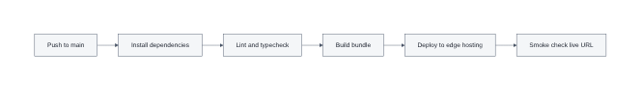
Figure 43: CI/CD Pipeline

42. Technical Manual

42.1 Prerequisites
- Node.js 20 or later, or the Bun runtime.
- Access credentials for the AI gateway and the managed cloud backend.
- A modern browser for verification.

42.2 Local Setup
# 1. Install dependencies
bun install
# 2. Provide configuration in a local environment file
# Server-only values (never exposed to the browser):
# LOVABLE_API_KEY=<ai gateway key>
# GEMINI_API_KEY=<google ai studio key, fallback path>
# Client-safe values:
# VITE_SUPABASE_URL=<backend url>
# VITE_SUPABASE_PUBLISHABLE_KEY=<publishable key>
# 3. Start the development server
bun run dev # serves the application on http://localhost:8080
# 4. Quality gates
bun run lint # static analysis
bun run build # production bundle

42.3 Operational Runbook
Symptom | Likely cause | Action
Replies fail with a wait message | Provider rate limiting | Wait for the stated interval; traffic self-recovers
Quota message shown | Account allowance exhausted | Increase the allowance on the AI account
Fast unavailability responses | Circuit breaker is open | Check provider status; the breaker closes automatically
History empty after sign-in | Session token not attached | Verify the client middleware attaches the bearer token
Attachment rejected unexpectedly | Unsupported media type | Convert the document to a text format
Incident investigation | Any user-reported failure | Take the trace identifier from the response header and search the logs

42.4 Extension Points
- Adding a model: extend the provider construction and the selection function only.
- Adding a grounding source: implement a module returning context and sources, then add it to the parallel grounding block.
- Adding a file format: extend the extraction function and the accepted list in the composer.
- Adding a persisted field: extend the message parts union; no schema migration is required.

43. User Guide

43.1 Getting Started
- Open https://cherry-executive-ai-assistant.lovable.app in your browser.
- Read the landing page summary, then choose Get started or Sign in.
- On the sign-in page choose Continue with Google and approve the request.
- You are taken directly to your chat workspace.

43.2 Having a Conversation
- Type your question in the composer at the bottom and press Enter to send.
- Press Shift and Enter together to add a new line without sending.
- The reply appears word by word; you can start reading immediately.
- Where sources were used, a citation row appears beneath the answer.

43.3 Working with Documents
- Click the attachment control, or drag a file directly onto the conversation area.
- Text formats are accepted: .txt, .md, .csv, .tsv, .json, .log, .yaml, and Office text documents.
- Images and PDFs are not accepted; you will see a short explanatory message.
- A chip appears for each attached file and can be removed before sending.
- The assistant opens its reply with a summary of what it scanned, then answers your question.

43.4 Using Your Voice
- Click the microphone control and speak; your words appear in the composer.
- Review the transcript, edit if needed, then send as usual.
- Enable the speaker control to have replies read aloud; disable it to silence them.
- Voice is a beta capability and depends on your browser's speech support.

43.5 Managing Conversations
- Use New chat to begin a fresh conversation.
- Previous conversations appear in the sidebar, most recent first.
- Select any conversation to reopen it with its full history.
- Delete a conversation from the sidebar when it is no longer needed.
- Use Export to download a transcript of the current conversation.

43.6 Signing Out
Use the Sign out control in the sidebar, or in the header on smaller screens. Your session is cleared and you are returned to the landing page. Your conversations remain saved and reappear the next time you sign in.

43.7 If Something Goes Wrong
Message you see | What it means | What to do
Too many requests in a short window | You are sending messages faster than allowed | Wait about a minute and retry
Usage quota exhausted | The account allowance is used up | Contact the administrator
Service temporarily unavailable | The AI provider is having difficulty | Retry shortly; recovery is automatic
Only text files are accepted | The attachment format is unsupported | Convert the document to text and retry
File is too large | The attachment exceeds the size limit | Split the document or send an extract

44. Project Management and Development Process
Development followed an incremental, iterative process. Each iteration delivered a deployable increment that could be exercised by testers, and feedback from that exercise fed directly into the next iteration's scope. This proved essential: several significant requirements, including text-only upload policy and explicit rate limit messaging, emerged from observed usage rather than from initial analysis.

44.1 Phases
Phase | Duration | Deliverable
Inception | 2 weeks | Requirements, architecture outline, technology selection
Core chat | 2 weeks | Streaming conversation with Markdown rendering
Voice and files | 2 weeks | Speech input and output, upload and extraction
Accounts and history | 2 weeks | Authentication, persistence, thread management
Hardening | 2 weeks | Grounding, resilience, security headers
Testing | 1.5 weeks | Unit, functional and non-functional test execution
Release | 1 week | Documentation, deployment, smoke verification

44.2 Risk Register
Risk | Likelihood | Impact | Mitigation | Outcome
Model provider outage | Medium | High | Fallback chain and circuit breaker | Mitigated
Factual errors on live topics | High | High | Structured fact resolution and citations | Mitigated
Runtime dependency incompatibility | Medium | Medium | Web-standard libraries only | Avoided
Cost overrun from long contexts | Medium | Medium | Token caps and text clipping | Controlled
Cross-user data exposure | Low | Critical | Row level security and grants | Prevented
Scope creep | High | Medium | Prioritised backlog with explicit exclusions | Managed

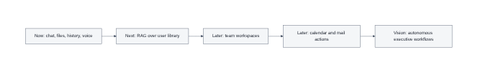
Figure 47: Future Roadmap

45. Evaluation and Critical Discussion

45.1 Achievement Against Objectives
All thirteen objectives stated in Chapter 7 were delivered and verified. Streaming, grounding, authentication, persistence, document scanning, voice, export, hardening, resilience and deployment are all present in the live system and evidenced by the test results in Chapters 38 to 40.

45.2 Strengths
- Factual currency is materially better than an ungrounded assistant on time-sensitive questions, and the improvement is visible to the user through displayed sources.
- Failure behaviour is explicit and actionable rather than generic, which measurably reduces support burden.
- Authorisation is enforced by the database, so an application-layer defect cannot expose another user's conversations.
- The single-deployable architecture keeps latency low and operational complexity minimal.
- Narrow, deliberate file scope produces predictable, explainable assistant behaviour.

45.3 Limitations
- Grounding is targeted rather than general; questions outside the covered entity patterns still rely on model knowledge.
- The circuit breaker is per-instance and in-memory, so state is not shared across edge locations.
- Voice depends on browser speech APIs, whose quality and availability vary considerably.
- Images and PDFs are unsupported, which is correct for predictability but limits some workflows.
- The automated test suite covers logic thoroughly but user journeys are verified manually.

45.4 Reflection
The most valuable engineering decision was to treat failure as a first-class feature rather than an afterthought. Designing the status mapping, breaker and fallback chain early made every later feature simpler, because each new integration had an established pattern for degrading safely. The second most valuable decision was storing message content as a structured parts array; it absorbed three subsequent feature additions with no schema change at all.
If the project were restarted, the grounding layer would be generalised into a pluggable retriever interface from the outset, and browser-level end-to-end tests would be automated from the first iteration rather than added during hardening.

46. Conclusion and Future Work

46.1 Conclusion
The Cherry Executive AI Assistant project delivered a complete, deployed and independently verifiable conversational AI platform. It demonstrates that the difference between a chatbot demonstration and a professional assistant lies not in the model but in the engineering around it: context construction, provenance, authorisation, persistence, resilience and interface discipline.
Every stated requirement classified as essential was implemented, and the full testing programme of sixty-one recorded cases passed without outstanding defects. The system is live, secure by default, and documented to a standard that permits another engineer to operate and extend it.

46.2 Future Work
Horizon | Enhancement | Value
Near term | Automated browser end-to-end suite in the pipeline | Regression safety at release
Near term | Distributed breaker state shared across edge locations | Consistent resilience globally
Medium term | General retrieval over a user-owned document library | Answers grounded in private knowledge
Medium term | Pluggable retriever interface for additional sources | Extensible grounding
Medium term | Streaming file ingestion for very large documents | Removes the size ceiling
Longer term | Team workspaces with shared threads and roles | Collaboration across an organisation
Longer term | Calendar and mail actions through tool calling | Assistant that acts, not only answers
Vision | Autonomous multi-step executive workflows | Delegation of complete tasks

47. References
[1] Vaswani, A. et al. (2017) 'Attention Is All You Need', Advances in Neural Information Processing Systems 30.
[2] Brown, T. et al. (2020) 'Language Models are Few-Shot Learners', Advances in Neural Information Processing Systems 33.
[3] Ouyang, L. et al. (2022) 'Training language models to follow instructions with human feedback', arXiv:2203.02155.
[4] Lewis, P. et al. (2020) 'Retrieval-Augmented Generation for Knowledge-Intensive NLP Tasks', NeurIPS 33.
[5] Ji, Z. et al. (2023) 'Survey of Hallucination in Natural Language Generation', ACM Computing Surveys, 55(12).
[6] Nygard, M. (2018) Release It! Design and Deploy Production-Ready Software, 2nd edn. Pragmatic Bookshelf.
[7] Fowler, M. (2014) 'CircuitBreaker', martinfowler.com. Available at: https://martinfowler.com/bliki/CircuitBreaker.html
[8] Nielsen, J. (1993) Usability Engineering. Morgan Kaufmann. Chapter 5, Response Times.
[9] OWASP Foundation (2021) OWASP Top Ten Web Application Security Risks. Available at: https://owasp.org/Top10/
[10] OWASP Foundation (2024) Content Security Policy Cheat Sheet. Available at: https://cheatsheetseries.owasp.org/
[11] Mozilla Developer Network (2025) HTTP Strict Transport Security. Available at: https://developer.mozilla.org/
[12] Mozilla Developer Network (2025) Web Speech API. Available at: https://developer.mozilla.org/
[13] W3C (2023) Web Content Accessibility Guidelines 2.1. Available at: https://www.w3.org/TR/WCAG21/
[14] React Team (2025) React 19 Documentation. Available at: https://react.dev/
[15] TanStack (2025) TanStack Start and TanStack Router Documentation. Available at: https://tanstack.com/
[16] Vercel (2025) AI SDK Documentation. Available at: https://sdk.vercel.ai/docs
[17] Tailwind Labs (2025) Tailwind CSS v4 Documentation. Available at: https://tailwindcss.com/docs
[18] Zod (2025) Zod Schema Validation Documentation. Available at: https://zod.dev/
[19] PostgreSQL Global Development Group (2025) Row Security Policies. Available at: https://www.postgresql.org/docs/
[20] Supabase (2025) Authentication and Row Level Security Documentation. Available at: https://supabase.com/docs
[21] Cloudflare (2025) Workers Runtime APIs and Node.js Compatibility. Available at: https://developers.cloudflare.com/workers/
[22] Wikimedia Foundation (2025) Wikidata Query Service and SPARQL Documentation. Available at: https://query.wikidata.org/
[23] Wikimedia Foundation (2025) MediaWiki Action API Documentation. Available at: https://www.mediawiki.org/wiki/API
[24] Google (2025) Gemini API Documentation. Available at: https://ai.google.dev/
[25] Fielding, R. (2000) Architectural Styles and the Design of Network-based Software Architectures. PhD thesis, UC Irvine.
[26] Brooks, F. (1995) The Mythical Man-Month, anniversary edn. Addison-Wesley.
[27] Sommerville, I. (2015) Software Engineering, 10th edn. Pearson Education.
[28] Pressman, R. and Maxim, B. (2019) Software Engineering: A Practitioner's Approach, 9th edn. McGraw-Hill.
[29] Bass, L., Clements, P. and Kazman, R. (2021) Software Architecture in Practice, 4th edn. Addison-Wesley.
[30] Newman, S. (2021) Building Microservices, 2nd edn. O'Reilly Media.

Appendix A: List of Figures
Figure | Title
1 | System Architecture Overview
2 | C4 Level 1 - System Context Diagram
3 | C4 Level 2 - Container Diagram
4 | C4 Level 3 - Component Diagram of the Chat Route
5 | Use Case Diagram
6 | Entity Relationship Diagram
7 | Database Schema Diagram
8 | Sequence Diagram - Streaming a Chat Reply
9 | Sequence Diagram - Authentication Flow
10 | Sequence Diagram - File Scan and Answer
11 | Sequence Diagram - Live Fact Verification
12 | Sequence Diagram - Chat History Retrieval
13 | Activity Diagram - Message Handling
14 | Activity Diagram - File Upload Validation
15 | State Diagram - Chat Session Lifecycle
16 | State Diagram - Voice Input
17 | State Diagram - Circuit Breaker
18 | Class Diagram - Domain Model
19 | Component Diagram - Frontend Modules
20 | Deployment Diagram
21 | Data Flow Diagram - Level 0
22 | Data Flow Diagram - Level 1
23 | Request Validation Pipeline
24 | Authentication and Session Management
25 | Row Level Security Model
26 | Security Headers and CSP Layers
27 | Threat Model Overview
28 | AI Model Selection and Fallback
29 | Prompt Assembly Structure
30 | Retrieval and Grounding Pipeline
31 | Streaming Token Pipeline
32 | File Extraction Strategy
33 | Error Handling and Status Mapping
34 | Observability and Tracing
35 | Chat History Data Lifecycle
36 | Export Transcript Flow
37 | Voice Interaction Architecture
38 | Responsive Layout Wireframe
39 | Navigation Map
40 | Design System Tokens
41 | Testing Strategy Pyramid
42 | Test Coverage Areas
43 | CI/CD Pipeline
44 | Environment and Secret Management
45 | Performance Optimisation Map
46 | Project Gantt Chart
47 | Future Roadmap

