ENERGY SECTOR ANALYSIS REPORT

A Comprehensive Analysis of US Energy Data

Date:
Prepared By: | Benson Otti
Project: | Data Analysis Group Project
Dataset: | Eight_Databases.xlsx - Energy Sheet

TABLE OF CONTENTS
1. Executive Summary
2. Data Overview
3. Summary Statistics
4. Trend Analysis
5. Production-Consumption Gap Analysis
6. Correlation Analysis
7. Key Findings
8. Recommendations
9. Conclusion
Appendix: Data Dictionary

1. Executive Summary
This report presents a comprehensive analysis of US energy sector data spanning 26 time periods. The analysis examines six key energy metrics: crude oil production, total energy consumption, nuclear generation, coal production, dry gas production, and fuel rates.
Key findings indicate that nuclear generation showed the most significant growth at 698.6%, while crude oil production changed by 20.3% over the analyzed period. The production-consumption gap analysis reveals important patterns in US energy independence.

2. Data Overview

2.1 Dataset Description
Variable | Description | Units
Crude Oil Production | Volume of crude oil extracted | Value
US Energy Consumption | Total energy consumed across all sectors | Value
US Nuclear Generation | Electricity generated from nuclear sources | Value
US Coal Production | Volume of coal mined domestically | Value
US Dry Gas | Natural gas production volume | Value
US Fuel Rate | Efficiency metric for fuel utilization | Rate

2.2 Data Period
The dataset covers 26 time periods, ranging from Year 1 to Year 26.

3. Summary Statistics
Variable | Mean | Median | Minimum | Maximum | Std Deviation
Crude Oil Production | 58.79 | 59.65 | 52.80 | 67.00 | 3.86
US Energy Consumption | 78.80 | 77.50 | 70.50 | 90.60 | 6.15
US Nuclear Generation | 414.75 | 398.85 | 83.50 | 674.70 | 193.42
US Coal Production | 876.46 | 893.10 | 598.60 | 1109.80 | 154.05
US Dry Gas | 18.37 | 18.70 | 16.10 | 21.70 | 1.35
US Fuel Rate | 17.76 | 17.45 | 13.40 | 21.60 | 2.89

4. Trend Analysis

4.1 Crude Oil Production Trends
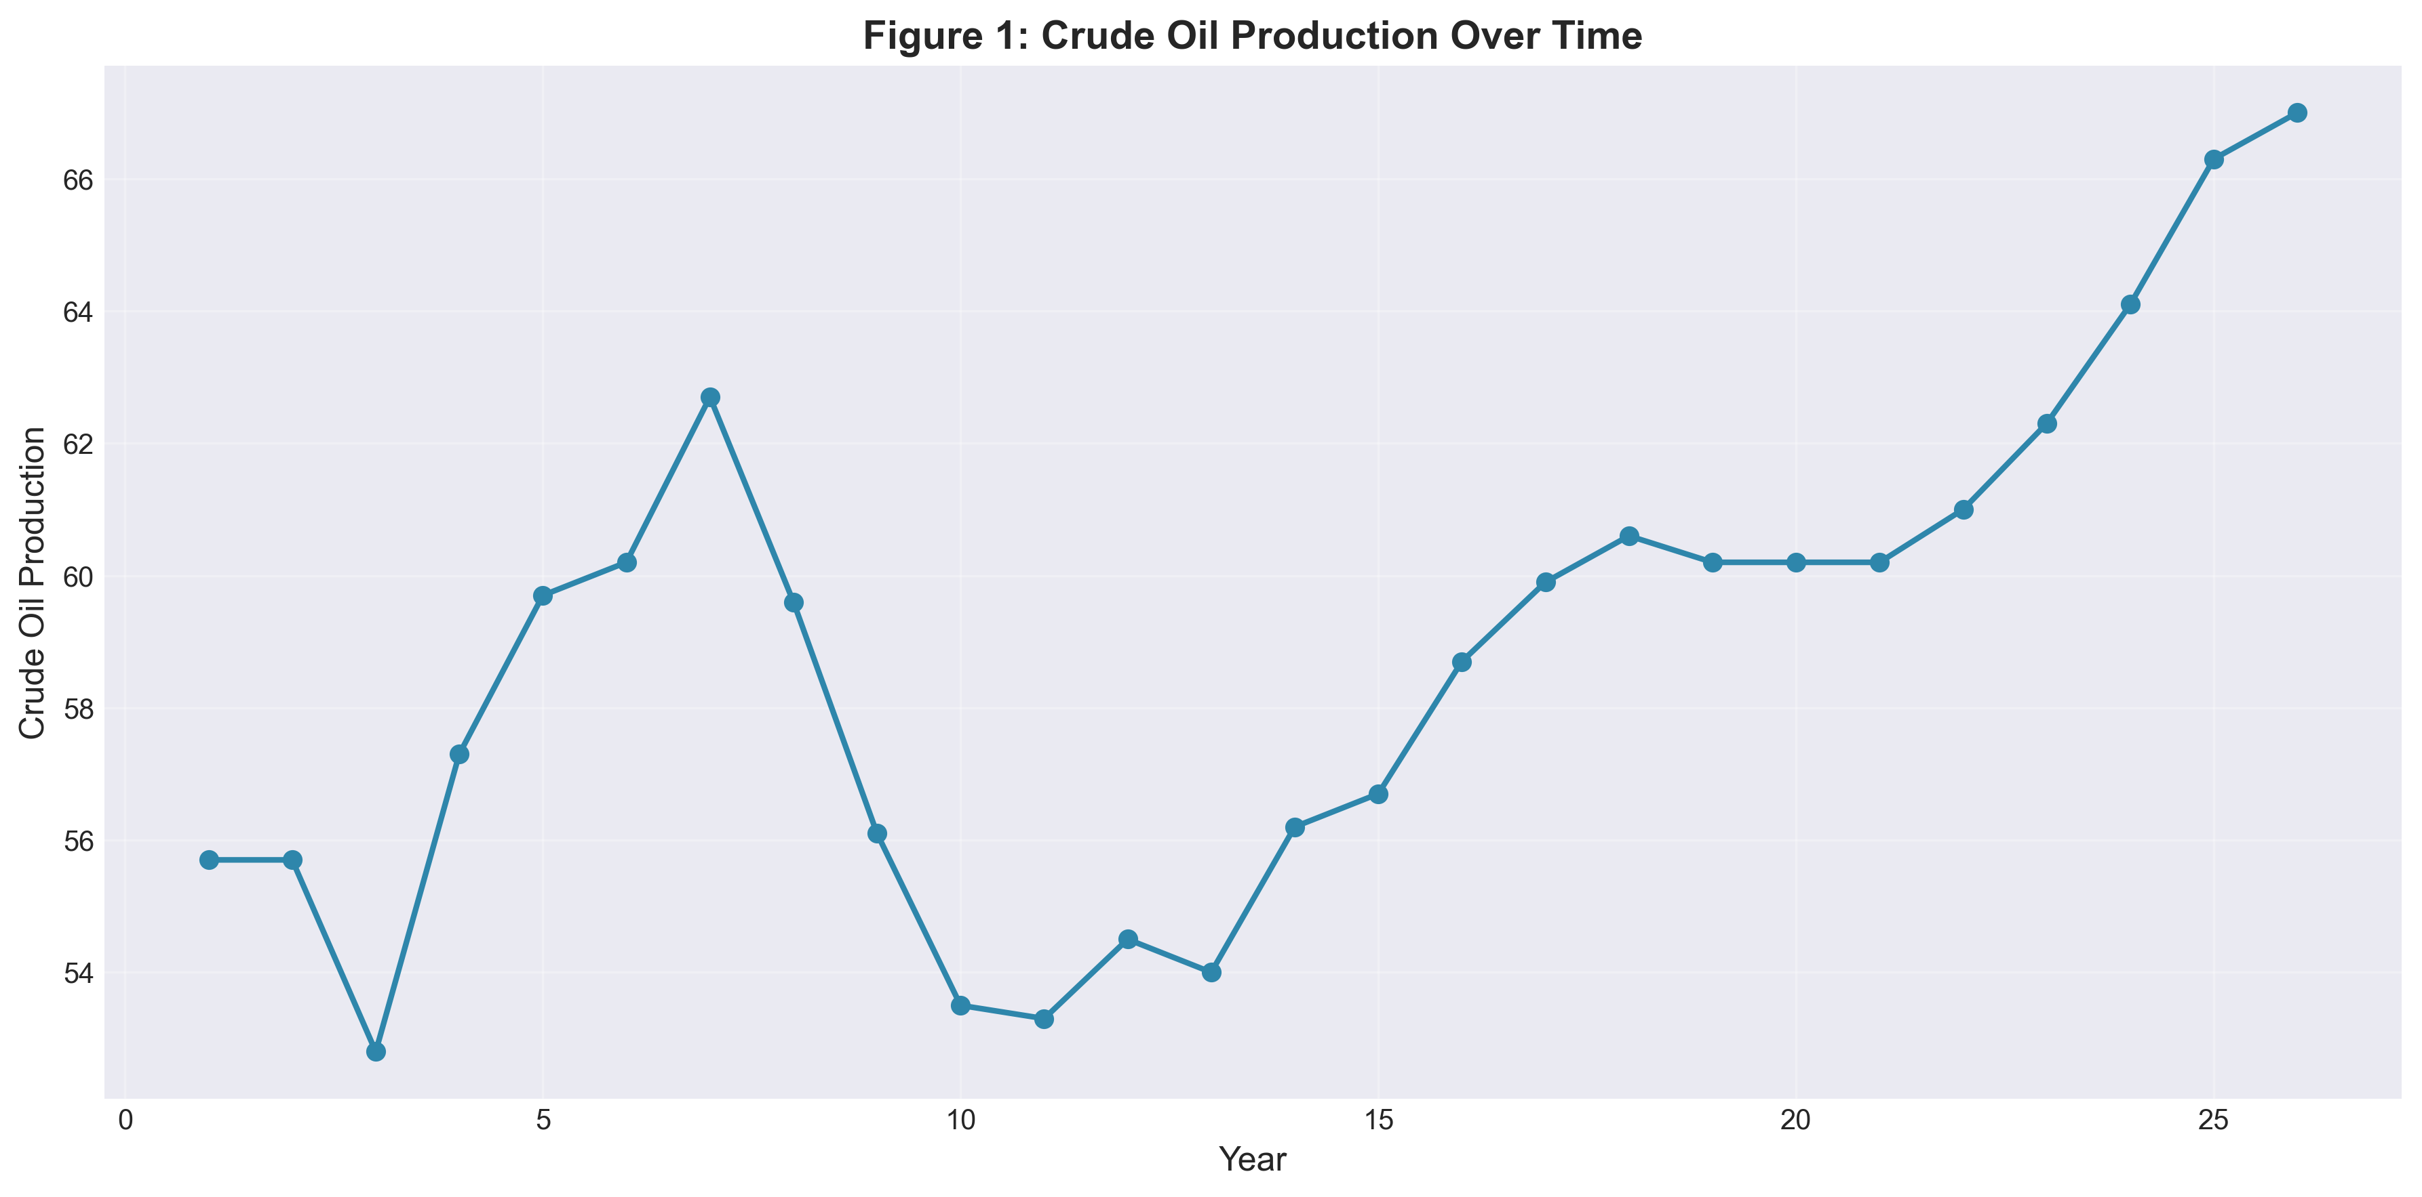
Figure 1 illustrates crude oil production trends over the analysis period. Production values ranged from 52.8 to 67.0, with a mean value of 58.8.

4.2 Comprehensive Energy Trends
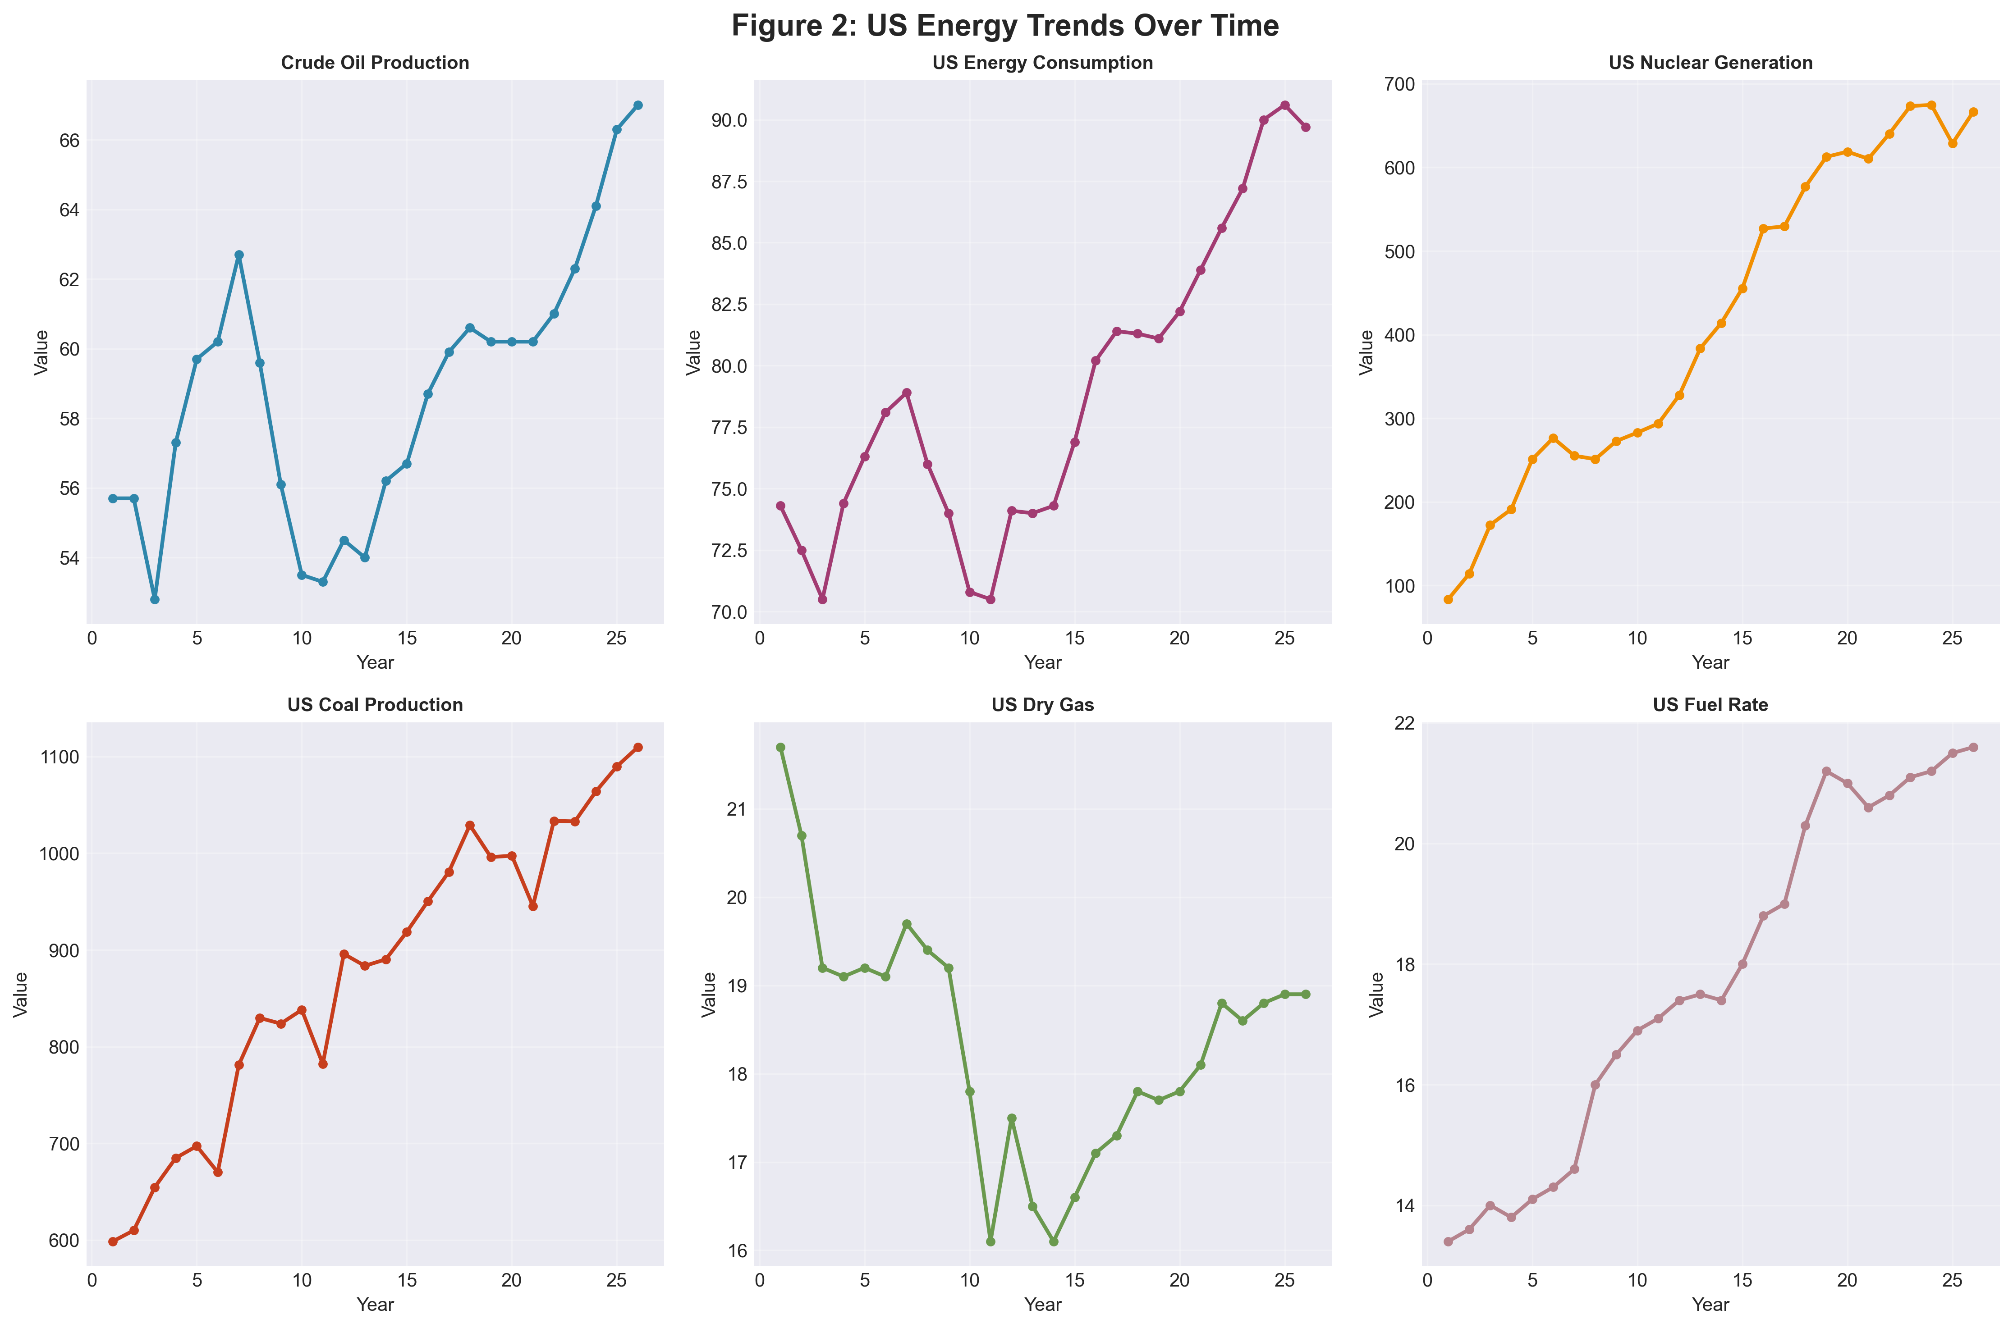
Key observations from Figure 2:
• Nuclear generation demonstrates the strongest growth trajectory
• Energy consumption shows a steady increasing trend
• Coal production exhibits cyclical patterns
• Fuel rates show overall improvement in efficiency

5. Production-Consumption Gap Analysis
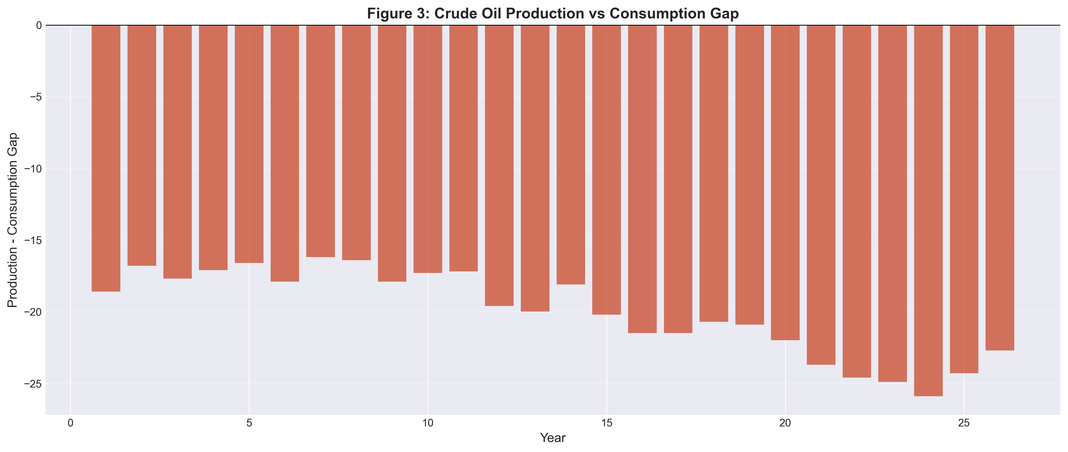
Figure 3 visualizes the gap between crude oil production and energy consumption. The average gap is -20.01, indicating that on average, consumption exceeds production.
Metric | Value
Average Gap | -20.01
Maximum Surplus | -16.20
Maximum Deficit | -25.90

6. Correlation Analysis
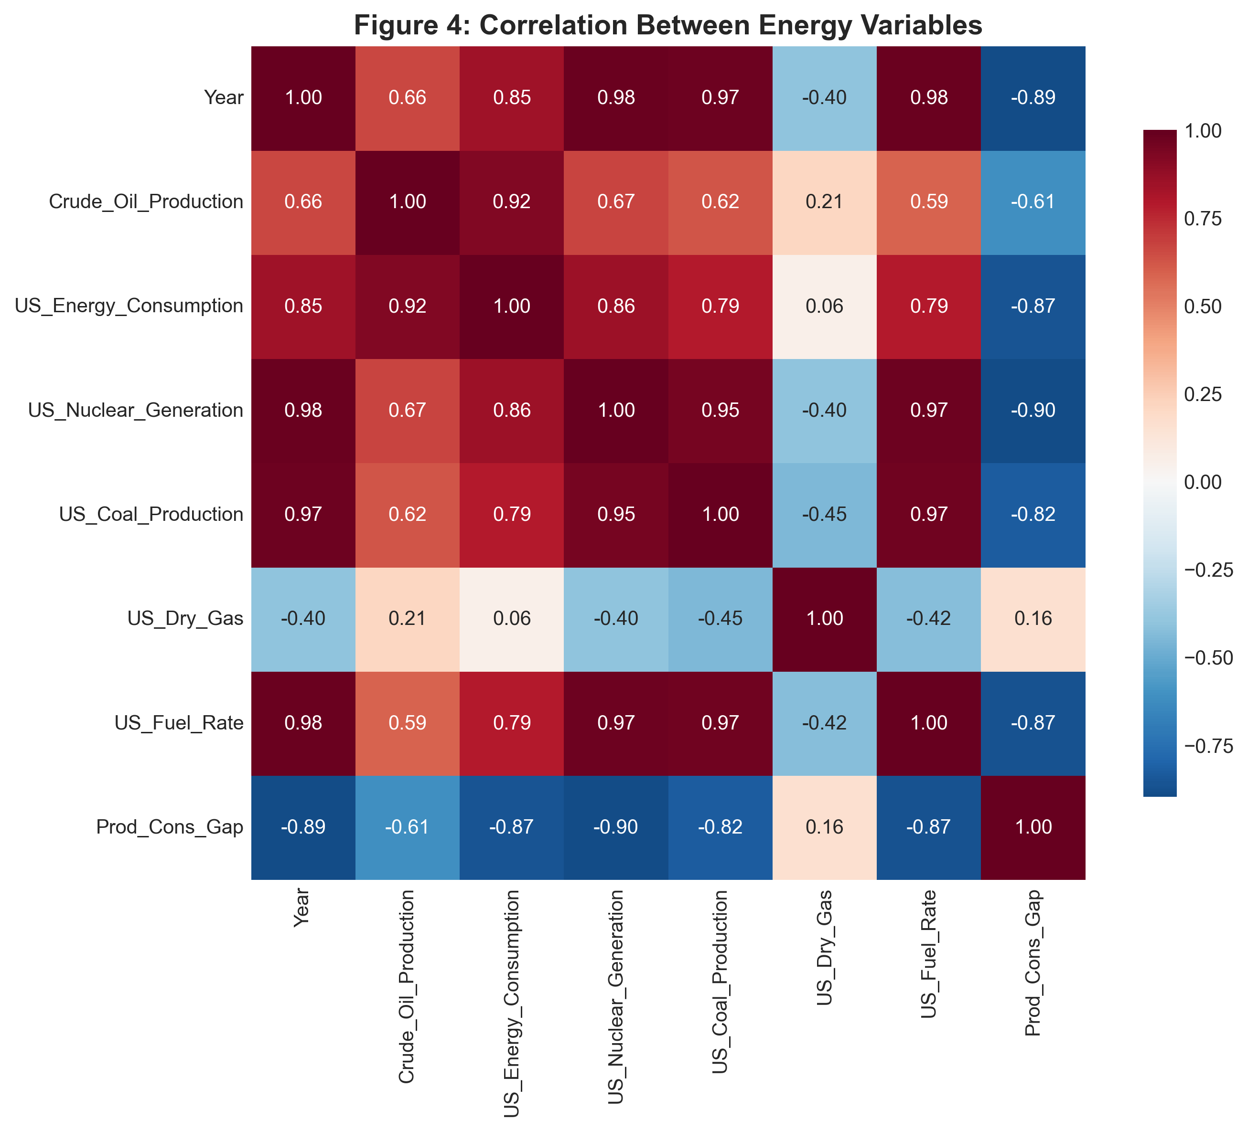
Variable Pair | Correlation Coefficient
Oil Production vs Energy Consumption | 0.923
Oil Production vs Nuclear Generation | 0.671
Oil Production vs Coal Production | 0.624
Energy Consumption vs Nuclear Generation | 0.856

7. Key Findings
1. Peak oil production occurred at Year 26 with value 67.0
2. Maximum energy consumption recorded at Year 25 with value 90.6
3. Nuclear generation showed strongest growth: 698.6% increase
4. Overall oil production change: +20.3%
5. Energy consumption change: +20.7%

8. Recommendations
Based on the analysis findings, the following recommendations are proposed:
• Continue monitoring nuclear generation as a growing energy source
• Investigate factors causing production volatility
• Develop strategies to address production-consumption gaps
• Update analysis with more recent data for current trends
• Consider correlation patterns for forecasting models

9. Conclusion
This analysis provides valuable insights into US energy sector dynamics over 26 time periods. Nuclear energy emerges as a significant growth area, while the production-consumption gap highlights important considerations for energy planning. The correlations identified can inform future forecasting and policy decisions.

Appendix: Data Dictionary
Variable Descriptions:
• Year: Time period indicator (1 through 26)
• Crude_Oil_Production: Volume of crude oil produced
• US_Energy_Consumption: Total energy consumed in the US
• US_Nuclear_Generation: Nuclear power generation output
• US_Coal_Production: Volume of coal produced
• US_Dry_Gas: Natural gas production volume
• US_Fuel_Rate: Fuel efficiency metric

Benson Otti| Data Analysis Group Project

