ENERGY MARKET ANALYSIS REPORT
US Gasoline, OPEC Oil Prices, and Natural Gas Trends

1. Introduction
This report presents an exploratory data analysis of energy market indicators, focusing on US gasoline prices, OPEC crude oil prices, US gasoline production, and natural gas prices. The objective is to uncover patterns, relationships, and trends that support data-driven decision-making in energy economics and policy planning.

2. Data Preparation and Cleaning
2.1 Data Cleaning Steps
- Checked and handled missing values across all variables
- Identified and removed duplicate records
- Ensured consistency in date formatting and time-series structure

2.2 Data Transformation
- Converted price variables from cents to USD for consistency and interpretability
- Structured dataset into time-series format using year, month, and date index

3. Exploratory Data Analysis (EDA)

3.1 Trend Analysis Over Time
- Gasoline and OPEC oil prices show a strong upward long-term trend
- Both variables move closely together over time

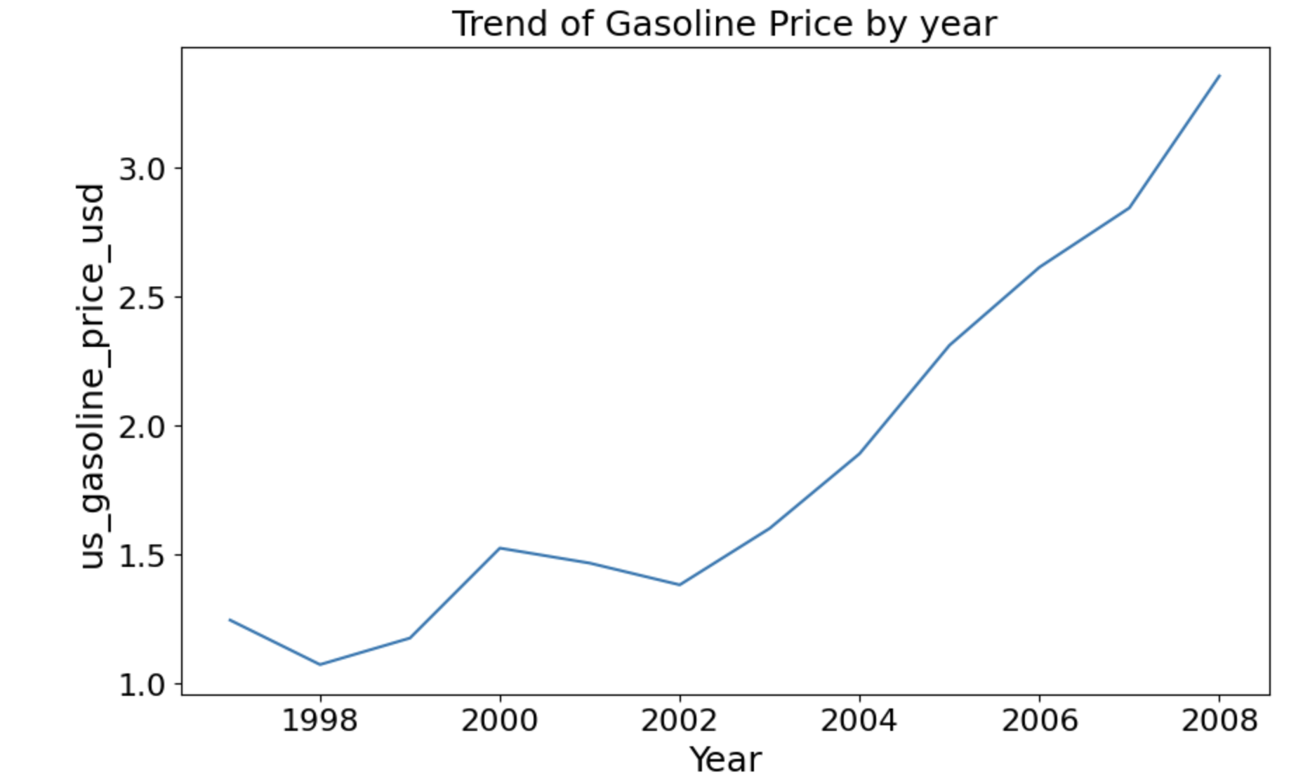

3.2 Seasonality Analysis
- Gasoline prices show clear seasonal patterns
- Certain months consistently have higher prices due to demand cycles
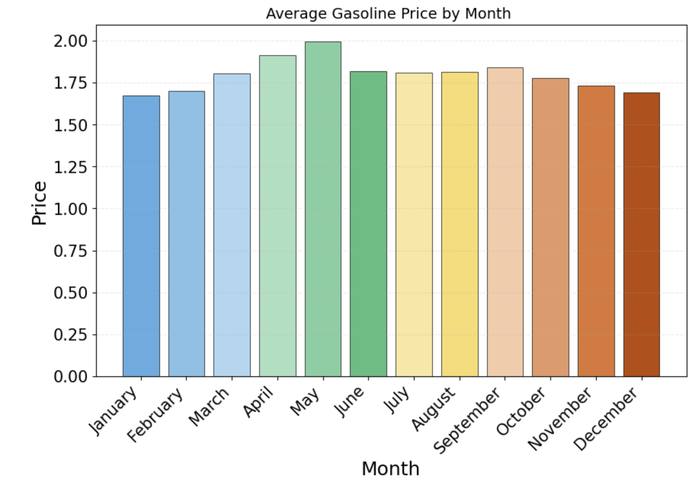

3.3 Lag Analysis
- Strong relationship between OPEC oil prices and gasoline prices
- Highest correlation at 1-month lag (0.977)
- Relationship remains strong across multiple months (>0.92 up to 11 months)
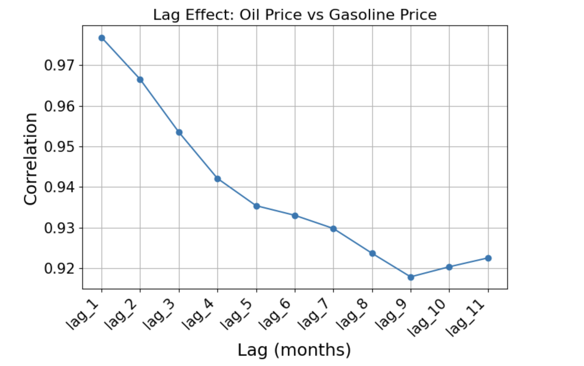

3.4 Market Relationship Insights
- Oil prices are the dominant driver of gasoline prices
- Production has secondary influence compared to oil prices

4. Key Insights Summary
- Oil prices are the primary driver of gasoline prices
- Price effects occur with a short delay (1 month)
- Oil shocks have long-lasting impacts
- Strong seasonal patterns exist in gasoline pricing

5. Business and Policy Implications

5.1 Energy Companies
- Improve pricing models using oil price trends and lag effects
- Adjust pricing strategies based on seasonality
- Optimize production and inventory planning

5.2 Government and Policymakers
- Anticipate inflation after oil price increases
- Time subsidies based on seasonal vulnerability
- Improve energy security planning

5.3 Analysts
- Use lag features in predictive models
- Incorporate seasonality in forecasting
- Combine oil price and production data for accuracy

6. Conclusion
Gasoline prices are highly dependent on global oil prices, with both immediate and long-term effects. The market shows strong predictability due to lagged relationships and seasonal patterns, making it suitable for forecasting and policy planning.

