Synthesis Report
Testbench1_syn | (Pass/Failed)
Testbench2_syn | (Pass/Failed)
Clock Cycle | Testbench1: Testbench2: (ns)
Cell Area | (Please report cell area)
Total Time | (ns)(Please report simulation time in testbench2)
Area*Time
APR Report
Testbench1_APR | (Pass/Failed)
Testbench2_APR | (Pass/Failed)
Clock Cycle | Testbench1: Testbench2: (ns)
Cell Area | (Please report Total area of Core)
Total Time | (ns)(Please report simulation time in testbench2)
Area*Time

How to report area in Design Vision?
- report_area > autoseller_area.txt, find Total cell area.
How to report area in Innovus?
- File > Report > Summary > choose Text only, file name: summaryReport.rpt>OK, find Total area of Core.

APR NanoRoute Innovus Result (截圖)
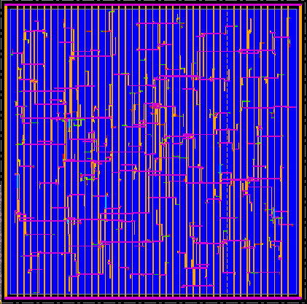

APR Simulation Result for testbench 2(截圖)
