training_args = TrainingArguments(
output_dir="./results",
num_train_epochs=4,
per_device_train_batch_size=16,
per_device_eval_batch_size=16,
warmup_steps=100,
weight_decay=0.01,
learning_rate=2e-5, # 新增，手动设置学习率
logging_dir="./logs",
logging_steps=20,
eval_strategy="epoch",
save_strategy="epoch",
load_best_model_at_end=True,
save_total_limit=2,
)
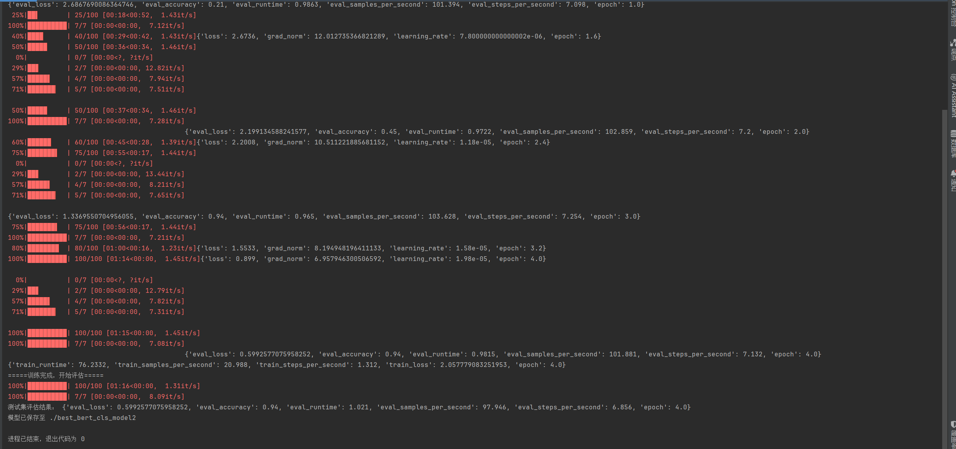

training_args = TrainingArguments(
output_dir="./results",
num_train_epochs=4,
per_device_train_batch_size=16,
per_device_eval_batch_size=16,
warmup_steps=100,
weight_decay=0.01,
logging_dir="./logs",
logging_steps=20,
eval_strategy="epoch",
save_strategy="epoch",
load_best_model_at_end=True,
save_total_limit=2,
)
