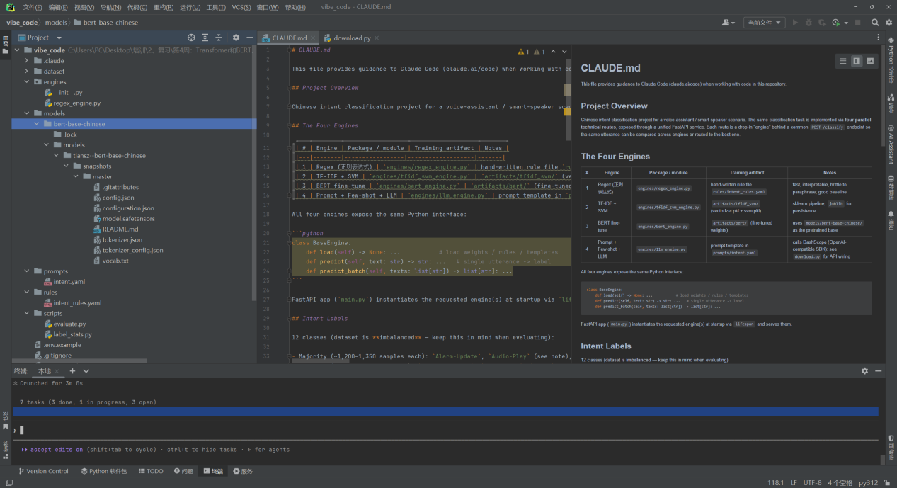

项目整体架构

核心理念：四条技术路线作为四个平行"引擎"，共享同一个 BaseEngine 接口，由 FastAPI 统一对外暴露 POST
/classify。调用方可以通过参数选择用哪个引擎，也可以做对比实验。

┌─────────────────────────────────────┐
│ FastAPI main.py /classify │
│ (lifespan 启动时加载指定引擎) │
└──────────┬──────────────────────────┘
│ BaseEngine.predict(text)
┌───────┬───────┼───────┬────────┐
▼ ▼ ▼ ▼ ▼
regex tfidf+svm bert llm (可扩展)

四个引擎的定位

┌─────────────────────────┬────────────────────────┬────────────────────┬─────────────────┐
│ 引擎 │ 优势 │ 局限 │ 角色 │
├─────────────────────────┼────────────────────────┼────────────────────┼─────────────────┤
│ 正则 │ 零训练、可解释、极快 │ 泛化差、维护成本高 │ 基线 / 兜底 │
├─────────────────────────┼────────────────────────┼────────────────────┼─────────────────┤
│ TF-IDF + SVM │ 训练快、小数据效果好 │ 语义理解弱 │ 强基线 │
├─────────────────────────┼────────────────────────┼────────────────────┼─────────────────┤
│ BERT 微调 │ 语义强、准确率高 │ 需要 GPU、推理较慢 │ 主力模型 │
├─────────────────────────┼────────────────────────┼────────────────────┼─────────────────┤
│ Prompt + Few-shot + LLM │ 无需训练、新增类别容易 │ 延迟高、成本高 │ 灵活兜底 / 对比 │
└─────────────────────────┴────────────────────────┴────────────────────┴─────────────────┘

几个关键设计决策

1. 统一接口 BaseEngine（load / predict / predict_batch）——四个引擎可互换，FastAPI 层无分支逻辑。
2. 数据注意：标签严重不均衡（多数类 ~1300，少数类 TVProgram-Play / Audio-Play / Other 仅 ~200），评估时必须看
per-class F1，不能只看 accuracy。
3. 数据编码：dataset.csv 是 UTF-8、无表头、tab 分隔，不是 GBK——后续脚本里要显式 encoding="utf-8"。
4. 本地 BERT：models/bert-base-chinese/ 已存在，训练脚本必须从本地路径加载，不要再下载。
5. LLM 走 DashScope：复用 download.py 里已有的 OpenAI 兼容 SDK 模式，但 API Key 走环境变量
DASHSCOPE_API_KEY，不硬编码。
6. 产物统一放 artifacts/<engine>/，全部 gitignore，不入库。

推荐实现顺序

1. 先搭 BaseEngine + main.py + regex_engine.py（最快闭环）
2. 加 evaluate.py + label_stats.py（评估基础设施）
3. 实现 tfidf_svm_engine.py + train_tfidf_svm.py
4. 实现 bert_engine.py + train_bert.py（最耗时）
5. 最后 llm_engine.py

需要我开始按这个顺序写代码吗？或者你想先调整架构（比如要不要 /compare 接口一次跑四个引擎对比）？

✻ Baked for 1m 24s

❯ 需要

Thought for 5s (ctrl+o to expand)

● 好，开始按顺序实现。先建任务列表跟踪进度。

Thought for 1s (ctrl+o to expand)

Thought for 1s (ctrl+o to expand)

Thought for 1s (ctrl+o to expand)

Thought for 1s (ctrl+o to expand)

Thought for 1s (ctrl+o to expand)

Thought for 1s (ctrl+o to expand)

Thought for 1s (ctrl+o to expand)

Thinking for 1s… (ctrl+o to expand)
⎿ Let me create all the base files now. I'll write them in parallel since they're independent.

─────────────────────────────────────────────────────────────────────────────────────────────────────────────────────── Create file
engines\__init__.py
╌╌╌╌╌╌╌╌╌╌╌╌╌╌╌╌╌╌╌╌╌╌╌╌╌╌╌╌╌╌╌╌╌╌╌╌╌╌╌╌╌╌╌╌╌╌╌╌╌╌╌╌╌╌╌╌╌╌╌╌╌╌╌╌╌╌╌╌╌╌╌╌╌╌╌╌╌╌╌╌╌╌╌╌╌╌╌╌╌╌╌╌╌╌╌╌╌╌╌╌╌╌╌╌╌╌╌╌╌╌╌╌╌╌╌╌╌╌╌
1 """Base interface for all intent classification engines."""
2
3 from __future__ import annotations
4
5 from abc import ABC, abstractmethod
6 from typing import List
7
8
9 class BaseEngine(ABC):
10 """Abstract base class every engine must implement.
11
12 Engines expose both single-utterance and batch prediction. The FastAPI
13 layer calls ``predict_batch`` for list inputs and ``predict`` for a
14 single string; both must return labels from the 12-label vocabulary,
15 never integer indices.
14 single string; both must return labels from the 12-label vocabulary,
15 never integer indices.

Thought for 1s (ctrl+o to expand)

Thought for 1s (ctrl+o to expand)

Thought for 1s (ctrl+o to expand)

Thought for 1s (ctrl+o to expand)

Thought for 1s (ctrl+o to expand)

Thought for 1s (ctrl+o to expand)

Thought for 1s (ctrl+o to expand)

● Write(engines\__init__.py)
⎿ Wrote 30 lines to engines\__init__.py
1 """Base interface for all intent classification engines."""
2
3 from __future__ import annotations
4
5 from abc import ABC, abstractmethod
6 from typing import List
7
8
9 class BaseEngine(ABC):
10 """Abstract base class every engine must implement.
… +20 lines (ctrl+o to expand)

Thought for 1s (ctrl+o to expand)

● Write(requirements.txt)
⎿ Wrote 9 lines to requirements.txt
1 fastapi>=0.110
2 uvicorn[standard]>=0.27
3 transformers>=4.38
4 torch>=2.1
5 scikit-learn>=1.4
6 jieba>=0.42
7 openai>=1.10
8 pyyaml>=6.0
9 joblib>=1.3

Thought for 2s (ctrl+o to expand)

● Write(.gitignore)
⎿ Wrote 24 lines to .gitignore
1 # Trained artifacts (not committed)
2 artifacts/
3
4 # Python
5 __pycache__/
6 *.py[cod]
7 *$py.class
8 .venv/
9 venv/
10 *.egg-info/
… +14 lines (ctrl+o to expand)

Thought for 2s (ctrl+o to expand)

● Write(rules\intent_rules.yaml)
⎿ Wrote 69 lines to rules\intent_rules.yaml
1 # 正则表达式规则文件（engines/regex_engine.py 加载）
2 #
3 # 格式：
4 # <LabelName>:
5 # - <正则1>
6 # - <正则2>
7 # ...
8 # 匹配顺序：从上到下逐条尝试，**第一条命中即返回该标签**。
9 # 所以请把更具体的规则放在前面，更宽泛的放在后面。
10 # `Other` 是兜底——一般不需要写规则，引擎在所有规则都未命中时自动返回 Other。
… +59 lines (ctrl+o to expand)

Thought for 1s (ctrl+o to expand)

● Write(prompts\intent.yaml)
⎿ Wrote 49 lines to prompts\intent.yaml
1 # LLM 引擎的 prompt 模板（engines/llm_engine.py 加载）
2 #
3 # 字段：
4 # system - 系统指令，定义角色、任务、输出格式约束
5 # few_shots - 列表，每项 {text, label}；作为 few-shot 示例拼入 user 消息
6 # user_template - 用户消息模板，{text} 会被替换为待分类文本
7 #
8 # 约束：模型必须 **只返回标签字符串本身**，不要解释、不要标点。
9
10 system: |
… +39 lines (ctrl+o to expand)

Thought for 1s (ctrl+o to expand)

● Write(.env.example)
⎿ Wrote 13 lines to .env.example
1 # 复制为 .env 后填入真实值（已被 .gitignore 忽略）
2
3 # 必填：引擎 #4 (LLM) 调用 DashScope 时使用
4 DASHSCOPE_API_KEY=sk-xxxxxxxxxxxxxxxxxxxxxxxx
5
6 # 可选：逗号分隔，启动时只加载指定引擎，默认全部加载
7 # INTENT_ENGINES=regex,tfidf,bert,llm
8
9 # 可选：覆盖本地 BERT 预训练模型路径
10 # BERT_MODEL_PATH=models/bert-base-chinese
… +3 lines (ctrl+o to expand)

Thought for 1s (ctrl+o to expand)

Thought for 1s (ctrl+o to expand)

Thought for 1s (ctrl+o to expand)

● Write(engines\regex_engine.py)
⎿ Wrote 68 lines to engines\regex_engine.py
1 """Regex-based intent classification engine."""
2
3 from __future__ import annotations
4
5 import re
6 from pathlib import Path
7 from typing import Dict, List, Pattern, Tuple
8
9 import yaml
… +58 lines (ctrl+o to expand)

Thought for 1s (ctrl+o to expand)

Thought for 1s (ctrl+o to expand)

Thought for 1s (ctrl+o to expand)

● Write(main.py)
⎿ Wrote 177 lines to main.py
1 """FastAPI service exposing all intent classification engines.
2
3 Run locally::
4
5 uvicorn main:app --host 0.0.0.0 --port 8000 --reload
6
7 Endpoints:
8 POST /classify {"text": "...", "engine": "bert"} -> {"label": "...", "engine": "..."}
9 {"text": "..."} -> runs all loaded engines
10 {"texts": [...], "engine": "..."} -> batch mode
… +167 lines (ctrl+o to expand)

Thought for 1s (ctrl+o to expand)

Thought for 2s (ctrl+o to expand)

Thought for 1s (ctrl+o to expand)

● Write(scripts\label_stats.py)
⎿ Wrote 44 lines to scripts\label_stats.py
1 """Print class distribution of dataset/dataset.csv.
2
3 Usage::
4
5 python scripts/label_stats.py
6 python scripts/label_stats.py --path path/to/other.tsv
7 """
8
9 from __future__ import annotations
… +34 lines (ctrl+o to expand)

Thought for 1s (ctrl+o to expand)

● Write(scripts\evaluate.py)
⎿ Wrote 202 lines to scripts\evaluate.py
1 """Engine-agnostic evaluation.
5 python scripts/label_stats.py
6 python scripts/label_stats.py --path path/to/other.tsv
7 """
8
9 from __future__ import annotations
… +34 lines (ctrl+o to expand)

Thought for 1s (ctrl+o to expand)

● Write(scripts\evaluate.py)
⎿ Wrote 202 lines to scripts\evaluate.py
1 """Engine-agnostic evaluation.
2
3 Usage::
4
5 python scripts/evaluate.py --engine regex
6 python scripts/evaluate.py --engine tfidf --split test
7 python scripts/evaluate.py --engine bert --test-path path/to/test.csv
8
9 Outputs:
10 - stdout: accuracy + per-class P/R/F1
… +192 lines (ctrl+o to expand)

