Management Groups

Internet of Things

Web and Mobile App

Data and Analytics

Monitor

Database

Networking

Compute
Icon | Name | Description | Info Link
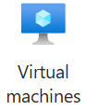 | Azure Virtual Machine | VM that is accessible by special Desktop App. Common scenario of IaaS. SKU determines specs. All OS types available. | https://learn.microsoft.com/en-us/azure/virtual-machines/windows/quick-create-portal?WT.mc_id=UI_empg
 | Azure Virtual Machine Scale Sets | VM’s with load balancer deployed at same time. | https://azure.microsoft.com/en-us/products/virtual-machine-scale-sets/
 | App Service | Deployment location for web application. Paas target. | https://azure.microsoft.com/en-us/products/app-service/
 | Azure (Serverless) Functions | Small workers that perform key roles to process data or transfer data from one item to next. | https://azure.microsoft.com/en-us/products/functions/
 | Azure Batch | Large scale work in azure for processing on routine schedule. | https://azure.microsoft.com/en-us/products/batch/
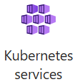 | Azure Kubernetes Service (AKS) | Most powerful and scalabe web hosting. Docker container vm’s monitored and maintained by central service. | https://azure.microsoft.com/en-us/products/kubernetes-service/
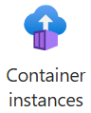 | Azure Container Instance (ACI) | Single docker container hosting for web apps. Hides logic and settings of Kubernetes. Simple deployment, but not scalable. Web site settings driven, not Yaml or command line driven. | https://learn.microsoft.com/en-us/azure/container-instances/container-instances-quickstart-portal
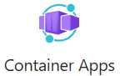 | Azure Container Apps | Scalable docker hosting that hides Kubernetes code and settings. Simple deployment. Web site settings driven, not Yaml or command line driven. | https://azure.microsoft.com/en-us/products/container-apps/#overview
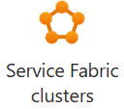 | Service Fabric | Competitor for Kubernetes. Works on prem or in cloud. Runs programmed or common MS services like skype, Cosmos, and more. Web site settings driven, not Yaml or command line driven. | https://learn.microsoft.com/en-us/azure/service-fabric/service-fabric-overview
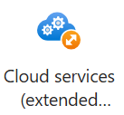 | Cloud Services | Competes with App Services. Runs external or inside VMs. Web workers or middle man worker roles.

Security and Identity

