Jim Johnson

Deploying to Azure App service from Visual Studio (without Docker)

Table of Contents
Tools/Resources for this exercise: 2
Three Websites to Know 2
1. Azure DevOps (logo is two half arrows that form a box) 2
2. Azure Portal (logo is does not show on landing page. Splash page is letter A folded from a blue ribbon) 2
3. GitHub (Logo is a cat silhouette) 2
Editors for Azure Work 3
1. Visual Studio 3
2. VS Code 3
Installing Local Resources 4
3. Install Visual Studio 4
k. Upgrade options. 7
l. Traditional Visual Studio Workloads installer dialog 8

Tools/Resources for this exercise:
- Azure Free Account Setup
- Visual Studio

Three Websites to Know
- Azure DevOps (logo is two half arrows that form a box)
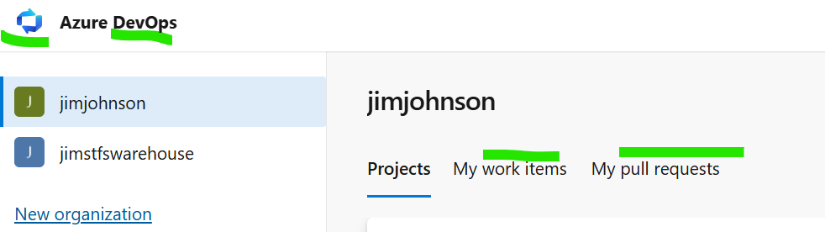
- Azure Portal (logo is does not show on landing page. Splash page is letter A folded from a blue ribbon)
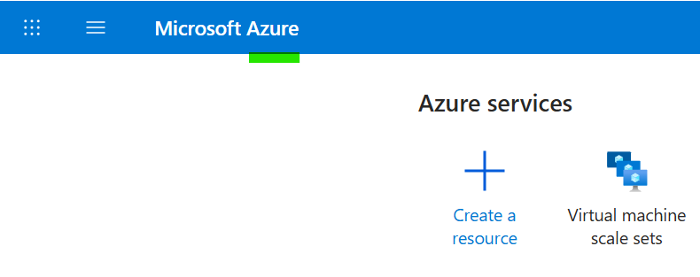
- GitHub (Logo is a cat silhouette)
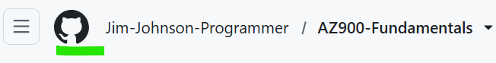

Editors for Azure Work
- Visual Studio
  - There are two major editors used for developing and deploying code to Azure: Visual Studio and VS Code. Visual Studio has been used the longest and has the largest market share. Visual Studio has been around since the late 1990s. It gets upgrades every year and continues to be upgraded. Visual Studio is wizard based so starting off this will be easier. Visual Studio comes with almost everything pre installed. Most things are done via step by step wizard, hence why it is chosen for this first exercise.
  - Both Visual Studio and VS Code have a mode where they can download and upload code to websites designed to manage source code. Visual Studio has been chosen to be the default for GitHub for downloads. There is an option for it on the GitHub website to encourage its use for downloading code. When the option is chosen, Visual Studio is launched in a special mode for linking the remote repository to a local folder on your machine that should be empty. The code will be downloaded to that folder without turning it into a zip file. This is the intended way that developers join a development effort and upload code for review if permissions are setup for the person downloading the code. We will see more on this shortly. GitHub was purchased by Microsoft. It is where startup and hobby developers display and share their code and their talent.

- VS Code
  - VS Code came later to attract Linux developers who were used to lighter weight tools that are not wizard based, meaning they do something directly such as a tree view of azure or are command line based. This started in early 20 teens (e.g. 2010+). There was an editor called sublime that was the inspiration for VS Code. It comes with only basic editing support, then extensions marketplace tab is used to add development support for almost anything is just a quick keyword search. Installing support is very easy and usually done in under 5 minutes.
  - VS code is the encouraged default on the website for downloading code from Azure DevOps. Azure DevOps is the main site Microsoft uses to manage development specs, stories, testing, and deployment. In other words, development and automated deployment is done in DevOps. Not hosting, or production environments which is done in Azure Portal.

Installing Local Resources
- Install Visual Studio
  - https://visualstudio.microsoft.com/downloads/

- Project Selection/Creation Dialog Window
  - Before Visual Studio shows, it launches the project selection/creation dialog window. You can bypass this window to get to the full window via the button on the bottom right. The catch is that you will face this dialog window again when you decide to create a project.
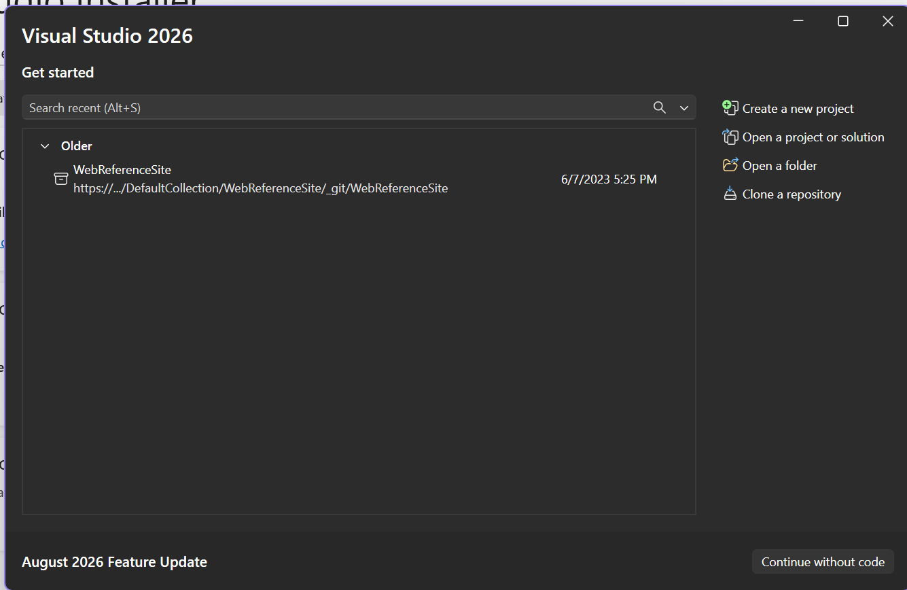
  - Creating a project
    - Click “Create a new project”
  - Then project type form is revealed.
    - Set dropdown for languages to “C#” as shown by marked item 2 on graphic
    - Type text “mvc” as shown by item 1 on graphic
    - Click on the option box that says “ASP.NET Core”. The white border is shown when you click on each item.
      - ASP.NET Core vs ASP.NET .Net Framework
        - There are many differences, but for our purposes, Core works in Linux and Windows, but .Net Framework only works in Windows.

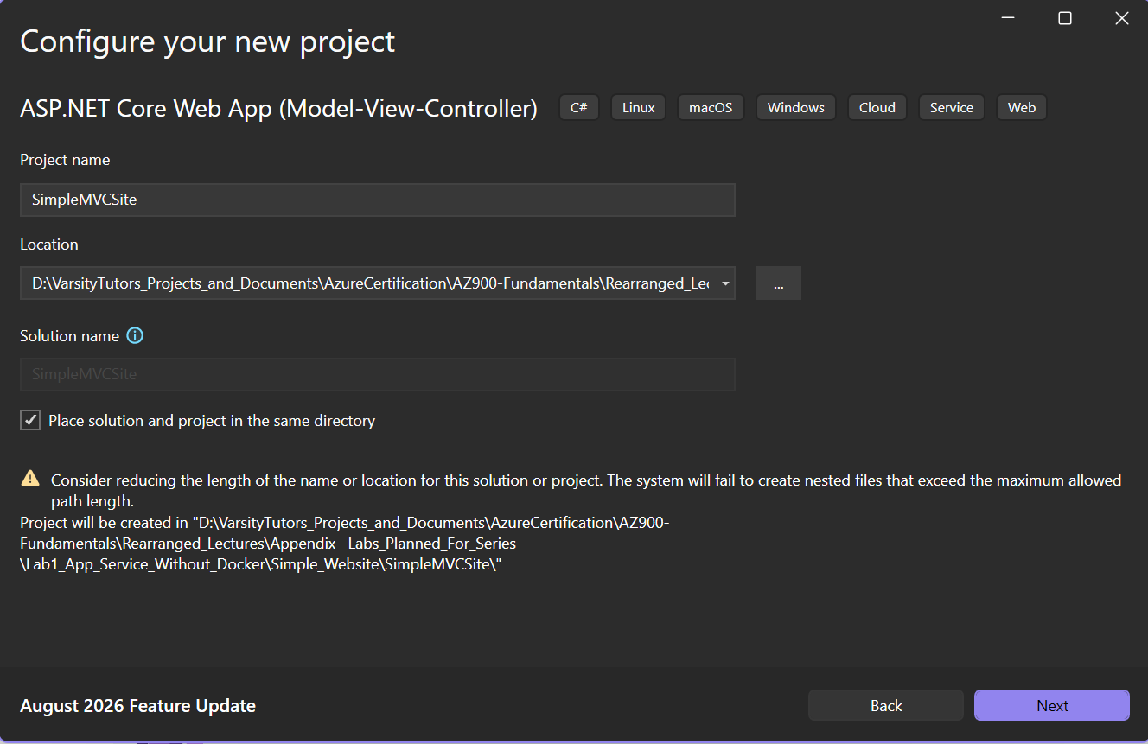
  - aaaaa
  - 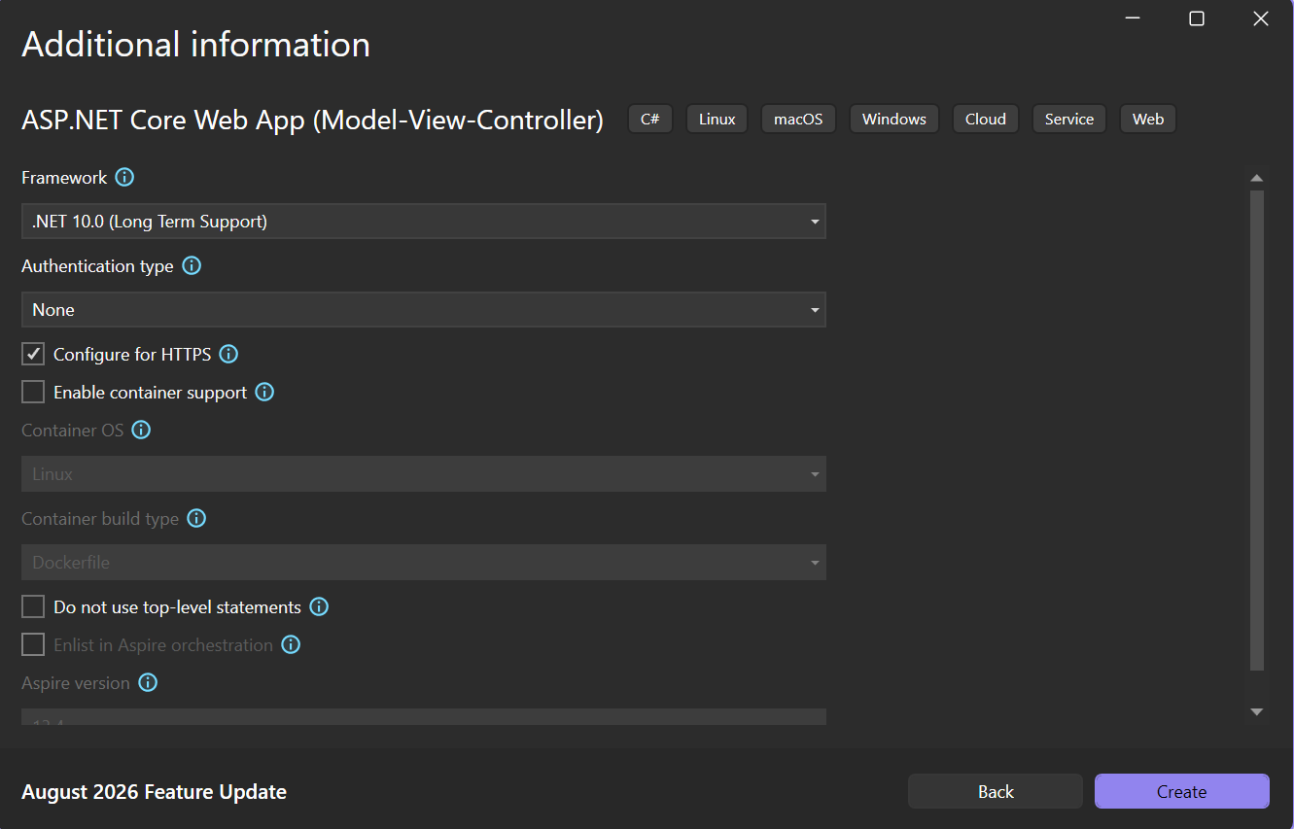
  - Aaa
  - 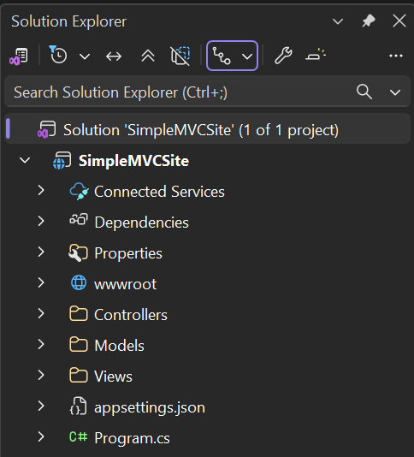
  - Gggggg
  - 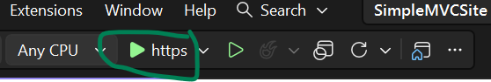
  - Deploy to Azure, quick deploy
  - 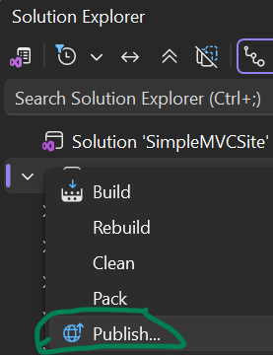
  - Asdf
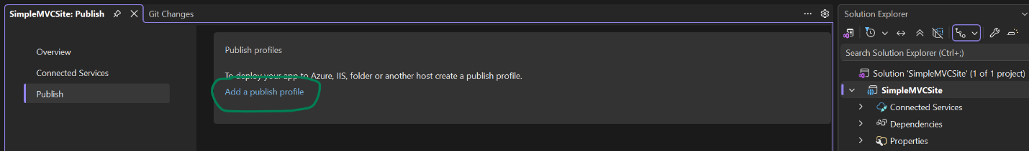
  - Ddd
  - 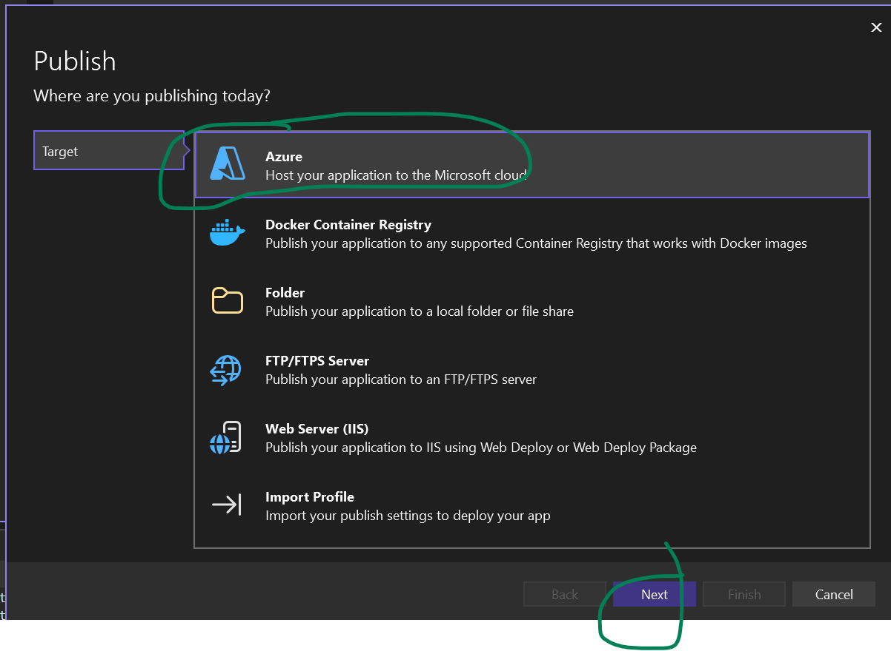
  - 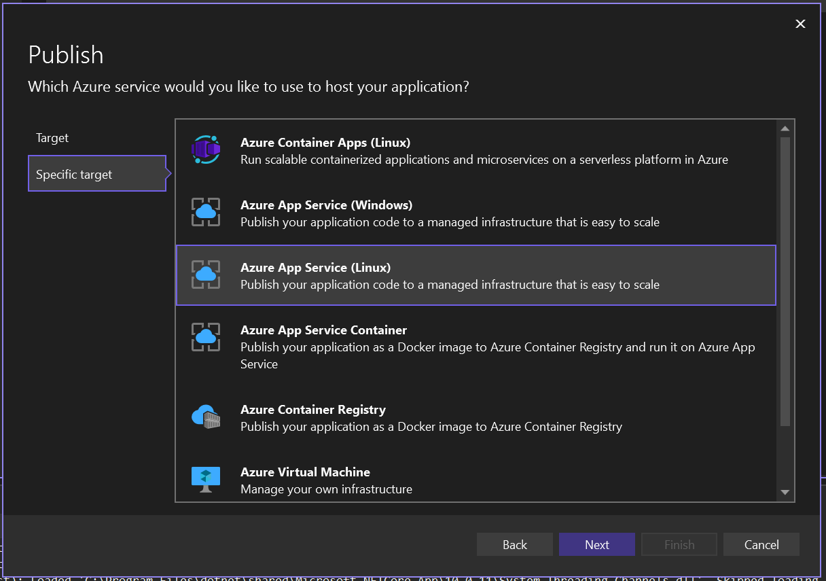
  - Asd
- 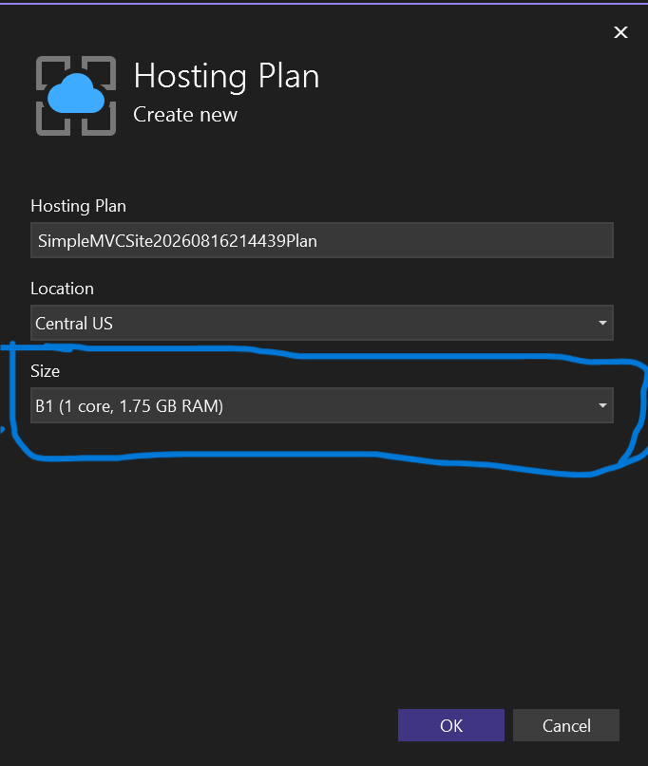
  - asdf
- 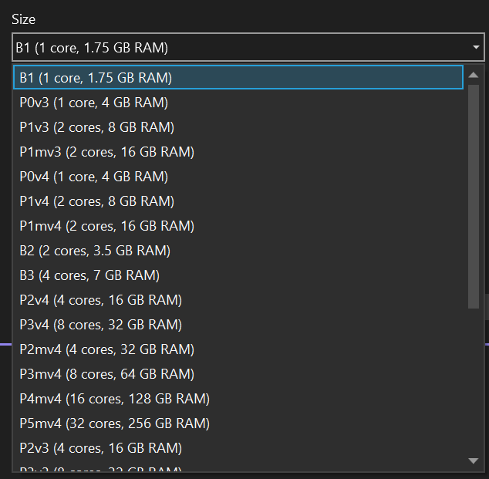
  - sadf
- 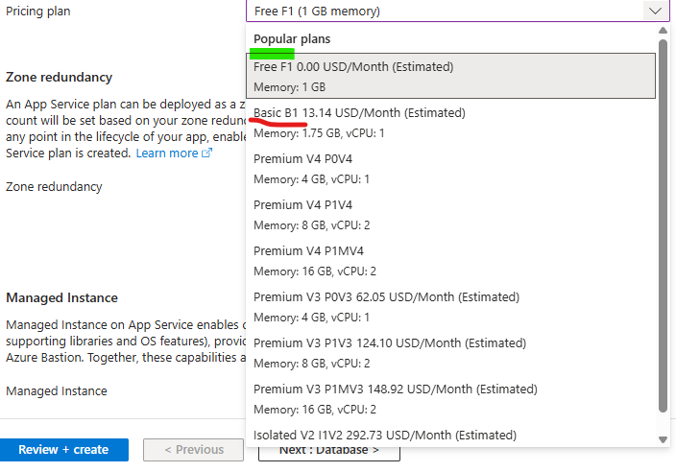
  - asdf
  - asdf

