Jim Johnson

installing Visual Studio 2026

Table of Contents
Tools/Resources for this exercise: 2
Three Websites to Know 2
1. Azure DevOps (logo is two half arrows that form a box) 2
2. Azure Portal (logo is does not show on landing page. Splash page is letter A folded from a blue ribbon) 2
3. GitHub (Logo is a cat silhouette) 2
Editors for Azure Work 3
1. Visual Studio 3
2. VS Code 3
Installing Local Resources 4
3. Install Visual Studio 4
k. Upgrade options. 7
l. Traditional Visual Studio Workloads installer dialog 8

Tools/Resources for this exercise:
- Azure Free Account Setup
- Visual Studio

Three Websites to Know
- Azure DevOps (logo is two half arrows that form a box)
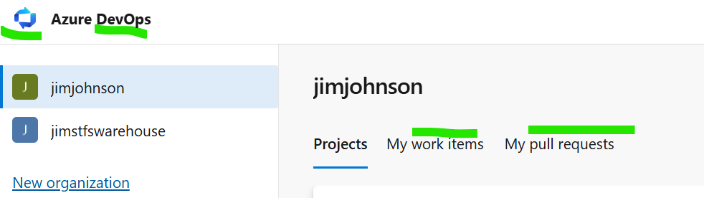
- Azure Portal (logo is does not show on landing page. Splash page is letter A folded from a blue ribbon)
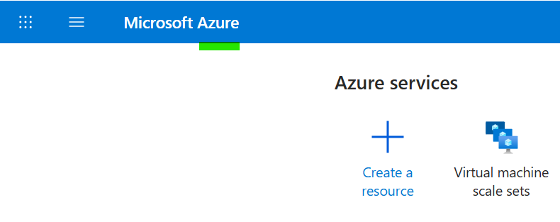
- GitHub (Logo is a cat silhouette)
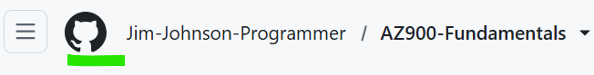

Editors for Azure Work
- Visual Studio
  - There are two major editors used for developing and deploying code to Azure: Visual Studio and VS Code. Visual Studio has been used the longest and has the largest market share. Visual Studio has been around since the late 1990s. It gets upgrades every year and continues to be upgraded. Visual Studio is wizard based so starting off this will be easier. Visual Studio comes with almost everything pre installed. Most things are done via step by step wizard, hence why it is chosen for this first exercise.
  - Both Visual Studio and VS Code have a mode where they can download and upload code to websites designed to manage source code. Visual Studio has been chosen to be the default for GitHub for downloads. There is an option for it on the GitHub website to encourage its use for downloading code. When the option is chosen, Visual Studio is launched in a special mode for linking the remote repository to a local folder on your machine that should be empty. The code will be downloaded to that folder without turning it into a zip file. This is the intended way that developers join a development effort and upload code for review if permissions are setup for the person downloading the code. We will see more on this shortly. GitHub was purchased by Microsoft. It is where startup and hobby developers display and share their code and their talent.

- VS Code
  - VS Code came later to attract Linux developers who were used to lighter weight tools that are not wizard based, meaning they do something directly such as a tree view of azure or are command line based. This started in early 20 teens (e.g. 2010+). There was an editor called sublime that was the inspiration for VS Code. It comes with only basic editing support, then extensions marketplace tab is used to add development support for almost anything is just a quick keyword search. Installing support is very easy and usually done in under 5 minutes.
  - VS code is the encouraged default on the website for downloading code from Azure DevOps. Azure DevOps is the main site Microsoft uses to manage development specs, stories, testing, and deployment. In other words, development and automated deployment is done in DevOps. Not hosting, or production environments which is done in Azure Portal.

Installing Local Resources
- Install Visual Studio
  - https://visualstudio.microsoft.com/downloads/
  - Be sure to choose the community edition of Visual Studio. We will not be needing the professional tools for network management and enterprise tools.
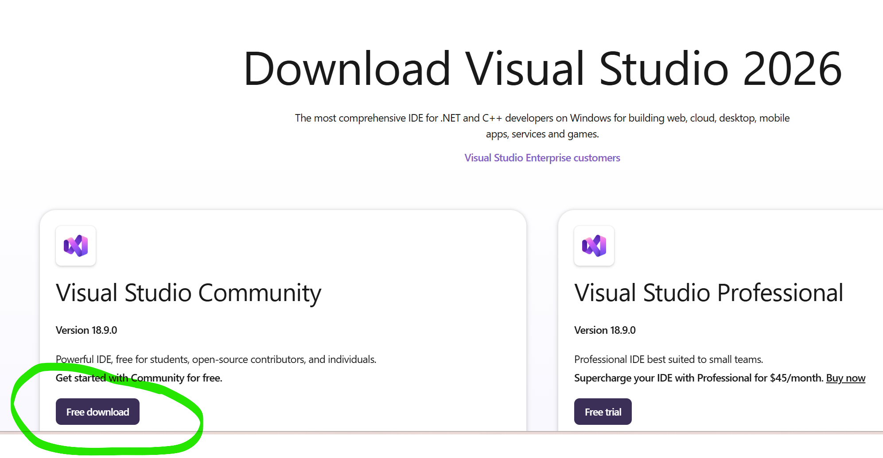
    - Community version is free and intended to support home development, startups, and open source small groups. Professional version is intended for businesses who want enterprise tools. Professional version gives you a trial then requires a credit card.
  - Click download and the download will start immediately. This installer is a download manager that is designed to download quickly.
  - You will be redirected to a page of tutorials and quick starts.
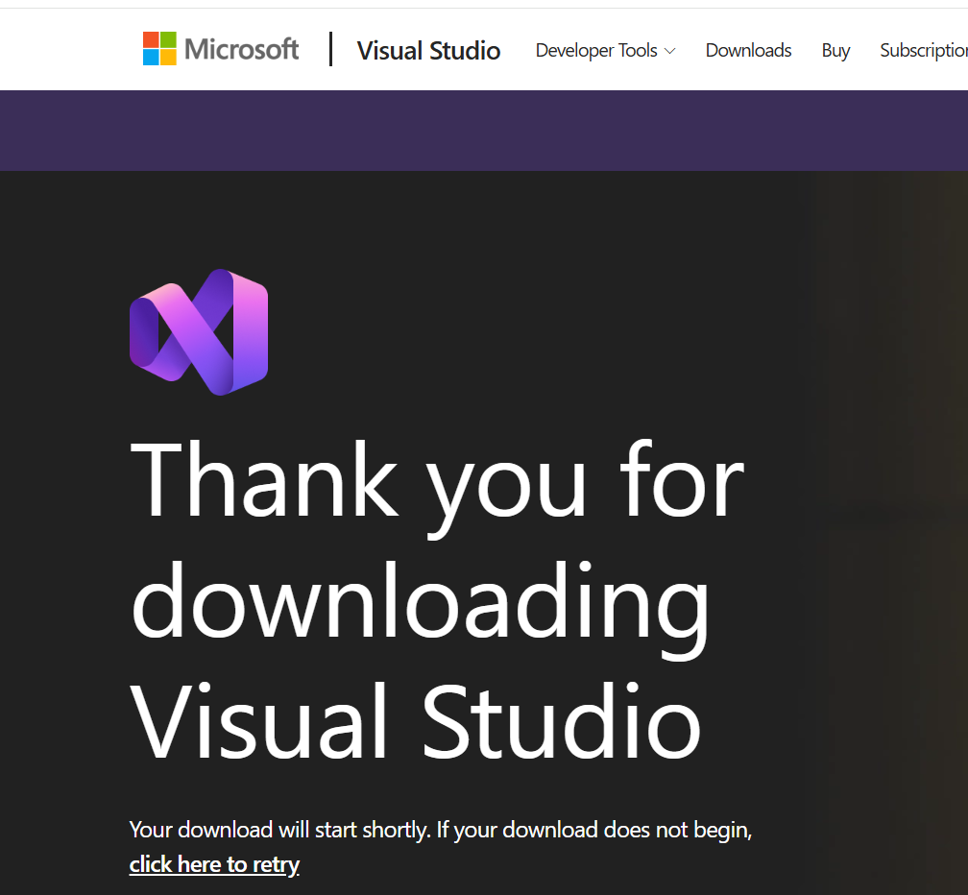
  - If necessary, the “Click here to retry” link will restart download of the installer.
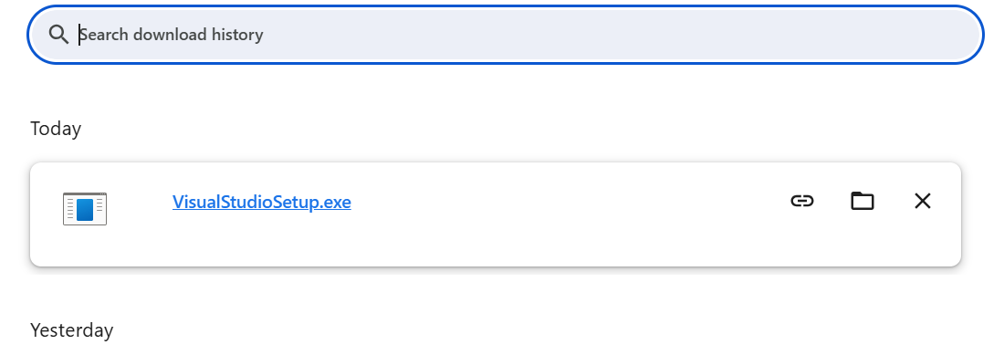
  - Below is the download section in Chrome browser.
  - Find the downloaded setup file and double click it. A small dialog with a progress bar loads first.
  - Next you will likely get a screen that takes over the computer with a dialog box in the center. This dialog box is asking for you to click “OK” or “Cancel”. In this case, “OK” grants permission to the setup program to have administrator permission finish its installation.
  - After clicking “OK” there will be a small dialog notifying of initial setup about to start.
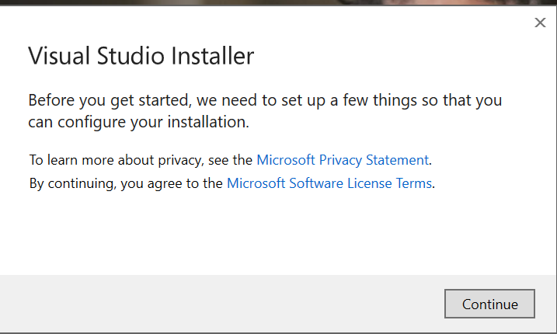
  - Click “continue” to start the installation
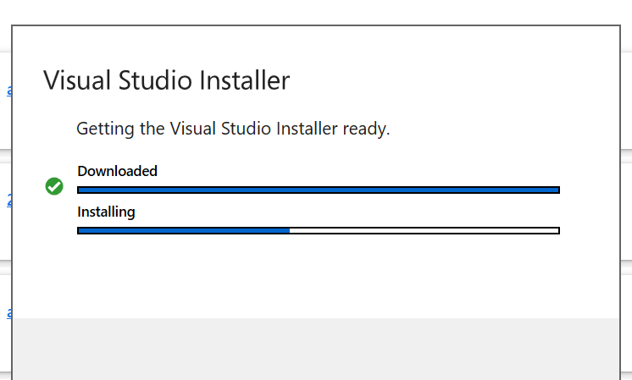
  - Upgrade options.
    - A key thing to know about Visual Studio is that a download installation installs next to older versions of Visual Studio. Microsoft does intend for you to be able to run older versions of Visual Studio to support older applications with familiar tools. Microsoft will make it hard to download older versions of Visual Studio, but will not wipe out what you have already installed from a new install.
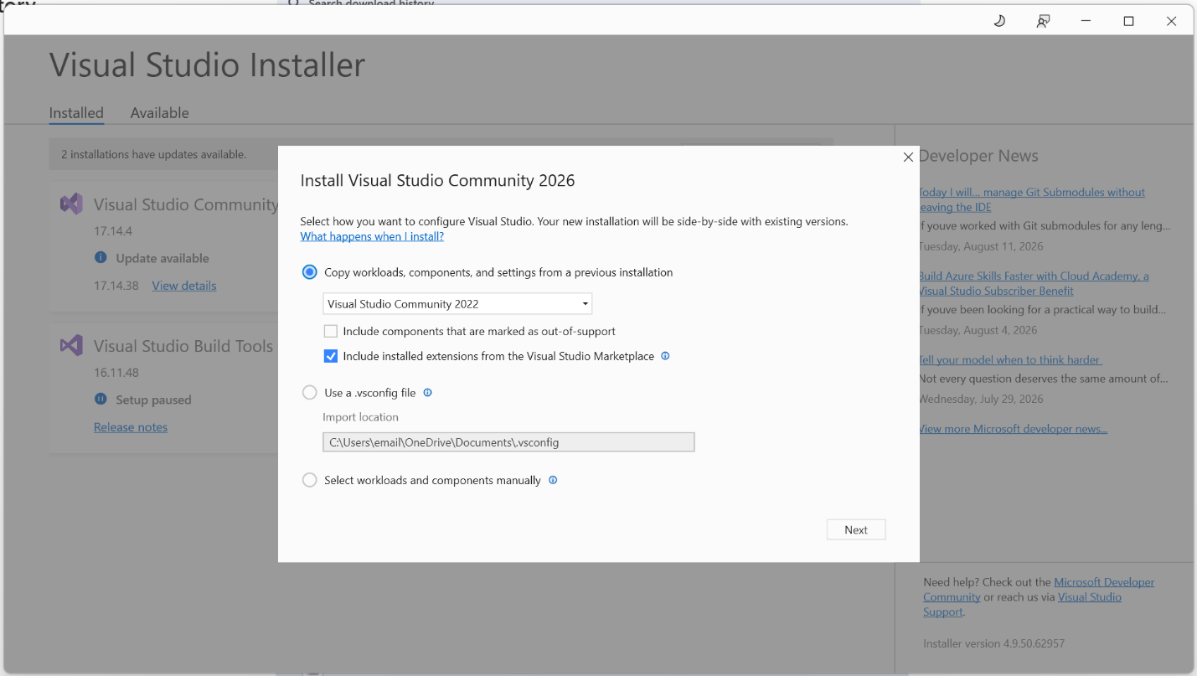
    - I have previously installed versions, so I am asked to import my settings into new install.
    - After clicking next, I am warned about discontinued packages and items in a dialog that appears over the traditional installer.
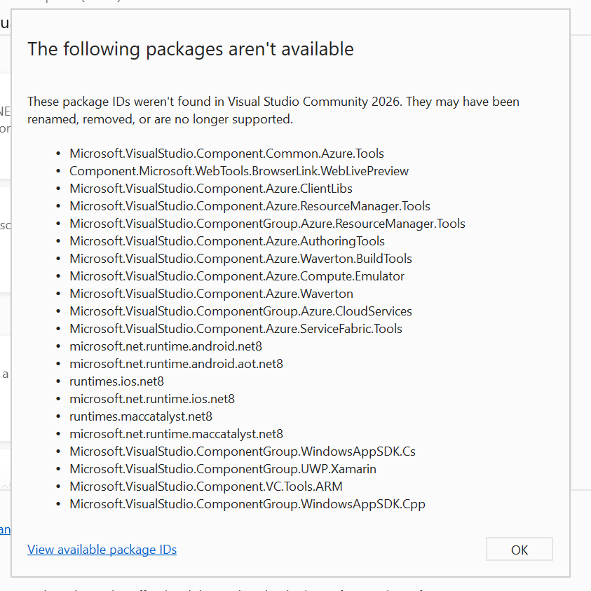
    - I click OK.
  - Traditional Visual Studio Workloads installer dialog
    - Workloads are packages that enable support for things like certain programming languages, desktop programming vs web programming and more.
    - These are the support behind the interface that add options to your wizard when you create projects.
    - You don’t need to worry about compatibility at this point. Our objective is to focus on the workloads for this lab.
    - We care about “ASP.NET and web development” and “Azure ad AI development”. Make sure those two checkboxes are checked.
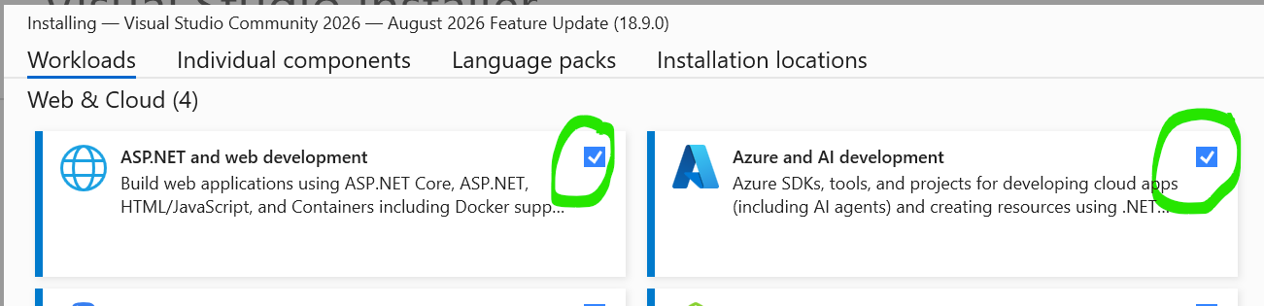
    - Then at the bottom of the dialog make sure drop down is set to Install while downloading and click the install button as shown.
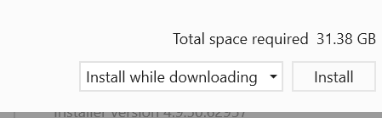
    - When the workloads selected are all loaded, you will see all installs of Visual Studio.
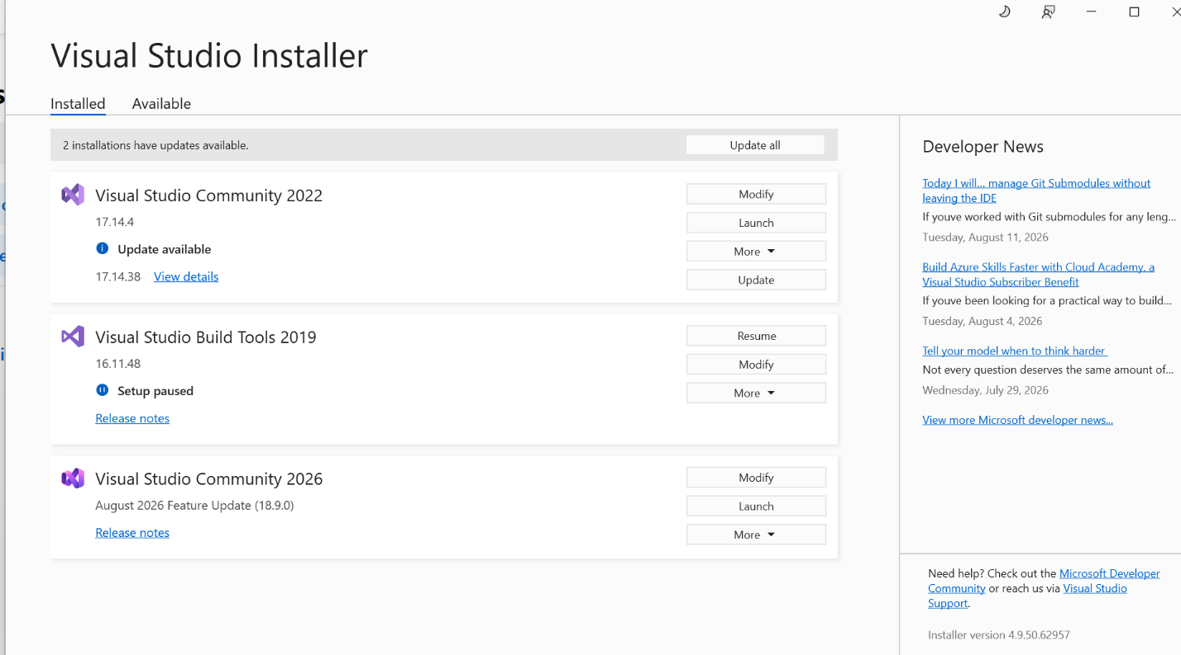

  - When you click the “More” drop down for each install of Visual Studio the options include the ability to uninstall.
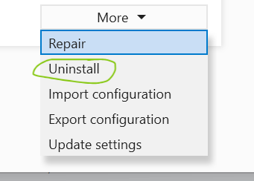
- The first time to run Visual Studio, you will need to launch Visual Studio from the installer. Do this from the “Launch” button.
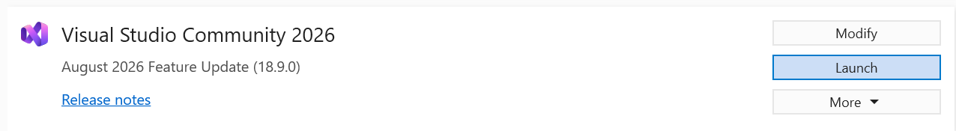
- The dialog will first ask you to sign in. The same credentials that allow you into Azure will also work for logging into Visual Studio. Once you login, you won’t have to login again unless you log out.

