STATS 201 Lab Class 1

LiYuzhuo-2019210146

#Gravity experiment

# Code and output

library(s20x)  
## Loading in the data.  
## Loading in the data.  
Gravity.df = read.table("GravityExpt.txt", header = TRUE)  
## Plot the data.  
## INSERT CODE HERE.  
plot(Height~Time, data=Gravity.df)

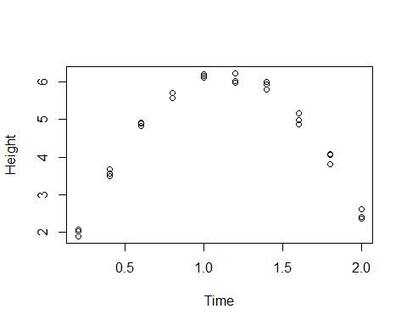

## Analyse the data.  
## INSERT CODE HERE.  
timefit=lm(Height~Time + I(Time^2), data=Gravity.df)  
plot(timefit,which=1)

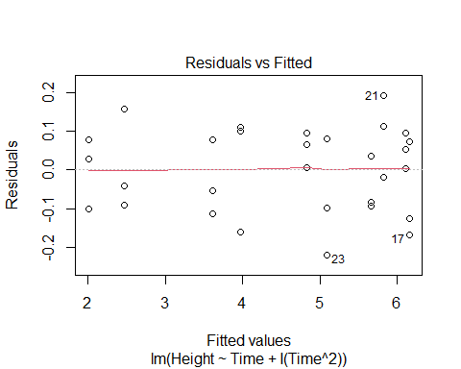

normcheck(timefit)

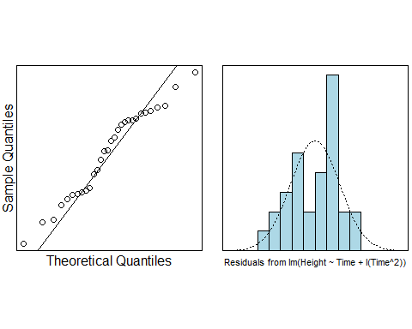

cooks20x(timefit)

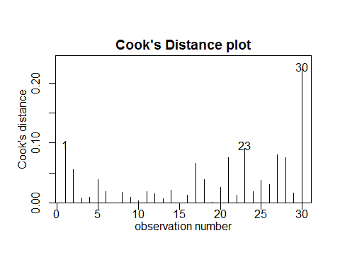

## Answer research questions.  
## INSERT CODE HERE.  
summary(timefit)

##   
## Call:  
## lm(formula = Height ~ Time + I(Time^2), data = Gravity.df)  
##   
## Residuals:  
## Min 1Q Median 3Q Max   
## -0.21914 -0.09378 0.01751 0.08025 0.19217   
##   
## Coefficients:  
## Estimate Std. Error t value Pr(>|t|)   
## (Intercept) 0.0008333 0.0748403 0.011 0.991   
## Time 10.9786742 0.1562823 70.249 <2e-16 ***  
## I(Time^2) -4.8740530 0.0692301 -70.404 <2e-16 ***  
## ---  
## Signif. codes: 0 '***' 0.001 '**' 0.01 '*' 0.05 '.' 0.1 ' ' 1  
##   
## Residual standard error: 0.1102 on 27 degrees of freedom  
## Multiple R-squared: 0.9946, Adjusted R-squared: 0.9942   
## F-statistic: 2505 on 2 and 27 DF, p-value: < 2.2e-16

confint(timefit)

## 2.5 % 97.5 %  
## (Intercept) -0.1527263 0.1543929  
## Time 10.6580094 11.2993390  
## I(Time^2) -5.0161015 -4.7320046

# Methods and Assumption Checks

We fitted a linear model with quadratic term the relationship between height and time is quadratic.

After fitting the quadratic,the residuals were fine, Our data do not strictly follow a normal distribution, but the impact on the overall effect is not significant, and there are no unduly influential points. We have independence from taking a random sample.

Our model is: $Height=β_{0}+β_{1}×Time+β_{2}×Time^{2}+ϵ_{i}$ where $ϵ_{i}∼iid N(0,σ^{2})$.

As Adjusted R-squared is 0.9942, so our model explains 99.42% total variation in the response variable, which shows the model fitted to the data is very well.

# Executive Summary

It was of interest to model the relationship between the height of the ball in meters and times after ejection of the steel ball.

We found strong evidence suggesting there is a quadratic relationship between height of the ball and time after ejection($p≈0$).

As the coefficient of the quadratic term is -0.5g, so we can concluded from the summary part, the estimated value of g is 9.74.

Our 95% confidence interval for estimated value of g ranges from 9.46 to 10.04, which included the theoretical value of 9.80.

As for the intercept term, we found the p-value of the intercept term is 0.991, which is not small enough to against the null assumption, shows that the intercept term in our analysis is zero. So we can concluded that our analysis is consistent with the true value of the coefficient of the intercept term.