**Warmup (optional): Find and correct the problems in the following code fragments**

1. 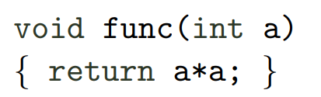

* The return type is void, so returning is not required nor desired.

1. 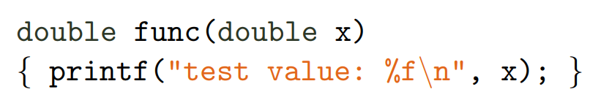
   * There is not return
   * The format specifier for a double is %lf for long float.
2. 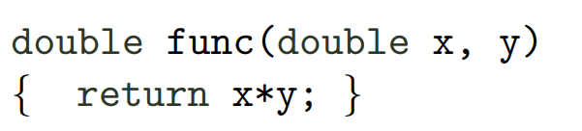
   * The parameter y has no type.
3. 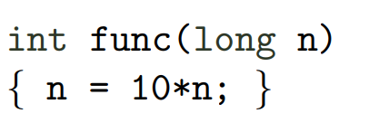
   * There is no return statement.

**Exercise 6.1. Write the prototypes of the following functions**

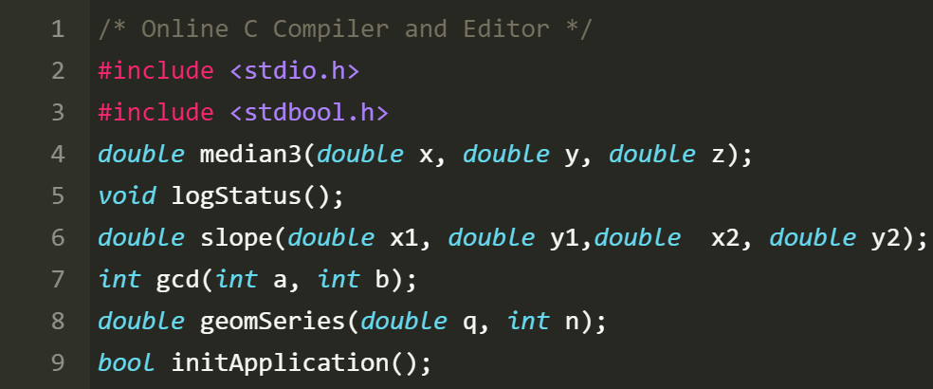

**Exercise 6.1.**

1. Try assigning your point structures directly to each other (to copy the coordinates of one point to the other). How does the situation change if you do not assign structures, but pointers to your structures?

**It works with the p1=p2. I don’t get what is asked on the second part.**

1. Try changing struct into union. Would your code still work? Why (not)?

**It doesn’t work, because with the union every coordinate would override the last one.**