CS_03550-1D Software:

Revision History: 1C

Test Program revision changes. Added HP VEE Test Data Server Setup.

Revision History: 1D

Added automated VSWR, Test Port Insertion Loss and Test Port Isolation tests.

CS_03550-1 Software supports testing for N12-3541 and N15-5350 (Semi-Automated Testing)

Revision B added a Test Data Server capability. Revision B software requires that a server directory be setup on one of the computers on the network. All computers running the revision B software must map the server file as their A:\ drive. Details are described below in the Server Section.

Revision C added Phase Testing capability. This test is specifically used for automating phase measurements on the N12-3541 and N15-5350 products.

Revision D added VSWR, Test Port Insertion Loss and Test Port Isolation semi-automated testing capability. This captures measurements from the scalar analyzer and saves it to the data record for Pre-Test and Final-Test data sheets.

Test Capability includes: Gain Testing, Temperature Sensor Testing, Noise Figure Testing, Input P1dB Compression Point Testing, Mixer Spur Testing, Phase Testing, VSWR, Test Port Insertion Loss and Test Port Isolation.

Each of the above tests are accomplished with independent test programs as follows:

HP VEE N12-3541 Gain Test

Arduino N12-3541 Temperature Sensor Test

NI LabView N12-3541 Noise Figure Test

HP VEE N12-3541 P1dB Test

HP VEE N12-3541 Mixer Spurs Test

Excel VBA N12-3541 Phase Test

HP VEE N12-3541 VSWR Test

Test Equipment as listed, or equivalent may be used.

HP VEE TEST DATA SERVER SETUP

Test Program Folder: VEE_SERVER_A1

To Setup Server

Install One Directory under the C: Drive (On the server computer)
VEE_SERVER
(Test data files are stored in subdirectories in this location.)

Ensure all computers writing data to this server have mapped their A:\ drive to the VEE_SERVER Directory Location.

The setup for each test program is unique and is documented below:

HP VEE N12-3541 Gain Test Setup

Test Program Folder: N12-3541 Gain_B1

To Setup and Run Test Program (N12-3541 Gain_B1.vxe – In VEE Programs Directory)

Install Three Directories under the C: Drive
VEE Programs; VEE Setup Data; VEE Test Data (Test data files are stored in this location.)

Install Agilent VEE Library 17.2; Agilent VEE 9.32; and Microsoft EXCEL (Office 12 or later)

Set test equipment to the correct HPIB addresses – As shown below

Test Equipment Required: (Reference ATP-03550 for additional Equipment Required.) GPIB Address:
HP8757D Scalar Analyzer 16
HP83640A RF Source (10MHz to 40 GHz) 19
Desktop/Laptop with Windows 10 OS
HP 82357B USB/GPIB Interface

Arduino N12-3541 Temperature Sensor Test

Test Program Folder: N12-3541 Temperature Sensor Test_A1

To Setup and Run Test Program (Arduino.exe)

Install Arduino 1.8.5

Install Test Program file (Delay_SPI_Temp_Sensor_Multi_Command_2012_08_14.ino) in directory Documents\Arduino\Delay_SPI_Temp_Sensor_Multi_Command_2012_08_14

Test Equipment Required: (Reference ATP-03550 for additional Equipment Required.)
Desktop/Laptop with Windows 10 OS

NI LabView N12-3541 Noise Figure Test Setup

Test Program Folder: N12-3541 Noise Figure_B1

To Setup and Run Test Program (N12-3541 Noise Figure_B1.exe)

Install One Directory under the C: Drive
AUTOTEST (AUTOTEST has three sub-directories (CALIBRATION, NI TEST DATA, and REF) and the application File (N12-3541 Noise Figure_B1.exe)
Install LABVIEW 2018 (LVRTE2018SP1_f3Patchstd.exe) – for 32 BIT Applications

Set test equipment to the correct HPIB addresses – As shown below

Test Equipment Required: (Reference ATP-03550 for additional Equipment Required.) GPIB Address:
HP8757D Noise Figure Meter Anything
HP83640A RF Source (10MHz to 40 GHz) Anything
Desktop/Laptop with Windows 10 OS
HP 82357B USB/GPIB Interface

HP VEE N12-3541 P1 dB Test Setup

Test Program Folder: N12-3541 P1 dB_B1

To Setup and Run Test Program (N12-3541 P1_dB_B1.vxe – In VEE Programs Directory)

Install Four Directories under the C: Drive
VEE Programs; VEE Calibration Data; VEE Setup Data; VEE Test Data

Install Agilent VEE Library 17.2; Agilent VEE 9.32; and Microsoft EXCEL (Office 12 or later)

Set test equipment to the correct HPIB addresses – As shown below

Test Equipment Required: (Reference ATP-03550 for additional Equipment Required.) GPIB Address:
HP83650B RF Source (10MHz to 50 GHz) 19
HP438A Power Meter 13
Desktop/Laptop with Windows 10 OS
HP 82357B USB/GPIB Interface

HP VEE N12-3541 Mixer Spurs Test Setup

Test Program Folder: N12-3541 Mixer Spurs_B1

To Setup and Run Test Program (N12-3541 Mixer Spurs_B1.vxe – In VEE Programs Directory)

Install Four Directories under the C: Drive
VEE Programs; VEE Calibration Data; VEE Setup Data; VEE Test Data

Install Agilent VEE Library 17.2; Agilent VEE 9.32; and Microsoft EXCEL (Office 12 or later)

Set test equipment to the correct HPIB addresses – As shown below

Test Equipment Required: (Reference ATP-03550 for additional Equipment Required.) GPIB Address:
HP83650B RF Source (10MHz to 50 GHz) 19
HP438A Power Meter 13
HP8565E Spectrum Analyzer (10MHz to 50 GHz) 14
Desktop/Laptop with Windows 10 OS
HP 82357B USB/GPIB Interface

Excel VBA N12-3541 Phase Test Setup

Test Program Folder: N12-3541 Phase_A1

To Setup and Run Test Program (Block_DC_Final_Test.xltm – In VEE Programs Directory)

Please refer to CS-03550-1C Appendix A (separate file) for installation notes.

Install Two Directories under the C: Drive
VEE Programs; VEE Test Data (Test data files are stored in this location.)

Install Agilent VEE Library 17.2; Agilent VEE 9.32; and Microsoft EXCEL (Office 12 or later)

Set test equipment to the correct HPIB addresses – As shown below

Test Equipment Required: (Reference ATP-03550 for additional Equipment Required.) GPIB Address:
HP8720B Vector Analyzer 16
Desktop/Laptop with Windows 10 OS
HP 82357B USB/GPIB Interface

HP VEE N12-3541 VSWR and Test Port Insertion & Isolation; Test Setups

Test Program Folder: N12-3541 VSWR

To Setup and Run Test Program (N12-3541 VSWR.vxe – In VEE Programs Directory)

Install three Directories under the C: Drive
VEE Programs; VEE Setup Data; VEE Test Data (Test data files are stored in this location.)

Under VEE Setup Data place the following 3 pictures called by this program
N12-3541 IF J7 VSWR Test SetUp.jpg
N12-3541 J6 Test Port VSWR, Insertion & Switch Isolation Test SetUp.jpg
N12-3541 RF VSWR Test SetUp.jpg
Also in this directory insure that the data template is the most current version
N12-3541 RF VSWR Test SetUp.xlsx
N15-5350 RF VSWR Test SetUp.xlsx

Install the same three Directories under the A: Drive (also known as the Server)
VEE Programs; VEE Setup Data; VEE Test Data (Test data files are stored in this location.)

Under the Server VEE Setup Data ensure the current data templates are present.
N12_3541_A1_Final_Data_Sheet.xlsx
N15_5350_A1_Final_Data_Sheet.xlsx

Install Agilent VEE Library 17.2; Agilent VEE 9.32; and Microsoft EXCEL (Office 12 or later)

Please refer to ATP-03550-1D Appendix A section 6.7 for the VSWR test usage instructions.

Set test equipment to the correct HPIB addresses – As shown below

Test Equipment Required: (Reference ATP-03550 for additional Equipment Required.) GPIB Address:
HP8757D Scalar Analyzer 16
HP83640A RF Source (10MHz to 40 GHz) 19
Desktop/Laptop Windows 10 OS
HP 82357B USB/GPIB Interface
HP 85027D Directional Bridge

Gain Test Setup:

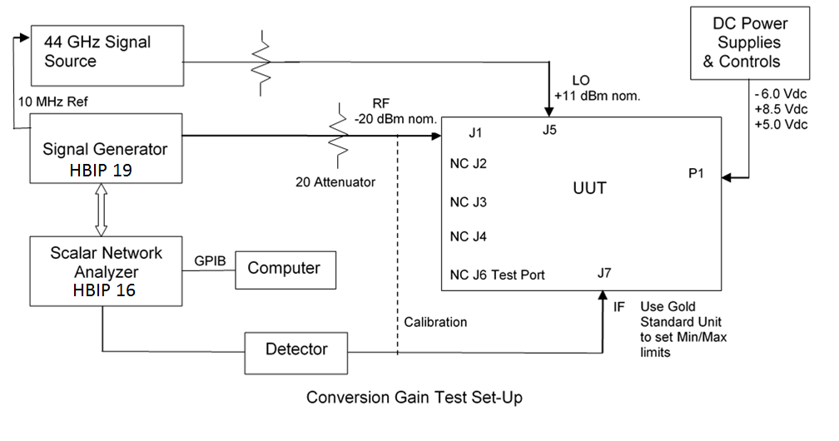

Temperature Sensor Test Setup:

Test Port
NC J6
UUT
NC J5
NC J4
DC Power Supplies
& Controls

Figure 6.2. Temperature Sensor Test Set-Up
Computer
NC J3
NC J2
NC J7
IF
P1
NC J1
- 6.0 Vdc
+8.5 Vdc
+5.0 Vdc

Noise Figure Test Setup:

P1 dB and Mixer Spurs Calibration Setup:

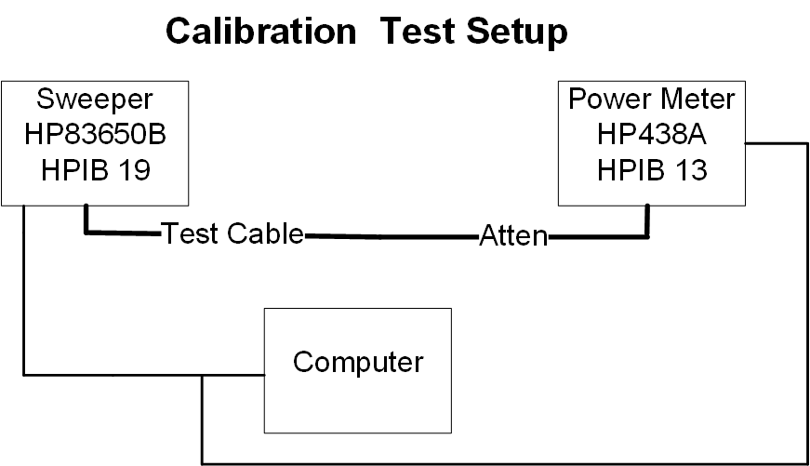

P1 dB Test Setup:
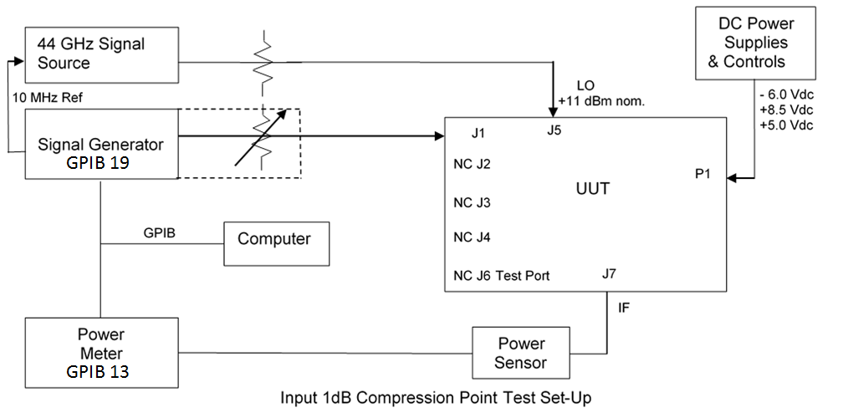

Mixer Spurs Test Setup (N12-3541):

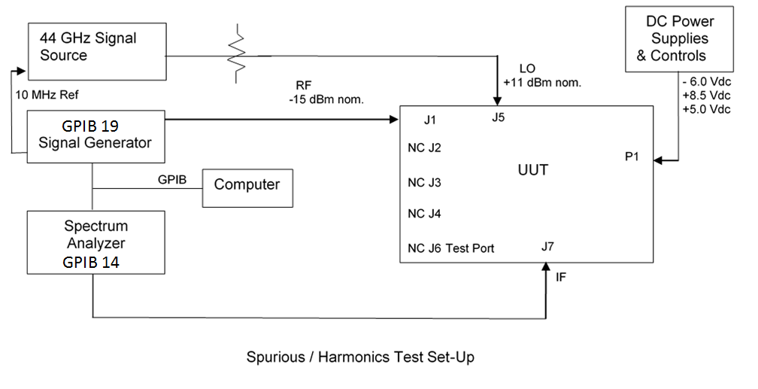

Mixer Spurs Test Setup (N12-3542):
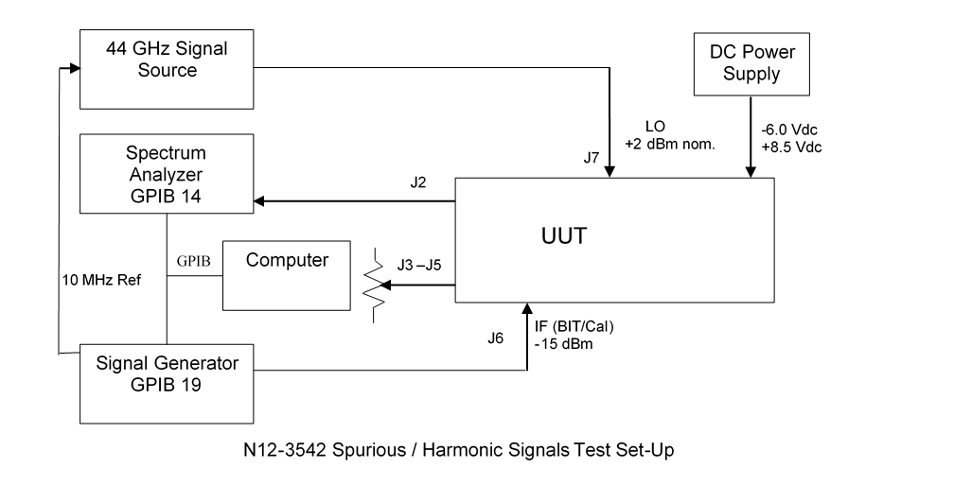

Phase Tracking Test Setup (N12-3541):
Signal Upconverter
Signal Generator
Vector Network Analyzer
11 GHz Signal Source

DC Power Supply & Controls
Figure 6.4.1. Phase Tracking Test Set-Up

Power Divider
J3
R
I
L
-10 dB
UUT
R
L
I
- 6.0 Vdc
+8.5 Vdc
+5.0 Vdc
10 MHz Ref
X4
X4
J5
J7
J1-J4
J6
N12-3542
J7
J4
Port 1
Port 2
P1
DC Power Supply & Controls
- 6.0 Vdc
+8.5 Vdc
P1
Use Gold Standard Unit for Calibration

VSWR: IF, RF & Test Port; and Test Port Insertion Loss & Test Port Switch On/Off Isolation: 