1. P. 4-5 Communication: definition and components

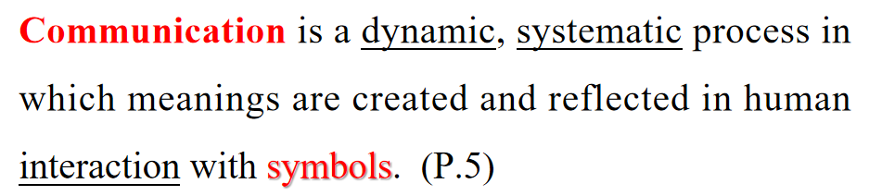

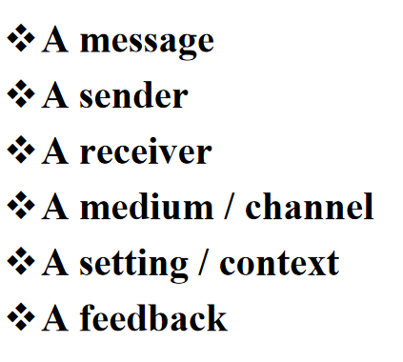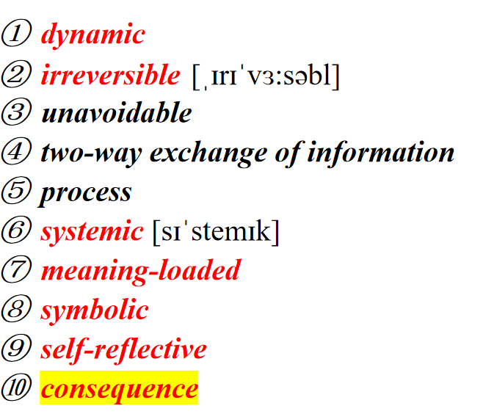

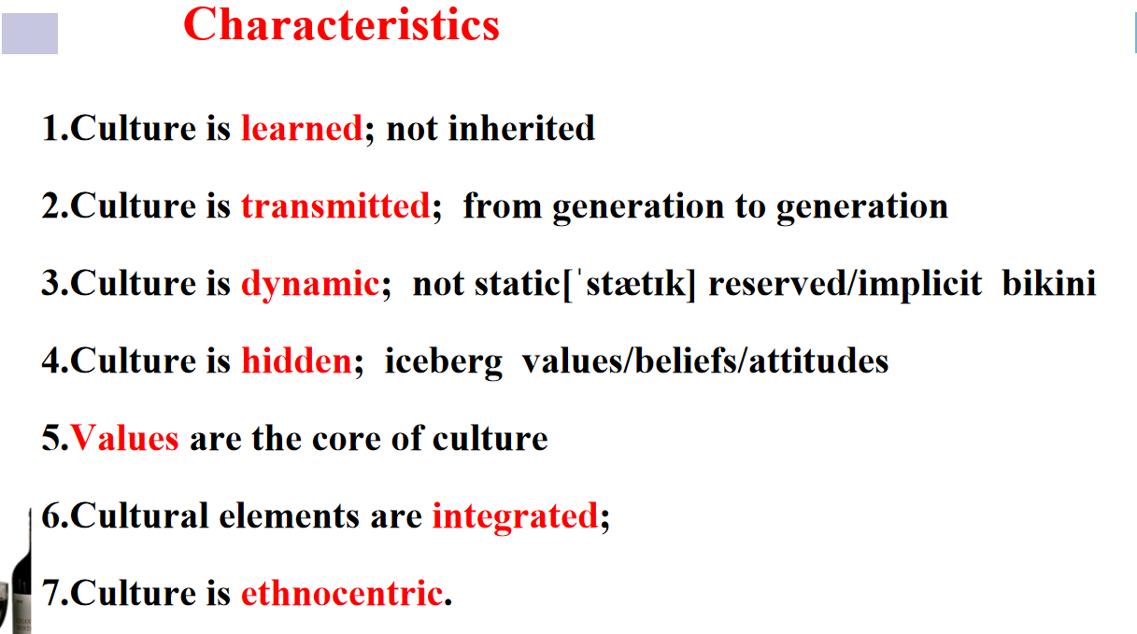

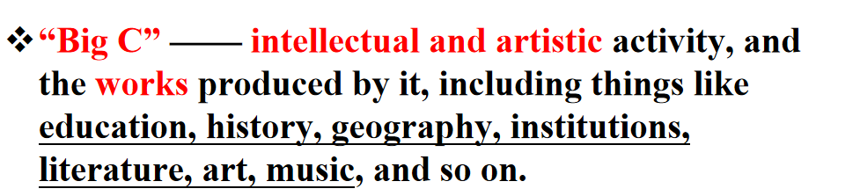

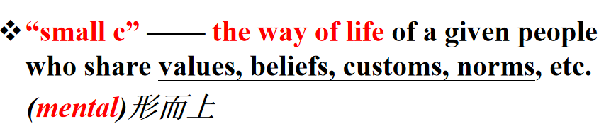

1. P. 26-30 Intercultural communication: Definition, levels, importance and difficulties

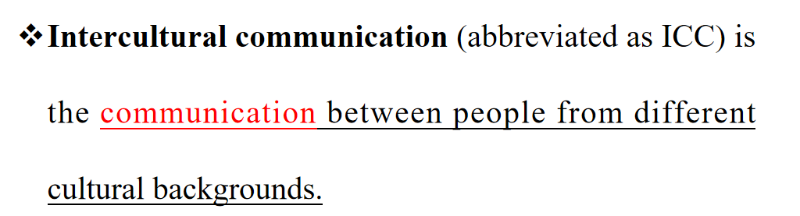

The definition of worldview

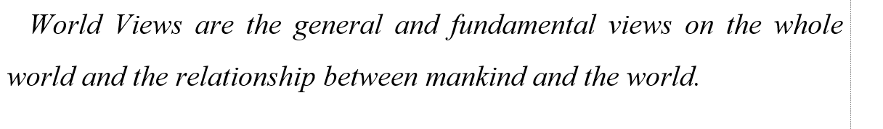

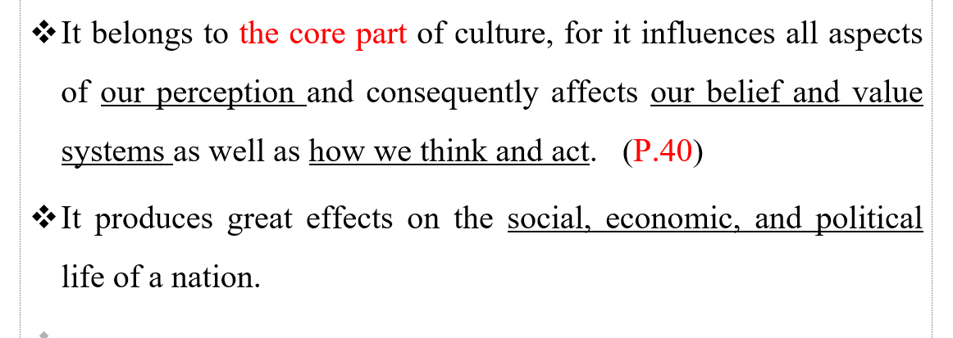

Holistic vs. Dualistic worldviews（定义+阐述+案例+分析）

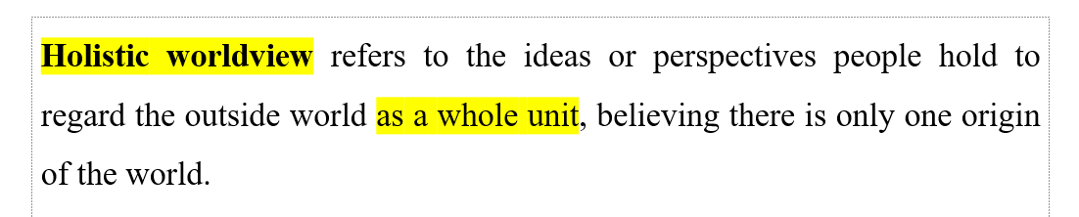

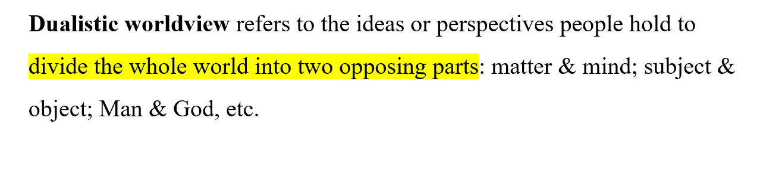

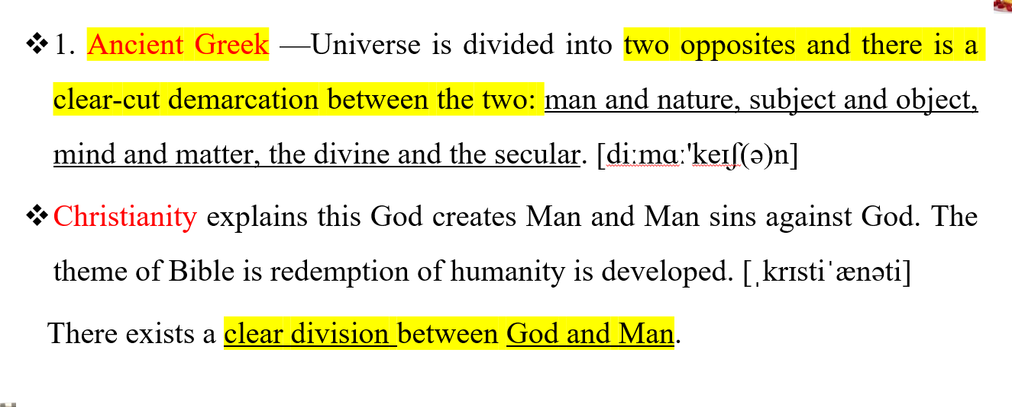

Holistic worldview refers to the notion that people tend to view the world as a whole, stressing the “One” “Unity” “Blending” “Integration” “Harmony” and “Wholeness”, etc.

Dualistic worldview means that people are likely to divide the world into two opposing (different) parts: subject and object, body and mind, man and nature, matter and form, etc.

Values: definition

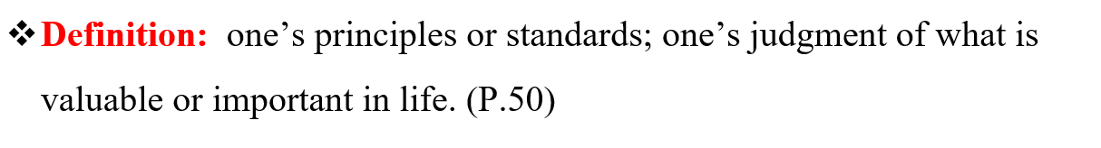

1. P. 51-53 Values: types, characteristics,

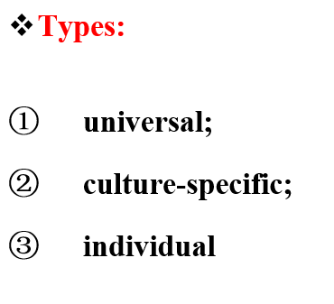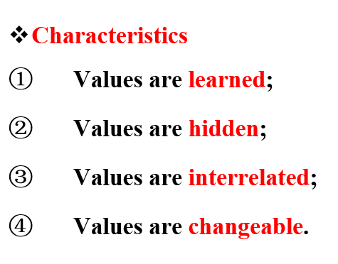

1. P. 54-58 Kluchhohn’s value orientation: human nature, man-nature orientation, time orientation, activity orientation, relational orientation(每一项做中西方对比分析）

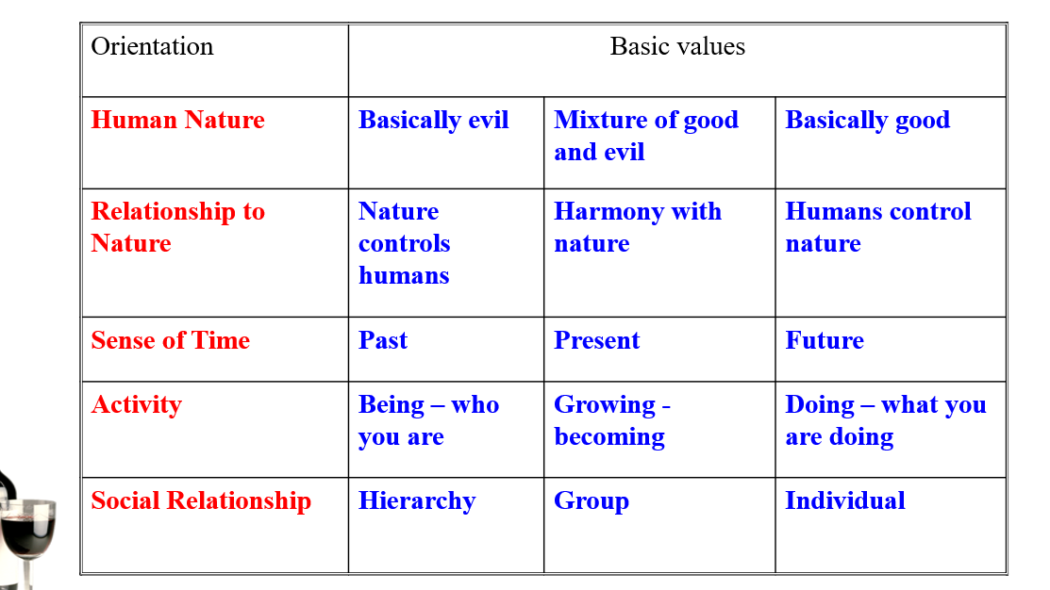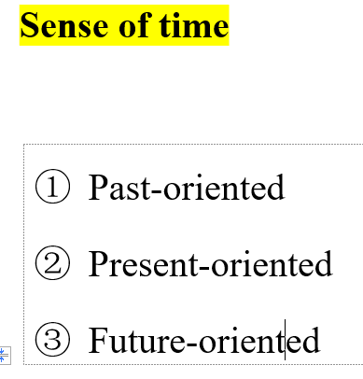

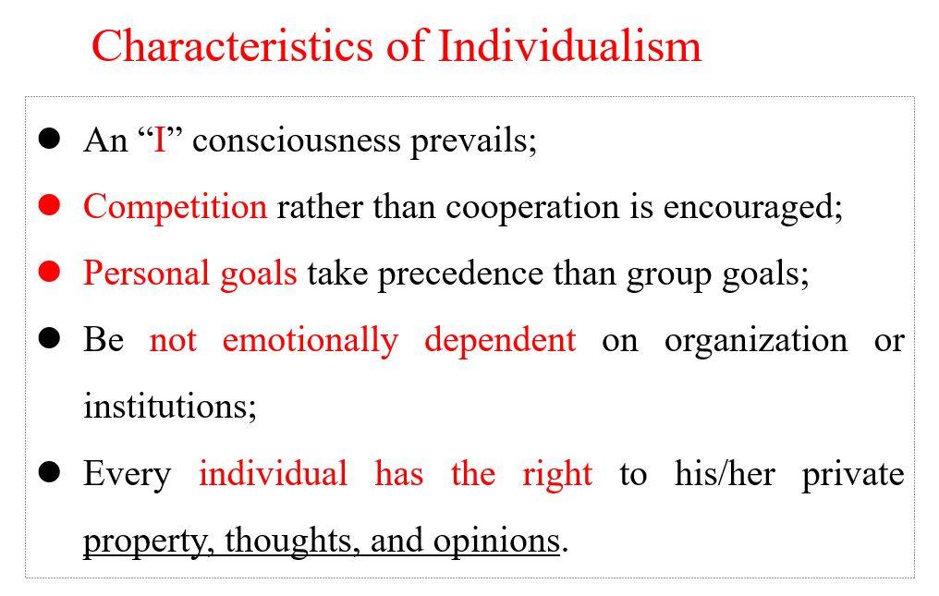

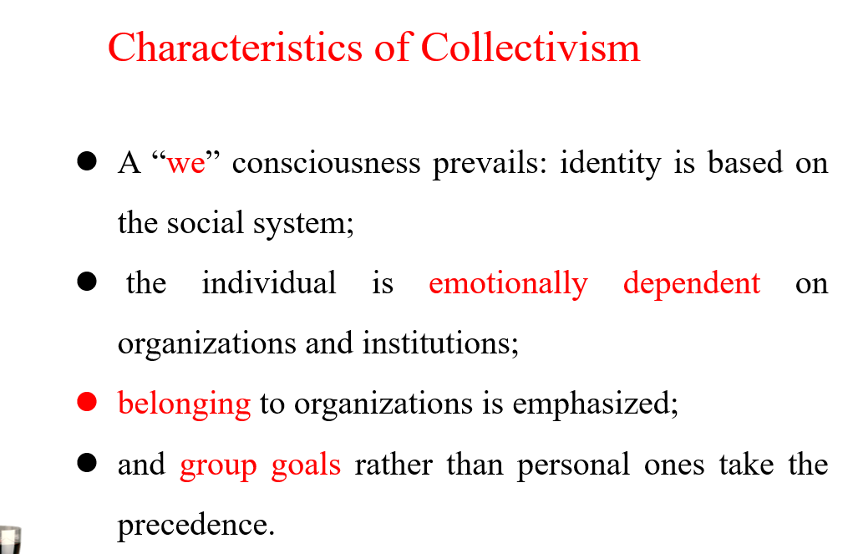

Power distance

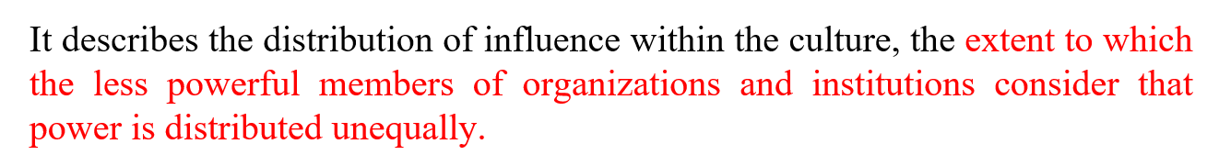

1. P. 58-61 Hofstede’s value dimensions: Individualism---collectivism（P.59，73-74）, power distance, masculinity----femininity(每一项做中西方对比分析）

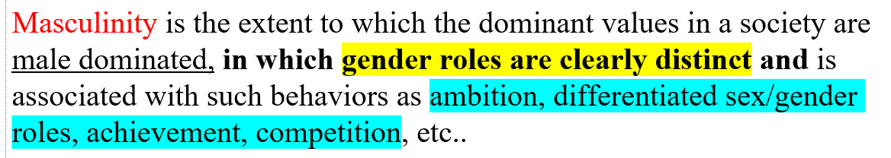

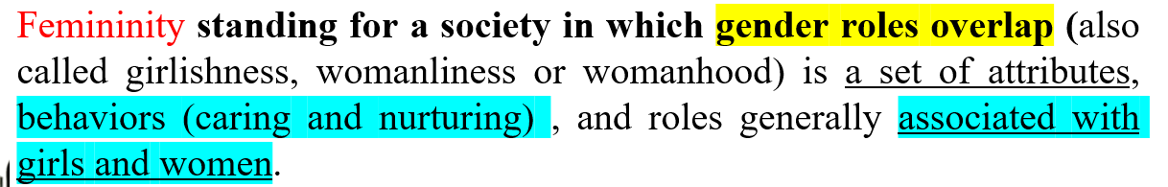

Uncertainty avoidance

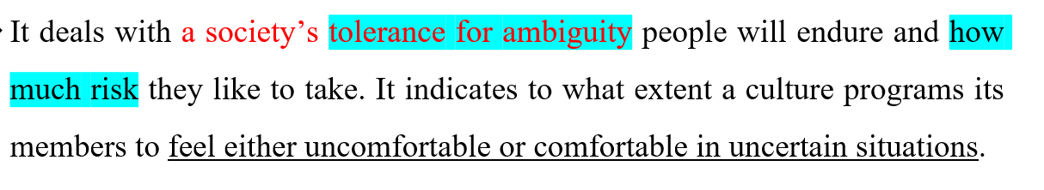

1. P.37-39 The Axial age and the different cultural spirits

