**Lab 5**

1. Review the Duck Application notes. We ended with a class diagram for the DuckApp, reproduced below. How will the Duck class use the FlyBehavior and QuackBehavior interfaces? Implement the diagram in Java, and make sure the answer to this question is clear in your code. To implement the methods like fly() and quack(), just print a phrase to the console, like “Flying with wings” or “Quack by squeaking.”   
     
   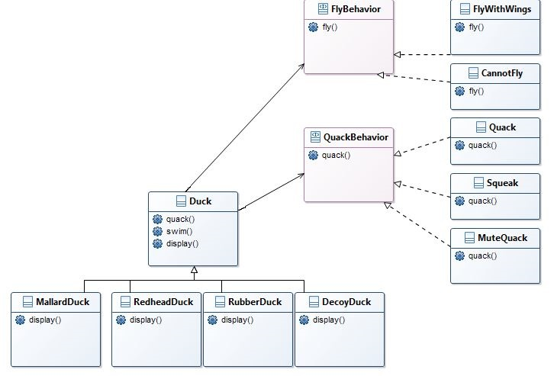To test your code, create a Main class like the following:  
     
   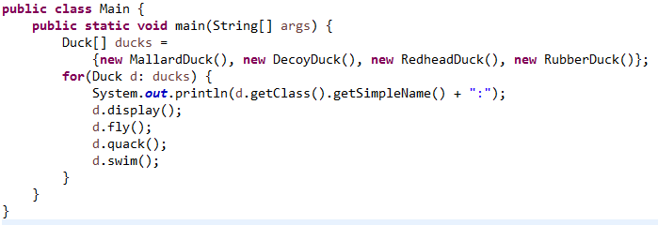

Output should look like this:

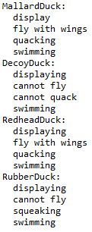

1. Create Java classes for Triangle, Rectangle, and Circle. Provide each class with a method

public double computeArea()

*Make all of these classes immutable.* (Follow the guidelines in the slides for creating this type of class – included with this lab.) Provide one constructor for each class; the constructor should accept the data necessary to specify the figure, and to compute its area. The values accepted by the constructor should be stored in (private) instance fields of the class. For example, Rectangle should have instance fields width and length, and the constructor should look like this

public Rectangle(double width, double length)

For Triangle, you may use arguments base and height. And for Circle, use radius as the constructor argument.

Whenever you create instance fields for one of these classes, provide public accessors for them (but do not provide mutators since the class is supposed to be immutable – for instance, the dimensions of a Rectangle should be read-only). For example, you will have in the Rectangle class:

private double width;   
public double getWidth() {  
 return width;  
}

Create a fourth class Main that will, in its main method, create multiple instances of these figures (you may invent your own input values), store them in a single list, and then *polymorphically* compute and write to the console the sum of the areas. In order to do this, you will need to create an appropriate interface.

Typical output:

Sum of Areas = 37.38

Draw a class diagram that includes all the types mentioned in this problem.

Here are some area formulas:

Area of a rectangle = width * height

Area of a triangle = 1/2 * base * height

Area of a circle = PI * radius