Lab 6

- Write the JavaFX code necessary to produce the following screen:

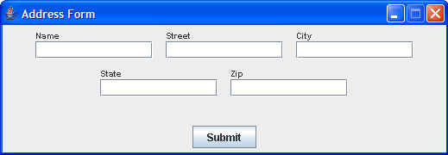

Add an appropriate EventHandler so that, when a user clicks the Submit button…
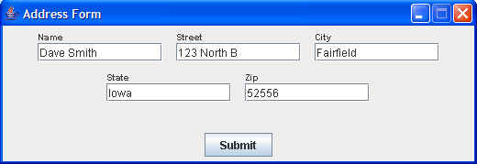

the data that has been entered into the GUI fields is output to the console in the following format:

Dave Smith
123 North B
Fairfield, Iowa 52556

2. Write the JavaFX code necessary to create the following screen:

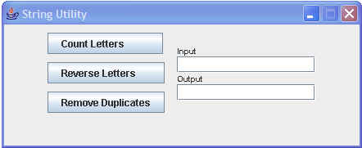

Create the necessary EventHandler so that, when Count Letters is clicked, the number of characters in the Input field is placed in the Output field,

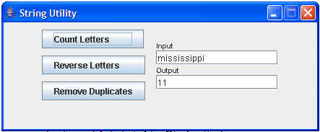

and, when Reverse Letters is clicked, the letters in the input area are reversed and placed in the output area,

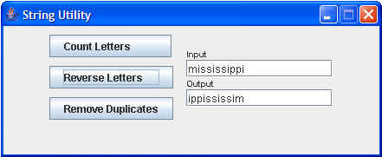

and, when the Remove Duplicates is clicked, the duplicate letters are removed and the result is placed in the output area.

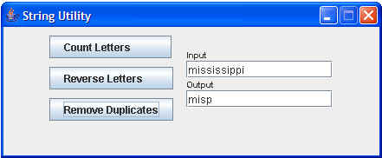

.

- Do the following SceneBuilder setup and demos:
https://docs.oracle.com/javafx/scenebuilder/1/use_java_ides/sb-with-eclipse.htm

https://docs.oracle.com/javafx/scenebuilder/1/user_guide/jsbpub-user_guide.htm

