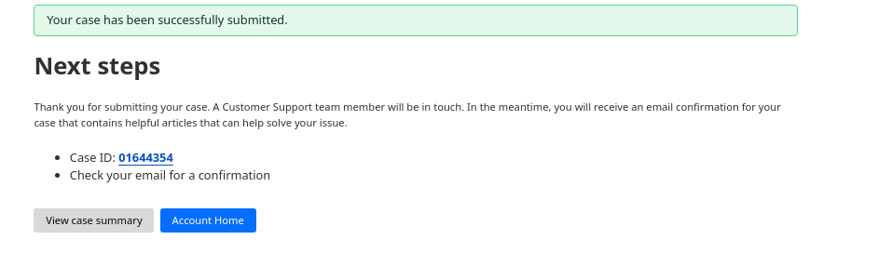

Nameserver Update Stuck for jg-tech.org (Cloudflare Registrar)

Hello Cloudflare Support,

I recently registered the domain jg-tech.org through Cloudflare Registrar under the account associated with jimgore61@gmail.com. While the dashboard correctly assigns the nameservers michael.ns.cloudflare.com and penny.ns.cloudflare.com, the public WHOIS listing still shows alina.ns.cloudflare.com and rex.ns.cloudflare.com.

As a result, my domain remains in a “Pending Nameserver Update” state and isn’t activating within my Cloudflare dashboard. I’ve already confirmed that all DNS records and GitHub Pages settings are properly configured, so this appears to be a sync issue between Cloudflare and the domain registry.

Could you please push the correct nameservers to the registry so the domain can fully activate? Let me know if you need any further information from my side.

Thanks for your help,

Jim

