|  |  |  |  |  |  |  |  |  |  |  |  |  |  |  |  |  |  |  |  |  |  |  |  |  |  |  |  |  |  |
| --- | --- | --- | --- | --- | --- | --- | --- | --- | --- | --- | --- | --- | --- | --- | --- | --- | --- | --- | --- | --- | --- | --- | --- | --- | --- | --- | --- | --- | --- |
| |  | | --- | |  | | |  |  |  |  |  | | --- | --- | --- | --- | --- | | |  |  |  |  | | --- | --- | --- | --- | | |  |  | | --- | --- | | |  | | --- | |  | |  |  | | --- | |  | | | | |  | | --- | |  | | | |  | | --- | | **jg-tech.org is not benefiting from Cloudflare's network. To boost speed and security, update its nameservers.** | | | |  | | --- | |  | | | |  | | --- | | **Why did I receive this email?**  jg-tech.org was added to your Cloudflare account. However, this domain is still not using Cloudflare's nameservers. | | | |  | | --- | |  | | | |  | | --- | | **How to update nameservers for this domain**  1. Log into your domain registrar ([See instructions](https://developers.cloudflare.com/dns/nameservers/update-nameservers/))   2. Replace your current nameserver records with only these two:  michael.ns.cloudflare.com  penny.ns.cloudflare.com   3. Once that’s done, log in to [your Cloudflare account](https://dash.cloudflare.com/?to=/:account/jg-tech.org) and check jg-tech.org’s status. | | | |  | | --- | |  | | | |  | | --- | | **Additional resources**   * [Change your nameservers](https://developers.cloudflare.com/dns/zone-setups/full-setup/setup/#update-your-nameservers) * [Domain status](https://developers.cloudflare.com/dns/zone-setups/reference/domain-status/) * Find your registrar on [ICANN Lookup](https://lookup.icann.org/en/lookup?name=) | | | |  | | --- | |  | | | |  | | --- | |  | | | |  | | --- | |  | | | |

|  |
| --- |
|  |
| Hi ,  This is an automated reminder that **this case will close in 48 business hours** **if we dont hear back from you** about Case #01644354.   Do you need more time to gather information or have updates? Were happy to accommodate that; let us know with a reply to this email.   About this case  Subject: Domain not Activating Description: Nameserver Update Stuck for jg-tech.org (Cloudflare Registrar)  Hello Cloudflare Support,  I recently registered the domain jg-tech.org through Cloudflare Registrar under the account associated with jimgore61@gmail.com. While the dashboard correctly assigns the nameservers michael.ns.cloudflare.com and penny.ns.cloudflare.com, the public WHOIS listing still shows alina.ns.cloudflare.com and rex.ns.cloudflare.com.  As a result, my domain remains in a Pending Nameserver Update state and isnt activating within my Cloudflare dashboard. Ive already confirmed that all DNS records and GitHub Pages settings are properly configured, so this appears to be a sync issue between Cloudflare and the domain registry.  Could you please push the correct nameservers to the registry so the domain can fully activate? Let me know if you need any further information from my side.  Thanks for your help, Jim Last update: |
|  |

Hello,

Thank you for contacting Cloudflare Support. We're sorry to hear that you're experiencing some difficulties, and we’re happy to assist.

Please note that this domain is still active in the same account where it was registered. However, that account is different from the one you are writing in from.

If you're unsure of the email associated with the account, please be aware that, per our security policy, we cannot disclose account information. You can use our forgot email portal here:<https://dash.cloudflare.com/forgot-email>

If you’re able to identify the correct email but cannot log in to create a ticket, please submit a request on behalf of the account needing assistance here:<https://dash.cloudflare.com/login-help> Please note that you must be logged out of the Cloudflare dashboard to access this portal, so it may help to open the link in a new browser or incognito window.

Please let me know if you have any questions.

Kind regards,   
  
Emily M   
Technical Support Engineer - Cloudflare   
Login to join the [Cloudflare Community](https://community.cloudflare.com/) for advice & insight.



|  |
| --- |
|  |
| Hi ,  Case (01644354) was created. To add to this case, reply to this email.  For reference:  Description Nameserver Update Stuck for jg-tech.org (Cloudflare Registrar)  Hello Cloudflare Support,  I recently registered the domain jg-tech.org through Cloudflare Registrar under the account associated with jimgore61@gmail.com. While the dashboard correctly assigns the nameservers michael.ns.cloudflare.com and penny.ns.cloudflare.com, the public WHOIS listing still shows alina.ns.cloudflare.com and rex.ns.cloudflare.com.  As a result, my domain remains in a “Pending Nameserver Update” state and isn’t activating within my Cloudflare dashboard. I’ve already confirmed that all DNS records and GitHub Pages settings are properly configured, so this appears to be a sync issue between Cloudflare and the domain registry.  Could you please push the correct nameservers to the registry so the domain can fully activate? Let me know if you need any further information from my side.  Thanks for your help, Jim |
|  |

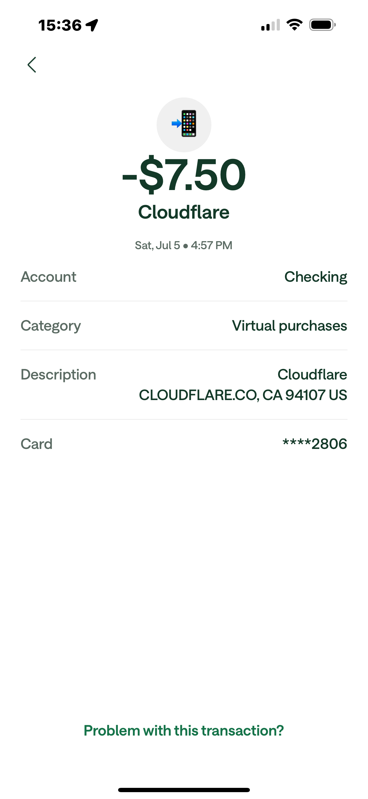

Jim Gore  
 J.Gore61@icloud.com  
  
 Sent from my iPhone