Intro

Game scope – covers ‘age of muskets’ roughly between 1660 and 1870

Battle of Blenheim 1704
Waterloo 1815
Gettysburg 1863

Historical Battles
Custom battles
Campaigns e.g. Napoleonic, American Civil war
Grand Campaign – play as one nation 1660 – 1870

Strategic Level

Recruit and equip armies
Research
Move on map

Tactical level – Battles

Option One

Terrain map with units
‘Real Time’
Fog of war
Commander quality
2D or 3D

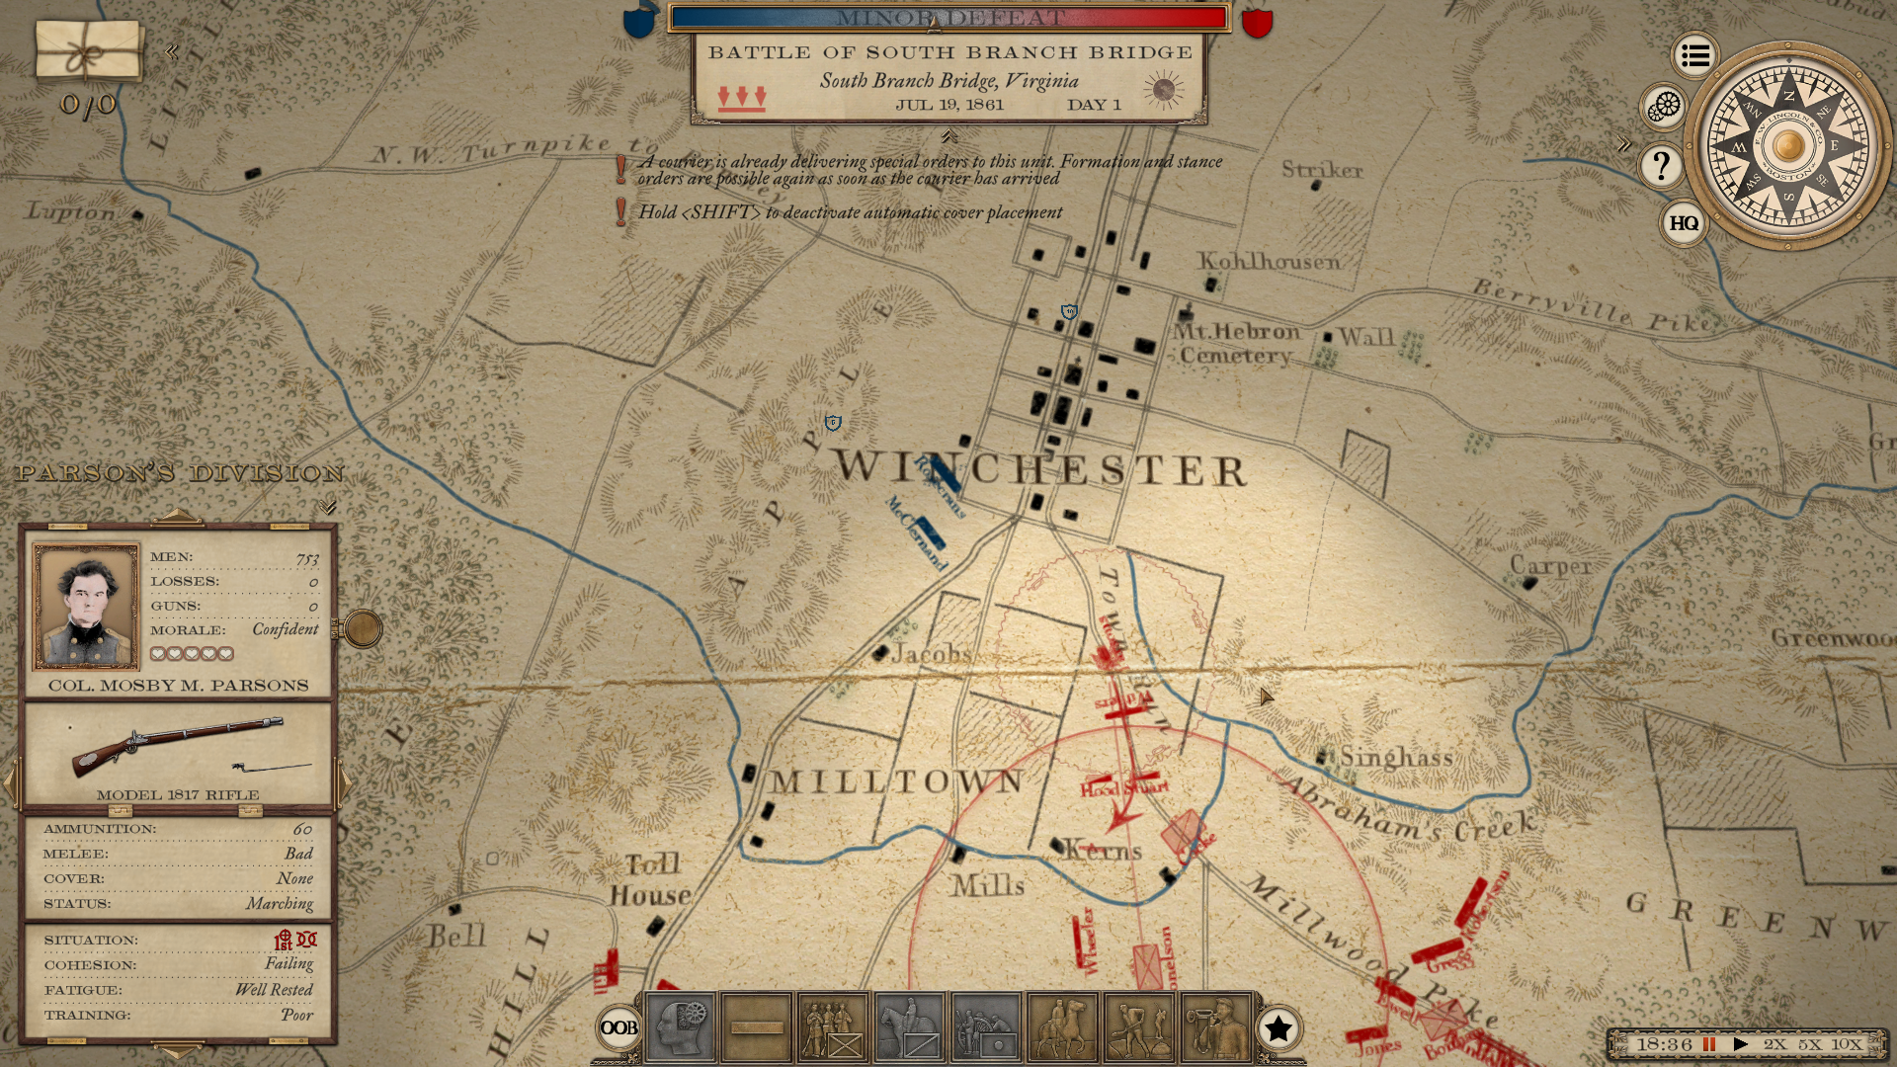

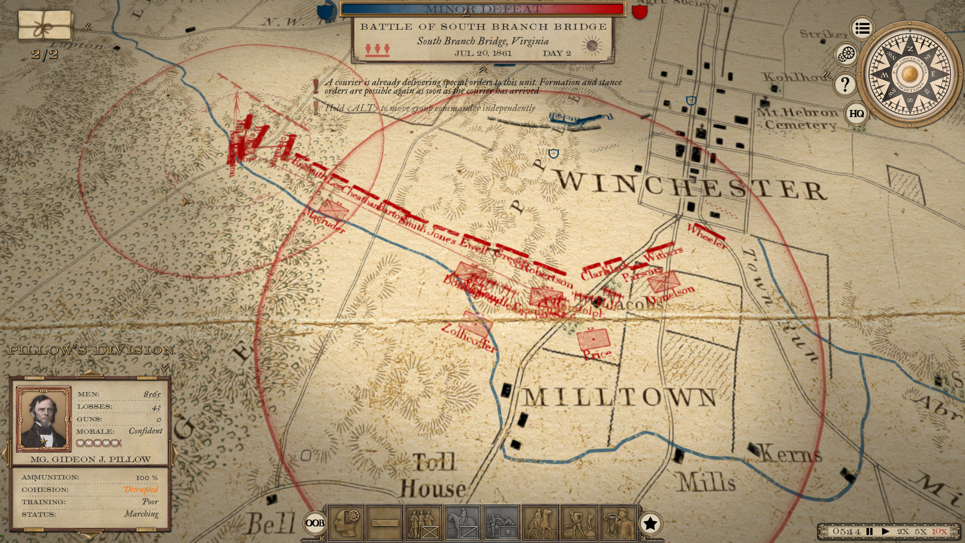

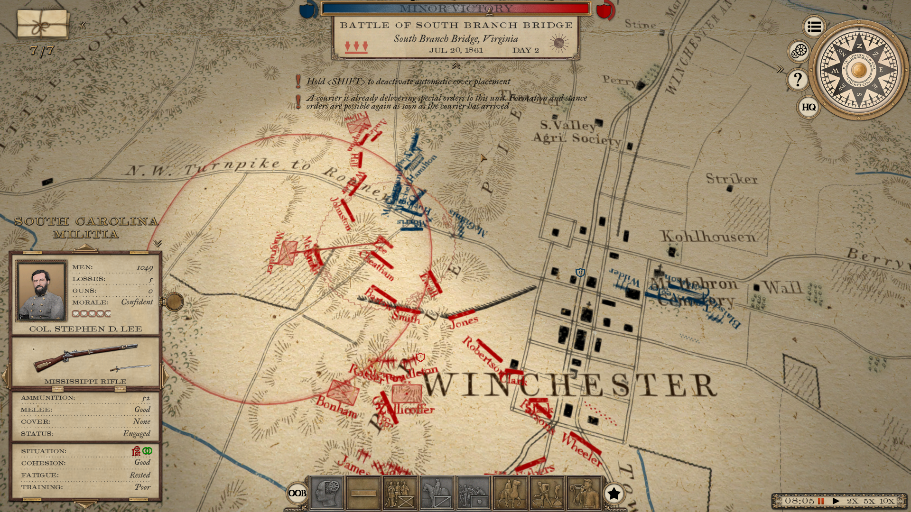

Test prototype

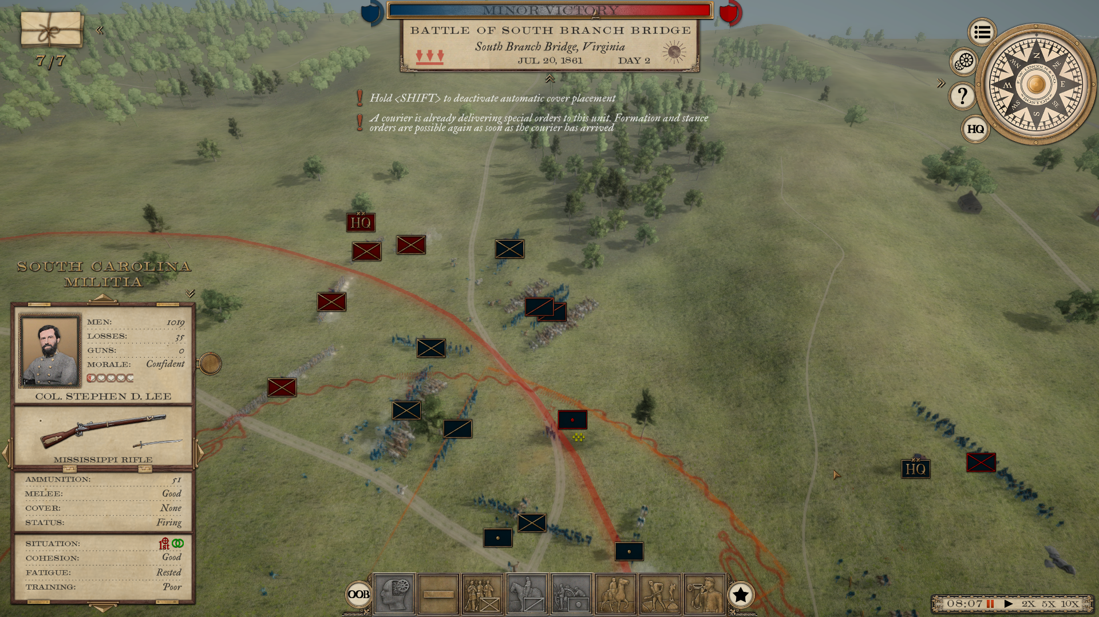
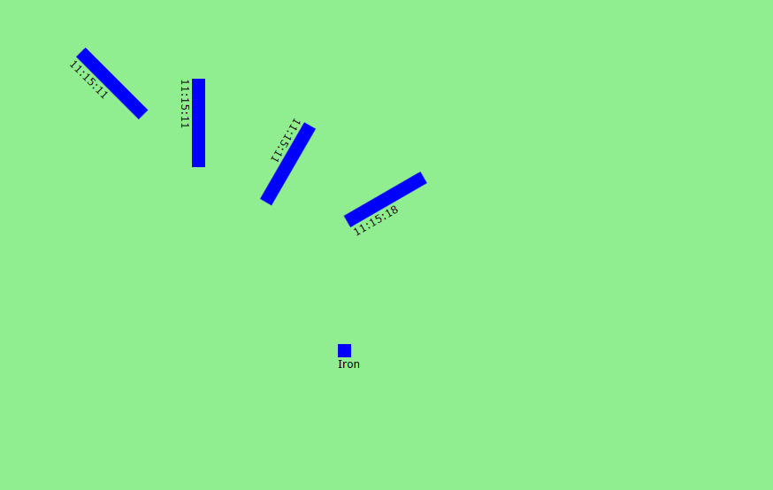
Option Two

Stylised battles

Map shows key terrain features

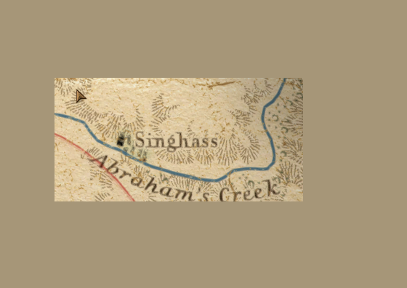
For example a hill with a river in front

Defender places forces on reach terrain piece

Attacker allocates forces to each terrain piece and gives orders;

‘Attack with your Division Singhass hill at 3PM’

‘Support the attack on the hill’

‘Flank to the left of Singhass hill’

Turn based player gets reports on how the battle is going.

Easier to program BUT boring ???
Historical Research

http://www.napolun.com/mirror/napoleonistyka.atspace.com/French_infantry.html

Battalions (aka Regiments)

Brigades

Divisions

Corps

Armies

Infantry battalion
- staff
staff of battalion - 1 grenadier company (80-90 men) - 8 fusilier companies (120 men each) French Battalion of line infantry 1805-1808: staff of battalion - 1 grenadier company (80-90 men) - 1 voltigeur company (120 men) - 7 fusilier companies (120 men each) French Battalion of line infantry 1808-1815: staff of battalion - 1 grenadier company (140 men) - 1 voltigeur company (140 men) - 4 fusilier companies (140 men each) Each French line and light regiment had: staff, 2-6 "war" battalions and 1 "depot" battalion. Pruissia Grenadier battalion had 805 men: . . . . . . 18 officers (and 4 surgeons) . . . . . . 56 NCOs . . . . . . 12 drummers and 8 fifers . . . . . . 8 sappers . . . . . . 600 grenadiers and 40 reserves [1] . . . . . . 40 Schutzen with 1 bugler . . . . . . 18 gunners (incl. 1 NCO) Fusilier battalion had 690 men: . . . . . . 19 officers (and 4 surgeons) . . . . . . 48 NCOs . . . . . . 5 drummers and 7 buglers . . . . . . 8 sappers . . . . . . 520 fusiliers and 40 reserves [1] . . . . . . 40 Schützen with 1 bugler. Each of the 120 musketier battalions had 830 men: . . . . . . 22 officers (and 5 surgeons) . . . . . . 60 NCOs . . . . . . 15 drummers (and 6 oboye players for the I Battalion) . . . . . . 10 sappers . . . . . . 600 musketiers and 50 reserves [1] . . . . . . 50 Schützen with 1 bugler. . . . . . . 18 gunners (incl. 1 NCO)

Rate of fire

Smoothbore musket e.g. Brown Bess

A properly trained group of regular infantry soldiers was able to load and fire four rounds per minute.
A crack infantry company could load and fire five rounds in a minute.

Fire rate

Elite 5
Veteran 4
Regular 3
Green 2
Untrained 1

Trials

Despite the inaccuracies of the smoothbore musket, studies were made by various nations in the 18th and 19th centuries to determine the effectiveness of a body of musketeers against the enemy.
At the trials a group of musketeers would aim and shoot at a target the size of a battalion or company and count the number of hits at one or more known ranges. Also there were trials to determine
how many volleys could be delivered over a given length of time. Prussian trials in 1810 found that a musketeer could deliver 2 to 2-1/2 rounds per minute, which is comparable to the British rate of fire.
However, the Prussian trials also showed that there was a lot of variability in the reloading rate

Percentage of musket ball hits on a fixed target

Target Type
Range (yd.) Infantry Cavalry
100 75.0% 83.3%
200 37.5% 50.0%
300 33.3% 37.5%

Another experiment described by Mueller (1811) involved the use of aiming versus no aiming. Infantrymen in the aiming group were encouraged to aim their muskets as hunters would instead of just pointing it roughly ahead and pulling the trigger. Each group fired 1,000 rounds against a cavalry target. The results of this experiment are shown below:

Range (yd.) Aimed shots Unaimed shots
100 53.4% 40.3%
200 31.8% 18.3%
300 23.4% 14.9%
400 13.0% 6.5%

These results demonstrate that aimed fire is significantly better than unaimed fire, even for a smoothbore musket, especially more significant at longer ranges.
This indicates that skirmishers using aimed fire from long range can actually cause significant casualties. However, skirmishers also tend to shoot less often than formed volley shooters,
roughly canceling out the increased benefit of aiming. British infantry of the Napoleonic Wars were taught to aim their volleys. Aimed fire and the excellent British reload training would
explain the factors contributing to the renowned British, superior fire discipline

Range (yd.) Percentage of hits
100 75%
200 42%
300 16%
400 4.5%

Actual Battlefield Results

At the Battle of Blenheim (1704) the British with five battalions attacked the French fortified positions along a front of 750 yds. The French had approximately 4,000 fusiliers deployed along 900 yds.
The French opened fire at 30 yards with a single devastating volley causing 33 percent casualties to the British attacking force.
This came to approximately 800 casualties. Therefore 20 percent of the French rounds were effective. If we assume that 15 percent of the French muskets misfired, this gives an effective rate of 23 to 24 percent of those muskets that actually fired.

At the Battle of Fontenoy (1745) five British battalions with a total strength of 2,500 men, less a few hundred men due to French artillery fire, let loose a volley at 30 yards
against an attacking force of five French battalions. The British volley caused 600 casualties to the French. This would mean that the British muskets were hitting with an effective rate of 25 percent.

At the Battle of Minden (1759) Hughes estimates that the effectiveness of musketry by both British and French was less than two percent per volley. In this battle the French and British engaged at much longer ranges, 100 to 150 yards. At the Battle of Albuera (1811) a French divisional column attacked the British position. The British muskets averaged a two-percent effectiveness rating at that battle at a range of 100 to 150 yards. However, at the same battle on the French left flank, the average effectiveness was about 5-1/2 percent per volley for both sides. Hughes concluded that at Albuera the actual effectiveness dropped off rapidly with range between 30 and 200 yards. He also stated that smoke on the battlefield often obscured the aim of the shooters, which would lower the effectiveness dramatically. Hughes also concluded that the infantry of the first half of the 18th century are better trained than those of the later 18th and early 19th centuries. If true, then one would expect higher musket effectiveness for the earlier period.

Based on the above historical incidences, wargame rules should take incorporate a range attenuation factor. Range attenuation simulates the effectiveness of the smoothbore musket in battle.
The first volley bonus has already been discussed. However, the effectiveness of infantry musketry is also affected by training, discipline, morale, and local conditions (smoke, cover, etc.).

At the Battle of the Plains of Abraham, in 1759, when British and colonial troops broke the power of France in North America, outside Quebec, this was how it was done.
The British force had landed in boats and scaled the bluffs up to the Plains of Abraham under cover of darkness. At dawn their 4,500 troops were drawn up in a line, two ranks deep and 1 km long, facing the walls of Quebec.
The French defenders also had about 4,500 men, but they had more militia and Native allies, and fewer Regulars than the British.
The French advanced towards the British lines from Quebec, and started firing from about 120 meters out. The British stood (and fell) silent in their ranks until the French had approached to 40 meters. Then they fired their rolling volleys, which stopped the French advance in its tracks and then sent them hurtling backwards.

Tactics

Volley Fire

The volley fire technique transformed soldiers carrying firearms into organized firing squads with each row of soldiers firing in turn and reloading in a systematic fashion.

Countermarch (Salvo fire ??)

This complex battlefield maneuver consisted of lining up three files of soldiers five ranks deep to shoot and then yield their place at the front to those who had been behind them and then to load again and continue in order to maintain a steady rate of fire

Attack column

In the 19th century, a new tactic was devised by the French during the French Revolutionary Wars. This was the colonne d'attaque, or attack column, consisting of one regiment up to two brigades of infantry. Instead of advancing slowly all across the battlefield in line formations, the French infantry were brought forward in such columns, preceded by masses of skirmishers to cover and mask their advance. The column would then normally deploy into line right before engaging the enemy with either fire or bayonet. This allowed the French Revolutionary and Napoleonic infantry a much greater degree of mobility compared to their Ancien Régime opponents, and also allowed much closer cooperation of infantry with cavalry and artillery, which were free to move in between the infantry columns of the former rather than being trapped in between the linear formation of the latter. The 'colonne d'attaque' was henceforth adopted by all European armies during and after the Napoleonic Wars. While some British historians, such as Sir Charles Oman, have postulated that it was the standard French tactic to charge enemy lines of infantry head on with their columns, relying on the morale effect of the huge column, and hence were often beaten off by the devastating firepower of the redcoats, more current research into the subject has revealed that such occasions were far from the norm, and that the French normally tried deploying into lines before combat as well.[51]

RANGE

For example, combat ranges of 300 yards were achievable using the rifled muskets of the American Civil War.[59]

Tests conducted by various European armies in the 18th c. make this much very clear. The Prussian M-1782 had a 60% hit rate on a target 10 ft long x 6 ft tall at 80 yards. The Charleville was slightly better; the Brown Bess somewhat worse. But these results were under ideal conditions: calm, rested, well-fed soldiers aiming at large targets of known size and range which didn’t return fire. In practice, anywhere from 10–33% of trigger-pulls ended in a misfire, usually due to damp conditions, sloppy loading or because the flints in the soldiers’ locks were dulled from constant firing, thereby producing insufficient sparks to ignite the priming charge. Throw in poor visibility due to smoke, fidgety hands, lack of sleep, dysentery, lack of sufficient calories, and other factors, and commanders reckoned that in combat their men achieved something more like a 10% hit rate overall.

During the Peninsular Campaign, the British estimated that it took 450 rounds to kill a Frenchman;

Laurema (1956) states that at the end of the eighteenth century 15 percent of musket shots misfired even in dry conditions

Gunpowder leaves a residue after igniting inside the chamber of a musket. This residue continues to accumulate during the heat of battle. This increases the reload time and increases the chance for a misfire. Also flints are brittle and can break, requiring replacement. During a battle a battalion will tend to increase its reload time and deliver less shot as the fouling increases over time. Therefore the most effective volley will be the initial volley and the early subsequent volleys. Some wargame rules give a bonus for the first time a unit shoots. Depending on the time scale of the ruleset, this is a valid factor.

The use of skirmishers during the period of the smoothbore musket to harass the enemy was not uncommon. Typically the skirmishers used the same weapon as the formed troops. Though shots at longer distances were inaccurate, an aimed shot at 50 yards could hit an intended, individual target.

Range of Engagement

Bodies of musketeers generally engaged in firefights at ranges of 100 yards. However, in the early period, it was not unusual to engage at longer ranges.
During the 18th century, it was not unusual to fire an initial volley at ranges of less than 50 yards. Firefights between opposing lines of infantry tended to last no more than 15 minutes.
At the end of this time one side or the other would give way due to morale loss. Wargame rules that use a first volley bonus cause a tendency amongst the players to withhold their fire until within the most effective range. This tends to simulate actual tactics of the period.

Clauswitz (http://old.scotwars.com/equip_smoothbore_musketry.htm)

Clauswitz was a general in the Prussian army during the Napoleonic Wars. After those wars he wrote a famous treatise on warfare, "Clauswitz on War."
One of his observations was that a body of troops can engage an enemy of frontage up to 50% of its own. Both sides would suffer the same casualty rate.
His reasoning was that the smaller frontage unit would present less of a target area. The larger unit would present a greater target area, allowing more hits by the smaller unit.
His premise was that one should deploy less troops on the line and hold back the rest in reserve.
I have never seen a set of rules (other than my own) that takes into account the frontage of the target in the casualty calculations.

Most battalions engaged in firefight at a range of 100 yards. A battalion's front was about 200 yards. Based on these one can infer the approximate scatter angle for a smoothbore musket is about 22-1/2 degrees. Another corollary for wargame rules is that a unit firing at a larger target gets a "to hit" bonus that is roughly equal to 50% for a target(s) covered within its full arc of fire.

Further Improvements

After the Napoleonic Wars, the next major innovation for the smoothbore musket was the invention of the percussion cap. The percussion cap eliminated the use of the flint. This invention further reduced misfires due to the flint failing. It also improved reliability in high winds, because there was no need for a firing pan with loose powder. It also decreased the reload time. Percussion muskets were also known as caplocks.

The caplock smoothbore musket was the ultimate weapon before the invention of the rifled musket. The invention of the greased patch and the rifling of the musket barrel in the 1850s ended the span of four centuries of the domination of the smoothbore musket in warfare.

Conclusions

The smoothbore musket was a firearm that dominated the battlefield from the 16th until 19th centuries. Wargame rules writers should look carefully at historical data to account for certain factors that influenced tactics on the battlefield. There is certainly hard evidence to give British Napoleonic infantry bonuses for their fire discipline due to greater rate of fire and aimed shooting. There is also evidence both from observation and mathematical analysis to support a bonus for shooting at a larger frontage target. Depending on the time scale of the ruleset, a bonus for the initial volley is appropriate. The first volley bonus tends to cause players to withhold the fire of their battalions until within effective range. However, the general effectiveness of musket fire is about 3 to 5 percent at ranges of 100 to 200 yards, which is far less than the theoretical maximum.

http://www.willegal.net/iron_brigade/musket.pdf

IDEAS FOR GAMERS
Since I am a wargamer, I will throw out some gaming type suggestions.
1) Fire should not be allowed at ranges above 150 yards.
2) A standard musket should have a fairly flat function of decreasing power out to 150 yards at
which point it should be considered ineffective.
2) Deductions may be made for troops with type 1 muskets that are only 50 to 60 percent as effective as the standard.
3) Deductions may be made at close range only, for troops with type 6 muskets.
4) You may consider a deduction for firing at troops over 100 yards away and on a lower elevation.

Strategic

Weekly (monthly turnss)

Political pressure - builds up over time - forces leaders to mount offensives

Provinces (land and sea, economic power, population, supply generation)

Ports - each province has a port capacity - supply, repair constuction

Links between provinces (distance, logistics, road, rail)

Borders between province (coast, mountain, plains etc) affects how units fight

Fronts - active passive - forces assigned to a border, strategic posture (attack defend)

Convoys bewteen ports

Offensives/operations take time to prepare - allows enemy time to detect the plan, larger forces take longer to prepare

Land offensives - launched against a border, success depends on forces, terrain, logistics, leadership, weather

Naval operations - launched from port - convoy raid, destroyer sweep, invasion, fleet battles, - success is based on speed (can you intercept the raiders in time) and forces commited

Population of england 1801–2019
Year Pop. ±%
1801 8,287,907 —
1811 9,405,342 +13.5%
1821 11,178,050 +18.8%
1831 12,976,329 +16.1%
1841 14,847,888 +14.4%
1851 16,738,495 +12.7%
1861 18,753,390 +12.0%
1871 21,361,235 +13.9%
1881 24,397,385 +14.2%
1891 27,231,229 +11.6%
1901 30,072,180 +10.4%
1911 33,561,235 +11.6%
1921 35,230,225 +5.0%

population of Britain

Year Foreign born Total population

1851 100,000 17,900,000 520,000 0.6
1861 150,000 20,100,000 600,000 0.7
1871 200,000 22,700,000 565,000 0.9
1881 275,000 26,000,000 560,000 1.1
1891 350,000 29,000,000 460,000 1.2
1901 475,000 32,500,000 425,000 1.5
1911 900,000 32,500,000 375,000 2.5
1921 750,000 37,900,000 365,000 2

France Historical population
Year Pop. ±%
1806 29,107,000 —
1821 30,462,000 +4.7%
1831 32,569,000 +6.9%
1841 34,230,000 +5.1%
1851 35,783,000 +4.5%
1872 36,103,000 +0.9%
1881 37,672,000 +4.3%
1891 38,343,000 +1.8%
1901 38,962,000 +1.6%
1911 39,605,000 +1.7%
1921 39,108,000 −1.3%
1931 41,524,000 +6.2%

Germany Historical population
Year Pop. ±%
1500 9,200,000 —
1550 12,900,000 +40.2%
1600 16,200,000 +25.6%
1650 10,000,000 −38.3%
1700 14,100,000 +41.0%
1750 17,400,000 +23.4%
1800 21,600,000 +24.1%
1850 33,700,000 +56.0%
1870 39,500,000 +17.2%
1900 55,200,000 +39.7%
1910 63,500,000 +15.0%
1920 62,400,000 −1.7%

Next Steps

Pick a smallish battle - order of battle
Pick a map style

Weapon Accuracy% at Close Order Infantry
Weapon Name | Year | 50 | 100 | 200 | 300 | 500 | 750 | 1000
Smoothbore Flintlock | 1700 | 25 | 12 | 6 | 3
Brown Bess
Enfield 1854

Target Type
Range (yd.) Infantry Cavalry
100 75.0% 83.3%
200 37.5% 50.0%
300 33.3% 37.5%
However, the general effectiveness of musket fire is about 3 to 5 percent at ranges of 100 to 200 yards
Most battalions engaged in firefight at a range of 100 yards
During the 18th century, it was not unusual to fire an initial volley at ranges of less than 50 yards. Firefights between opposing lines of infantry tended to last no more than 15 minutes.
Range (yd.) Aimed shots Unaimed shots
100 53.4% 40.3%
200 31.8% 18.3%
300 23.4% 14.9%
400 13.0% 6.5%
Range (yd.) Percentage of hits
100 75%
200 42%
300 16%
400 4.5%

Waterloo 1815
145000 infantry British guards division 4266, 1st Brigade 1628, battalions about 800-1000 ish Infantry Division 8000 3 brigades e,.g. 2274 2087 3315 4 battalions 630 - 490

145000 all but 8000 were smoothbore muskets, 25 shots each, 3.5 million, casualties 54000 casulalties 60 % artillery swords etc, 40% muskets 162 muskets shots per injury
aimed fire 80 yards accurate, 150 inaccurate
7 out of 10 at close range < 100 yards
La haye saint 800 defenders

From a smooth-bore musket, from 42% to 48% of bullets hit the target at a distance of 200 yards. At a distance of 300 yards, 18% of the bullets hit the target. For a rifle, the results were much better. From a rifle, 46% to 58% of bullets hit the target at a distance of 300 yards; 24% to 42% at 500 yards.[8] This potential accuracy, however, required skills only acquired through advanced training and practice; a rifle-musket in the hands of a raw recruit would not have performed very much better than a smoothbore. Nevertheless, the musket was still a formidable force on the battlefield. At the beginning of the American Civil War, some infantry regiments chose to keep smooth-bore muskets, preferring them because they could shoot "buck and ball".[9]

References

https://www.historynet.com/weaponry-the-rifle-musket-and-the-mini-ball/?f

https://www.forbes5.pitt.edu/article/production-muskets-and-their-effects-eighteenth-century
https://www.battlefields.org/learn/articles/small-arms-across-three-wars#:~:text=Most%20muskets%20were%20lethal%20up,was%20used%20in%20each%20shot.

