1. Download GitHub Desktop at: <https://desktop.github.com/>
2. Install it. When installed, the app will ask you to sign into your GitHub account. If you are new to GitHub, create your account.
3. Click Authorize GitHub Desktop button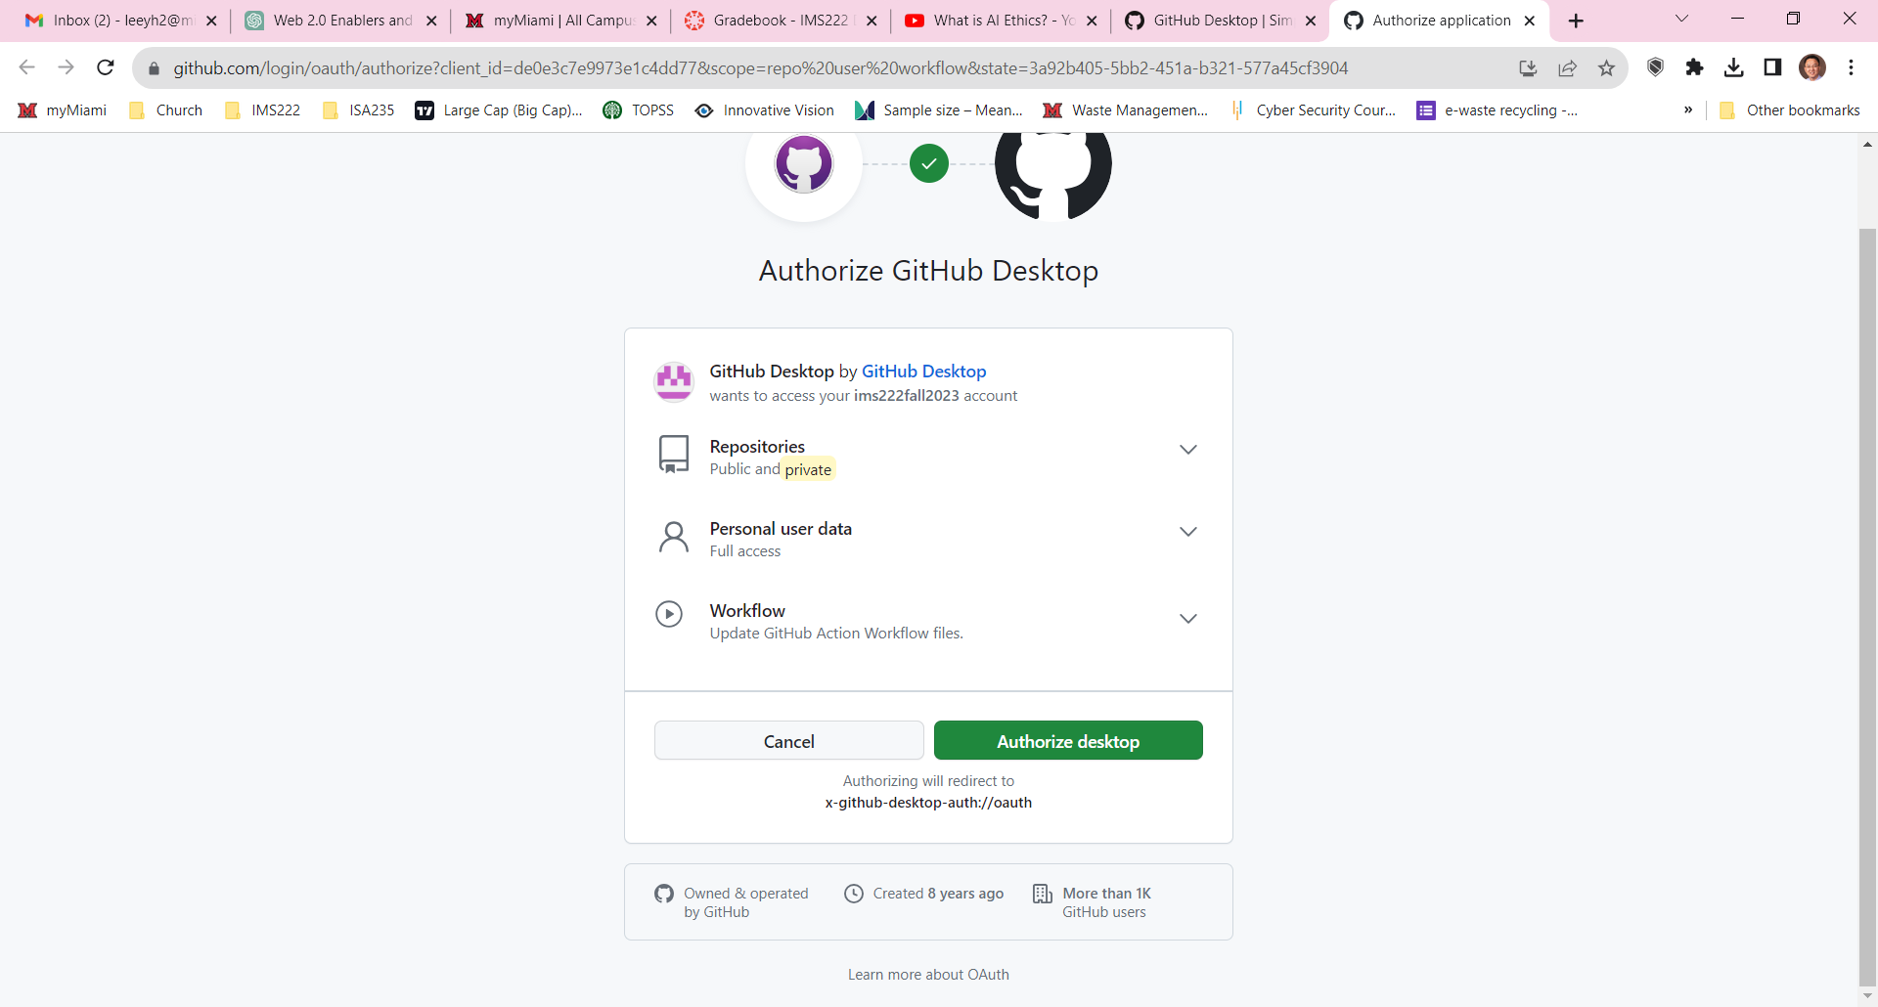
4. then Config Git and click Finish

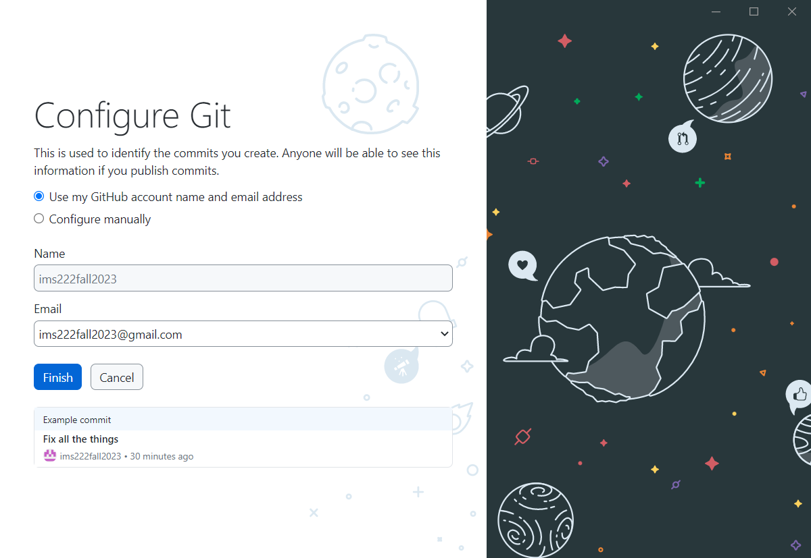

1. A screenshot of a computer

   Description automatically generatedFirst look at the Desktop app (without active repository)
2. Click Create a New Repository on Your Hard Drive option and fill out the form. You can either find an existing repository or clone a repository from the Internet (including your own repository)

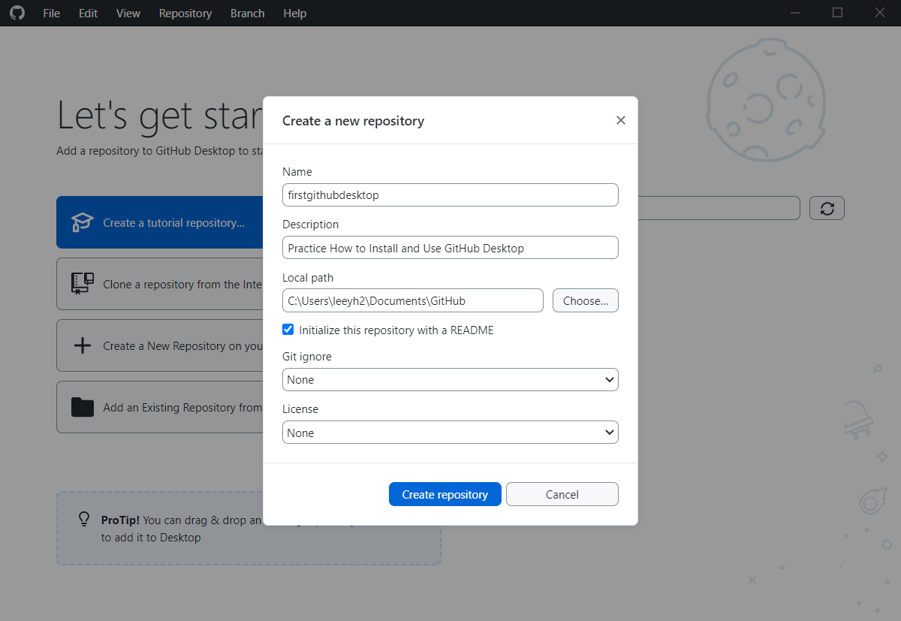

1. A screenshot of a computer

   Description automatically generatedA look at the GitHub Desktop interface:
2. When working with your local repository: work in your IDE of choice. Files are available offline on your computer, meaning you can work anytime from your computer.
3. Navigate the desktop interface.

Repository

Branch

1. Change history

Commit, push/pull, fetch origin.

Commit box: summary title

and description, as well as

commit branch

Push: Push the new commit

to the repository

Fetch: Check for new

updates online

Pull: Get new commit from

repository online

Hands-on Activity:

1. Download and setup GitHub Desktop (following the steps above)
2. Log in to your account and create a new local repository.

1. Download GHDemo.zip from this week’s Module.
2. Put and unzip the demo inside the local repository.
3. Play around with the Repository:
4. Initial Commit: Commit the repository and push to your GitHub

* Name the commit: “init commit”, write some descriptions in the box

1. Working on the Repository:

* Open up *index.html* file using Bracket
* Add a new table into <body>, under the comment:



<table>

<tr>

<td>Hello</td>

<td>World</td>

</tr>

<tr>

<td>Welcome</td>

<td>Friend</td>

</tr>

</table>

* Check your GitHub Desktop, make a commit, and push to online repository.

1. Pulling online repository from computer

* A screenshot of a computer

  Description automatically generatedGetting a new repository:

Since we created our repository offline, it is stored in the list already. However, to create the offline repository from an existing online repository:

* Go to your GitHub website, find your repository

+ A quick way to do this is by navigating the *Repository* tab. There are several functions (and keyboard shortcuts) you can use. Here, we use *View on GitHub* to directly access the repository online (might require signing in to GitHub website again)

* On GitHub website, press the period button [.] to open web editor.

The editor is a version of Visual Studio, but you don’t need to install Visual Studio (any version) on your computer to function.

* Edit the *index.html* file, add a new list under the comment:



<ul>

<li>Earth</li>

<li>Mars</li>

<li>World</li>

</ul>

* On the left-hand side, type in a message (commit title) and press *Commit & Push.*
* You have committed some changes outside of your local offline repository (controlled by GitHub Desktop). Open GitHub Desktop:

+ Changes might not be detected automatically. Press *Fetch Origin* and wait until the button changes to *Pull Origin* (detect new commit on the same branch in the same repository):

* Now the new changes made online have been updated into your local repository. This doesn’t only include changes you made online, but also any commits made by your teammates.

NOTE: GitHub Desktop is an excellent tool for working in the local environment (offline, using your local IDE), but it lacks many functionalities available on [github.com](https://github.com/)

For other functionalities including website hosting, reviewing commits and pull requests, use the website. Otherwise, to work on the files, you can utilize GitHub Desktop.