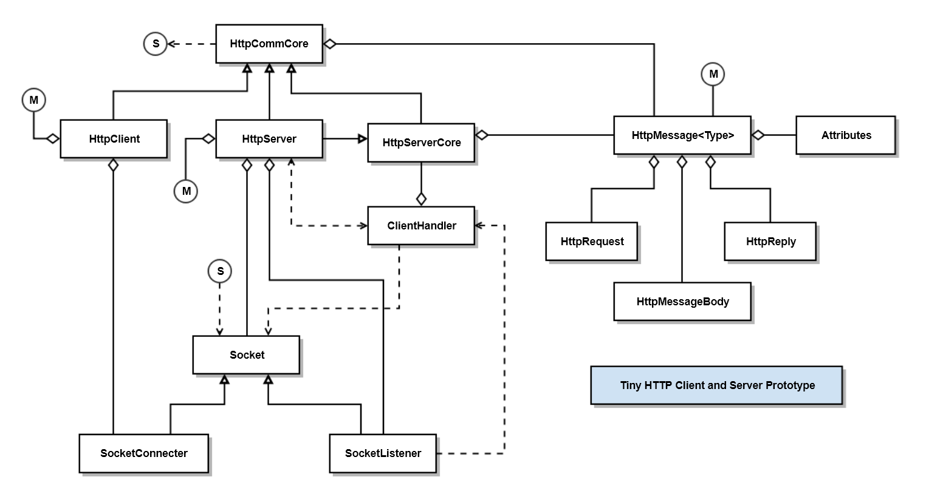

|  |  |
| --- | --- |
| Class | Responsibility |
| HttpCommCore | Implements core HTTP Communication functionality |
| HttpClient | Sends HttpMessage<HttpRequest> and receives HttpMessage<HttpRely> messages. |
| HttpServer | Listens for HttpMessage<HttpRequest> messages and sends HttpMessage<HttpReply> reply messages. |
| HttpMessage<Type> | Creates and parses HttpMessage<Type> instances, where Type is either HttpRequest or HttpReply. |
| HttpRequest | Manages command line for request messages, e.g., GET, PUT, POST, DELETE, or HEAD |
| HttpReply | Manages command line for reply messages, e.g., status and status text. |
| HttpMessageBody | Reads and writes an ordered collection of bytes. |
| Attributes | A map of key:value string pairs |
| Socket | Used by ClientHandler thread to communicate with client |
| SocketConnecter | Used by client to connect to SocketListener -> Socket |
| SocketListener | Used by server to listen for connections and return connection as Socket. |