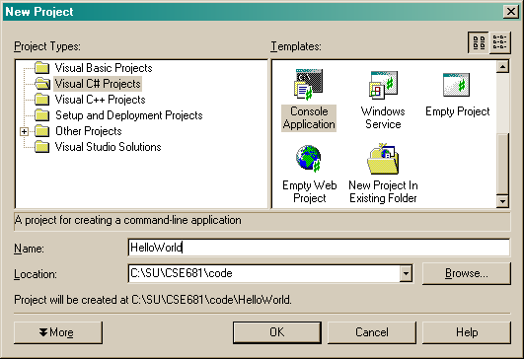
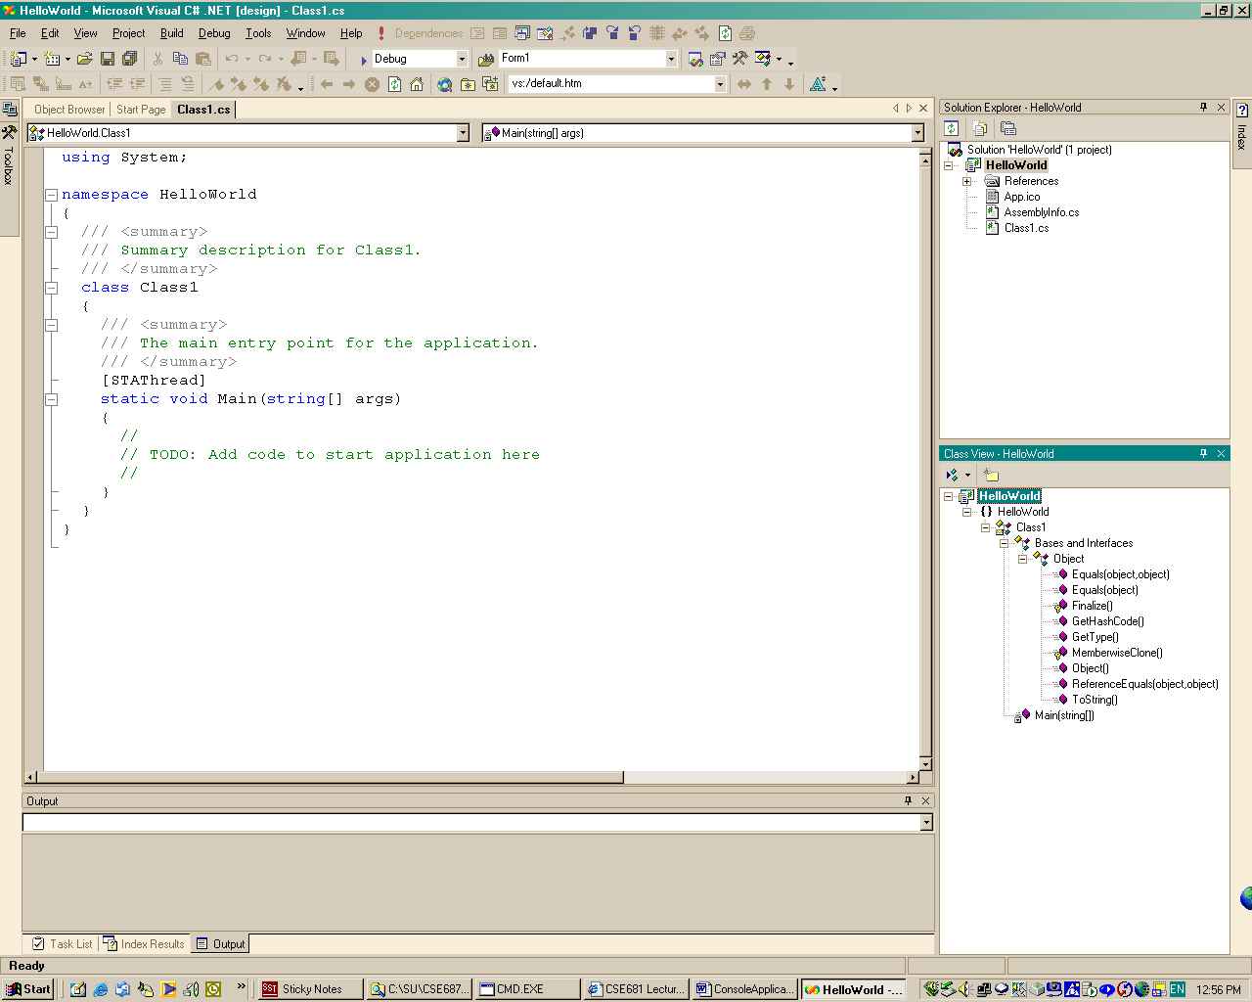
Will rename file to Hello.cs, with right click and rename.
Will rename class to Chello with right click and editing name in property sheet.
These funny looking comments are for a webpage document. I will delete them to give a clearer view of the code.
Solution view shows all the files in your project.
Class view shows the classes in your project and their base classes.
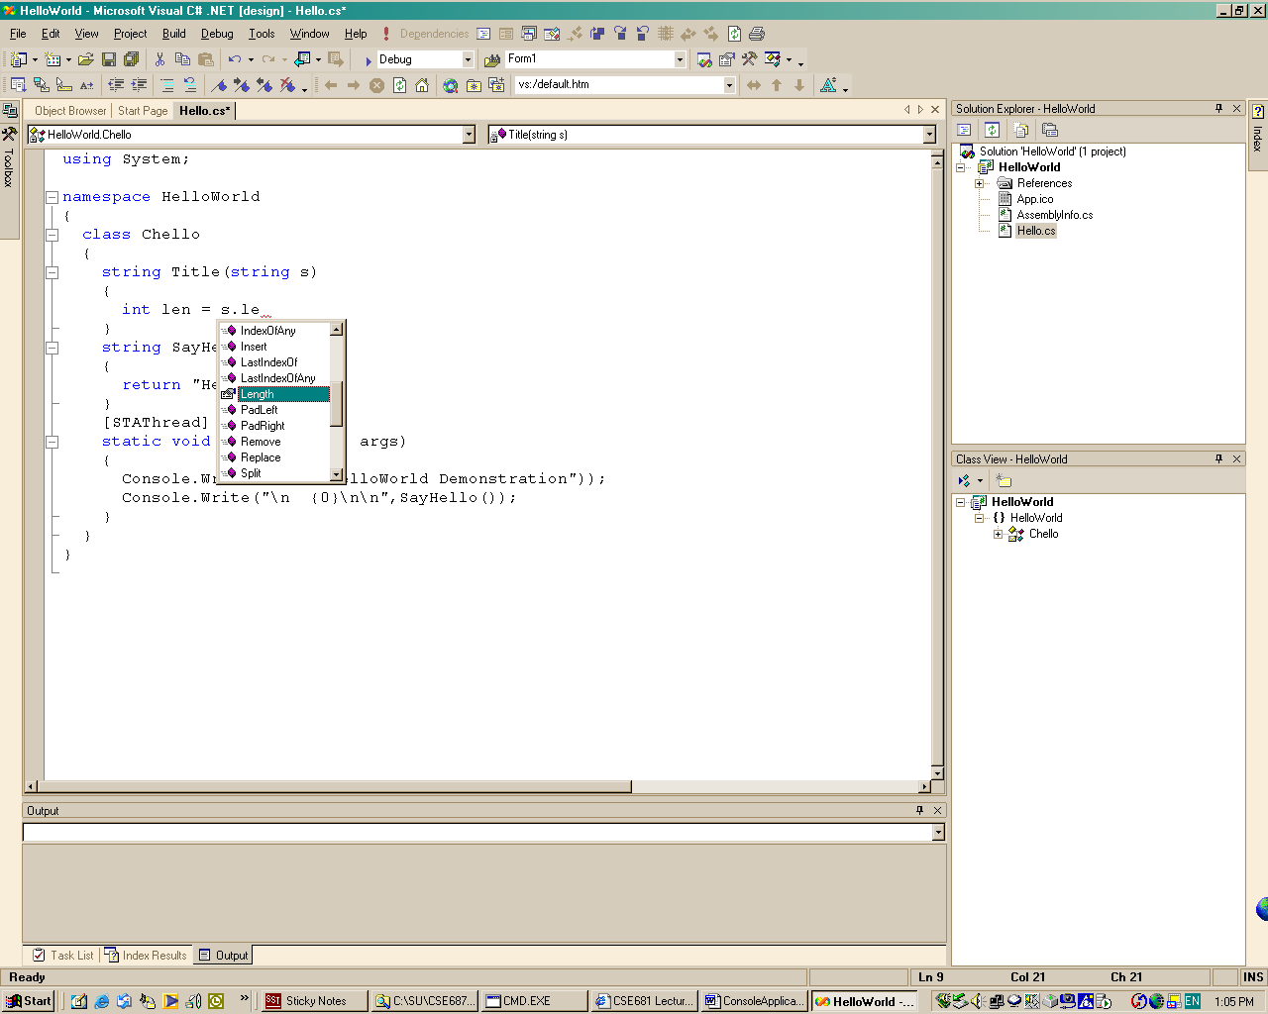
Intellisense is providing completions that are a great aid in learning the .Net libraries..
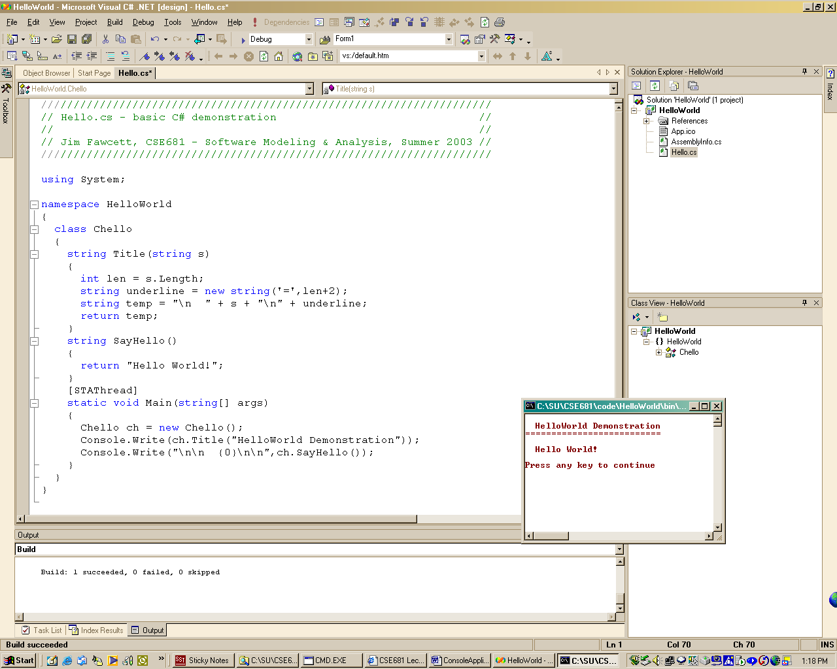
There are no global functions or data in C#. Every function is a static or non-static member of a class, even Main()!
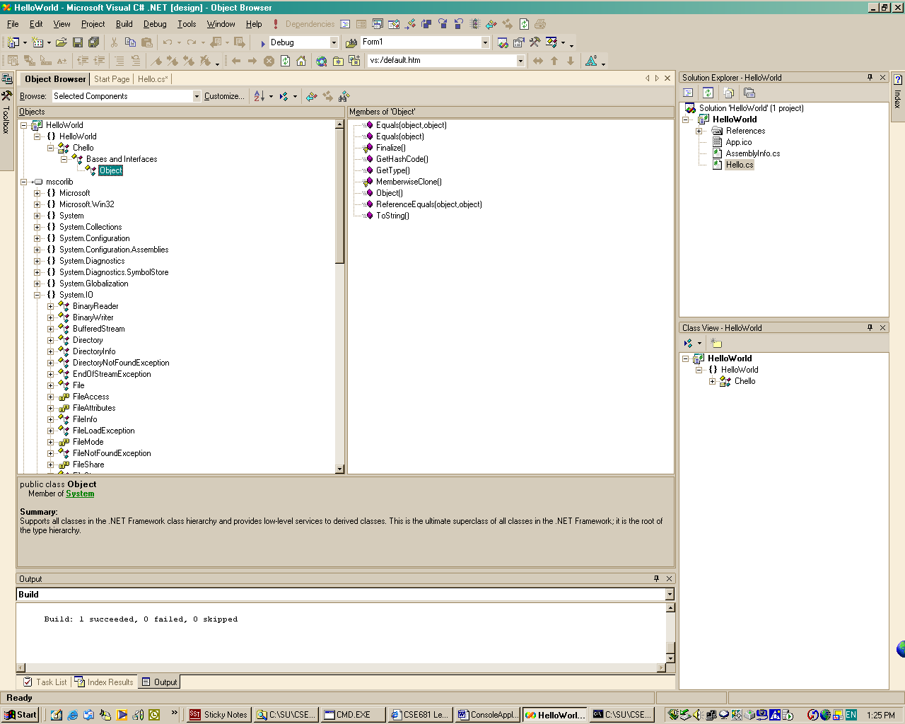
The Object Browser is a terrific learning tool.
It is easy to explore the .Net libraries to learn about classes like file.
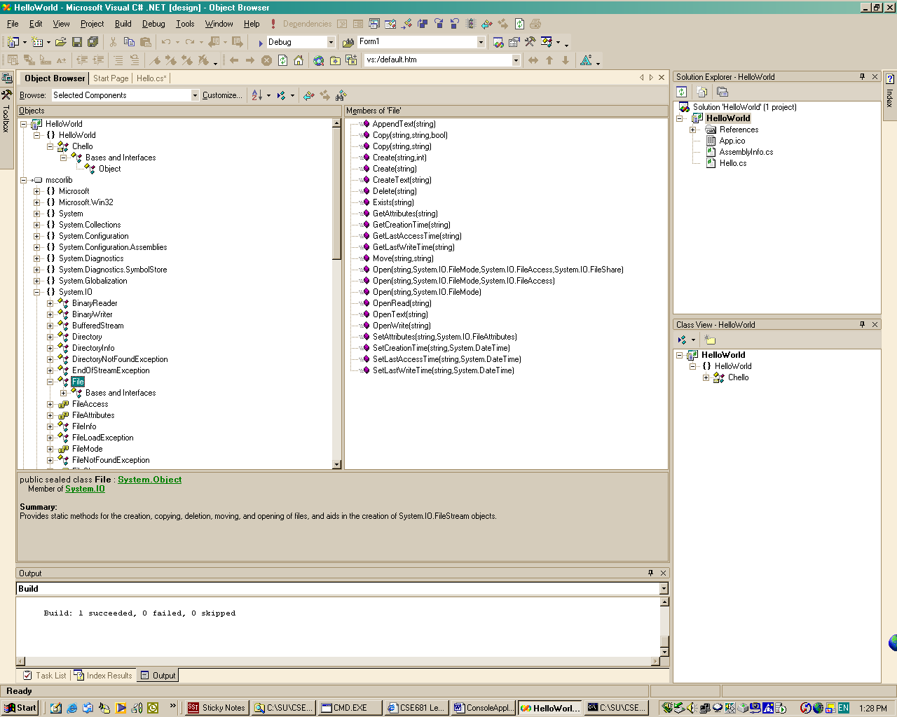
Here, I’ve selected file and we see all its members.
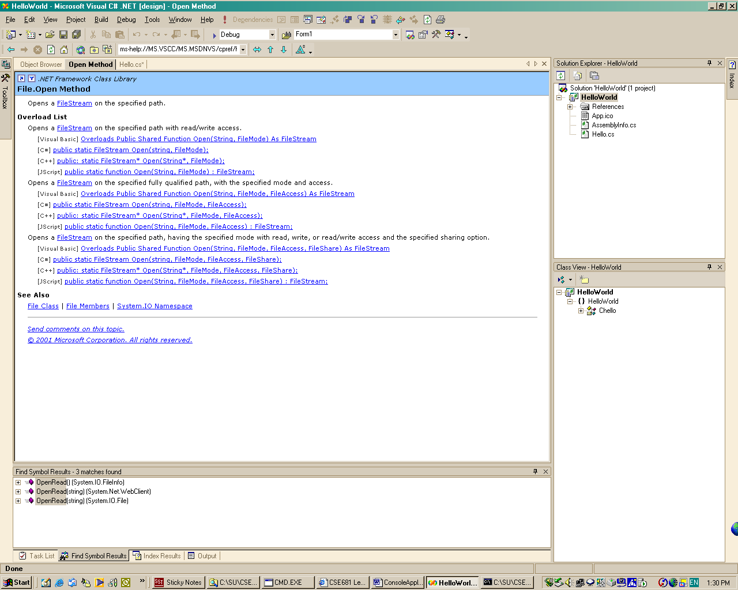
I selected the File.open method, and hit F1 key. That gets us to the appropriate help page.

