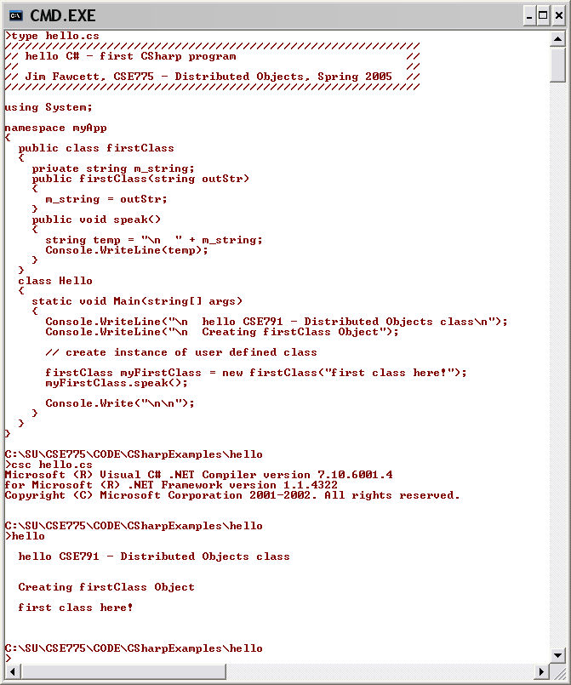
All methods have to be defined inline, like this.
IO is rather Pascal-like.

