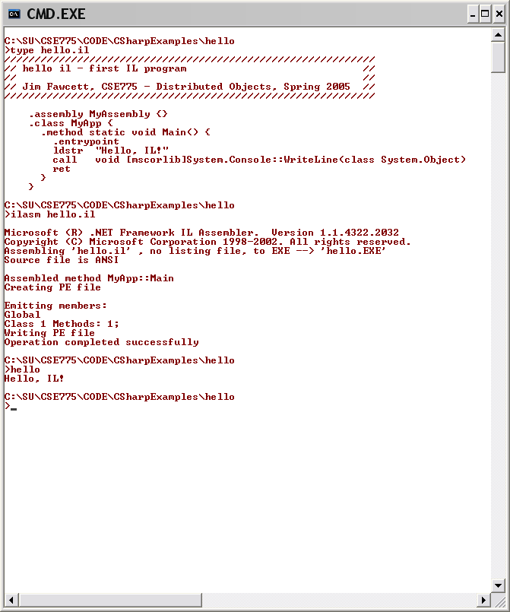
Loads literal string onto top of evaluation stack
Syntax is to state function signature.
Call takes arguments from evaluation stack

