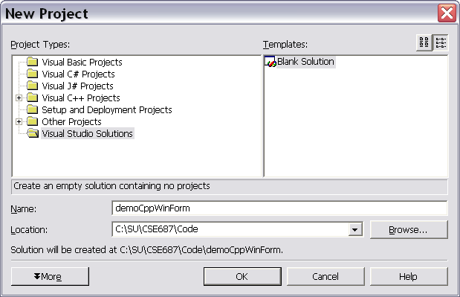

Create a blank solution in the directory of your choice.
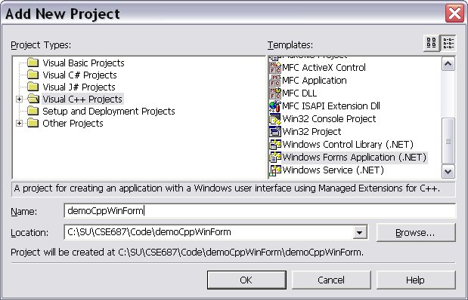

Create a Forms Application Project with C++ Selected in the left pane.
That opens a resource editor showing a new form and you have access
to the toolbox to drag controls onto the form. Now you’re ready for business.
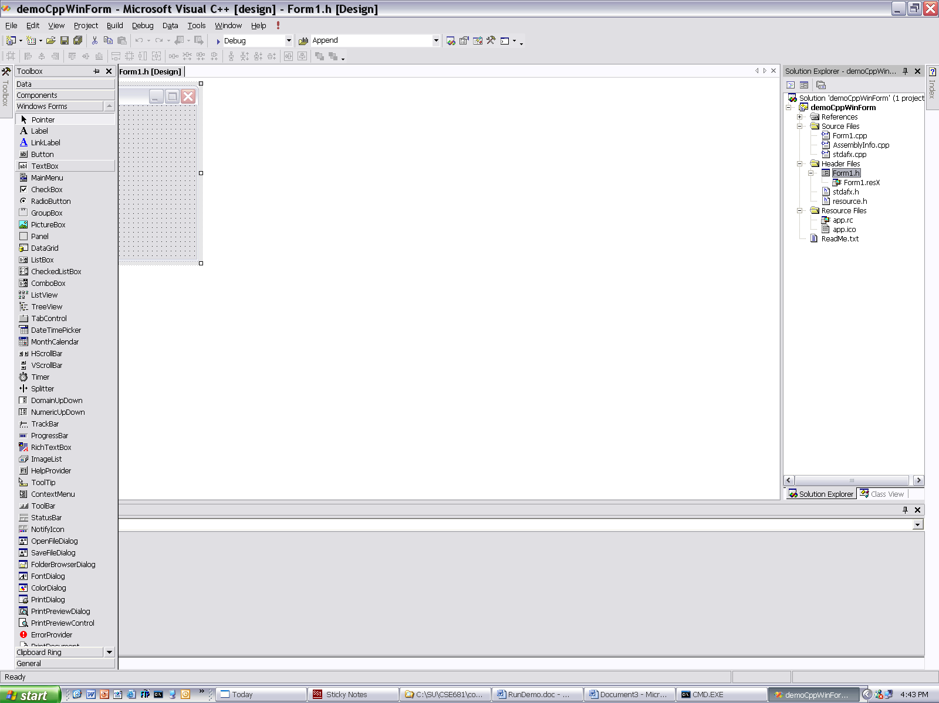
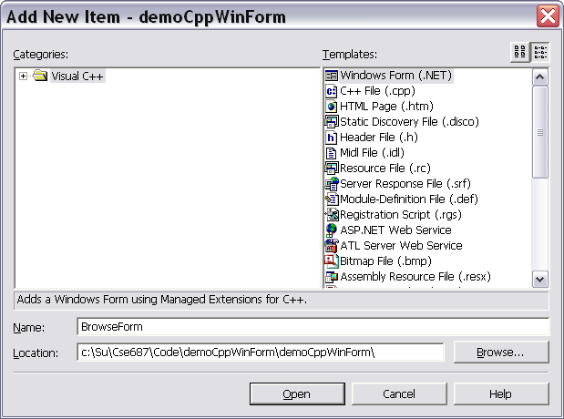
Now we’re going to add another form, used to browse for a folder on some drive.
After that we will copy a control, derived form TreeView, and written in C#, to use
with this C++ application. Amazingly, that works! We’ll pull the control onto our browse
form and start wiring it up.
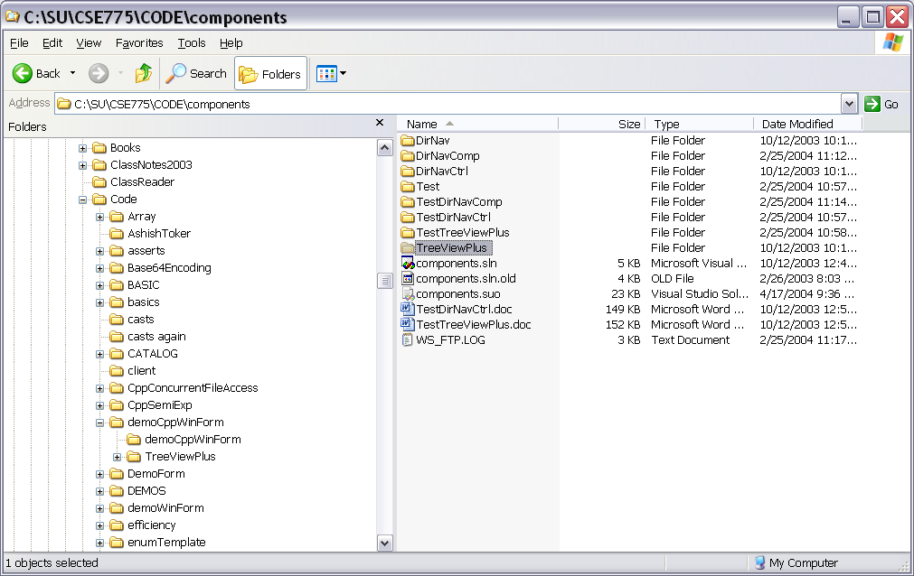
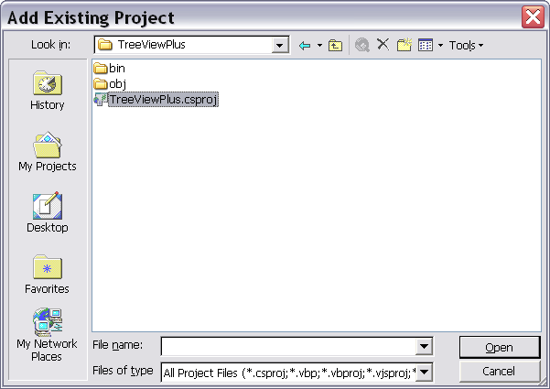

We just copied the control project from another solution to our solution. Now, here’s where we
add the control to our solution. First add the control to the toolbox by right clicking on the components
tab and selecting Add/Remove. You see the resulting dialog below. Just click the browse button and
navigate to the folder containing the control’s dll (in debug directory of the control folder). Double
clicking will add the control to the toolbox; and now you can pull it onto your browse form.
