<https://rcplanes.online/index5.htm>

**Aerodynamics**

* **Stability Concepts**  
    
  The aircraft's response to momentary disturbance is associated with its  
  inherent degree of stability built in by the designer, in each of the three axes,  
  and occurring without any reaction from the pilot.  
    
  There is another condition affecting flight, which is the aircraft's state of trim  
  or equilibrium (where the net sum of all forces equals zero).  
  Some aircraft can be trimmed by the pilot to fly 'hands off' for straight and  
  level flight, for climb or for descent.  
    
  Free flight models generally have to rely on the state of trim built in by the  
  designer and adjusted by the rigger, while the remote controlled models have  
  some form of trim devices which are adjustable during the flight.  
    
  An aircraft's stability is expressed in relation to each axis:  
  **lateral stability** (stability in roll), **directional stability** (stability in yaw)  
  and **longitudinal stability**(stability in pitch).  
  Lateral and directional stabilities are inter-dependent.  
    
  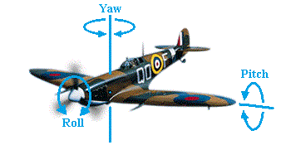  
    
  Stability may be defined as follows:  
  - Positive stability: tends to return to original condition after a disturbance.  
  - Negative stability: tends to increase the disturbance.  
  - Neutral stability: remains at the new condition.  
    
  - **Static stability**: refers to the aircraft's **initial** response to a disturbance.  
  A statically unstable aircraft will uniformly depart from a condition of equilibrium.  
    
  - **Dynamic stability**: refers to the aircraft's ability to damp out oscillations, which  
    depends on how fast or how slow it responds to a disturbance.  
  A dynamically unstable aircraft will (after a disturbance) start oscillating with  
  increasing amplitude.  
  A dynamically neutrally stable aircraft will continue oscillating after a disturbance  
  but the amplitude of the oscillations will not change.  
    
  So, a statically stable aircraft may be dynamically unstable.  
  Dynamic instability may be prevented by an even distribution of weight inside the  
  fuselage, avoiding too much weight concentration at the extremities or at the [**CG**](https://rcplanes.online/index5.htm#CG).  
  Also, control surfaces' max throws may affect the flight stability, since a too much  
  control throw may cause instability, e.g. Pilot Induced Oscillations (PIO).  
    
  Static stability is proportional to the stabilizer area and the tail moment.  
  You get double static stability if you double the tail area or double the tail moment.  
  Dynamic stability is also proportional to the stabilizer area but increases with the  
  square of the tail moment, which means that you get four times the dynamic stability  
  if you double the tail arm length.  
    
  However, making the tail arm longer or encreasing the stabilizer area will move  
  the mass of the aircraft towards the rear, which may also mean the need to make  
  the nose longer in order to minimize the weight required to balance the aircraft...  
    
  A totally stable aircraft will return, more or less immediately, to its trimmed state  
  without pilot intervention.  
  However, such an aircraft is rare and not much desirable. We usually want an  
  aircraft just to be reasonably stable so it is easy to fly.  
  If it is too stable, it tends to be sluggish in manoeuvring, exhibiting too slow  
  response on the controls.  
    
  Too much instability is also an undesirable characteristic, except where an  
  extremely manoeuvrable aircraft is needed and the instability can be continually  
  corrected by on-board 'fly-by-wire' computers rather than the pilot, such as a  
  supersonic air superiority fighter.  
    
  **Lateral stability** is achieved through dihedral, sweepback, keel effect and  
  proper distribution of weight.  
  The dihedral angle is the angle that each wing makes with the horizontal (see  
  Wing Geometry).  
  If a disturbance causes one wing to drop, the lower wing will receive more lift  
  and the aircraft will roll back into the horizontal level.  
    
  A sweptback wing is one in which the leading edge slopes backward.  
  When a disturbance causes an aircraft with sweepback to slip or drop a wing,  
  the low wing presents its leading edge at an angle more perpendicular to the  
  relative airflow. As a result, the low wing acquires more lift and rises, restoring  
  the aircraft to its original flight attitude.  
    
  The keel effect occurs with high wing aircraft. These are laterally stable simply  
  because the wings are attached in a high position on the fuselage, making the  
  fuselage behave like a keel.  
  When the aircraft is disturbed and one wing dips, the fuselage weight acts like  
  a pendulum returning the aircraft to the horizontal level.  
    
  The tail fin determines the **directional stability**.  
  If a gust of wind strikes the aircraft from the right it will be in a slip and the fin  
  will get an angle of attack causing the aircraft to yaw until the slip is eliminated.  
    
    
  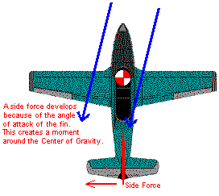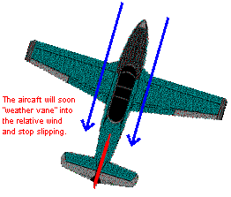  
    
  **Longitudinal stability** depends on the location of the center of gravity, the  
  stabilizer area and how far the stabilizer is placed from the main wing.  
  Most aircraft would be completely unstable without the horizontal stabilizer.  
    
  Non-symmetrical cambered airfoils have a higher lift coefficient, but they also  
  have a negative pitching moment (Cm) tending to pitch nose-down, and thus  
  being statically unstable, which requires the counter moment produced by the  
  horizontal stabilizer to get adequate longitudinal stability.  
  The stabilizer provides the same function in longitudinal stability as the fin does  
  in directional stability.  
    
  Symmetrical (zero camber) airfoils have normally a zero pitching moment,  
  resulting in neutral stability, which means the aircraft goes wherever you point it.  
  Reflexed airfoils (with trailing edge bent up) have a positive pitching moment  
  making them naturally stable, they are often used with flying wings (without the  
  horizontal stabilizer).  
    
  It is of crucial importance that the aircraft's **Center of Gravity (CG)** is located  
  at the right point, so that a stable and controllable flight can be achieved.  
  This is the point about which an aircraft would balance if suspended on it.  
  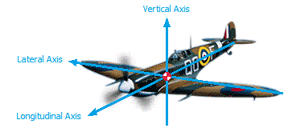  
  However, during the field or bench Balance Point control, the Center of Gravity  
  is usually checked only along its Longitudinal Axis (nose to tail), disregarding  
  both the Lateral and the Vertical Axis locations.  
    
  In order to achieve a good longitudinal stability, the CG should be ahead of the  
  **Neutral Point (NP)**, which is the Aerodynamic Center of the whole aircraft.  
  NP is the position through which all the net lift increments act for a change in  
  angle of attack.  
  The major contributors are the main wing, stabilizer surfaces and fuselage.  
    
  The bigger the stabilizer area in relationship to the wing area and the longer  
  the tail moment arm relative to the wing chord, the farther aft the NP will be and  
  the farther aft the CG may be, provided it's kept ahead of the NP for stability.  
    
  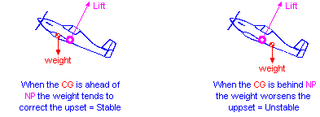  
    
  The angle of the fuselage to the direction of flight affects its drag, but has little  
  effect on the pitch trim unless both the projected area of the fuselage and its  
  angle to the direction of flight are quite large.  
    
  A **tail-heavy** aircraft will be more unstable and susceptible to stall at low speed  
  e. g. during the landing approach.  
  A **nose-heavy** aircraft will be more difficult to takeoff from the ground and to  
  gain altitude and will tend to drop its nose when the throttle is reduced. It also  
  requires higher speed in order to land safely.  
    
  The angle between the wing chord line and the stabilizer chord line is called  
  the **Longitudinal Dihedral (LD)** or decalage.  
  For a given center of gravity, there is a LD angle that results in a certain  
  trimmed flight speed and pitch attitude.  
  If the LD angle is increased the plane will take on a more nose up pitch attitude,  
  whereas with a decreased LD angle the plane will take on a more nose down  
  pitch attitude.  
  There is also the **Angle of Incidence**, which is the angle of a flying surface  
  related to a common reference line drawn by the designer along the fuselage.  
  The designer might want this reference line to be level when the plane is flying  
  at level flight or when the fuselage is in it's lowest drag position.  
  The purpose of the reference line is to make it easier to set up the relationships  
  among the thrust, the wing and the stabilizer incidence angles.  
  Thus, the Longitudinal Dihedral and the Angle of Incidence are interdependent.  
    
  Longitudinal stability is also improved if the stabilizer is situated so that it lies  
  outside the influence of the main wing downwash.  
  Stabilizers are therefore often staggered and mounted at a different height in  
  order to improve their stabilising effectiveness.  
    
  It has been found both experimentally and theoretically that, if the aerodynamic  
  force is applied at a location 1/4 from the leading edge of a rectangular wing  
  at subsonic speed, the magnitude of the aerodynamic moment remains nearly  
  constant even when the angle of attack changes.  
  This location is called the wing's **Aerodynamic Center AC**.  
  (At supersonic speed, the aerodynamic center is near 1/2 of the chord).  
    
  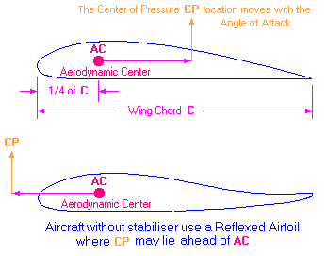  
    
  In order to obtain a good Longitudinal Stability the **Center of Gravity CG**  
  should be close to the main wings' **Aerodynamic Center AC**.  
  For wings with other than rectangular form (such as triangular, trapezoidal,  
  compound, etc.) we have to find the **Mean Aerodynamic Chord - MAC**,  
  which is the average for the whole wing.  
  The MAC calculation requires rather complicated mathematics, so a simpler  
  method called 'Geometric Mean Chord' GMC or 'Standard Mean Chord' SMC  
  may be used as shown on the drawings below.  
  MAC is only slightly bigger than GMC except for sharply tapered wings.  
  Taper ratio = tip chord/root chord.  
    
  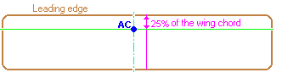  
  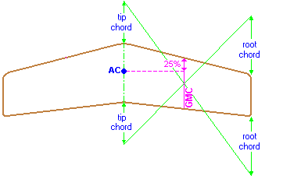  
  To calculate MAC of a tapered wing, the following simplified equation  
  may be used:  
  MAC = root chord \* 2/3 \* ((1+T+T2)/(1+T))  
  Where T is the wing's taper ratio.  
    
  The MAC distance from the center line may be calculated as follows:  
  distance = half span \* (1+2\*T)/(3+3\*T)  
    
  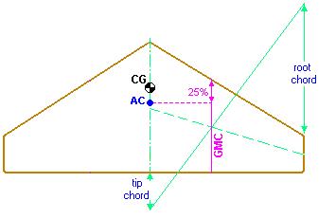  
  For a delta wing the **CG** should be located 10% ahead of the geometrically  
  calculated **AC** point as shown above.  
  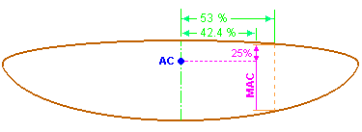  
  The MAC of an elliptical wing is 85% of the root chord and is located at 42.4% of  
  the half wingspan from the root chord.  
  Elliptical wing's area = pi \* wingspan \* root chord/4  
    
  The **AC** location for biplanes with positive stagger (top wing ahead of the bottom  
  wing), is found according to the drawing below.  
  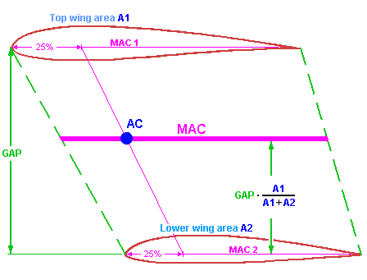  
  For conventional designs (with main wing and horizontal stab) the **CG** location  
  range is usually between 28% and 33% from the leading edge of the main  
  wing's MAC, which means between about 5% and 15% ahead of the aircraft's  
  Neutral Point **NP**.  
  This is called the **Static Margin**, which is expressed as a percentage of MAC.  
  When the static margin is zero (CG coincident with NP) the aircraft is considered  
  "neutrally stable".  
  However, for conventional designs the static margin should be between 5% and  
  15% of the MAC ahead of the NP.  
    
  The CG location as described above is pretty close to the wing's Aerodynamic  
  Center AC because the lift due to the horizontal stab has only a slightly effect on  
  the conventional R/C models.  
    
  However, those figures may vary with other designs, as the NP location depends  
  on the size of the main wing vs. the stab size and the distance between the main  
  wing's AC and the stab's AC.  
  The simplest way of locating the aircraft's NP is by using the areas of the two  
  horizontal lifting surfaces (main wing and stab) and locate the NP proportionately  
  along the distance between the main wing's AC point and the stab's AC point.  
  For example, the NP distance to the main wing's AC point would be:  
  D = L **·** (stab area) / (main wing area + stab area) as shown on the picture below:  
  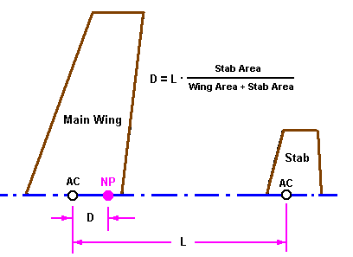  
    
  There are other factors, however, that make the simple formula above inaccurate.  
  In case the two wings have different aspect ratios (different dCL/d-alpha) the NP  
  will be closer to the one that has higher aspect ratio.  
  Also, since the stab operates in disturbed air, the NP will be more forward than  
  the simple formula predicts.  
    
  The figure below shows a somewhat more complex formula to locate the NP but  
  would give a more accurate result using the so called Tail Volume Ratio, **Vbar**.  
  This formula gives the NP position as a percentage (%) of the wing's MAC aft of  
  the wing's AC point.  
    
  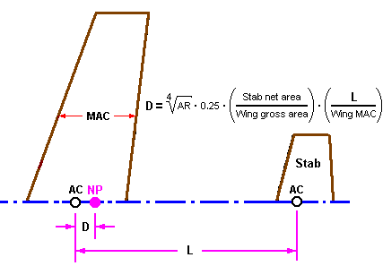  
    
  For those who are not so keen on formulas and calculations there is the  
  [Aircraft Center of Gravity Calculator](https://rcplanes.online/cg_calc.htm" \t "_blank), which automatically calculates the CG  
  location as well as other usuful parameters based on the formula above.  
    
  For Canards:  
  [Canard Center of Gravity Calculator](https://rcplanes.online/cg_canard.htm)  
    
  For Flying Wings:  
  [Flying Wing CG Calculator](https://rcplanes.online/cg_wing.htm)

Values for Stabilizer Efficiency (E) Dropdown

<select name="E">

<option value=".85">Std.</option>

<option value=".95">T-tail</option>

<option value=".65">Low</option>

# Single Panel Wing JS Calculations:

<SCRIPT language=JavaScript1.1>

function compute(obj) {

var CALC="T"

var A=obj.A.value;

var B=obj.B.value;

var S=obj.S.value;

var Y=obj.Y.value;

var CG1=obj.CG1.value;

var AA=obj.AA.value;

var BB=obj.BB.value;

var SS=obj.SS.value;

var YY=obj.YY.value;

var D=obj.D.value;

var E=obj.E.value;

if (A==""){alert("Invalid value for Wing Root Chord (A)");CALC="F"}

if (AA==""){alert("Invalid value for Tail Root Cord (AA)");CALC="F"}

if (B==""){alert("Invalid value for Wing Tip Chord (B)");CALC="F"}

if (BB==""){alert("Invalid value for Tail Tip Chord (BB)");CALC="F"}

if (Y==""){alert("Invalid vlaue for Wing Half Span (Y)");CALC="F"}

if (YY==""){alert("Invalid vlaue for Tail Half Span (YY)");CALC="F"}

if (S==""){alert("Invalid value for Wing Sweep Distance (S). Enter 0 to indicate a straight leading edge.");CALC="F"}

if (SS==""){alert("Invalid value for Tail Sweep Distance (SS). Enter 0 to indicate a straight leading edge.");CALC="F"}

if (CG1==""){alert("Invalid value for Static Margin. Enter a safe value between 5 and 15.");CALC="F"}

if (D==""){alert("Invalid value for Distance between Wing and Tail LE's (D)");CALC="F"}

if (CALC=="T")

{

<!-- Wing sweep distance at MAC-->

W1 = (S\*(eval(A)+2\*eval(B))) / (3\*(eval(A)+eval(B)));

obj.result1.value = Math.round(100\*(W1))/100;

<!-- Wing MAC -->

W2 = (eval(A) - ((2\*(eval(A)-eval(B)) \* (.5\*eval(A)+eval(B))) / (3\*(eval(A)+eval(B)))));

obj.result2.value = Math.round(100\*(W2))/100;

<!-- Wing MAC distance d-->

//W3 = eval(Y) \* ((eval(A) - W2) / (eval(A) - eval(B)));

W3 = eval(Y)/3 \* (1 + 2\*eval(B)/eval(A))/(1 + eval(B)/eval(A));

obj.result3.value = Math.round(100\*(W3))/100;

<!-- Wing AC distance from LD-->

W4 = (0.25 \* W2) + W1;

obj.result4.value = Math.round(100 \* W4) / 100;

<!-- Tail sweep distance -->

T1 = (SS\*(eval(AA)+2\*eval(BB))) / (3\*(eval(AA)+eval(BB)));

//-- Tail MAC -->

T2 = (eval(AA) - ((2\*(eval(AA)-eval(BB)) \* (.5\*eval(AA)+eval(BB))) / (3\*(eval(AA)+eval(BB)))));

//-- Tail AC -->

T3 = (0.25\*T2)+T1;

<!-- Neutral Point -->

D2 = (eval(D) - W4) + T3;

Area1 = (eval(Y)\*eval(A)+eval(Y)\*eval(B));

Area2 = (eval(YY)\*eval(AA)+eval(YY)\*eval(BB));

Area = Area2 / Area1;

AR = Math.pow((eval(Y)\*2),2)/Area1;

ARs = Math.pow((eval(YY)\*2),2)/Area2;

As = 0.095/(1+(18.25/ARs\*0.095));

Aw = 0.11/(1+(18.25/AR\*0.11));

Vbar = Area\*(D2/W2);

N1 = (eval(E)\*Vbar\*(As/Aw)\*(1-35\*(Aw/AR))\*W2)+W4;

// N1 = (eval(E)\* Vbar\*Math.pow(AR,.25)\*.25\*W2)+W4

obj.result5.value = Math.round(100 \* N1) / 100;

<!-- CG distance from LE -->

N2 = N1 - (eval(CG1) / 100) \* W2;

obj.result6.value = Math.round(100 \* N2) / 100;

<!-- Wing Area -->

N3 = Area1;

obj.result7.value = Math.round(10 \* N3)/ 10;

<!-- Tail Area -->

N4 = Area2;

obj.result8.value = Math.round(10 \* N4)/ 10;

N5 = AR;

obj.result9.value = Math.round(100 \* N5)/ 100;

N6 = Vbar;

obj.result10.value = Math.round(100 \* N6)/ 100;

}else{

obj.result1.value = "Error"

obj.result2.value = "Error"

obj.result3.value = "Error"

obj.result4.value = "Error"

obj.result5.value = "Error"

obj.result6.value = "Error"

obj.result7.value = "Error"

obj.result8.value = "Error"

obj.result9.value = "Error"

obj.result10.value = "Error"

} } <!-- end hiding from old browsers --&amp;amp;amp;amp;gt;-->

</SCRIPT>

<script>

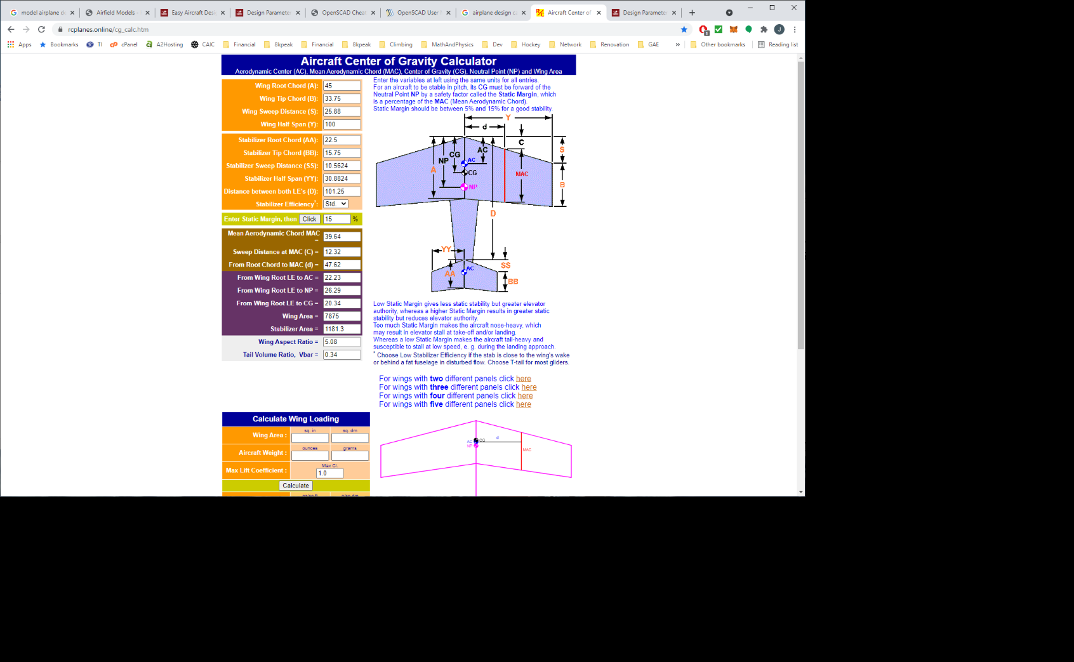

# Two Panel Wing JS Calculations:

<SCRIPT language=JavaScript1.1>

function compute(obj) {

var CALC="T"

var A=obj.A.value;

var B=obj.B.value;

var B2=obj.B2.value;

var S=obj.S.value;

var S2=obj.S2.value;

var Y=obj.Y.value;

var Y2=obj.Y2.value;

var CG1=obj.CG1.value;

var AA=obj.AA.value;

var BB=obj.BB.value;

var SS=obj.SS.value;

var YY=obj.YY.value;

var D=obj.D.value;

var E=obj.E.value;

if (A==""){alert("Invalid value for Wing Root Chord (A)");CALC="F"}

if (AA==""){alert("Invalid value for Tail Root Cord (AA)");CALC="F"}

if (B==""){alert("Invalid value for Panel Chord1 (B)");CALC="F"}

if (B2==""){alert("Invalid value for Wing Tip Chord (B2)");CALC="F"}

if (BB==""){alert("Invalid value for Tail Tip Chord (BB)");CALC="F"}

if (Y==""){alert("Invalid vlaue for Wing Panel Span1 (Y)");CALC="F"}

if (Y2==""){alert("Invalid vlaue for Wing Panel Span2 (Y2)");CALC="F"}

if (YY==""){alert("Invalid vlaue for Tail Half Span (YY)");CALC="F"}

if (S==""){alert("Invalid value for Wing Sweep Distance1 (S). Enter 0 to indicate a straight leading edge.");CALC="F"}

if (S2==""){alert("Invalid value for Wing Sweep Distance2 (S2). Enter 0 to indicate a straight leading edge.");CALC="F"}

if (SS==""){alert("Invalid value for Tail Sweep Distance (SS). Enter 0 to indicate a straight leading edge.");CALC="F"}

if (CG1==""){alert("Invalid value for Static Margin. Enter a safe value between 5 and 15.");CALC="F"}

if (D==""){alert("Invalid value for Distance between Wing and Tail LE's (D)");CALC="F"}

if (CALC=="T")

{

<!-- Wing sweep distance1 at MAC1-->

W1 = (S\*(eval(A)+2\*eval(B))) / (3\*(eval(A)+eval(B)));

<!-- Wing sweep distance2 at MAC2-->

W2 = eval(S) + ((S2-S)\*(eval(B)+2\*eval(B2))) / (3\*(eval(B)+eval(B2)));

<!-- panel areas -->

Area1 = (eval(Y)\*eval(A))+(eval(Y)\*eval(B));

Area2 = (eval(Y2)\*eval(B))+(eval(Y2)\*eval(B2));

<!-- tail area -->

Area3 = (eval(YY)\*eval(AA))+(eval(YY)\*eval(BB));

<!-- Wing MAC1 -->

W3 = (eval(A) - ((2\*(eval(A)-eval(B)) \* (.5\*eval(A)+eval(B))) / (3\*(eval(A)+eval(B)))));

<!-- Wing MAC2 -->

W4 = (eval(B) - ((2\*(eval(B)-eval(B2)) \* (.5\*eval(B)+eval(B2))) / (3\*(eval(B)+eval(B2)))));

<!-- Wing MAC -->

//W5 = (W3 - ((2\*(W3-W4) \* (.5\*W3+W4)) / (3\*(W3+W4))));

W5 = ((W3\*.5\*Area1)+(W4\*.5\*Area2))/(.5\*(Area1+Area2))

obj.result1.value = Math.round(100\*(W5))/100;

<!-- MAC1 distance d1-->

//W6 = eval(Y) \* ((eval(A) - W3) / (eval(A) - eval(B)));

W6 = eval(Y)/3 \* (1 + 2\*eval(B)/eval(A))/(1 + eval(B)/eval(A));

<!-- MAC2 distance d2-->

// W7 = eval(Y) + (eval(Y2) \* ((eval(B) - W4) / (eval(B) - eval(B2))));

W7 = eval(Y) + eval(Y2)/3 \* (1 + 2\*eval(B2)/eval(B))/(1 + eval(B2)/eval(B));

<!-- MAC distance d-->

W8 = ((.5\*Area1\*W6)+(.5\*Area2\*W7))/(.5\*(Area1+Area2));

obj.result10.value = Math.round(100\*(W8))/100;

<!-- Tail sweep distance at MAC-->

T1 = (SS\*(eval(AA)+2\*eval(BB))) / (3\*(eval(AA)+eval(BB)));

//-- Tail MAC -->

T2 = (eval(AA) - ((2\*(eval(AA)-eval(BB)) \* (.5\*eval(AA)+eval(BB))) / (3\*(eval(AA)+eval(BB)))));

//-- Tail AC -->

T3 = (.25\*T2)+T1;

<!-- Wing AC distance from LD-->

A1 = (.25\*W3)+ W1;

A2 = (.25\*W4)+ W2;

A3 = ((.5\*Area1\*A1)+(.5\*Area2\*A2))/(.5\*(Area1+Area2));

obj.result3.value = Math.round(100 \* A3) / 100;

//-- Wing sweep distance C at MAC-->

A4 = A3-(W5\*.25);

obj.result11.value = Math.round(100 \* A4) / 100;

<!-- Tail arm -->

D2 = (eval(D) - A3) + T3;

Area = Area3 / (Area2 + Area1);

AR = Math.pow(((eval(Y)+eval(Y2))\*2),2)/(Area1+Area2);

ARs = Math.pow((eval(YY) \* 2), 2) / Area3;

As = 0.095/(1+(18.25/ARs\*0.095));

Aw = 0.11/(1+(18.25/AR\*0.11));

Vbar = Area\*(D2/W5);

<!-- Neutral Point -->

N1 = (eval(E)\*Vbar\*(As/Aw)\*(1-35\*(Aw/AR))\*W5)+A3;

// N1 = (eval(E)\* Vbar\*Math.pow(AR,.25)\*.25\*W5)+A3;

obj.result4.value = Math.round(100 \* N1) / 100;

<!-- CG distance from LE -->

N2 = N1 - (eval(CG1) / 100) \* W5;

obj.result5.value = Math.round(100 \* N2) / 100;

<!-- Wing Area -->

N3 = (Area2 + Area1);

obj.result6.value = Math.round(10 \* N3)/ 10;

<!-- Tail Area -->

N4 = Area3;

obj.result7.value = Math.round(10 \* N4)/ 10;

N5 = AR;

obj.result8.value = Math.round(100 \* N5)/ 100;

N6 = Vbar;

obj.result9.value = Math.round(100 \* N6)/ 100;

}else{

obj.result1.value = "Error"

obj.result2.value = "Error"

obj.result3.value = "Error"

obj.result4.value = "Error"

obj.result5.value = "Error"

obj.result6.value = "Error"

obj.result7.value = "Error"

obj.result8.value = "Error"

obj.result9.value = "Error"

} } <!-- end hiding from old browsers --&amp;amp;amp;amp;gt;-->

</SCRIPT>

# Three Panel Wing JS Calculations:

<SCRIPT language=JavaScript1.1>

function compute(obj)

{

var CALC="T"

var A=obj.A.value;

var B=obj.B.value;

var B2=obj.B2.value;

var B3=obj.B3.value;

var S=obj.S.value;

var S2=obj.S2.value;

var S3=obj.S3.value;

var Y=obj.Y.value;

var Y2=obj.Y2.value;

var Y3=obj.Y3.value;

var CG1=obj.CG1.value;

var AA=obj.AA.value;

var BB=obj.BB.value;

var SS=obj.SS.value;

var YY=obj.YY.value;

var D=obj.D.value;

var E=obj.E.value;

if (A==""){alert("Invalid value for Wing Root Chord (A)");CALC="F"}

if (AA==""){alert("Invalid value for Tail Root Cord (AA)");CALC="F"}

if (B==""){alert("Invalid value for Panel Chord1 (B1)");CALC="F"}

if (B2==""){alert("Invalid value for Panel Chord2 (B2)");CALC="F"}

if (B3==""){alert("Invalid value for Wing Tip Chord (B3)");CALC="F"}

if (BB==""){alert("Invalid value for Tail Tip Chord (BB)");CALC="F"}

if (Y==""){alert("Invalid vlaue for Wing Panel Span1 (Y)");CALC="F"}

if (Y2==""){alert("Invalid vlaue for Wing Panel Span2 (Y2)");CALC="F"}

if (Y3==""){alert("Invalid vlaue for Wing Panel Span3 (Y3)");CALC="F"}

if (YY==""){alert("Invalid vlaue for Tail Half Span (YY)");CALC="F"}

if (S==""){alert("Invalid value for Wing Sweep Distance1 (S1). Enter 0 to indicate a straight leading edge.");CALC="F"}

if (S2==""){alert("Invalid value for Wing Sweep Distance2 (S2). Enter 0 to indicate a straight leading edge.");CALC="F"}

if (S3==""){alert("Invalid value for Wing Sweep Distance3 (S3). Enter 0 to indicate a straight leading edge.");CALC="F"}

if (SS==""){alert("Invalid value for Tail Sweep Distance (SS). Enter 0 to indicate a straight leading edge.");CALC="F"}

if (CG1==""){alert("Invalid value for Static Margin. Enter a safe value between 5 and 15.");CALC="F"}

if (D==""){alert("Invalid value for Distance between Wing and Tail LE's (D)");CALC="F"}

if (CALC=="T")

{

<!-- Wing sweep distance1 at MAC1-->

W1 = (S\*(eval(A)+2\*eval(B))) / (3\*(eval(A)+eval(B)));

<!-- Wing sweep distance2 at MAC2-->

W2 = eval(S) + ((S2-S)\*(eval(B)+2\*eval(B2))) / (3\*(eval(B)+eval(B2)));

<!-- Wing sweep distance3 at MAC3-->

W22 = eval(S2) + ((S3-S2)\*(eval(B2)+2\*eval(B3))) / (3\*(eval(B2)+eval(B3)));

<!-- panel areas -->

Area1 = (eval(Y)\*eval(A))+(eval(Y)\*eval(B));

Area2 = (eval(Y2)\*eval(B))+(eval(Y2)\*eval(B2));

Area22 = (eval(Y3)\*eval(B2))+(eval(Y3)\*eval(B3));

<!-- tail area -->

Area3 = (eval(YY)\*eval(AA))+(eval(YY)\*eval(BB));

<!-- Wing MAC1 -->

W3 = (eval(A) - ((2\*(eval(A)-eval(B)) \* (.5\*eval(A)+eval(B))) / (3\*(eval(A)+eval(B)))));

<!-- Wing MAC2 -->

W4 = (eval(B) - ((2\*(eval(B)-eval(B2)) \* (.5\*eval(B)+eval(B2))) / (3\*(eval(B)+eval(B2)))));

<!-- Wing MAC3 -->

W44 = (eval(B2) - ((2\*(eval(B2)-eval(B3)) \* (.5\*eval(B2)+eval(B3))) / (3\*(eval(B2)+eval(B3)))));

<!-- Wing MAC -->

//W5 = (W3 - ((2\*(W3-W4) \* (.5\*W3+W4)) / (3\*(W3+W4))));

W5 = ((W3\*.5\*Area1)+(W4\*.5\*Area2)+(W44\*.5\*Area22))/(.5\*(Area1+Area2+Area22))

obj.result1.value = Math.round(100\*(W5))/100;

<!-- MAC1 distance d1-->

//W6 = eval(Y) \* ((eval(A) - W3) / (eval(A) - eval(B)));

W6 = eval(Y)/3 \* (1 + 2\*eval(B)/eval(A))/(1 + eval(B)/eval(A));

<!-- MAC2 distance d2-->

// W7 = eval(Y) + (eval(Y2) \* ((eval(B) - W4) / (eval(B) - eval(B2))));

W7 = eval(Y) + eval(Y2)/3 \* (1 + 2\*eval(B2)/eval(B))/(1 + eval(B2)/eval(B));

<!-- MAC3 distance d3-->

W77 = eval(Y) + eval(Y2) + eval(Y3)/3 \* (1 + 2\*eval(B3)/eval(B2))/(1 + eval(B3)/eval(B2));

<!-- MAC distance d-->

W8 = ((.5\*Area1\*W6)+(.5\*Area2\*W7)+(.5\*Area22\*W77))/(.5\*(Area1+Area2+Area22));

obj.result10.value = Math.round(100\*(W8))/100;

<!-- Tail sweep distance at MAC-->

T1 = (SS\*(eval(AA)+2\*eval(BB))) / (3\*(eval(AA)+eval(BB)));

//-- Tail MAC -->

T2 = (eval(AA) - ((2\*(eval(AA)-eval(BB)) \* (.5\*eval(AA)+eval(BB))) / (3\*(eval(AA)+eval(BB)))));

//-- Tail AC -->

T3 = (.25\*T2)+T1;

<!-- Wing AC distance from LD-->

A1 = (.25\*W3)+ W1;

A2 = (.25\*W4)+ W2;

A22 = (.25\*W44)+ W22;

A3 = ((.5\*Area1\*A1)+(.5\*Area2\*A2)+(.5\*Area22\*A22))/(.5\*(Area1+Area2+Area22));

obj.result3.value = Math.round(100 \* A3) / 100;

//-- Wing sweep distance C at MAC-->

A4 = A3-(W5\*.25);

obj.result11.value = Math.round(100 \* A4) / 100;

<!-- Tail arm -->

D2 = (eval(D) - A3) + T3;

Area = Area3 / (Area1 + Area2 + Area22);

AR = Math.pow(((eval(Y)+eval(Y2)+eval(Y3))\*2),2)/(Area1+Area2+Area22);

ARs = Math.pow((eval(YY) \* 2), 2) / Area3;

As = 0.095/(1+(18.25/ARs\*0.095));

Aw = 0.11/(1+(18.25/AR\*0.11));

Vbar = Area\*(D2/W5);

<!-- Neutral Point -->

N1 = (eval(E)\*Vbar\*(As/Aw)\*(1-35\*(Aw/AR))\*W5)+A3;

// N1 = (eval(E)\* Vbar\*Math.pow(AR,.25)\*.25\*W5)+A3;

obj.result4.value = Math.round(100 \* N1) / 100;

<!-- CG distance from LE -->

N2 = N1 - (eval(CG1) / 100) \* W5;

obj.result5.value = Math.round(100 \* N2) / 100;

<!-- Wing Area -->

N3 = (Area1 + Area2 + Area22);

obj.result6.value = Math.round(10 \* N3)/ 10;

<!-- Tail Area -->

N4 = Area3;

obj.result7.value = Math.round(10 \* N4)/ 10;

N5 = AR;

obj.result8.value = Math.round(100 \* N5)/ 100;

N6 = Vbar;

obj.result9.value = Math.round(100 \* N6)/ 100;

}else{

obj.result1.value = "Error"

obj.result2.value = "Error"

obj.result3.value = "Error"

obj.result4.value = "Error"

obj.result5.value = "Error"

obj.result6.value = "Error"

obj.result7.value = "Error"

obj.result8.value = "Error"

obj.result9.value = "Error"

} } <!-- end hiding from old browsers --&amp;amp;amp;amp;gt;-->

</script>

https://rcplanes.online/cg\_calc.htm

|  |
| --- |
| **Aircraft Center of Gravity Calculator** Aerodynamic Center (AC), Mean Aerodynamic Chord (MAC), Center of Gravity (CG), Neutral Point (NP) and Wing Area |

|  |  |  |  |  |  |  |  |  |  |  |  |  |  |  |  |  |  |  |  |  |  |  |  |  |  |  |  |  |  |  |  |  |  |  |  |  |  |  |  |  |  |  |  |  |  |  |  |  |  |  |  |
| --- | --- | --- | --- | --- | --- | --- | --- | --- | --- | --- | --- | --- | --- | --- | --- | --- | --- | --- | --- | --- | --- | --- | --- | --- | --- | --- | --- | --- | --- | --- | --- | --- | --- | --- | --- | --- | --- | --- | --- | --- | --- | --- | --- | --- | --- | --- | --- | --- | --- | --- | --- |
| |  |  | | --- | --- | |  | | | **Wing Root Chord (A):** |  | | **Wing Tip Chord (B):** |  | | **Wing Sweep Distance (S):** |  | | **Wing Half Span (Y):** |  | |  | | | **Stabilizer Root Chord (AA):** |  | | **Stabilizer Tip Chord (BB):** |  | | **Stabilizer Sweep Distance (SS):** |  | | **Stabilizer Half Span (YY):** |  | | **Distance between both LE's (D):** |  | | **Stabilizer Efficiency\*:** |  | |  | | | **Enter Static Margin, then** | % | |  | | | **Mean Aerodynamic Chord MAC =** |  | | **Sweep Distance at MAC (C) =** |  | | **From Root Chord to MAC (d) =** |  | | **From Wing Root LE to AC =** |  | | **From Wing Root LE to NP =** |  | | **From Wing Root LE to CG =** |  | | **Wing Area** = |  | | **Stabilizer Area** = |  | | **Wing Aspect Ratio** = |  | | **Tail Volume Ratio,  Vbar** = |  | | Enter the variables at left using the same units for all entries.     For an aircraft to be stable in pitch, its **CG** must be forward of the     Neutral Point **NP** by a safety factor called the **Static Margin**, which     is a percentage of the **MAC** (Mean Aerodynamic Chord).     Static Margin should be between 5% and 15% for a good stability.        Low Static Margin gives less static stability but greater elevator     authority, whereas a higher Static Margin results in greater static     stability but reduces elevator authority.     Too much Static Margin makes the aircraft nose-heavy, which     may result in elevator stall at take-off and/or landing.     Whereas a low Static Margin makes the aircraft tail-heavy and     susceptible to stall at low speed, e. g. during the landing approach.     **\*** Choose Low Stabilizer Efficiency if the stab is close to the wing's wake     or behind a fat fuselage in disturbed flow. Choose T-tail for most gliders.        For wings with **two** different panels click [here](https://rcplanes.online/cg2_calc.htm)       For wings with **three** different panels click [here](https://rcplanes.online/cg3_calc.htm)       For wings with **four** different panels click [here](https://rcplanes.online/cg4_calc.htm)       For wings with **five** different panels click [here](https://rcplanes.online/cg5_calc.htm) |

|  |
| --- |
| **Aircraft Center of Gravity Calculator** Aerodynamic Center (AC), Mean Aerodynamic Chord (MAC), Center of Gravity (CG), Neutral Point (NP) and Wing Area |

|  |  |  |  |  |  |  |  |  |  |  |  |  |  |  |  |  |  |  |  |  |  |  |  |  |  |  |  |  |  |  |  |  |  |  |  |  |  |  |  |  |  |  |  |  |  |  |  |  |  |  |  |  |  |  |  |  |  |
| --- | --- | --- | --- | --- | --- | --- | --- | --- | --- | --- | --- | --- | --- | --- | --- | --- | --- | --- | --- | --- | --- | --- | --- | --- | --- | --- | --- | --- | --- | --- | --- | --- | --- | --- | --- | --- | --- | --- | --- | --- | --- | --- | --- | --- | --- | --- | --- | --- | --- | --- | --- | --- | --- | --- | --- | --- | --- |
| |  |  | | --- | --- | |  | | | **Wing Root Chord (A):** |  | | **Panel Chord1 (B):** |  | | **Wing Tip Chord (B2):** |  | | **Wing Sweep Distance1 (S):** |  | | **Wing Sweep Distance2 (S2):** |  | | **Wing Panel Span1 (Y):** |  | | **Wing Panel Span2 (Y2):** |  | |  | | | **Stabilizer Root Chord (AA):** |  | | **Stabilizer Tip Chord (BB):** |  | | **Stabilizer Sweep Distance (SS):** |  | | **Stabilizer Half Span (YY):** |  | | **Distance between both LE's (D):** |  | | **Stabilizer Efficiency\*:** |  | |  | | | **Enter Static Margin, then** | % | |  | | | **Mean Aerodynamic Chord MAC =** |  | | **Sweep Distance at MAC (C) =** |  | | **From Root Chord to MAC (d) =** |  | | **From Wing Root LE to AC =** |  | | **From Wing Root LE to NP =** |  | | **From Wing Root LE to CG =** |  | | **Wing Area** = |  | | **Stabilizer Area** = |  | | **Wing Aspect Ratio** = |  | | **Tail Volume Ratio,  Vbar** = |  | | Enter the variables at left using the same units for all entries.     For an aircraft to be stable in pitch, its **CG** must be forward of the     Neutral Point **NP** by a safety factor called the **Static Margin**, which     is a percentage of the **MAC** (Mean Aerodynamic Chord).     Static Margin should be between 5% and 15% for a good stability.        Low Static Margin gives less static stability but greater elevator     authority, whereas a higher Static Margin results in greater static     stability but reduces elevator authority.     Too much Static Margin makes the aircraft nose-heavy, which     may result in elevator stall at take-off and/or landing.     Whereas a low Static Margin makes the aircraft tail-heavy and     susceptible to stall at low speed, e. g. during the landing approach.     \*Choose Low Stabilizer Efficiency if the tail is close to the wing's wake     or behind a fat fuselage in disturbed flow. Choose T-tail for most gliders.      For wings with **single** panel click [here](https://rcplanes.online/cg_calc.htm)     For wings with **three** different panels click [here](https://rcplanes.online/cg3_calc.htm)     For wings with **four** different panels click [here](https://rcplanes.online/cg4_calc.htm)     For w |

|  |
| --- |
| **Aircraft Center of Gravity Calculator** Aerodynamic Center (AC), Mean Aerodynamic Chord (MAC), Center of Gravity (CG), Neutral Point (NP) and Wing Area |

|  |  |  |  |  |  |  |  |  |  |  |  |  |  |  |  |  |  |  |  |  |  |  |  |  |  |  |  |  |  |  |  |  |  |  |  |  |  |  |  |  |  |  |  |  |  |  |  |  |  |  |  |  |  |  |  |  |  |  |  |  |  |  |  |
| --- | --- | --- | --- | --- | --- | --- | --- | --- | --- | --- | --- | --- | --- | --- | --- | --- | --- | --- | --- | --- | --- | --- | --- | --- | --- | --- | --- | --- | --- | --- | --- | --- | --- | --- | --- | --- | --- | --- | --- | --- | --- | --- | --- | --- | --- | --- | --- | --- | --- | --- | --- | --- | --- | --- | --- | --- | --- | --- | --- | --- | --- | --- | --- |
| |  |  | | --- | --- | |  | | | **Wing Root Chord (A):** |  | | **Panel Chord1 (B1):** |  | | **Panel Chord2 (B2):** |  | | **Wing Tip Chord (B3):** |  | | **Wing Sweep Distance1 (S1):** |  | | **Wing Sweep Distance2 (S2):** |  | | **Wing Sweep Distance3 (S3):** |  | | **Wing Panel Span1 (Y1):** |  | | **Wing Panel Span2 (Y2):** |  | | **Wing Panel Span3 (Y3):** |  | |  | | | **Stabilizer Root Chord (AA):** |  | | **Stabilizer Tip Chord (BB):** |  | | **Stabilizer Sweep Distance (SS):** |  | | **Stabilizer Half Span (YY):** |  | | **Distance between both LE's (D):** |  | | **Stabilizer Efficiency\*:** |  | |  | | | **Enter Static Margin, then** | % | |  | | | **Mean Aerodynamic Chord MAC =** |  | | **Sweep Distance at MAC (C) =** |  | | **From Root Chord to MAC (d) =** |  | | **From Wing Root LE to AC =** |  | | **From Wing Root LE to NP =** |  | | **From Wing Root LE to CG =** |  | | **Wing Area** = |  | | **Stabilizer Area** = |  | | **Wing Aspect Ratio** = |  | | **Tail Volume Ratio,  Vbar** = |  | | Enter the variables at left using the same units for all entries.     For an aircraft to be stable in pitch, its **CG** must be forward of the     Neutral Point **NP** by a safety factor called the **Static Margin**, which     is a percentage of the **MAC** (Mean Aerodynamic Chord).     Static Margin should be between 5% and 15% for a good stability.        Low Static Margin gives less static stability but greater elevator     authority, whereas a higher Static Margin results in greater static     stability but reduces elevator authority.     Too much Static Margin makes the aircraft nose-heavy, which     may result in elevator stall at take-off and/or landing.     Whereas a low Static Margin makes the aircraft tail-heavy and     susceptible to stall at low speed, e. g. during the landing approach.     \*Choose Low Stabilizer Efficiency if the tail is close to the wing's wake     or behind a fat fuselage in disturbed flow. Choose T-tail for most gliders.      For wings with **single** panel click [here](https://rcplanes.online/cg_calc.htm)     For wings with **two** different panels click [here](https://rcplanes.online/cg2_calc.htm)     For wings with **four** different panels click [here](https://rcplanes.online/cg4_calc.htm) |

|  |
| --- |
| **Aircraft Center of Gravity Calculator** Aerodynamic Center (AC), Mean Aerodynamic Chord (MAC), Center of Gravity (CG), Neutral Point (NP) and Wing Area |

|  |  |  |  |  |  |  |  |  |  |  |  |  |  |  |  |  |  |  |  |  |  |  |  |  |  |  |  |  |  |  |  |  |  |  |  |  |  |  |  |  |  |  |  |  |  |  |  |  |  |  |  |
| --- | --- | --- | --- | --- | --- | --- | --- | --- | --- | --- | --- | --- | --- | --- | --- | --- | --- | --- | --- | --- | --- | --- | --- | --- | --- | --- | --- | --- | --- | --- | --- | --- | --- | --- | --- | --- | --- | --- | --- | --- | --- | --- | --- | --- | --- | --- | --- | --- | --- | --- | --- |
| |  |  | | --- | --- | |  | | | **Wing Root Chord (A):** |  | | **Wing Tip Chord (B):** |  | | **Wing Sweep Distance (S):** |  | | **Wing Half Span (Y):** |  | |  | | | **Stabilizer Root Chord (AA):** |  | | **Stabilizer Tip Chord (BB):** |  | | **Stabilizer Sweep Distance (SS):** |  | | **Stabilizer Half Span (YY):** |  | | **Distance between both LE's (D):** |  | | **Stabilizer Efficiency\*:** |  | |  | | | **Enter Static Margin, then** | % | |  | | | **Mean Aerodynamic Chord MAC =** |  | | **Sweep Distance at MAC (C) =** |  | | **From Root Chord to MAC (d) =** |  | | **From Wing Root LE to AC =** |  | | **From Wing Root LE to NP =** |  | | **From Wing Root LE to CG =** |  | | **Wing Area** = |  | | **Stabilizer Area** = |  | | **Wing Aspect Ratio** = |  | | **Tail Volume Ratio,  Vbar** = |  | | Enter the variables at left using the same units for all entries.     For an aircraft to be stable in pitch, its **CG** must be forward of the     Neutral Point **NP** by a safety factor called the **Static Margin**, which     is a percentage of the **MAC** (Mean Aerodynamic Chord).     Static Margin should be between 5% and 15% for a good stability.        Low Static Margin gives less static stability but greater elevator     authority, whereas a higher Static Margin results in greater static     stability but reduces elevator authority.     Too much Static Margin makes the aircraft nose-heavy, which     may result in elevator stall at take-off and/or landing.     Whereas a low Static Margin makes the aircraft tail-heavy and     susceptible to stall at low speed, e. g. during the landing approach.     **\*** Choose Low Stabilizer Efficiency if the stab is close to the wing's wake |