How to convert a Word document to USFM
using the SILAS template
Jim.Henderson44@Gmail.com

Introduction
This file is to help you convert a Word document containing formatted Scripture text to USFM.
If you have not installed the SILAS formatting template, or if you have not updated your copy of the template recently, download it and install it. You can get it from
files.lingtransoft.info/Publishing_win/SILAS_low-end_publishing_through_MS_Word/
or from your local copy of the files in the LangTran system. This version of SILAS will produce USFM codes as they are in version 3.0.10.
You should also access the USFM documentation at
paratext.org/usfm/usfm-documentation/
If the file you want to import into Paratext or Translation Editor was formatted with the old PNG Scripture template, or with the template from International, go to section 2. Scriptures formatted with a standard template.
If the file was formatted with styles, but the stylenames do not match USFM nor the names in one of the standard templates, go to section 3. Scriptures formatted with a non-standard template.
If the file has been typed with some USFM backslash codes, go to section 4. Scriptures formatted with USFM backslash codes.
If the file was formatted with Word's explicit formatting, such as bold, italic and centring for section headings, go to section 5. Scriptures formatted with Bold, Italic etc.

Scriptures formatted with a standard template
Open the file in Word, hold down the Alt key and type TF to attach the SILAS template. You may need to add an ID line to the file, and you may need to set up a Language information entry for the SILAS system. Follow the prompts in the dialogs that open when you attach the template.
Run the task Save as USFM Scripture.
If your version of Word is 2007 or 2010 or later,
tap the Alt key
tap the X key to open the Add Ins tab in the ribbon.
tap the F key run the task.
If your version of Word is older than the 2007 version
hold down the Alt key and type FF to open the File menu and run the task.

Scriptures formatted with a non-standard template
Open the file in Word, hold down the Alt key and type TF to attach the SILAS template. You may need to add an ID line to the file, and you may need to set up a Language information entry for the SILAS system. Follow the prompts in the dialogs that open when you attach the template.
After that, the job is the same here, but first you need to apply the right styles to the different kinds of information in the document, as described in section 5. Scriptures formatted with Bold, Italic etc.
Then save the file as a USFM document as described in section 2. Scriptures formatted with a standard template.

Scriptures formatted with USFM backslash codes
Open the file in Word and make sure that the file contains at least one \v code.
Hold down the Alt key and type TF to attach the SILAS template. Since there is a \v code in the document, SILAS will assume that this file has been typed with at least some backslash codes. He will then run the macro USFM2Styles.FixCodes, which shows this dialog:
This macro will insert an \id line, a \h line and a \mt line, which you should edit, as well as adding \c, \s and \p codes as described in that dialog. When you click one of the buttons, the macro will stop running, and you can check the \codes.
It’s a good idea to turn on the marking of whitespace characters, so you can see where the paragraph breaks are. A quick way to do this in all Windows versions of Word is to hold down Ctrl and Shift and tap 8.
You may also need to set up a Language information entry for the SILAS system. Follow the prompts in the dialogs that open when you attach the template.
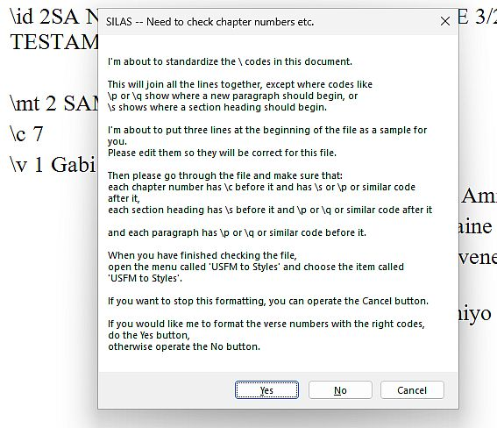
When you have attended to the points above, save a copy under a different name, in case the next step doesn’t produce the desired results.
SILAS provides a macro, FixCodes, which can check that the USFM codes have been formatted properly. It also offers to save the document as a text file suitable for importing into Paratext. This macro will place a \p code at the beginning of each Word paragraph.
To run this macro, hold down the Alt key and tap TMM to open the Macros dialog. Type FixCodes, select that macro and operate the Run button.
After much blinking and flashing, the file should be fairly suitable for import into Paratext. The macro will open the Save As dialog. Approve the folder and filename (or choose different ones) and save the file.
If the file contains multiple books, split it into separate files, one for each book.
Then import the file(s) into Paratext and run checks to make sure the punctuation and codes are acceptable.

Scriptures formatted with Bold, Italic etc
SILAS provides macros to convert the official Paratext stylenames into the corresponding USFM codes, so you could apply those styles to paragraphs throughout the document, and then run those macros. (These styles have names like mt - Title - Major Title Level 1) The following steps describe an easy way to do that. (Alternatively, you could add codes like \c, \s and \p at relevant points in the doucument as described in section 4. Scriptures formatted with USFM backslash codes above.)
For each paragraph in the document,
Put the cursor somewhere in the document,
Hold down Ctrl and Shift and tap S to open the Style box. (In recent versions of Word you can drag this box to a vacant part of the screen.)
Type the first few letters of the stylename that is appropriate for that paragraph, such as
mt for mt - Title - Major Title Level 1
c for c - Chapter Number
s for s - Heading - Section Level 1
It's a good idea to do all the paragraphs of a particular type in a single pass through the document. Here's the easy way to do that:
Apply the style to the first paragraph, as described above.
Move the cursor into the next paragraph of the same kind,
then hold down the Ctrl key and tap Y to make the same change again.
Repeat until you have applied the style to all paragraphs of that type.
Then do File->Save As and give the document a new name that says what you have just done, such as
Bwaidoka PHM, chapter numbers
to show that you have applied the style to the chapter numbers in the document.
There is no need to apply a style to verse numbers, as there's a macro that can do that for you. Just make sure that you have applied the appropriate styles to chapter numbers and crossreferences before you run the macro.
When you are ready to apply the style to the verse numbers,
open the menu called USFM to Styles as follows: Tap Alt then X then Y1
select the item Format Verse Numbers and respond to the dialogs that pop up.
When you have finished those steps, run the task Save As USFM Scripture as described in section 2. Scriptures formatted with a standard template.
End of documentation.

You can read about the LangTran software distribution system at http://lingtransoft.info/apps/langtran-software-distribution-system

