Some initial summarization and plotting of data can often reveal errors. In this example, we continue with some of the WDFW fisheries data for 2014.

library(tidyr)  
library(dplyr)

##   
## Attaching package: 'dplyr'  
##   
## The following object is masked from 'package:stats':  
##   
## filter  
##   
## The following objects are masked from 'package:base':  
##   
## intersect, setdiff, setequal, union

library(ggplot2)  
df <- read.csv("D:/fishdata.csv", header = TRUE, sep = ",")

Initially, we create an xy plot of Weight x Length for the entire dataset and including all species.

qplot(Length_meas, Weight_meas, data = df)

## Warning: Removed 338 rows containing missing values (geom_point).

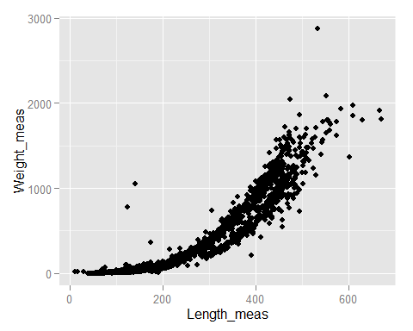

It's clear that there are some outliers at the lengths <200. So we'll filter the data and replot for these smaller lengths.

df200 <- df %>%  
 filter(Length_meas < 200)  
qplot(Length_meas, Weight_meas, data = df200)

## Warning: Removed 335 rows containing missing values (geom_point).

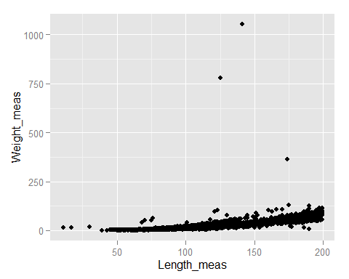

This chart makes it clear that there are 3 unusual observations. Often these are due to clerical errors (e.g., decimal in the wrong place).

We can again filter the dataset to extract the outlying observations.

dfoutliers <- df %>%  
 filter(Length_meas < 200) %>%  
 filter(Weight_meas > 250)  
dfoutliers

## WWSurveyId_id SurveyNum_id FishSampNum_id Species_code Length_meas  
## 1 10167 113 1 LW 125  
## 2 10167 117 9 TNC 141  
## 3 10167 120 10 BBH 174  
## FishLenMo_code Weight_meas  
## 1 NA 780  
## 2 NA 1054  
## 3 NA 363