Timing Circuit

Homework 3

For transfer function, we test input pulse width in range [100, 200] with step=1ps.

As we can see in the transfer function, the time resolution of our design is 7 ps.



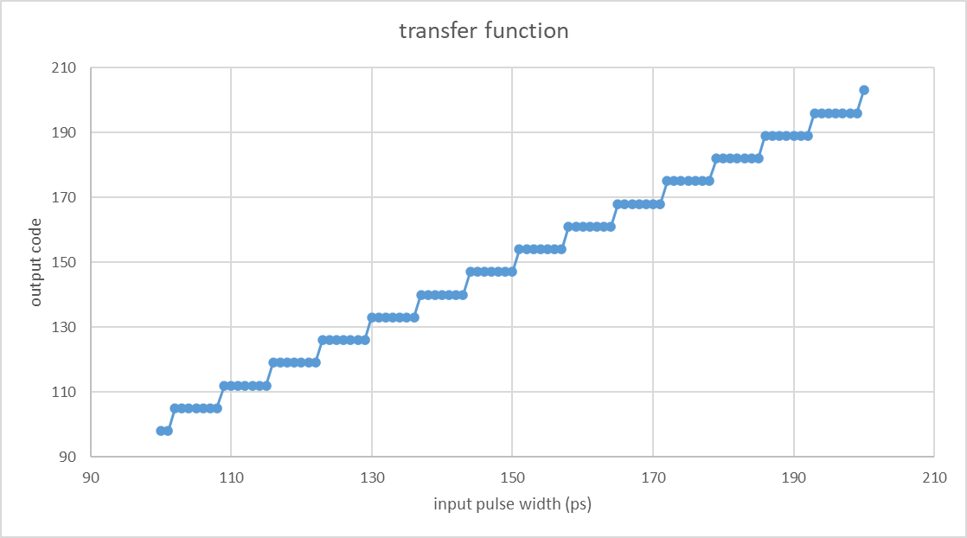

Since we use cell-based design, we can’t simulate how noise effect the output. Therefore, we get 10 same results in this part.

Output code = 147

