Benchmark #2
This benchmark is based on a field dataset from the 2011 Japan tsunami in Hilo Harbor, Hawaii. While modelers will of course aim to achieve the best agreement with the measured data, this is not the primary goal of this exercise. The aim of this benchmark is to understand the importance of model resolution and numerics on the prediction of tsunami currents. Some of the questions that modelers tried to answer are:

- What level of precision can we expect from a model with regard to modeling currents on real bathymetry?
- Will a model converge with respect to speed predictions and model resolution?
- What is the variation across different models, using the same wave forcing, resolution, and bottom friction?

To attempt to most clearly answer these questions, this field case will be somewhat idealized, or reduced in complexity, to give the modeling results the best chance of an "apples-to-apples" comparison of shallow water, tsunami currents. For this benchmark, free surface elevation (from tide stations) and velocity information (from the Acoustic Doppler Current Profiler (ADCPs))are compared. Data for this benchmark test has been provided by Randy LeVeque and Kwok Fai Cheung, who have both examined this location (Arcos and LeVeque (2015) and Cheung et al. (2013)).

Figure 2 shows a plot of the bathymetry data from Hilo Harbor, Hawaii. The data is provided in (lat,long) on a 1/3 arcsec grid. Note that shown on this figure are also the simulation control point (white dot), the two ADCP locations (black dots) and the tidal station (blue dot).As mentioned above, this problem has been "reduced" in an attempt to isolate differences in the employed incident wave forcing. For the bathymetry data, this "reduction" manifests as a flattening of the bathymetry at a depth of 30 meters; in the offshore portion of the bathymetry grid, there are no depths greater than 30 m.

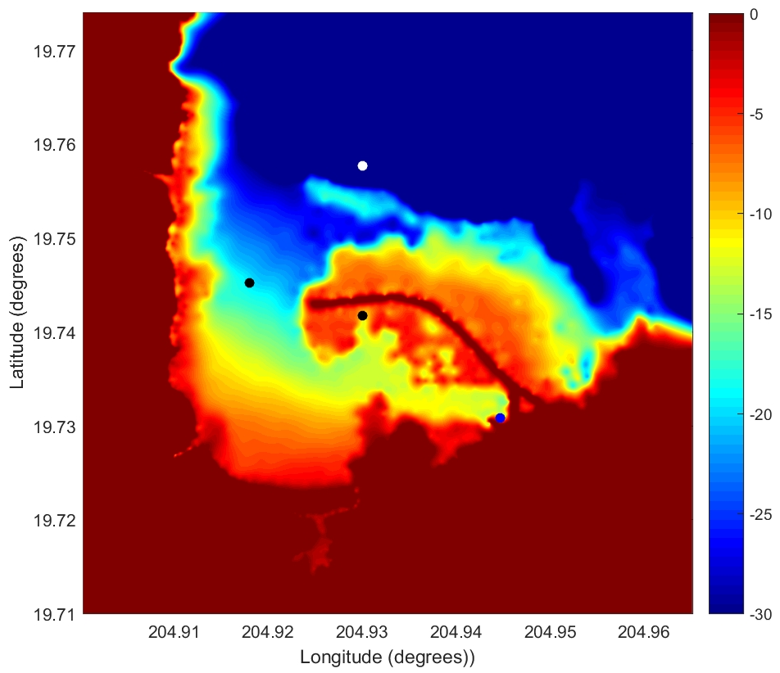
Figure 2: Bathymetry data from Hilo Harbor, Hawaii. Also shown on this figure are the simulation control point (white dot), the two ADCP locations (black dots) and the tidal station (blue dot).

For the incident wave case, modelers are asked to drive their simulations with an offshore simulated free surface elevation time series (the "control point"). The location of this time series is (lat,long)= [19.7576, 204.93]. Modelers may force their simulations in whichever way is convenient (e.g. through upper grid boundary, or with an internal source generator in the northern part of the domain), but should check with their modeled time series at the control point to ensure that they are generating the proper offshore wave condition. Note that the above simplification will lead to a physical mismatch between the simulated and actual data; as the incident wave will vary spatially (albeit weakly) as it approaches the harbor. Modelers are of course encouraged to simulate the complete problem with their models (from source to harbor with nesting), but this is optional.

The first comparison for the free surface elevation case is to check the water surface elevation at the tidal station:

- Hilo Tide Station: [lat, long]=( 19.7308, 204.9447 )

Modelers may have to shift the simulated and tidal data such that the leading numerical wave arrives at the proper time, and this same time shift has tobe used in the velocity comparisons. The official locations of the ADCPs are:

- HA1125, Harbor Entrance: [lat, long] = (19.7452, 204.9180)
- HA1126, Inside Harbor: [lat, long] = (19.7417, 204.9300)

Modelers were requested to provide results for at least three different numerical configurations:

- Simulation result at ~20 m resolution (2/3 arcsec, de-sample the input bathymetry), using a Mannings n coefficient of 0.025 (or approximate equivalent if using a different bottom stress model)
- Simulation result at ~10 m (1/3 arcsec) resolution using a Mannings n coefficient of 0.025 (or approximate equivalent if using a different bottom stress model)
- Simulation result at 5 m resolution (1/6 arcsec, or the lowest resolution possible; use bi-linear interpolation), using a Mannings n coefficient of 0.025 (or approximate equivalent if using a different bottom stress model)

Modelers were encouraged to compare simulation results both locally (required by the benchmark) as well as to examine statistical measures of spatial variability between the different resolutions.

