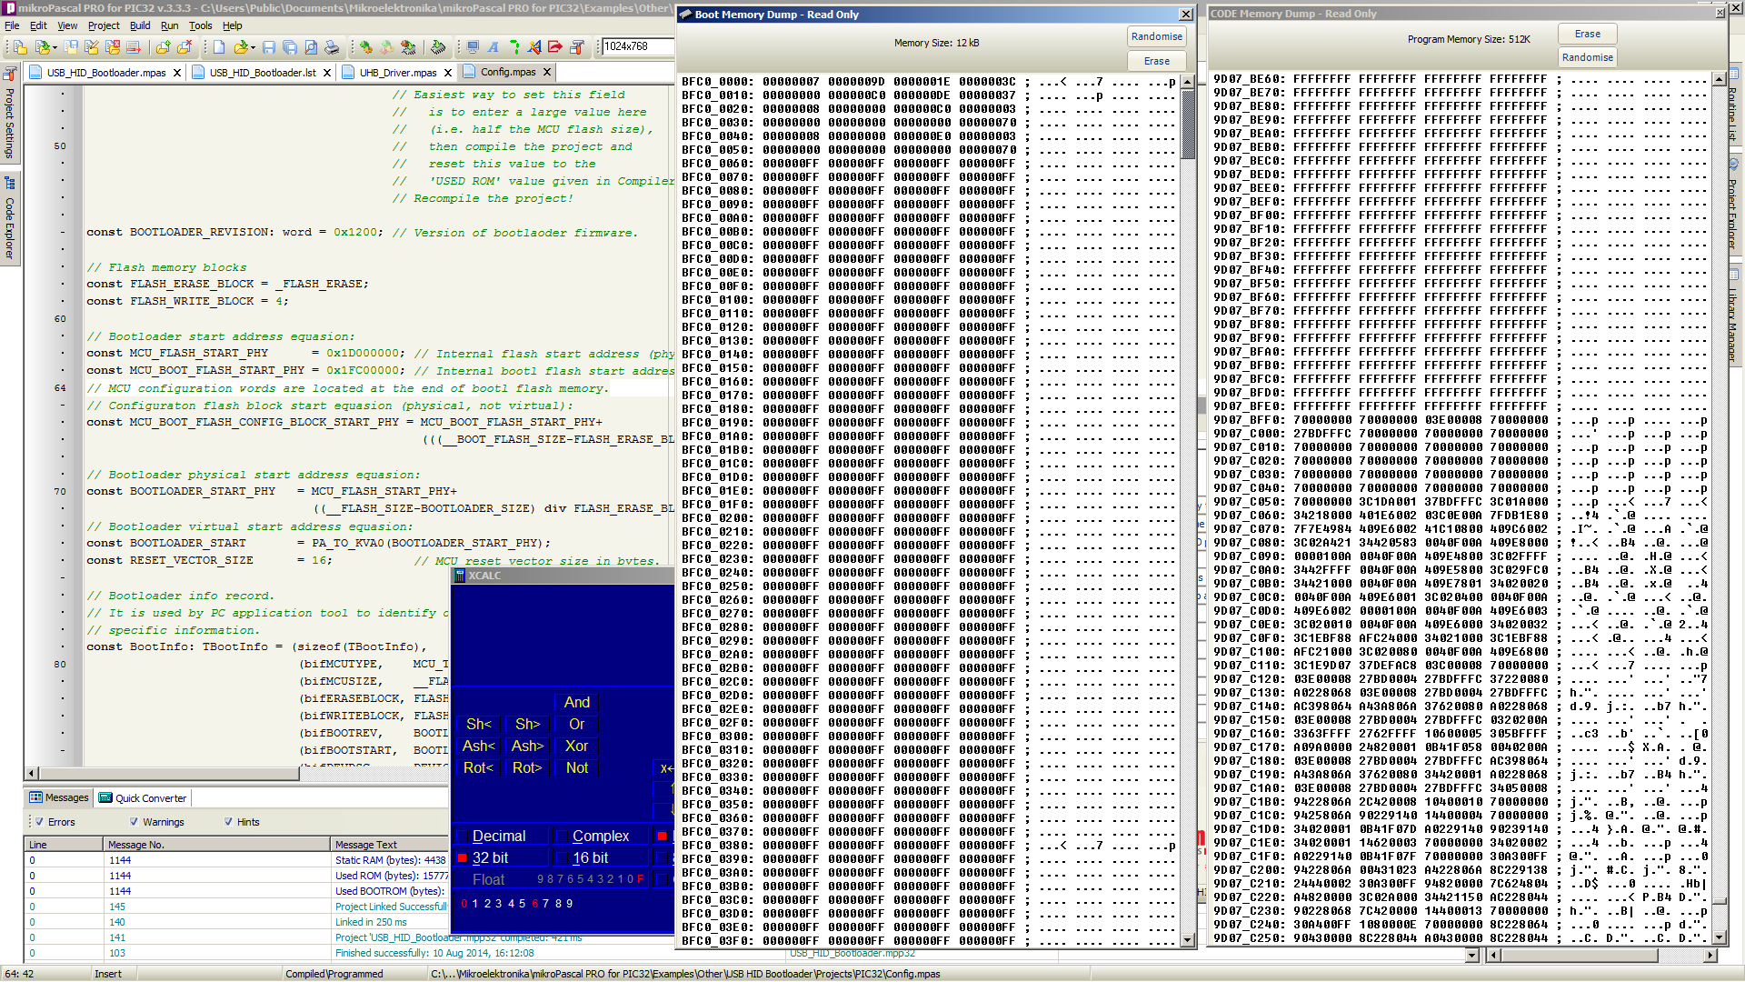

Bootloader Fresh Load

_SYNC: _ERASE: 0x1D000000 _WRITE: 0x1D000000 - 108 bytes _ERASE: 0x1D07B000 _WRITE: 0x1D07B000 - 4096 bytes _ERASE: 0x1FC01000 _ERASE: 0x1FC00000 _WRITE: 0x1FC00000 - 4096 bytes _WRITE: 0x1FC01000 - 392 bytes
_REBOOT:

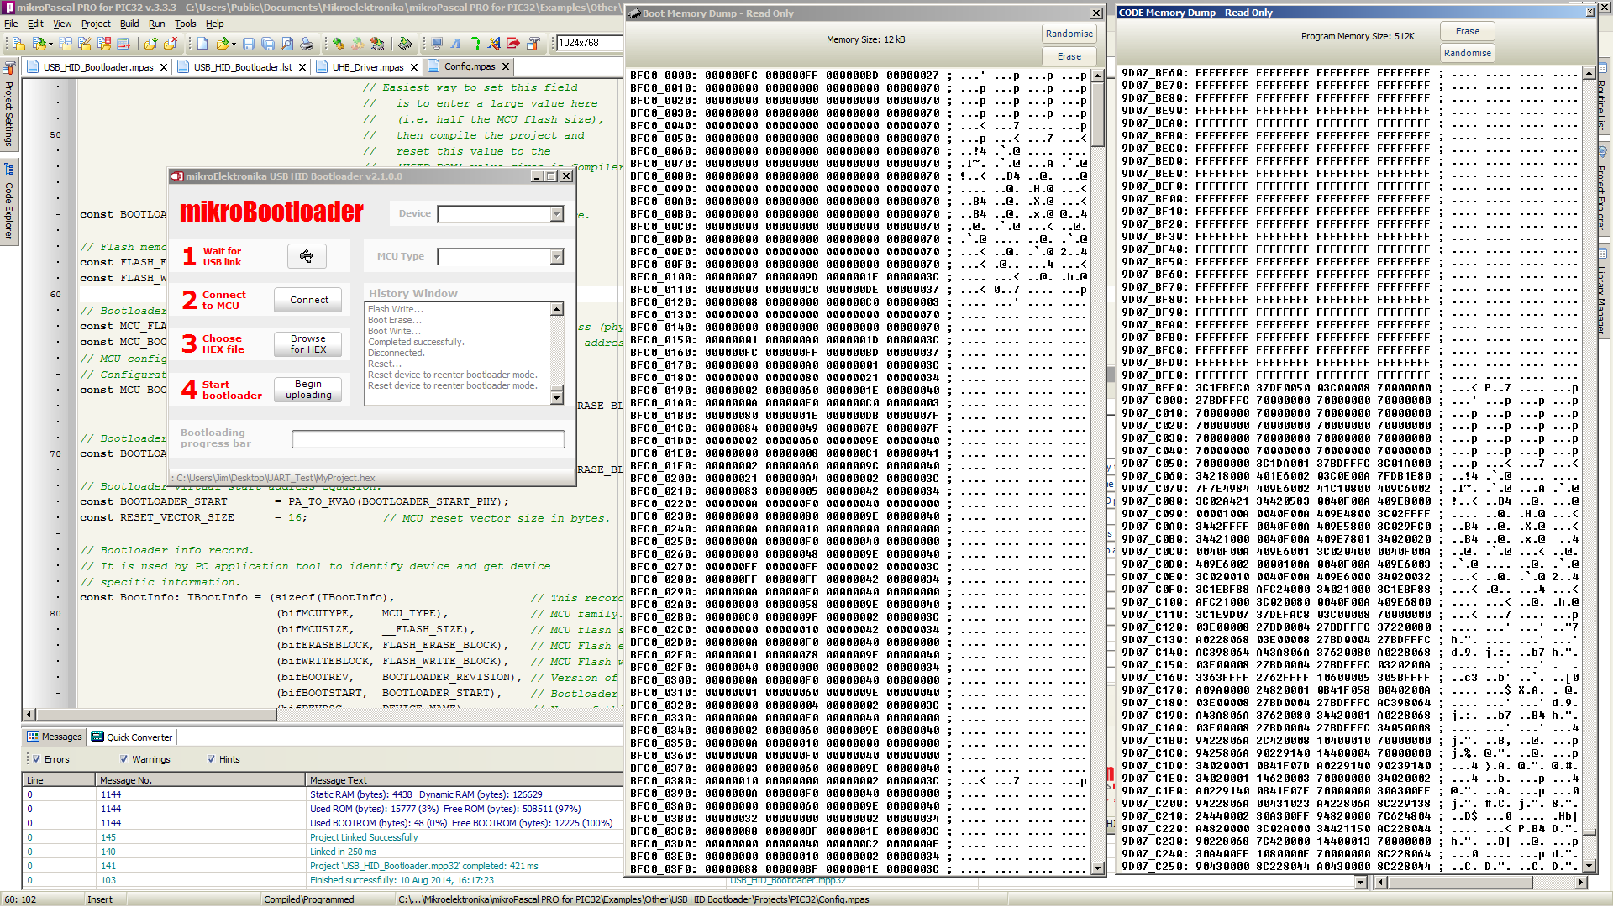
Application Loaded
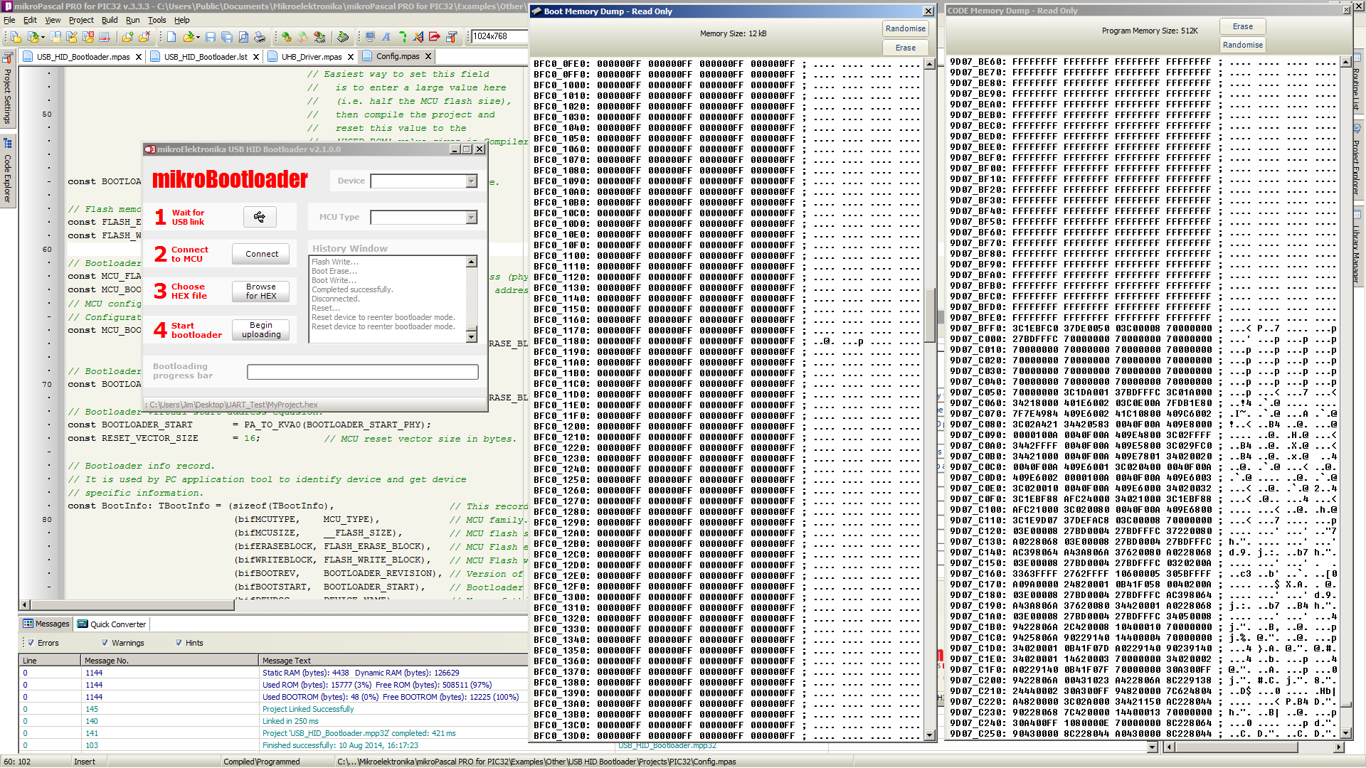

Application Loaded at 0x1FC01000

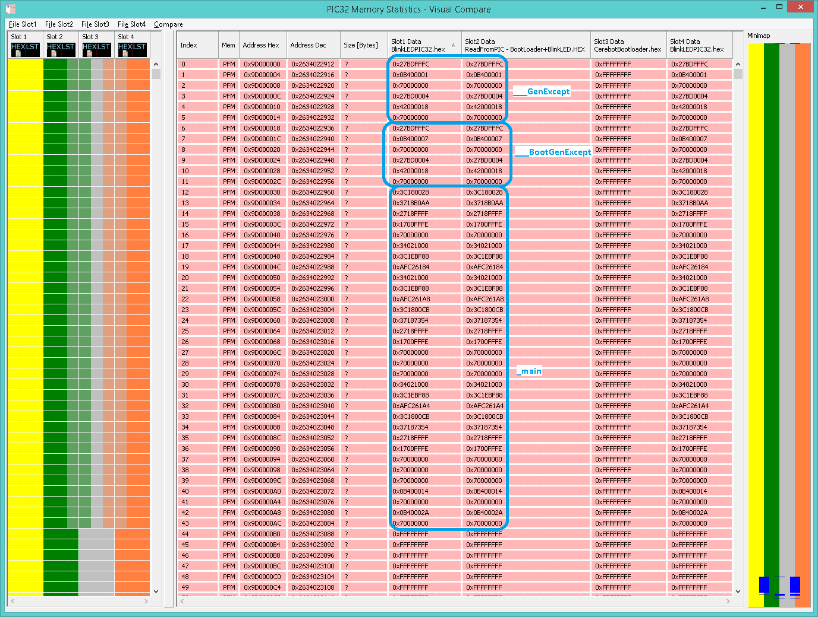
From address 0x9D000000 (start of PFM KSEG0) to address 0x9D0000AC:
___GenExcept
___BootGenExcept
_main

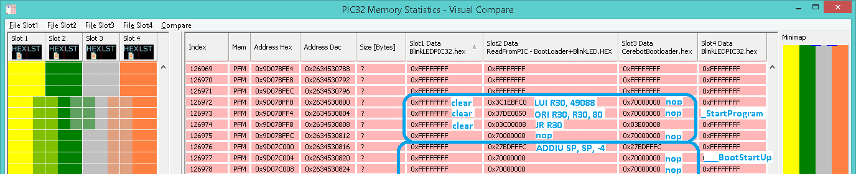
The bootloaded application (BlinkLED.hex) has no entries at addresses 0x9D07BFF0 to 0x9D07BFFC, they are blank (marked with “clear” in the above screenshot).

procedure StartProgram();
begin
// nops to accomodate MCU reset vector size.
asm nop end; //First nop replaced by LUI R30, 49088
{$IFDEF P32}
asm nop end; //Second nop replaced by ORI R30, R30, 80
{$ENDIF}
end;

The Bootloader has two nops at the first two addresses in this range, which will be replaced by a loading to R30 (rx) register. In the example above, the adress loaded in R30 is 0xBFC00050. This is a BootFlash KSEG1 address, containing nop, both for original BlinkLED application and the application read back after bootloading. This means the bootloader doesn't touch this entry. See below:

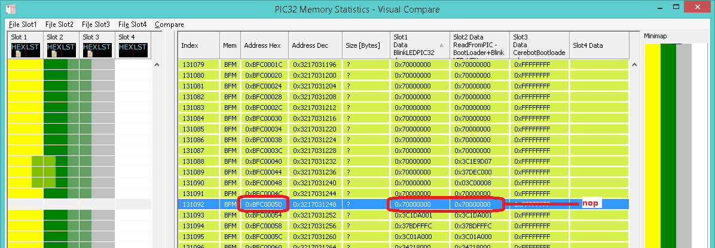

After _StartProgram and ___BootStartUp, almost until the end of the memory, there are no differences between the compared files.
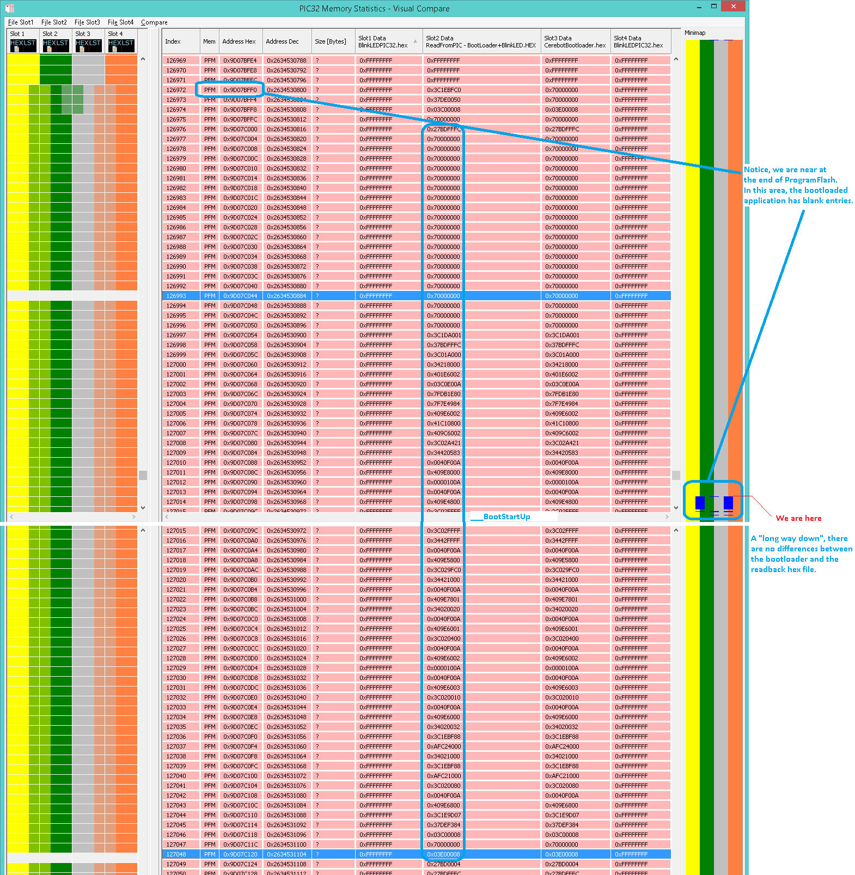

The ProgramFlash entries end with constants used by the bootloader application (e.g. USB constants):

;,0 :: _initBlock_3 [30]
; Containing: device_dsc [18]
; DEVICE_NAME [8]
; strd1 [4]
0x9D07F7E4 0x02000112 ;_initBlock_3+0 : device_dsc at 0x9D07F7E4
0x9D07F7E8 0x08000000 ;_initBlock_3+4
0x9D07F7EC 0x00011234 ;_initBlock_3+8
0x9D07F7F0 0x02010001 ;_initBlock_3+12
0x9D07F7F4 0x65430100 ;_initBlock_3+16 : DEVICE_NAME at 0x9D07F7F6
0x9D07F7F8 0x6F626572 ;_initBlock_3+20
0x9D07F7FC 0x03040074 ;_initBlock_3+24 : strd1 at 0x9D07F7FE
0x9D07F800 0x0409 ;_initBlock_3+28
; end of _initBlock_3

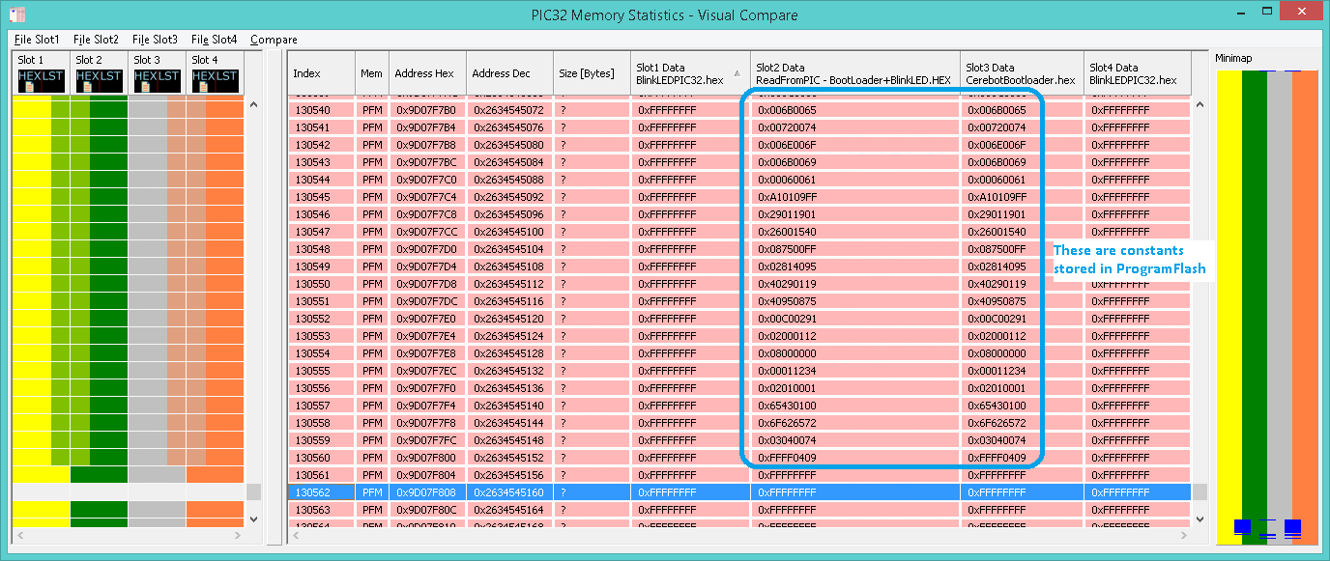
From the last ProgramFlash entry to the end of ProgramFlash the memory is blank (unused) because the bootloader is aligned to an erase page.
Next, at the beginning of the BootFlash memory, there are many different entries:

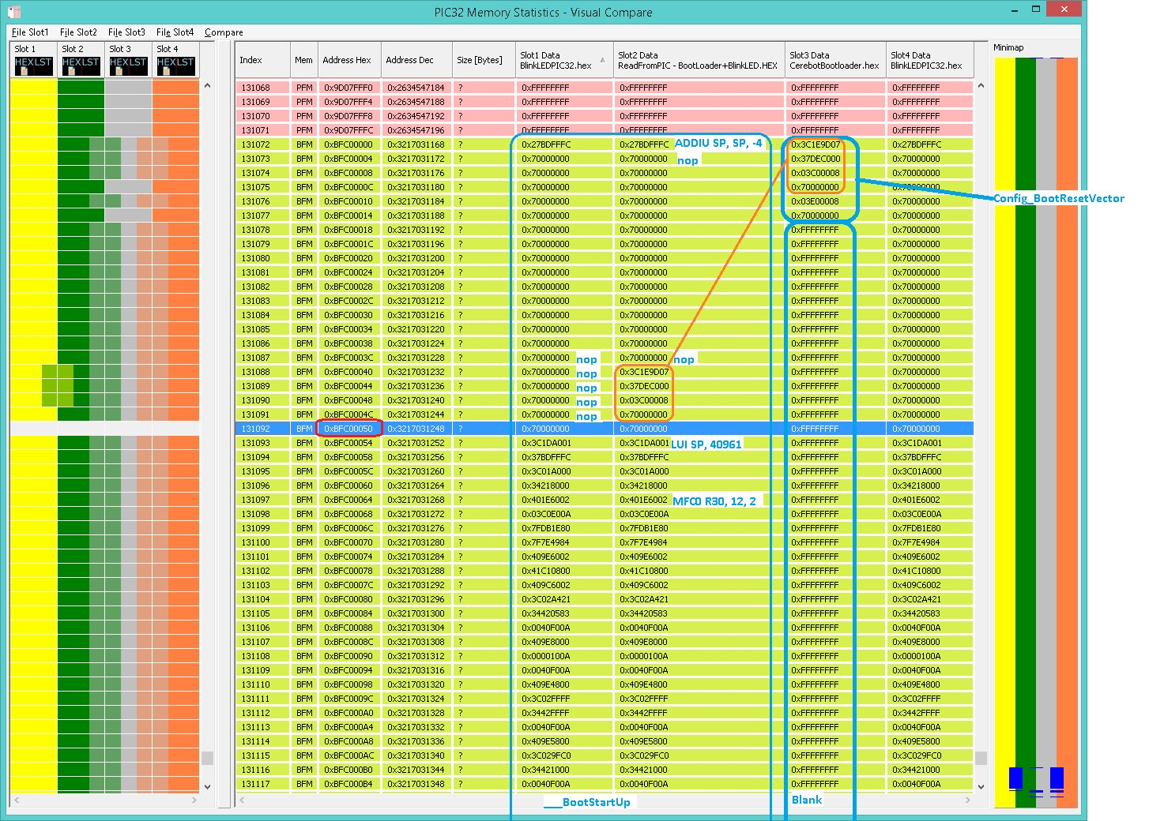
___BootStartUp is the only routine in BootFlash in the user application. (starts at 0xBFC0000, ends at 0xBFC00124).
The code from Config_BootResetVector (bootloader application) is shifted from 0xBFC0000 to 0xBFC0040, somewhere in the middle of ___BootStartUp routine. The whole content of Config_BootResetVector is replaced during bootloading.
Second set of files: SVN \OpenMikroBootloader\Tools\mikroPascal\Bootloader Files
revision 43:
MyProject.hex
mE_Bootloader+MyProject.HEX
mE_Bootloader.HEX
For instruction decoding and explanations, see previous screenshots. The following examples show only the entries which are different, being compared as Slot1 against Slot2 and Slot2 against Slot3.
Also, please notice various routines based on existing content in each slot.

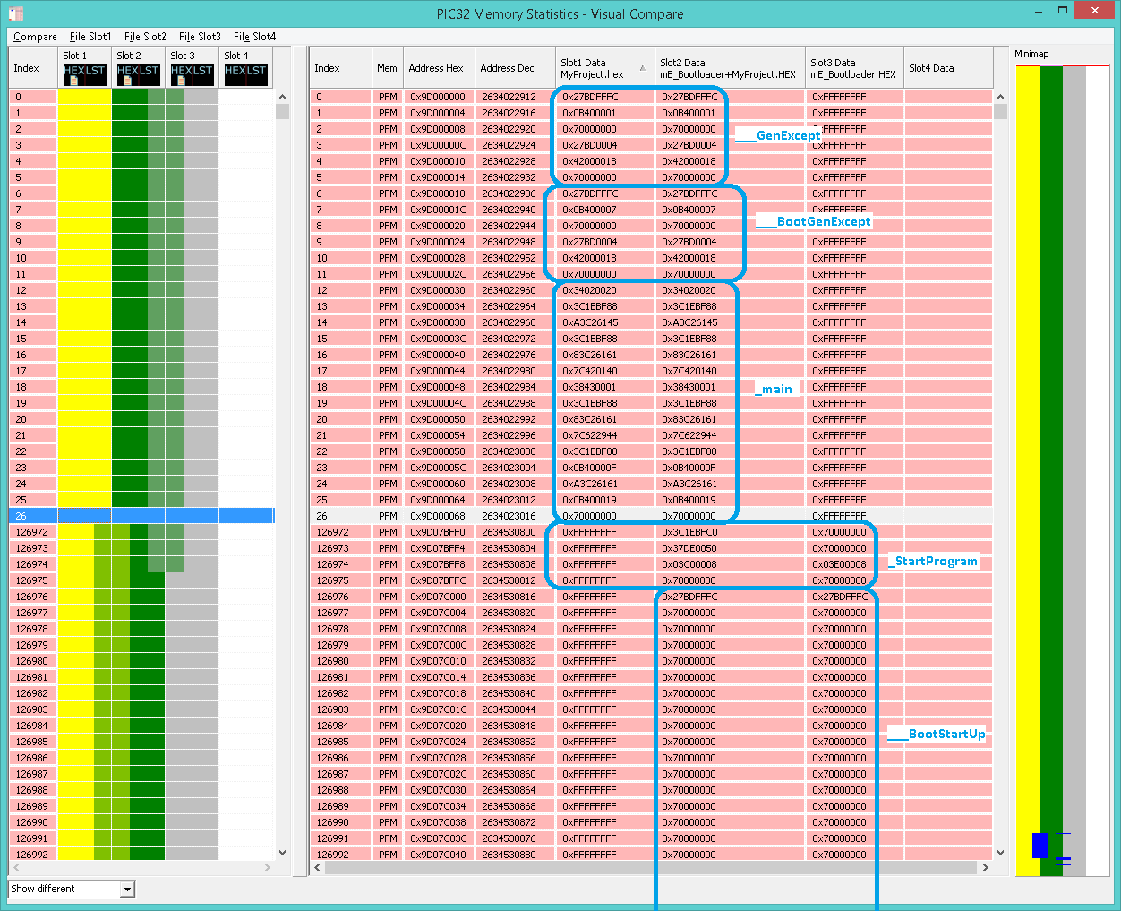

Again, see previous example for details

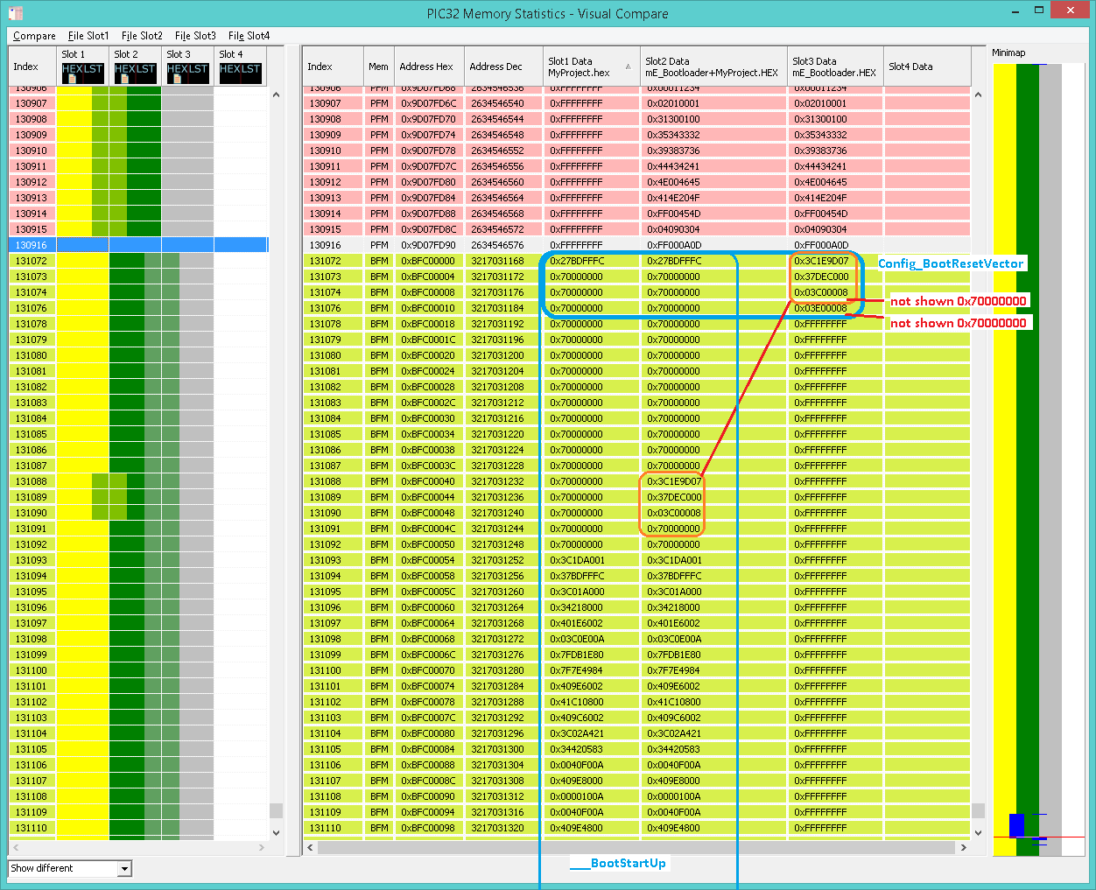

The jump to GenExcept is also replaced by PC application:
