Macintosh HD:Users:James:Google Drive:rest:Bluesat:Promotional/Recruiting:Logo:blues student space projects.pdf

**BLUEsat Stratospheric Balloon Flight**

**Faculty Funding Request**

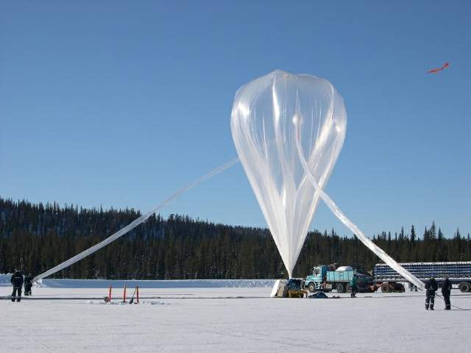

Presented by

**BLUEsat**

University of New South Wales

Sydney, Australia

# Executive Summary

The first phase of the BLUEsat project has been completed, and has successfully produced a working satellite. The team now wishes to reconstruct a flight model of the satellite for flight on a Stratospheric Balloon. The test will yield detailed telemetry on the behavior and performance of the satellite in near-space conditions. A total of $35 000 AUD is required to carry out the launch.  The launch event will provide publicity for the success of the BLUEsat project and space engineering at UNSW.

# Contents

# 

Executive Summary 2

Contents 2

1 Introduction 3

2 Flight 5

2.1 Experiments and Data 6

3 Project Plan and Budget 7

3.1 Launch Vehicle Assembly and delivery 7

3.2 Flight Model Budget 7

3.3 Launch Operations Budget 7

4 University Benefits 8

4.1 Building Capability for Future Projects 8

4.2 Industry Links 8

4.3 Publicity 8

4.4 Staff Endorsement 9

5 Conclusions 10

Appendices 11

Appenidx A – Launch Budget 11

Appenidx B – Path to Launch Gantt Chart 13

# Introduction

Over the course of the last fifteen years, the BLUEsat project has designed and produced one of the few undergraduate satellites in Australia. In July of 2013, this project was completed and successfully demonstrated full functionality to the Warrawal consortium.

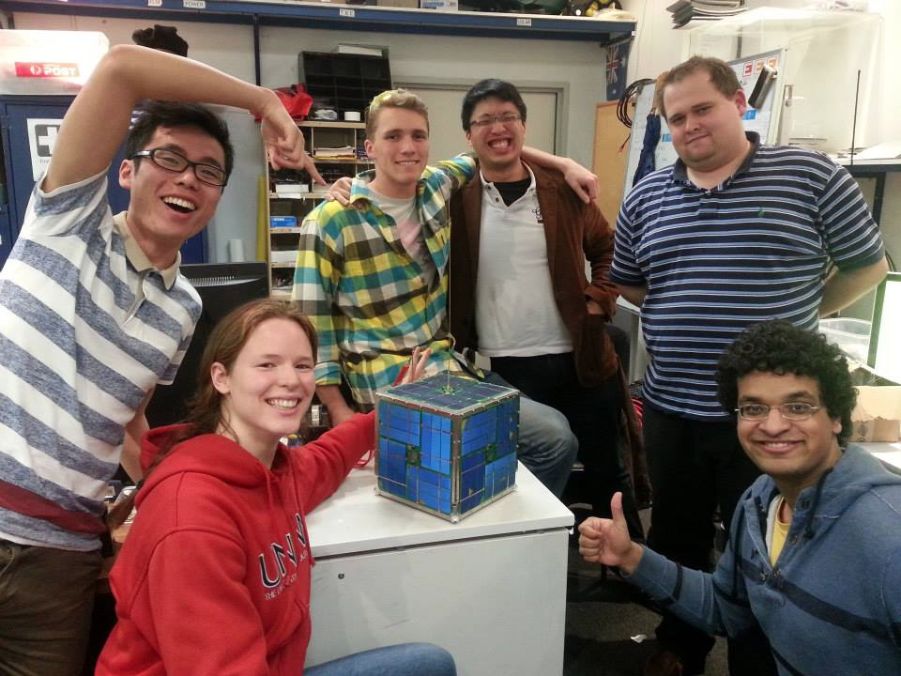

Figure - Finished BLUEsat satellite before the Warrawal Consortium demonstration.

The final step in the plan is to provide definitive proof of the design through a test flight on a stratospheric balloon. This will demonstrate the functionality of the satellite’s hardware and software in near-space conditions and provide a fitting capstone to a successful project. Data from the flight will also provide valuable feedback and test data to be used in follow-up space projects to be undertaken by the BLUEsat Group.

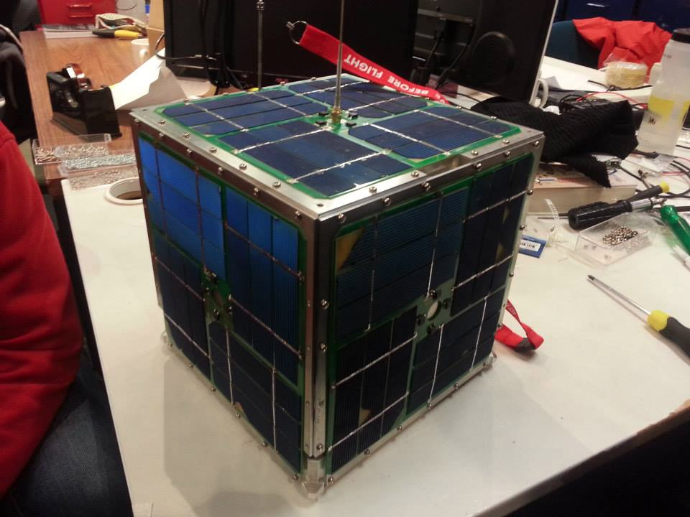

Figure - Finished Satellite Structure

The balloon will be mounted under a Raven Aerostar zero-pressure helium balloon and lifted to an altitude of approximately 35km. It will remain at this altitude for up to 24 hours, environmental conditions permitting. During this time, it will be in constant communication with the ground crew, providing telemetry on the satellite’s function, as well as conducting communication experiments with amateur radio clubs throughout south eastern Australia.

After the test is concluded, the satellite will land by parachute and be recovered. The photographs taken by the onboard camera will be retrieved, and the satellite will be transported back to UNSW for a full disassembly, post-flight inspection, and analysis.

# Flight

The aim of the flight is to provide a proof of concept of the project, bringing BLUEsat to a logical conclusion. Study of the data carried out by on-board experiments will play a significant role developing UNSW’s space engineering capabilities. The event will also provide a spectacular finish to the BLUEsat project, generating publicity for UNSW undergraduate projects.

The goals of the flight are to

1. Prove and evaluate the performance of the satellite in near space conditions, providing a final finish to the first cycle of the BLUEsat Project.
2. Provide data and feedback for development of future space hardware by the BLUEsat Group and the Australian Centre for Space Engineering Research (ACSER)
3. Generate publicity for space engineering and undergraduate projects at UNSW
4. Strengthen links between UNSW and Industrial sponsors.



Figure 3 - An example of a stratospheric ballon flight by CNES from Northern Sweden

## **Experiments and Data**

The most important technical goal of the launch is proof of concept of the BLUEsat design in near-space conditions. During the balloon flight, the satellite will experience pressure and temperature conditions close to that of Low Earth Orbit. Its performance under these conditions for up to 24 hours will provide validation of the satellite’s design and onboard software. The payload will also include a camera designed to take pictures from the edge of space.

The key novelty of the experiments is evaluating the performance of commericial, off-the-shelf hardware as assembled and designed by undergraduate university students. Live onboard telemetry and post-flight analysis will provide the following information on the satellite systems systems:

* Behaviour and performance of the onboard operating system and software during an extended test.
* Performance of the satellite radio and communication systems.
* Successful communication with amateur radio clubs, proving that the success of the satellite as a telecommunications enabler for the amateur radio community
* Environmental performance of the satellite, especially thermal behaviour during the day/night cycle.
* Thermal behaviour and response of the onboard electronics, all designed using commercially available off-the-shelf hardware.

# Project Plan and Budget

## Launch Vehicle Assembly and delivery

In order for the launch to take place, a flight model of the satellite needs to be constructed and the launch vehicle assembled. The complete system will then be transported to Wagga Wagga via ADFA for launch. During flight the balloon will remain aloft for 24 hours while being tracked and monitored by BLUEsat team members on the ground. After flight termination, the satellite will parachute to the ground and be recovered. On-board pictures and data will be retrieved, and the satellite will be transported back to UNSW for analysis. This process is being undertaken under the guidance of Professor Ravi Sood from UNSW@ADFA.

For a successful balloon test flight, the following milestones must take place:

1. Purchase and integration of the balloon itself and associated safety/flight hardware.
2. Rebuild of the satellite to produce a flight model which will perform under required conditions.
3. Arrange launch permissions with CASA.
4. Arrange logistics and transport of personnel and equipment to launch site in Wagga.
5. Perform in-flight monitoring and tests, as specified.
6. Recover satellite for post-flight disassembly and analysis.
7. Produce report and promotional/informational material based off of launch.

A detailed project plan of the path to launch is attached in Appendix B.

## Flight Model Budget

The current qualification model of the satellite has gone through destructive testing, and as such requires critical component replacement in order to create a flight-ready model. Reconstruction of the flight model of the satellite is expected to cost $4.4k AUD replacement of electronics and fasteners. The core mechanical support structure of the satellite does not need to be remade.

A detailed budget is given in Appendix A

## Launch Operations Budget

Operation of a successful launch requires that launch hardware, such as the balloon itself and all tracking hardware be purchased. The initial quote and study provided by Professor Ravi Sood from ADFA@UNSW places the total launch operations cost at $27.7k AUD. A detailed budget is given in Appendix A.

# University Benefits

Supporting the successful launch and flight of BLUEsat will provide a range of benefits to projects and student life at UNSW.

## Building Capability for Future Projects

A study of the performance of BLUEsat during the flight will provide additional experience that can be leveraged for future space-design projects at UNSW. BLUEsat will publish the results of the pre and post flight analysis for study and evaluation. This information can be the subject of both undergraduate and postgraduate research projects at UNSW, generating opportunities for UNSW students to gain more experience in practical space engineering.

The subsequent knowledge and experienced gained can be used for the BLUEsat Group’s future endeavours. The Group aims to carry on its mission of providing space experience for UNSW students and furthering UNSW’s space engineering Capabilities. The proof of UNSW-built technology and feedback from the flight will be captured as ‘lessons-learnt’ for future projects at UNSW.

BLUEsat plans to use this knowledge to enter the Canadian Space Design Challenge and NASA Lunabotics Competition. Full detail of future BLUEsat projects can be found in the BLUEsat Roadmap, Document BLUE2013.7.0.

## Industry Links

The inclusion of industry sponsors in this effort will provide positive exposure for future relationships between UNSW and industry. The project will seek to external sponsors for the funding required for the project.BLUEsat also maintains strong links with other undergraduate projects, including the UNSW FIRST Robotics Society and CreateUNSW. Sponsor involvement can then be used to foster more industry involvement with UNSW space projects and student engineering projects.

## Publicity

Successful execution of the BLUEsat balloon launch will provide a highly public and successful conclusion to the BLUEsat project, demonstrating the ongoing success of UNSW’s student space projects. Photos generated from the Satellite’s camera can be used to generate publicity material over the web and in national media.

As the test approaches, BLUEsat will contact media to promote the project and publicise the launch.  We have already made contact with The Advertiser, the local newspaper in Wagga Wagga. We will also take advantage of press contacts through the Australian Centre for Space Engineering Research to publicise the launch further. The launch itself will also be recorded by photography and video, which will be used to produce online content.

## Staff Endorsement

# Conclusions

Now that the BLUEsat design has been completed and verified, the team is ready to move forward with the proof of concept. To ensure a successful balloon test, the team will now need to purchase hardware for the assembly of a fresh launch model and stratospheric balloon launch vehicle. This will be assembled and tested at UNSW before transport to Wagga Wagga for the flight test. After the test is complete, the satellite will be recovered and transported to UNSW for telemetry and post-flight analysis.

Investing in the stratospheric balloon flight of BLUEsat will reap significant benefits to the University, and is a worthwhile endeavour.

|  |  |  |  |  |  |
| --- | --- | --- | --- | --- | --- |
| **Balloon Launch Operations**  **By April 2014** | | | | | |
| Item | Need By | Unit Cost | Quantity | Total | Contingency (+20%) |
| Raven Aerostar 3990m3 Balloon | Mar-14 | $5,000 | 2 | $10,000 | $12,000 |
| Helium Gas | Mar-14 | $1,500 | 1 | $1,500 | $1,800 |
| Radio Uplink | Nov-13 | $750 | 1 | $750 | $900 |
| Radio Downlink | Nov-13 | $750 | 1 | $750 | $900 |
| Balloon Altimeter | Nov-13 | $2,000 | 1 | $2,000 | $2,400 |
| Balloon Termination Device | Nov-13 | $1,000 | 1 | $1,000 | $1,200 |
| Payload Recovery Parachute | Feb-14 | $3,000 | 1 | $3,000 | $3,600 |
| Parachute release device | Dec-13 | $1,000 | 1 | $1,000 | $1,200 |
| Secondary Power Supply - Lithium Non-Rechargable 28V 30Ah | Dec-13 | $2,000 | 1 | $2,000 | $2,400 |
| Recovery Costs | Apr-14 |  |  | 0 |  |
| Misc. Launch Hardware | Mar-14 | $5,000 | 1 | $5,000 | $6,000 |
| Personnel | Mar-14 |  | 5 | 0 |  |
| Transport Costs: Personnel + Hardware to Wagga Wagga (Optional) | Apr-14 | $500 | 1 | $500 | $600 |
| Accomodation (Optional) | Apr-14 | 200 | 5 | $1,000 | $1,200 |
| Total - Base | | | | $27,000 | $32,400 |
| Total - With Options | | | | $28,500 | $34,200 |

# Appendices

## Appenidx A – Launch Budget

Industry Partnership Proposal

|  |  |  |  |  |  |
| --- | --- | --- | --- | --- | --- |
| **Satellite Flight Model**  **By March 2014** | | | | | |
| Item | Need By | Unit Cost | Quantity | Total | Contingency (+20%) |
| Batteries | Jan-14 | $400 | 1 | $400 | $480 |
| Passive Components (Resistors, Capactiors etc) | Nov-13 | $500 | 1 | $500 | $600 |
| Integrated Circuits | Nov-13 | $700 | 1 | $700 | $840 |
| Custom PCBs (Set) | Nov-13 | $2,000 | 1 | $2,000 | $2,400 |
| Transmitter Radio + Tuning | Dec-13 | $400 | 1 | $400 | $480 |
| Reciever Radio + Tuning | Dec-13 | $400 | 1 | $400 | $480 |
| Mechanical Structure Fasteners (Non-Optional) | Dec-13 | $1,500 | 1 | $1,500 | $1,800 |
| Mechanical Structure - Labour and tooling (Optional) | Jan-14 | $8,500 | 1 | $8,500 | $10,200 |
|  |  |  | Total - Base | $4,400 | $5,280 |
|  |  |  | Total - With Options | $14,400 | $17,280 |

## Appenidx B – Path to Launch Gantt Chart

(see attached)