60 Years of Dreams: A Comprehensive Overview of Barbie’s Dreamhouses
by Rana Schenke | 10 Feb 2022
Play Through History
Share
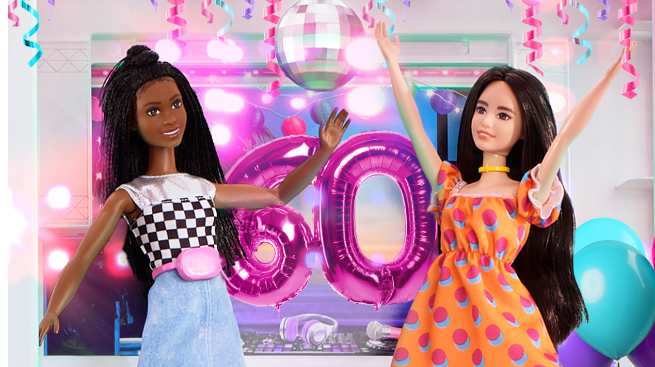
2022 marks 60 years since Barbie moved into a place just as fabulous as she is — her first Dreamhouse!

Over the past 60 years, Barbie’s Dreamhouse has transformed from a simple fold-out studio with cardboard furniture to a three-story abode with a pool, elevator and light and sound features.

Scroll through this article for an overview of the 20+ Dreamhouses Barbie has owned over the years!

(Note: this article only covers Barbie houses branded as “Dream” houses. It is not a comprehensive guide to all Barbie houses.)

1962 Barbie Dreamhouse

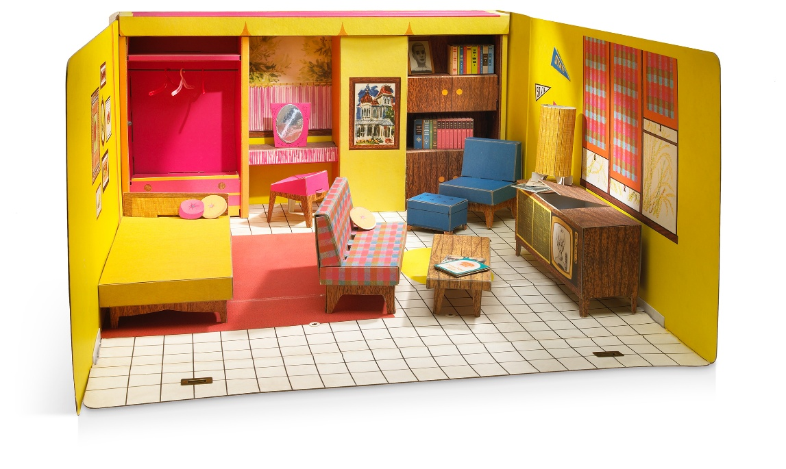
Image: Mattel, Inc.
Barbie’s first Dreamhouse was this cute fold-out house with a studio layout. This is the only Barbie house Mattel has done reproductions of — there have been two reproductions of this house so far!

Fun features: The furniture and accessories in this house are made of cardboard, which allowed the house to sell for the low price of $4.44 — only slightly more expensive than buying a Barbie and a Ken doll at the time! Some of the cutest accessories are the little record albums, which are miniatures of real albums available at the time.

1964 Barbie New Dreamhouse
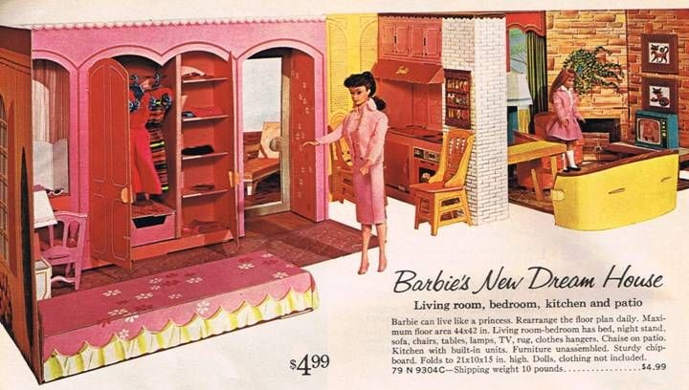

Image: Catalog image via Pinterest

Released in 1964, Barbie’s new Dreamhouse was more detailed than the original, with a two-room setup, kitchenette, patio and more. Although still made of cardboard, this house has many clever features that would become standard for Barbie houses in years to come!

Fun features: This house has a real sliding door to the patio! It also came with a TV with removable screens and cabinets and closets with doors that can be opened and closed.

1965 Barbie and Skipper Deluxe Dreamhouse

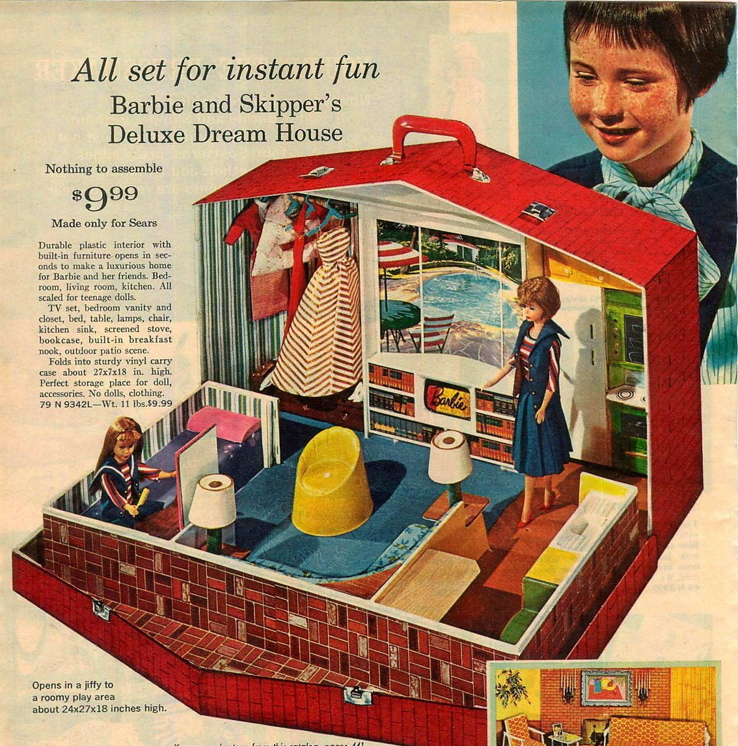

Image: Catalog image via Pinterest

This cute Dreamhouse for Barbie and Skipper had a simple, fold-out design compared to Barbie’s New Dreamhouse, but is much more sturdy as it was made of plastic. This house was a Sears exclusive.

Fun features: The construction of this house meant it could be used as a carrying case, making it easy to bring dolls and a play scene to playdates!

1979 Barbie Dreamhouse

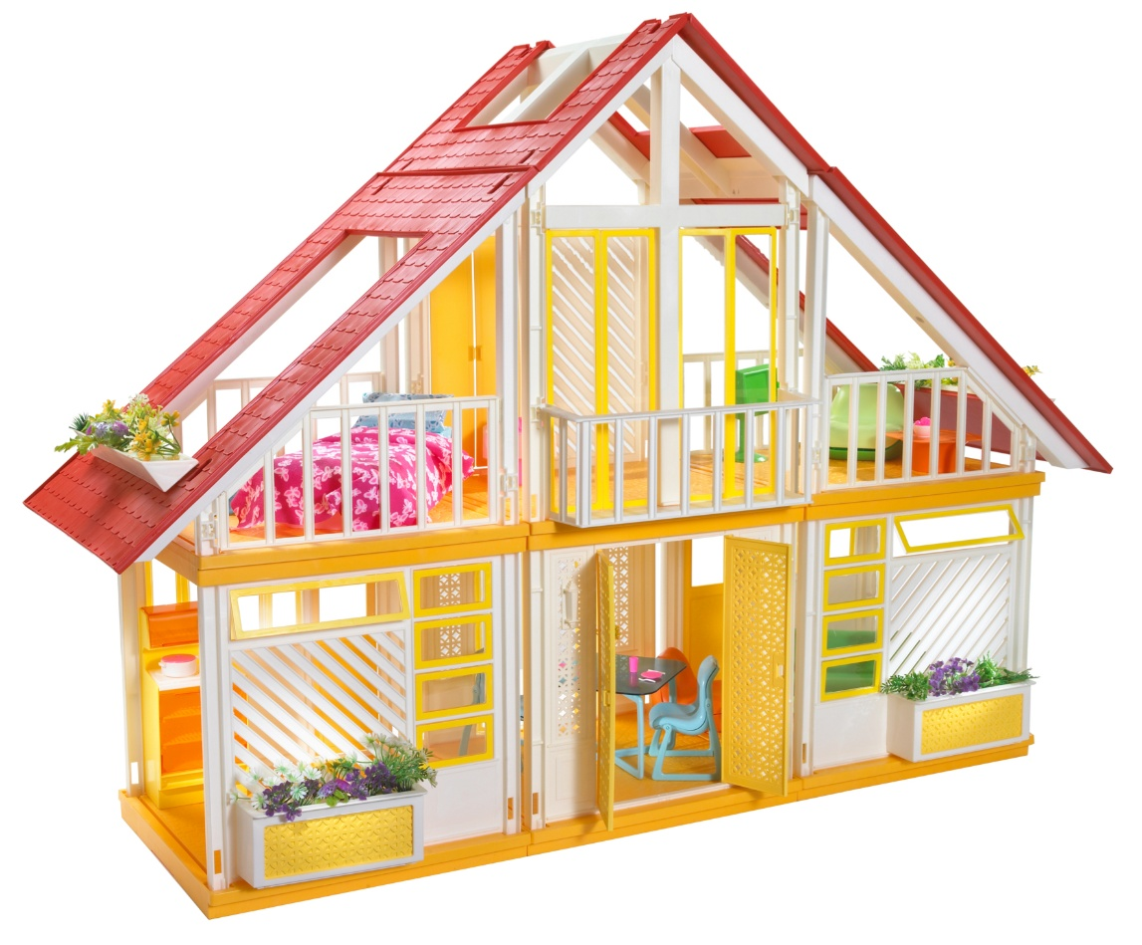

Image: Mattel, Inc.

Throughout the late ‘60s and most of the ‘70s, Barbie lived in a variety of case houses, motor homes and townhouses, but the classic Dreamhouse reappeared in 1979 with a totally new design. The iconic A-frame house was a hot seller and can still be found relatively easily today.

Fun features: This house has an open plan and huge "skylights," making it easy to play with. The three sections are also separate, allowing them to be used separately or rearranged for a custom play experience.

1984 Barbie Dream Cottage

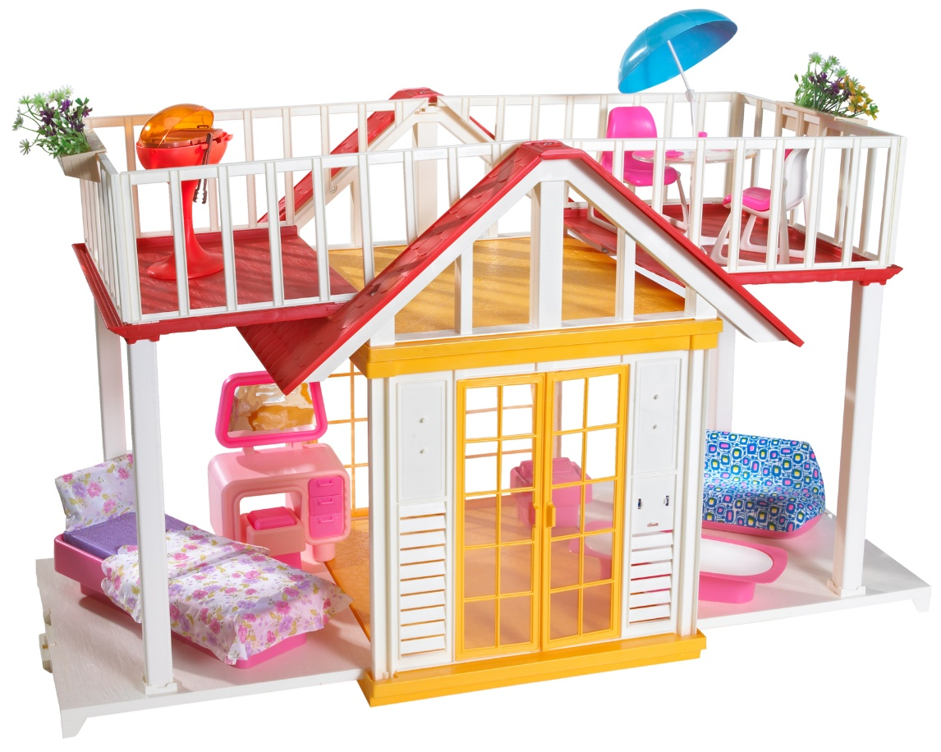

Image: Mattel, Inc.

The Barbie Dream Cottage echoes the styling of the ‘79 Dreamhouse in color scheme and furnishings, but at a significantly smaller size.

Fun features: The rooftop balcony and barbeque grill allow for plenty of outdoor parties for Barbie!

1986 Barbie Dreamhouse

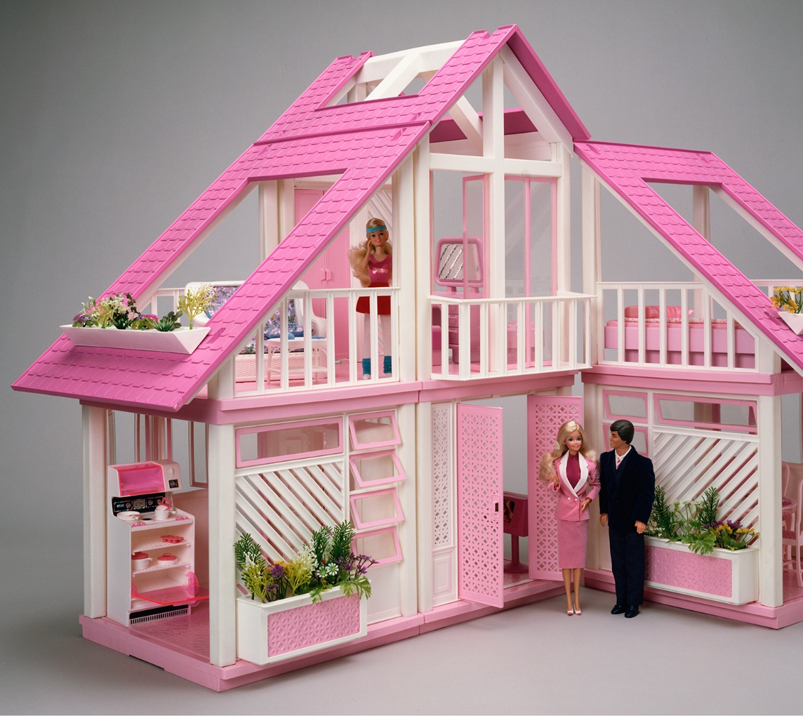

Image: Mattel, Inc.

This Dreamhouse uses the same molds as the ‘79 Dreamhouse, but with a pink color scheme.

Fun features: The new color scheme and updated furnishings give this house a completely different vibe than the ‘79 house.

1995 Barbie Dreamhouse

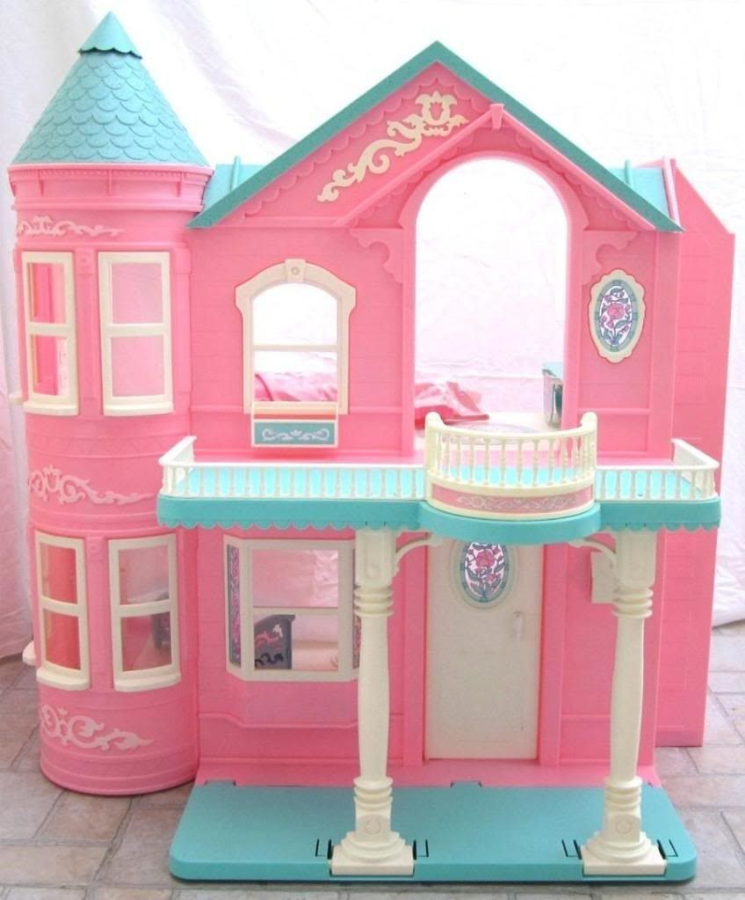

Image via Pinterest

A beautiful two-story Victorian-style house with a balcony, elevator and stained glass windows. This house was also made into a Hallmark ornament in 1995.

Fun features: Elevators were a common feature with the Barbie Townhouses of the ‘70s and ‘80s, but this elevator was battery-operated. Plus, this house has a turret, and what little girl doesn’t want a Barbie house with a turret?

1998 Barbie Deluxe Dreamhouse

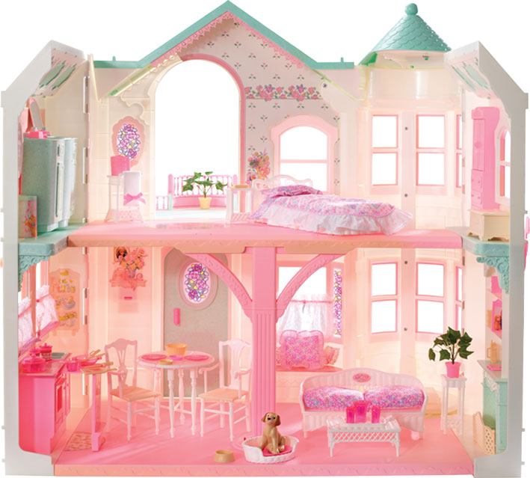

Image: Mattel, Inc.

This house is an updated version of the pink Victorian house. It came with updated furniture and significantly more accessories. It should be noted that while this house also has an elevator, its elevator is not battery-operated.

Fun features: This house has many of the same features as the ‘95 house, including the dresser/vanity that folds down to become a bathtub and the extending counter in the kitchen. A fun new addition, however, is a Kelly-sized swing on the front porch.

2000 Barbie Dreamhouse

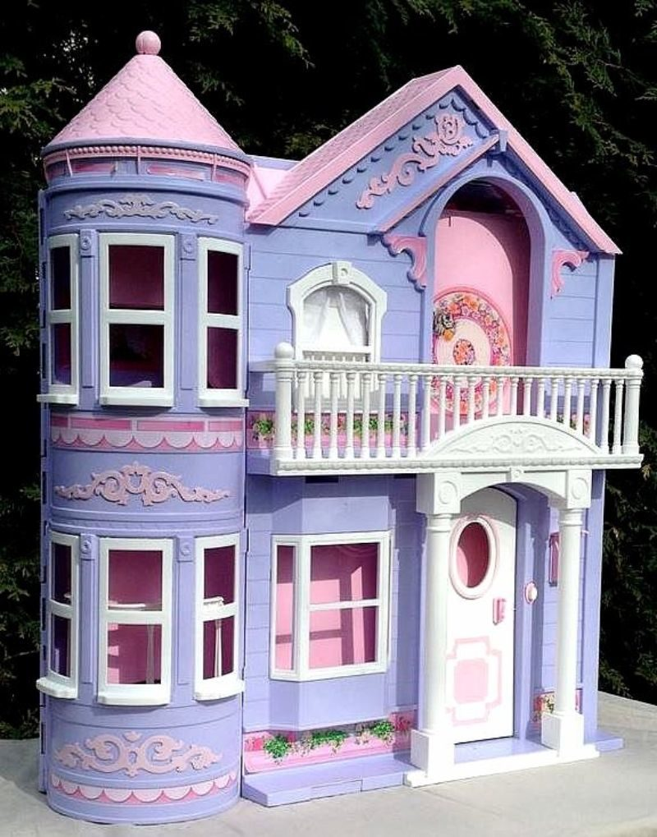

Image: BarbieDB.com

At first glance, this Dreamhouse looks like a recolored version of the ‘98 Dreamhouse or the ‘95 Dreamhouse, but there are some important differences. First, the balcony/porch combination has been modified, so it no longer folds out and is now significantly smaller and fixed in place. The stained glass windows are gone; the window on the front door is now open and the oval-shaped window on the second floor no longer exists. This house also has updated stickers and furniture.

Fun features: New features of this house include a claw-foot tub, a small sink and mirror and a crib for Krissy, Barbie’s baby sister.

Note: The purple plastic used for this house can become discolored. Discolored houses will appear to be a muted green color.

2006 Barbie 3-Story Dreamhouse

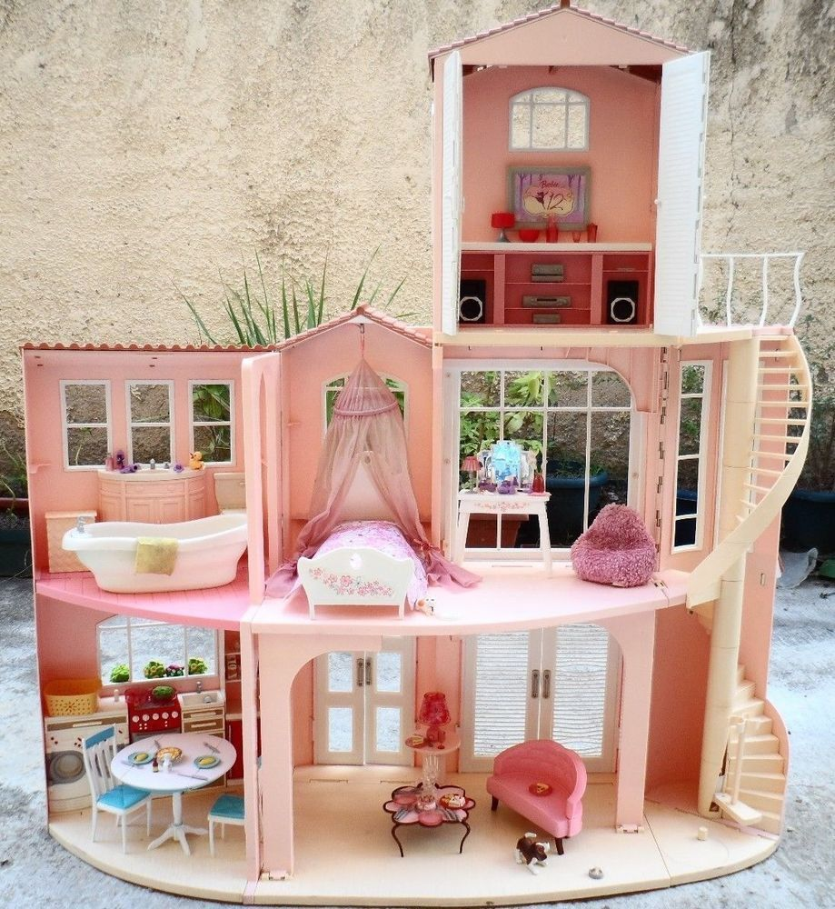

Image via Pinterest

This house is one of the largest houses produced for Barbie, and it sports three floors and is packed with amazing furniture and features.

Fun features: First, the third story on this house can be removed and played with separately. This house also has a spiral staircase, sound features and great amenities for Barbie, such as a washer and dryer and a full bathroom setup with sink, tub and toilet.

2008 Barbie 3-Story Dreamhouse

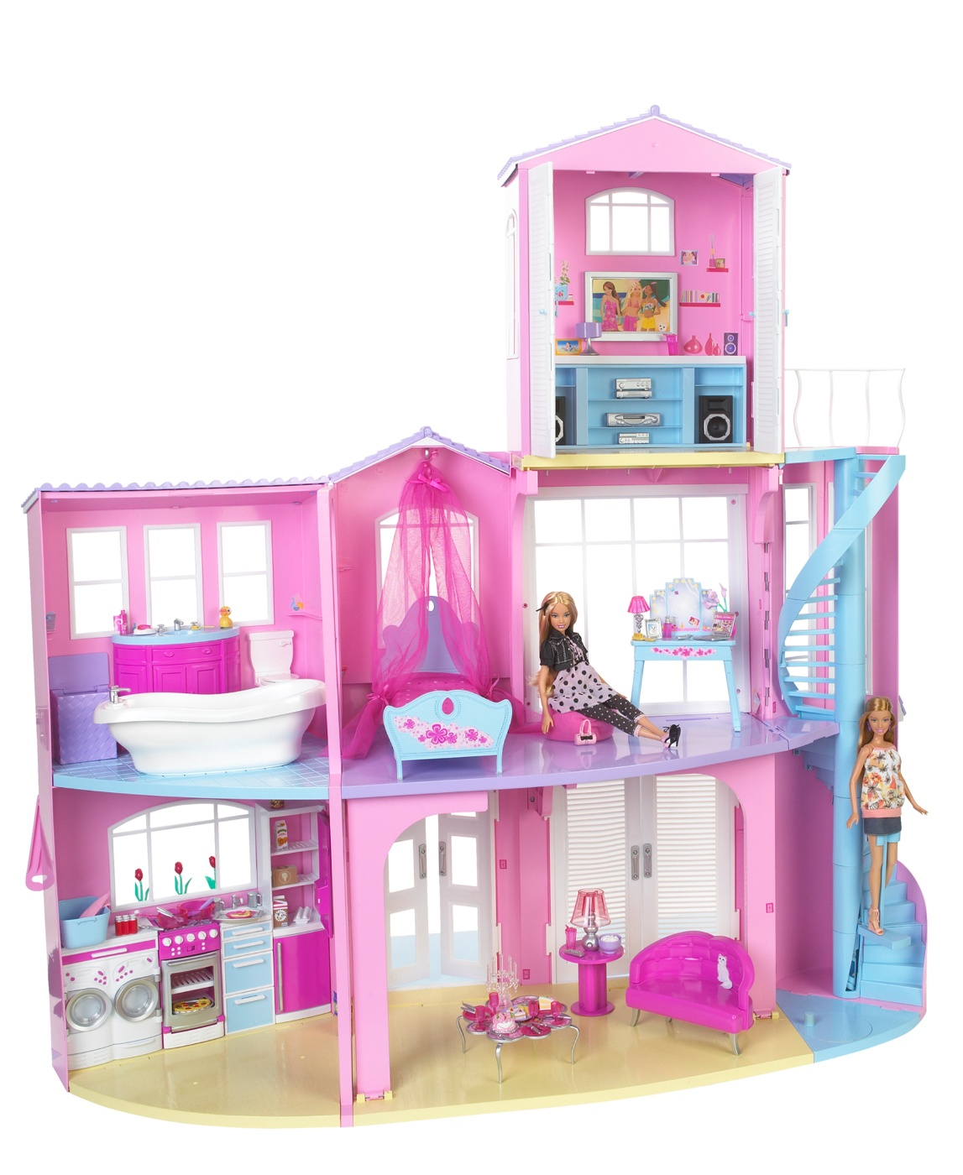

Image: Mattel, Inc.

This Toys 'R Us exclusive Dreamhouse uses the same molds as the 2006 house, but with an updated color scheme and new furniture.

Fun features: The color scheme on this house gives it a different, more “fun” vibe than the previous house. Like the other house, it has a spiral staircase with a mechanism to move a doll up the stairs.

2009 Barbie 3-Story Dream Townhouse

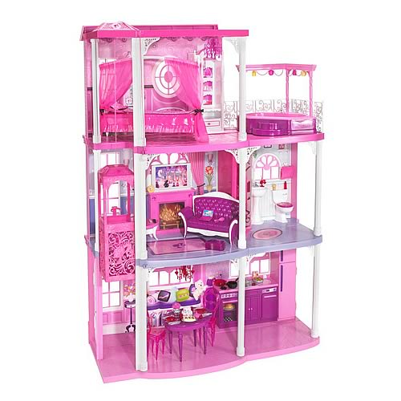

Image: Entertainment Earth

This house is highly reminiscent of the Barbie townhouses of the ‘70s with its 3-story structure and elevator operated by a pull string.

Fun features: This house has a 3rd-story balcony with a hot tub! It also has much more “glam” styling than previous Barbie houses, which is a lot of fun.

2011 Barbie Malibu Dreamhouse

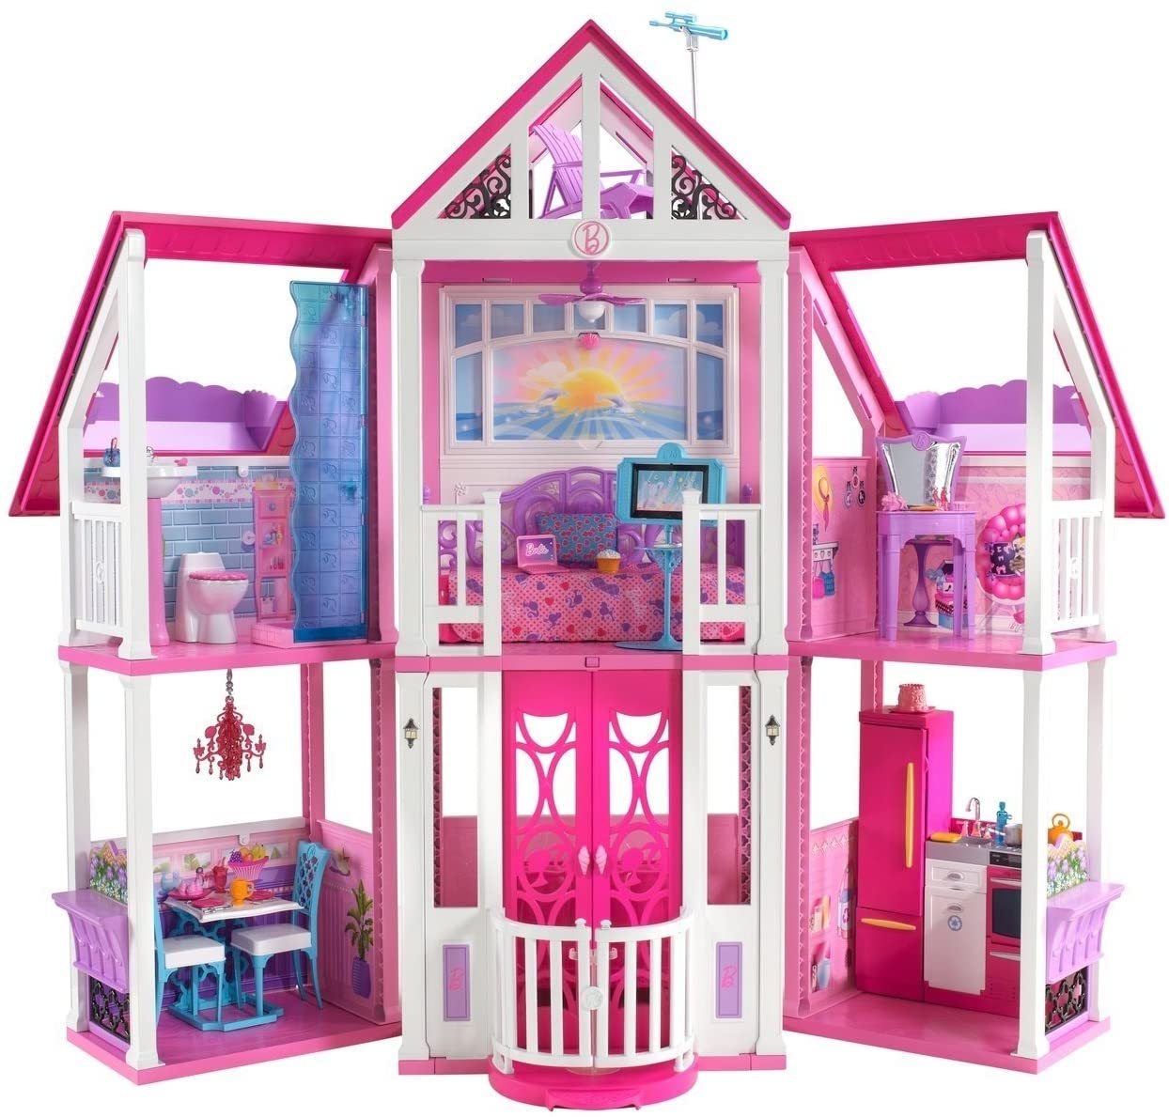

Image: Amazon

The structure of this house is a definite callback to the A-frame style of the ‘79 house, but updated with modern features. This house was a Toys ‘R Us exclusive and was essentially a repackaged version of the Barbie California house from 2010 (non-U.S. released).

Fun features: This house has a rooftop balcony with a telescope for stargazing! How cute is that?

2012 Barbie 3-Story Dream Townhouse

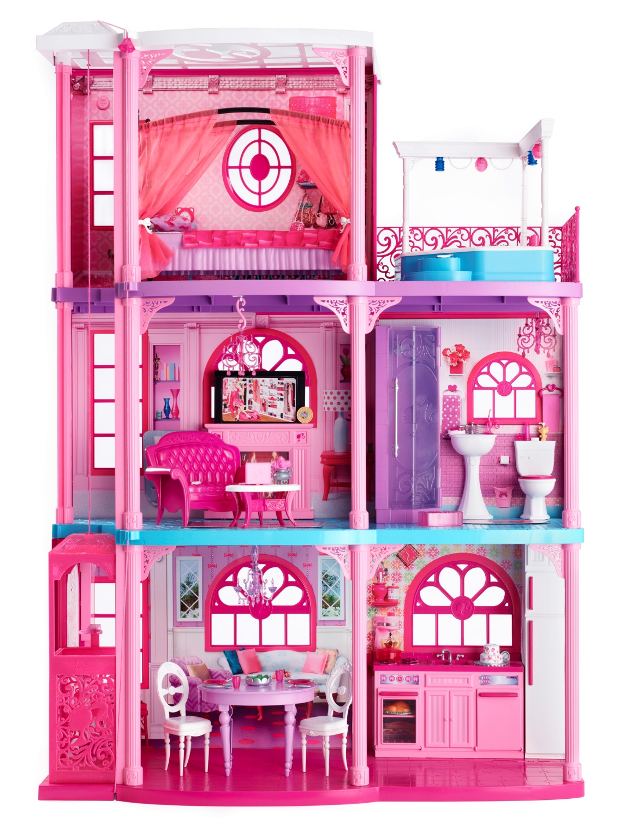

Image: Mattel, Inc.

This house is a recolored version of the 2009 house. It is still mainly pink, but uses more blue and purple accents. Updated graphics also help give this house a fresh look.

Fun features: This house is almost identical, feature-wise, to the 2009 house. Something of note is both houses include a shower instead of a tub, most likely for space reasons. Most Dreamhouses up to this point had tubs instead of showers, if a bathroom was included at all.

2013 Barbie Dreamhouse

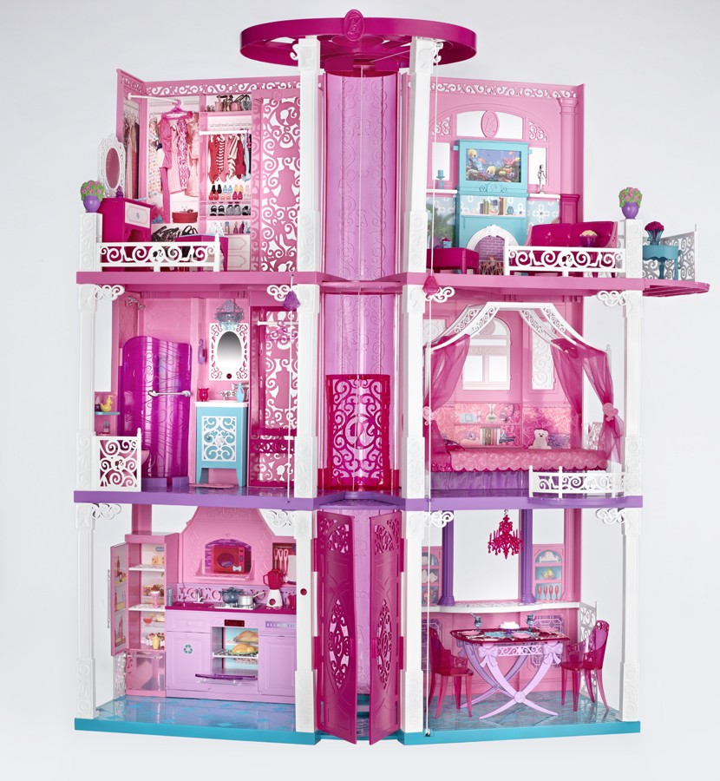

Image: Mattel, Inc.

This is the titular Dreamhouse of the “Barbie: Life in the Dreamhouse” series! As such, it’s appropriately large, glamorous and well-furnished. It’s three stories and boasts six distinct rooms and a balcony.

Fun features: This house has two elevators: one in the center of the house for dolls and one in the walk-in closet for accessories. The accessories elevator goes down to the bathroom, so Barbie can pick out her outfit and send it down to the bathroom to change into after a shower!

2015 Barbie Dreamhouse

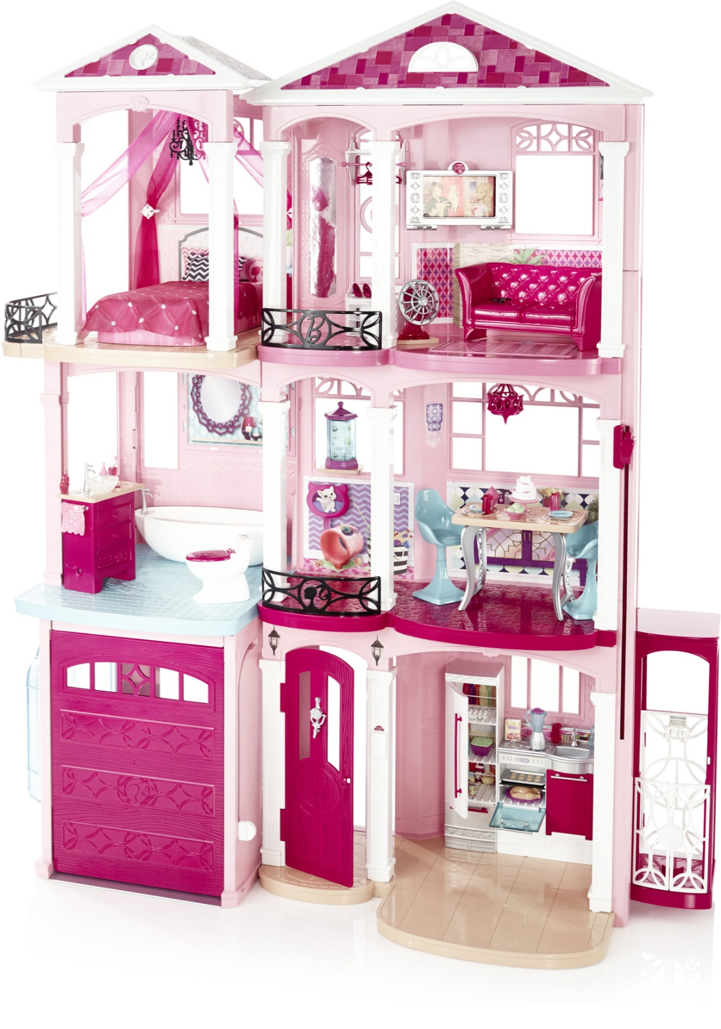

Image: Mattel, Inc.

While also boasting three stories, this house is not as spacious as the 2013 house. It has a more subtle styling while still capturing the “glam” feel of the previous house.

Fun features: This house actually has a garage with a garage door so Barbie can park her car! This is the first Barbie house with this feature. It also had a TV with a flip-down feature so you could insert a smartphone and play your own videos.

Note: This house was released under multiple stock numbers, but each is essentially identical. According to the Mattel parts website, the house was released in 2015 with stock numbers CJR47 and DHC10, and in 2016 under stock #FFY84.

2016 Hello Dreamhouse

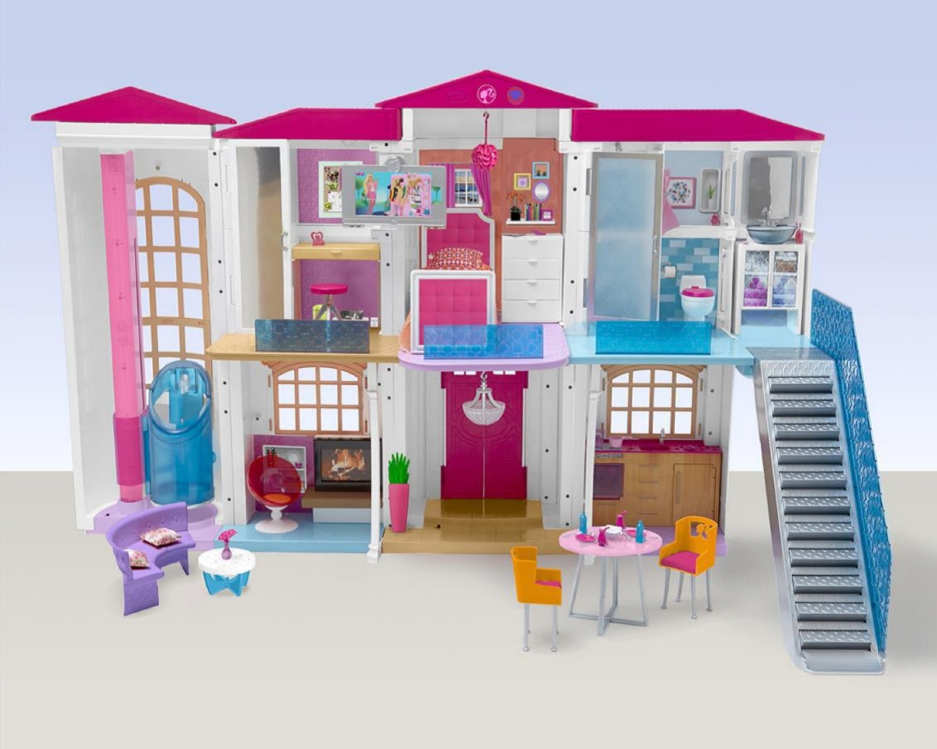

Image: Mattel, Inc.

This Dreamhouse is Barbie’s first Smart Home. While many of the previous houses have had light and sound features, this is the first Barbie house that is voice-controlled.

Fun features: Some of the voice-controlled features include the elevator, the front door and a staircase that turns into a slide. If that’s not the coolest thing, I don’t know what is.

2018 Barbie Dreamhouse

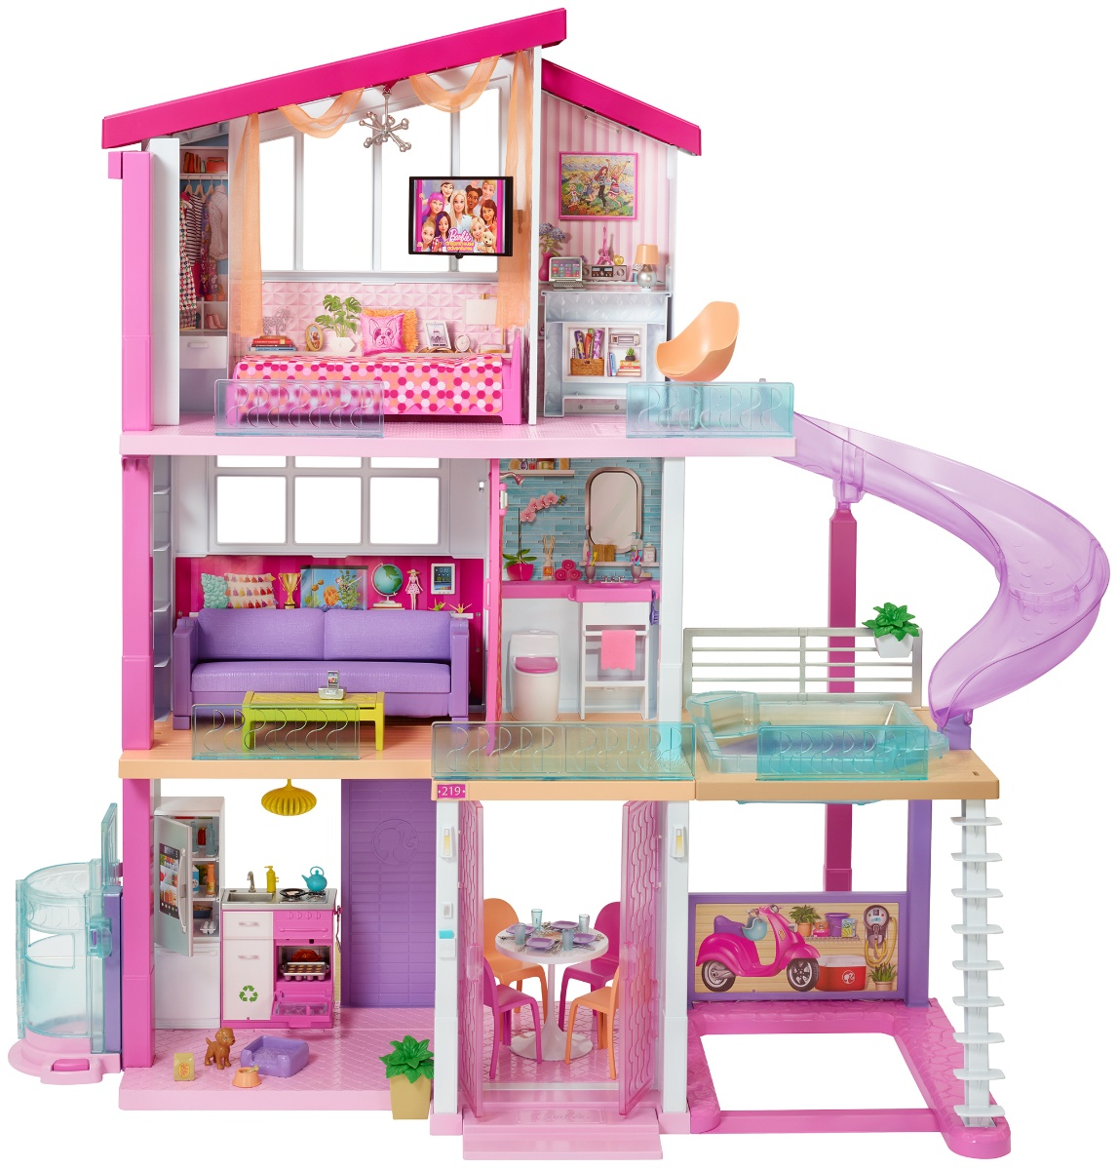

Image: Amazon

This Barbie Dreamhouse was released in conjunction with the “Barbie: Dreamhouse Adventures” series and boasts three floors, eight rooms and over 70 accessories.

Fun features: This Dreamhouse has a pool and a waterslide! Other fun features include converting furniture, light and sound features and a home office for Barbie.

2019 Barbie Dreamhouse

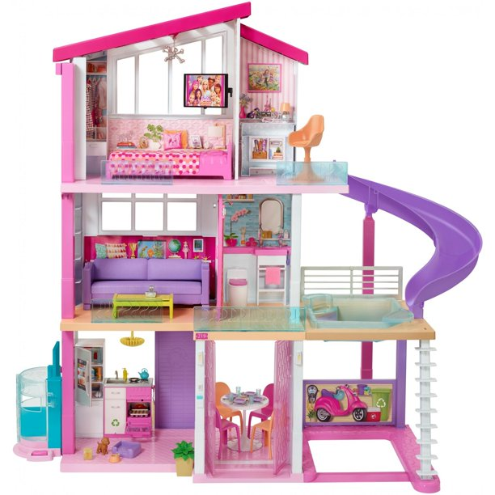

Image: Walmart

The 2019 Dreamhouse is essentially a recolored version of the 2018 Dreamhouse. Some accessories and graphics have also been modified on this house.

Fun features: Like in the 2018 house, the pool on the balcony can actually hold water!

2020 Barbie Dreamhouse

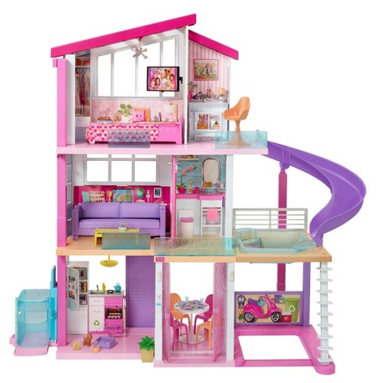

Image: Target

This Dreamhouse is identical to the 2019 house, except with a modified elevator.

Fun features: The elevator can now hold a doll in a wheelchair, or four standing dolls!

2021 Barbie Dreamhouse

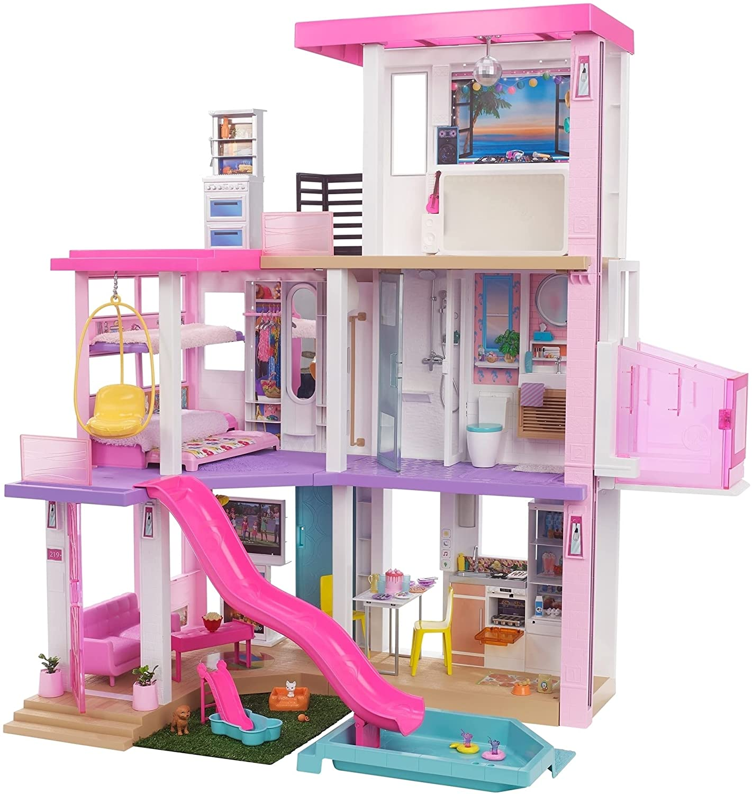

Image: Mattel, Inc.

The latest iteration of Barbie’s Dreamhouse boasts expanded play areas, more transforming furniture and cool new accessories.

Fun features: The best part of this house is that it can be customized. The pool, slide and lawn pieces can be placed in different spaces on and around the house. This house also has a wheelchair-accessible elevator and three beds for Barbie and her sisters!

