Decoding 12 Lesbian Symbols From Ancient to Modern
LAST UPDATED ON AUGUST 1, 2025 BY ISA
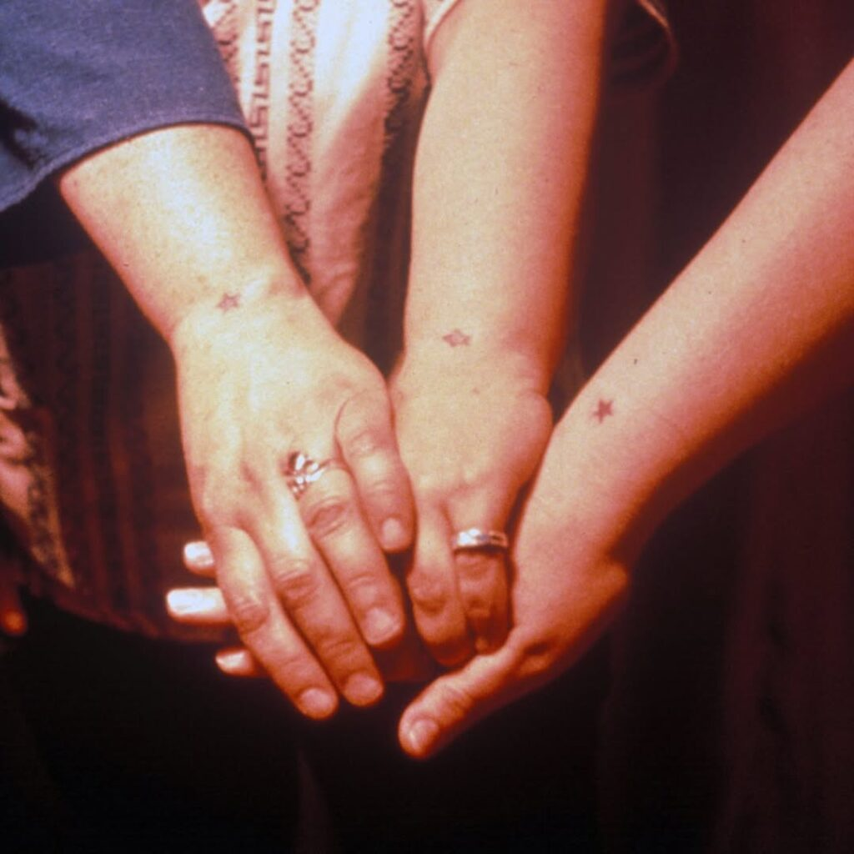
A carabiner clipped to a belt loop. A nautical star wrist tattoo. A “lavender menace” shirt. These are just some of many sapphic symbols I’ve slowly been discovering that signal lesbian identity, pride, and history. Beyond the rainbow flag and woven into objects, colors, and even emojis, each carrying its own unique story. Let’s decode them.
Some of these lesbian signs and symbols trace their roots back centuries as the violets immortalized in Sappho’s poetry. Others are freshly minted, born from today’s sapphic renaissance, where young queer women are reclaiming and redefining their identity through modern icons.
x
Ad ends in 1
Video Muted
Why do these symbols matter? Because they’re more than markers of identity. They’re a way to connect. Sometimes, it’s the subtle glint of sapphic jewelry that sparks recognition in the wild, especially for those of us still finding our queer community. Other times, it’s a loud choice to wear your pride on your sleeve: through a lesbian tattoo.

1. Violet Flowers
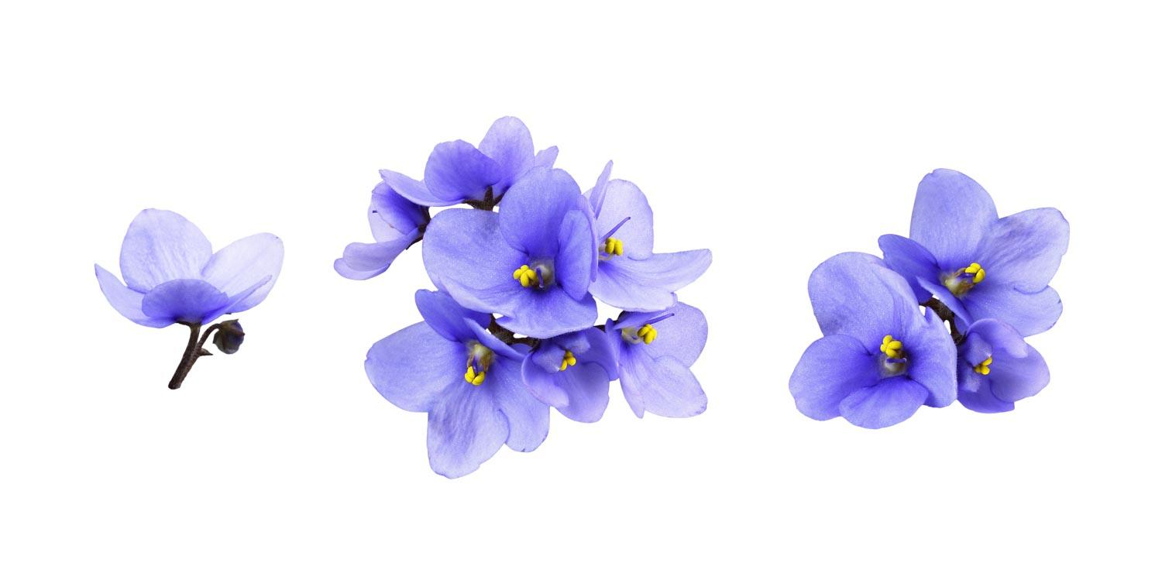
Sapphic violet begins with Sappho, the ancient Greek poet who lived on the island of Lesbos around 600 BCE. Often referred to as the OG of sapphic love poems, she used violets in her poetry as symbols of love and desire between women. Over time, the delicate violet became forever tied to her legacy, solidifying its role as a symbol of sapphic love. It’s no coincidence that the very words “lesbian” and “sapphic” come from her name and home, making her a cultural cornerstone of queer identity.
Fast forward to the modern times, violets reemerged. In 1926, Edouard Bourdet’s play The Captive debuted in Paris, tells the story of a same-sex love affair between two women, a plotline that was both groundbreaking and scandalous. In one key scene, one of the women receives a bouquet of violets from her lover. This simple act struck a chord with queer people in the audience, who began wearing violets as a subtle signal of support for the play. A violet pinned to a lapel or tucked into a hat became a lesbian flower symbolism.
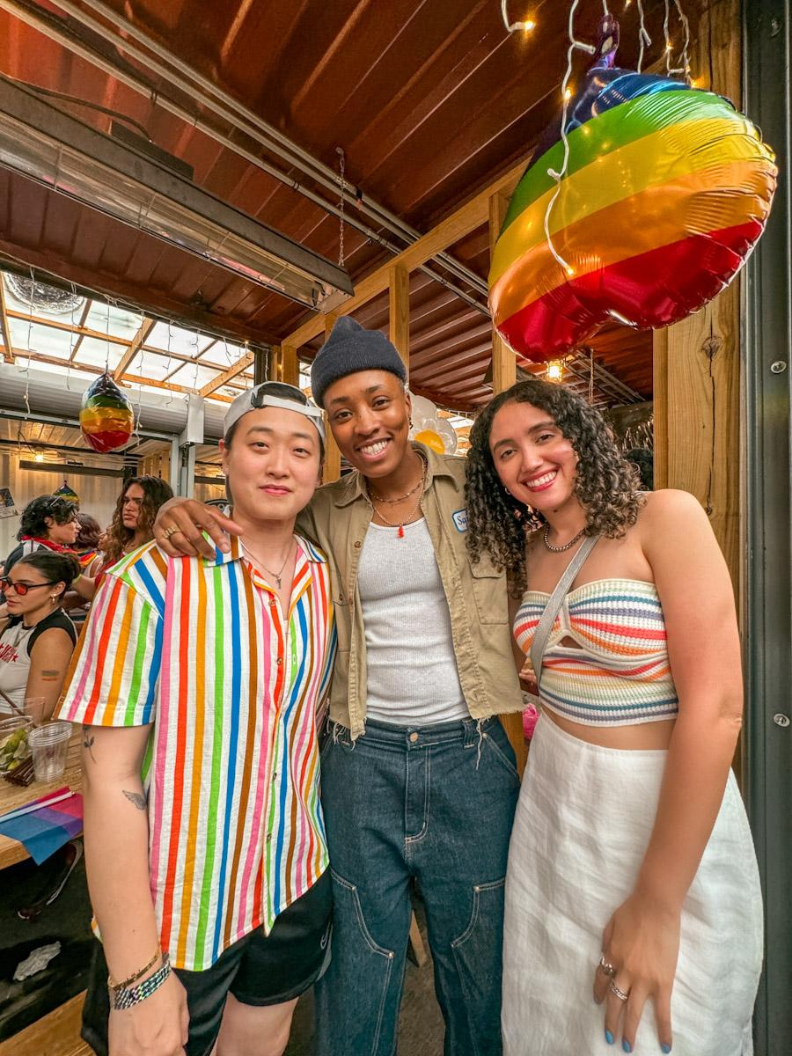

Queer/Sapphic Culture Newsletter
Get queer culture updates monthly! That includes: What's going on in Lesbian TikTok? A lesbian positive news section. Queer culture news. All in one email!
SUBSCRIBE
We use your personal data for interest-based advertising, as outlined in our Privacy Notice.

2. Scissors
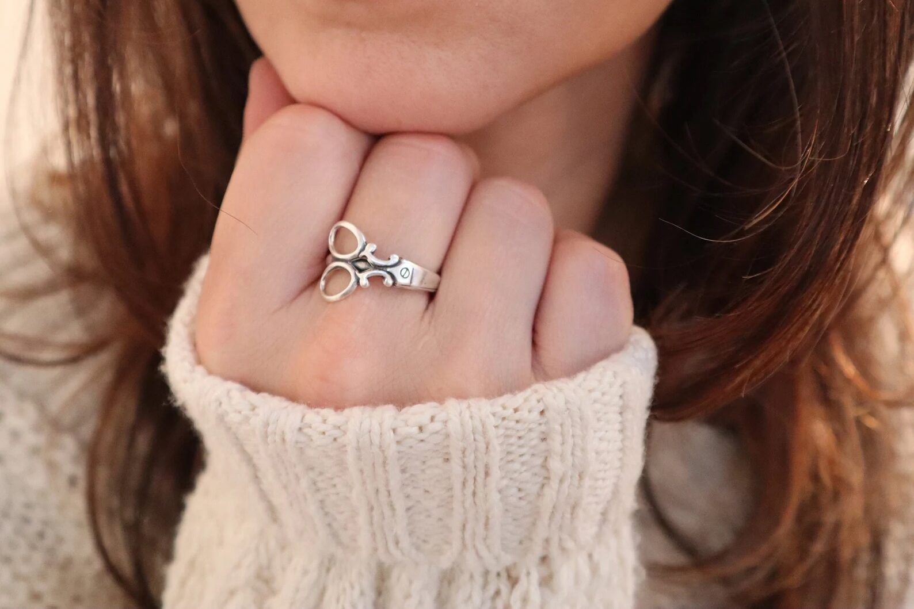
Yes, those scissors. A cheeky, irreverent symbol of lesbian intimacy and connection. Playful and unapologetic, scissors have taken on a life of their own, winking at one of the most debated (and perhaps misunderstood) positions in queer circles. Is scissoring real? Maybe, maybe not. But That’s hardly the point.
Scissoring AKA “tribadism,” has been documented in the 1800s to describe various forms of genital contact between women. But the history of tribadism goes much further than modern-day memes or bedroom jokes. The term originates from the ancient Greek word tribas, derived from tribein, meaning “to rub.”
This symbol has become a story of reclamation, taking what was once a fetishized stereotype and flipping it into an empowering symbol, an inside joke, and a lighthearted celebration of connection. Symbolizing the ways queer culture defiantly creates its own language.

3. Snake
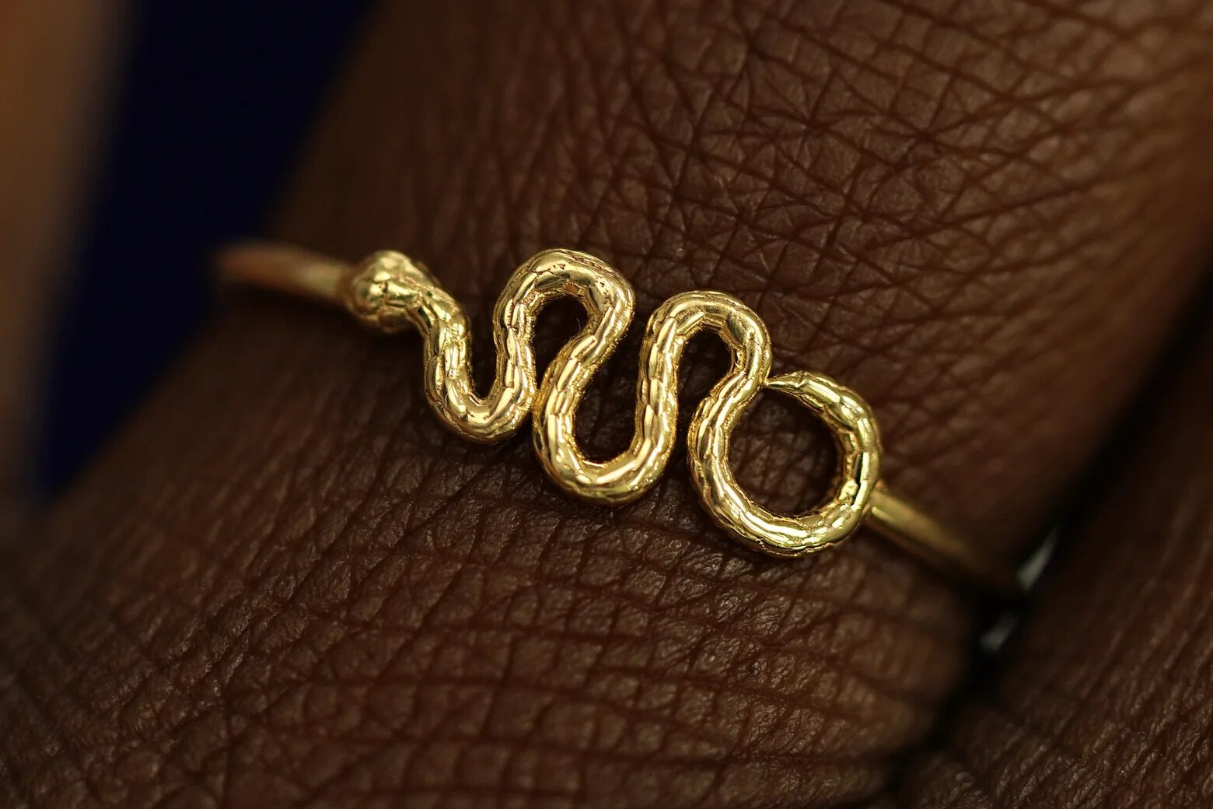
Automic Gold
In the 2020s, snakes have slithered into the spotlight as one of the most iconic symbols of the lesbian renaissance, embraced particularly by Gen Z sapphics. Spot a girl with a snake tattoo? Chances are, she’s queer. From lesbian rings and tattoos to countless other forms of personal expression.
Why snakes? Part of their appeal lies in their rebellious energy or what some might call “dark femininity.” Snakes have long been associated with defiance, often demonized in religious and cultural narratives. In Christianity, for example, the serpent in the Garden of Eden is portrayed as a figure of temptation and sin, reinforcing their image as forbidden and subversive.
Snakes are also deeply tied to themes of transformation, making them an especially resonant symbol for the queer experience. As creatures that shed their skin, snakes represent renewal, growth, and the ability to leave behind what no longer serves them. For many queer individuals, this process mirrors the journey of coming out, breaking free from societal expectations, or embracing fluid identities.
In ancient mythology, snakes have often represented healing and rebirth. For instance, in Greek culture, the ouroboros (a snake eating its own tail) symbolizes infinity and the cycle of renewal, ideas that align perfectly with the self-discovery and reinvention that define so many queer lives.
In Indian art, the serpent goddess Nagini symbolizes growth while in African traditions, snakes are revered as bringers of wisdom. In Mayan and Aztec spirituality, they also represent rebirth and renewal.

4. Interlocking Double Venus
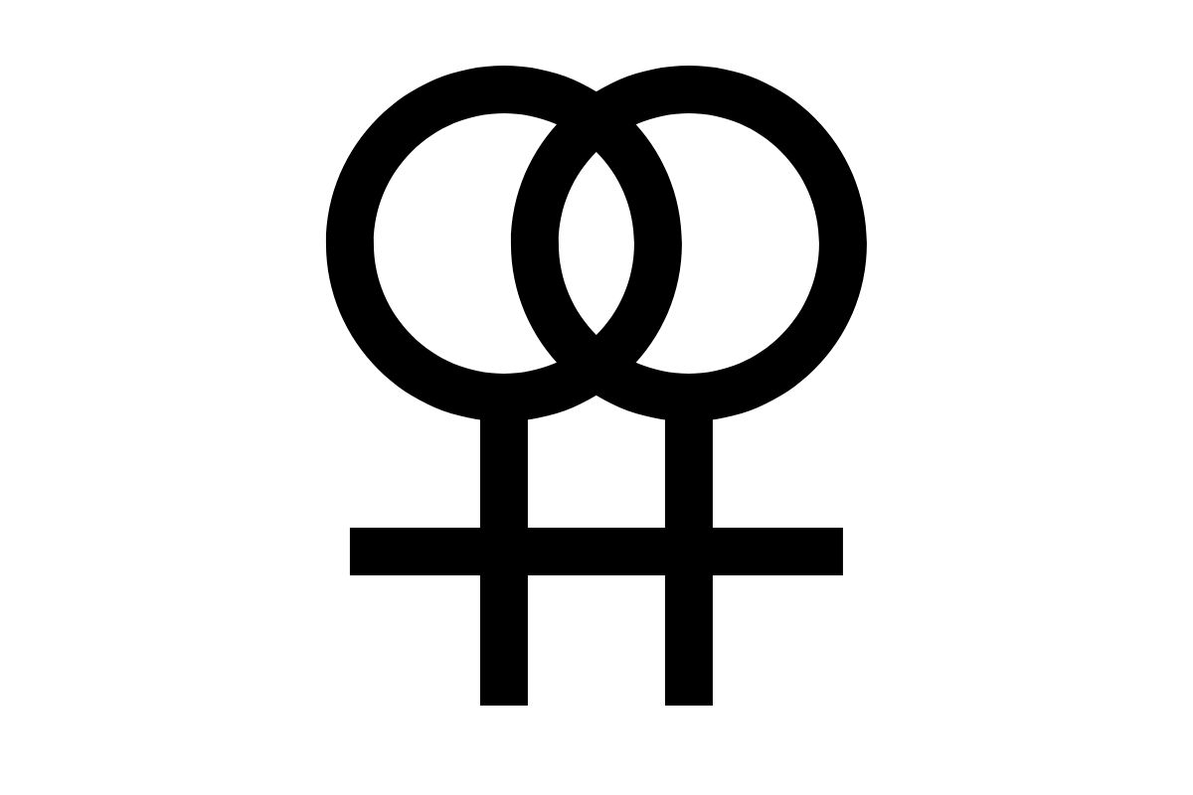
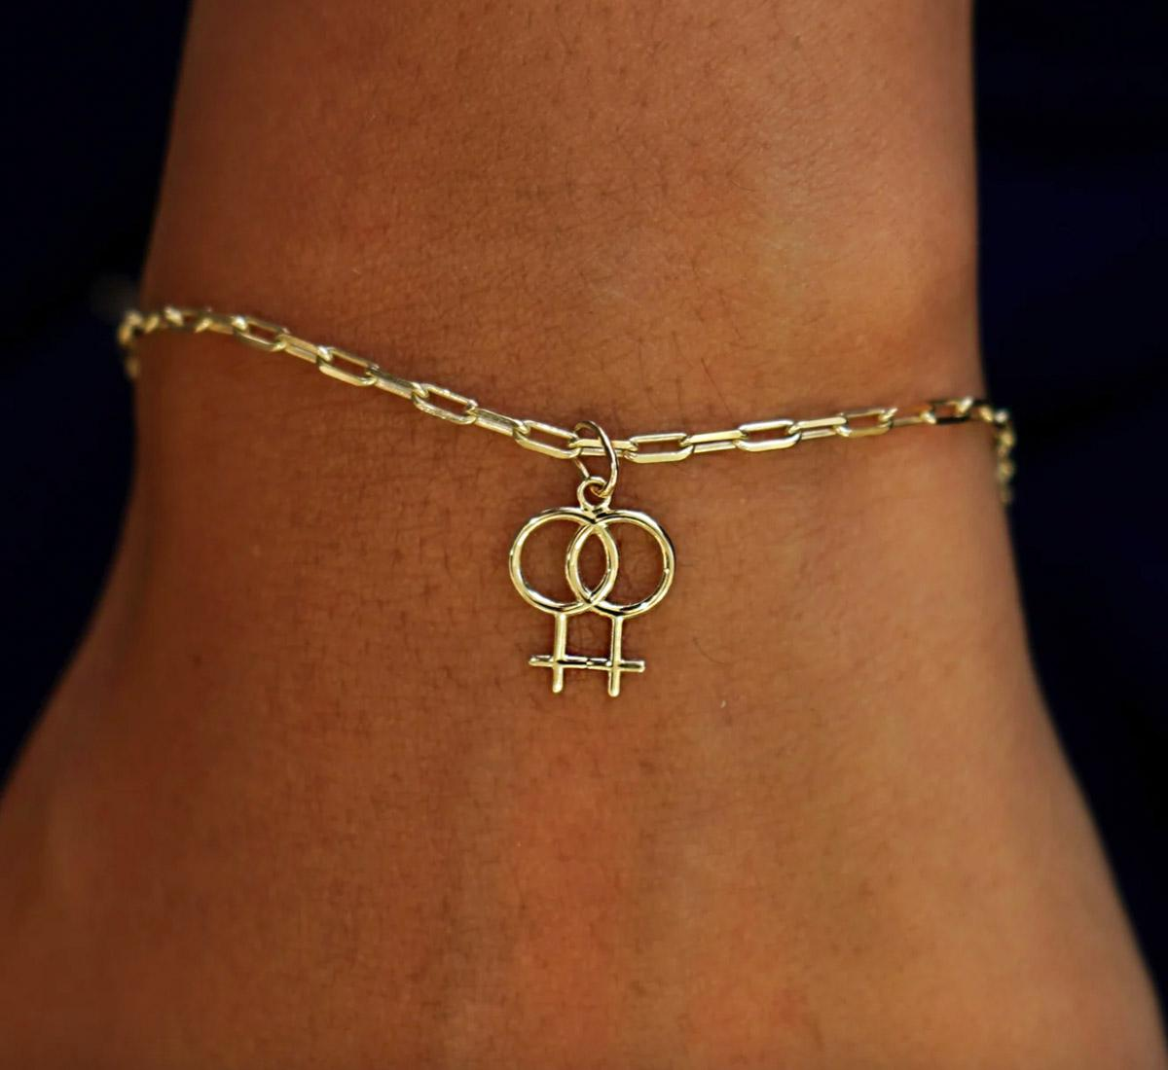
Automic Gold
Two interlocked female symbols become the universal shorthand for love between women.
The story of the Venus symbol itself goes back to ancient times. Named for Venus, the goddess of love, beauty, and fertility, her symbol represents femininity and attraction. The idea of pairing two interlocked Venus symbols came later as a visual metaphor for unity and love between women.
By the 1900s, the double Venus had solidified its place in feminism and lesbian culture, appearing on stickers, jewelry, flags, and tattoos.

5. Black Triangle
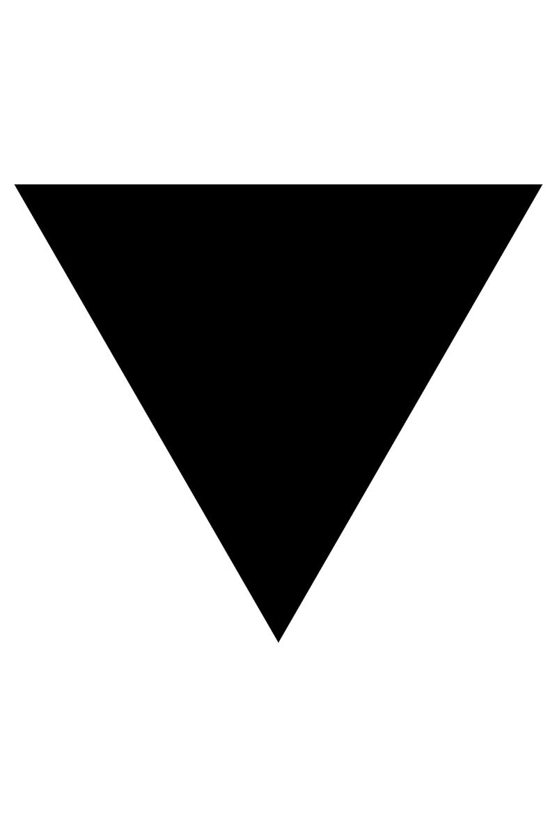
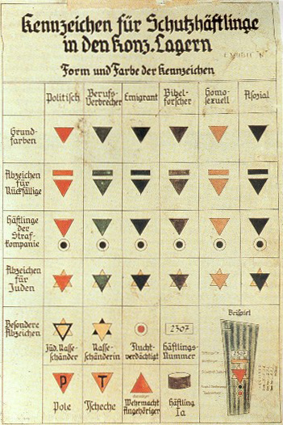
The black triangle’s dark history begins during World War II, when Nazi Germany used geometric shapes to classify prisoners in concentration camps. Similar to how Jewish people were forced to wear yellow stars, gay men were marked with downward-pointing pink triangles. And lesbians (and others deemed “asocial”) were labeled with black triangles. This category, intentionally broad and dehumanizing, included sex workers, people with disabilities, and suspected lesbians.
So the black triangle was double-edged for lesbians because by labeling them as “asocial,” the Nazis denied their existence as queer women, erasing their identities while simultaneously marking them for exclusion and punishment.
But as history has shown, queer communities have a unique ability to reclaim and redefine. During the feminist and LGBTQ+ rights movements of the 1970s, activists began transforming the black triangle into a marker of defiance. Like the pink triangle for gay men, the black triangle became a reclaimed badge of honor, representing the resilience and strength of those who had been targeted and silenced.

6. Lavender Color & Word
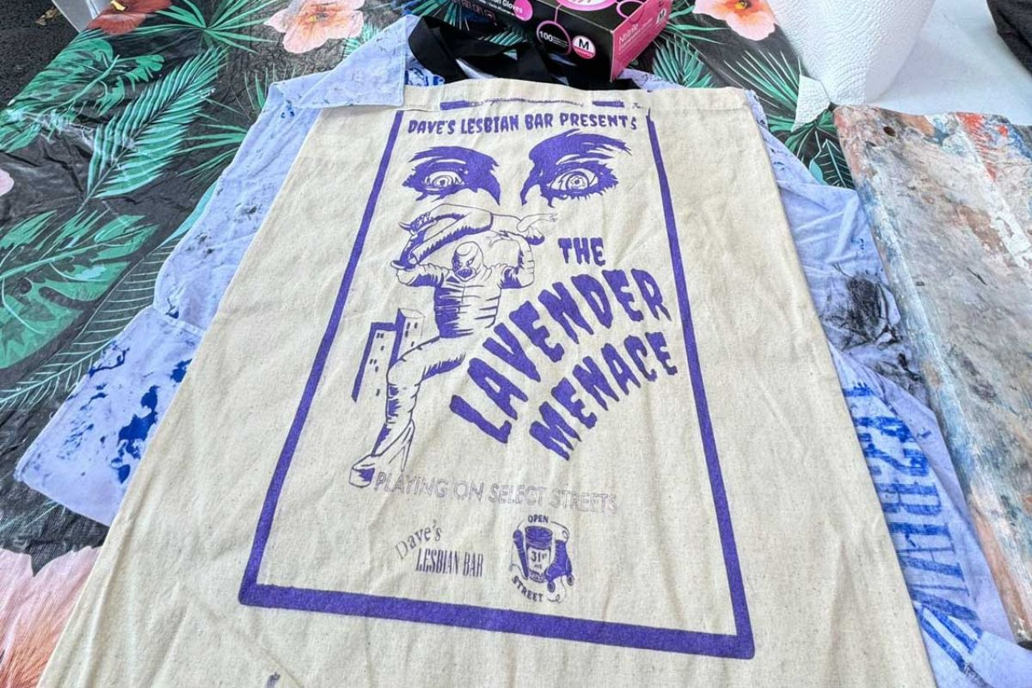
During the Lavender Scare of the 1950s, the U.S. government labeled thousands of gay men and women as “security risks” and purged them from federal jobs because they were deemed easier for extortion by communists. There’s a great TV show about this called Fellow Travelers.
In 1969, Betty Friedan, the famed feminist and author of The Feminine Mystique, labeled lesbians in the feminist movement a “lavender menace,” fearing their presence would derail the cause of women’s equality. So a year later, a group of unapologetic lesbian feminists proudly adopted the name “Lavender Menace,” storming the stage at the Second Congress to Unite Women in hand-dyed lavender t-shirts bearing the phrase. Their protest didn’t just reclaim Friedan’s insult. It demanded a seat at the feminist table and kickstarted a vital conversation about inclusivity and intersectionality.

7. Labrys (Double-Headed Axe)
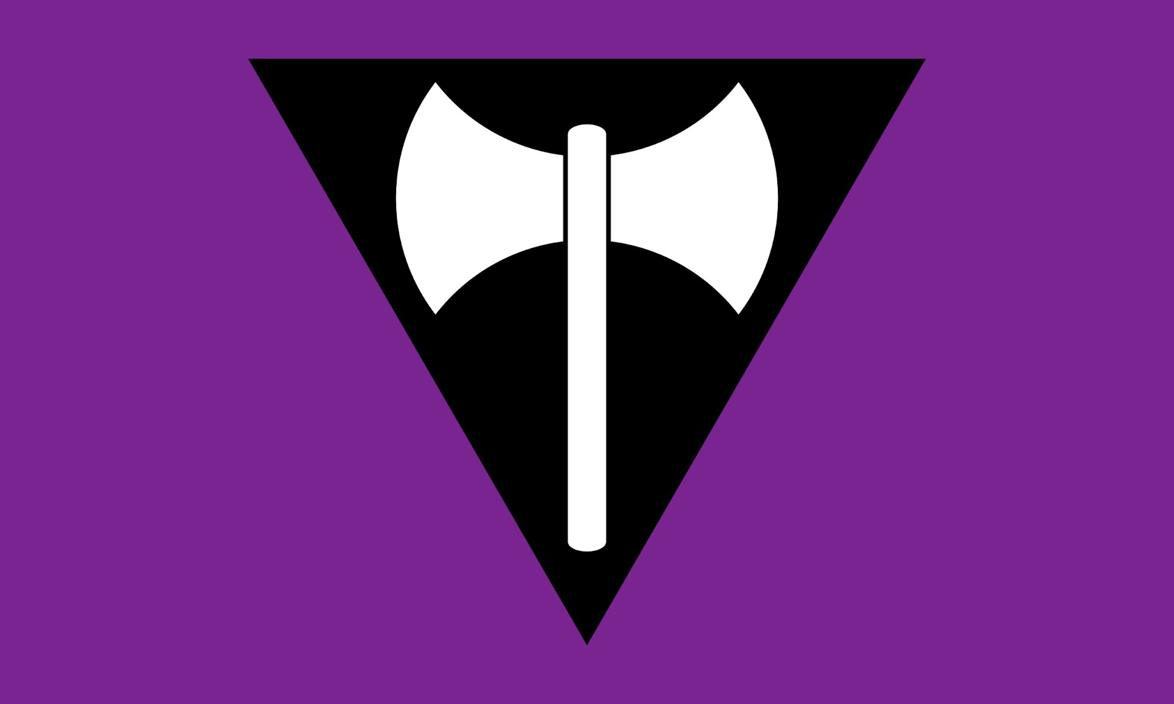
A labrys is a double-headed axe. According to Pitt Rivers Museum, in ancient Minoan Crete, the labrys was sacred, closely tied to goddess worship. Some myths link it to the Amazons, the fierce warrior women of Greek lore. Throughout time, the labrys has become associated with strength, autonomy, and matriarchal societies.
Fast forward to the 1970s, when lesbian feminists reclaimed the labrys as a symbol of resistance and resilience. For women fighting for equality and visibility, the labrys was a perfect fit: powerful, unapologetic, and rooted in a history that predated patriarchal systems.
Then, in 1999, the labrys took center stage on the labrys lesbian flag, designed by Sean Campbell. Featuring a white labrys over an inverted black triangle on a violet background, the flag carries layers of meaning (see black triangle and violet listed above). This flag is considered by some to be the oldest explicitly lesbian flag, although it never gained widespread popularity due to its stark design and probably the use of the black triangle, which some find too tied to trauma.

8. Nautical Star
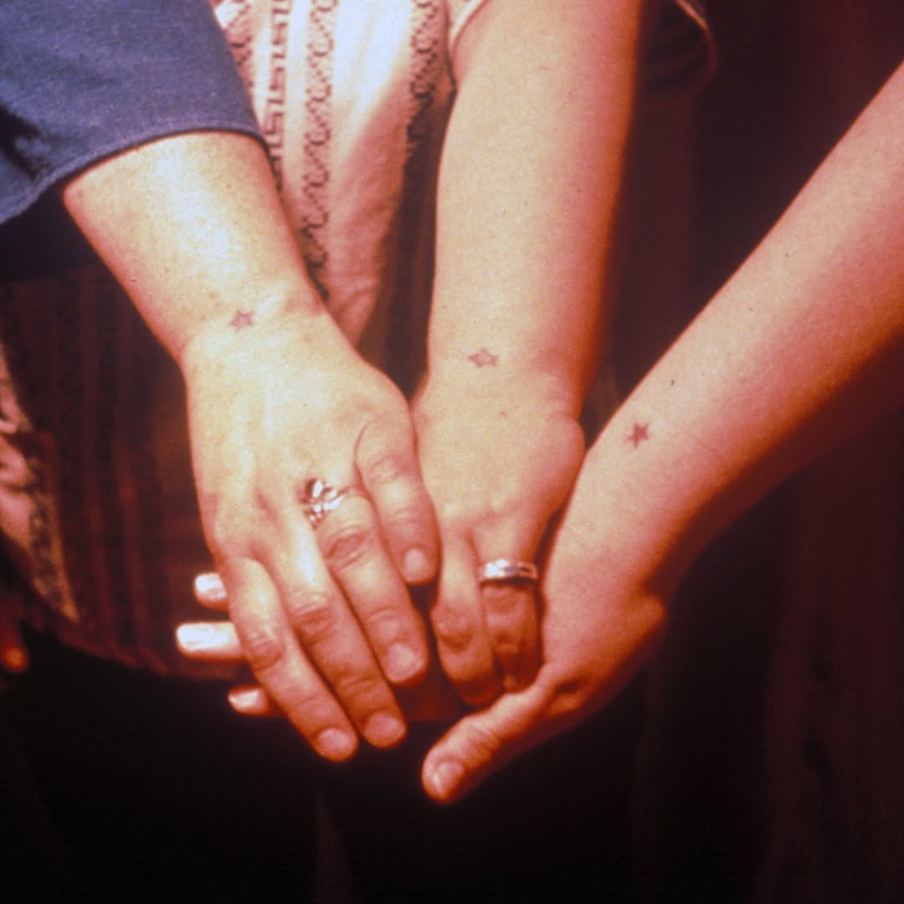
Lesbian Herstory Archives
The nautical star as a lesbian symbol originated in Buffalo, New York, in the 1950s, where lesbians often wore it as a tattoo on their wrists. Its placement wasn’t just aesthetic; it was practical. A star tattoo on the wrist could easily be hidden beneath a watch, offering a crucial layer of discretion at a time when being openly queer could lead to harassment, job loss, or worse.
It signaled belonging to an underground sapphic community, a way to find others like themselves without risking exposure.
Today, the nautical star continues to hold its place in sapphic symbolism, appearing not just as tattoos but also on rings, necklaces, and other accessories.

9. Lesbian Sunset Flag Colors
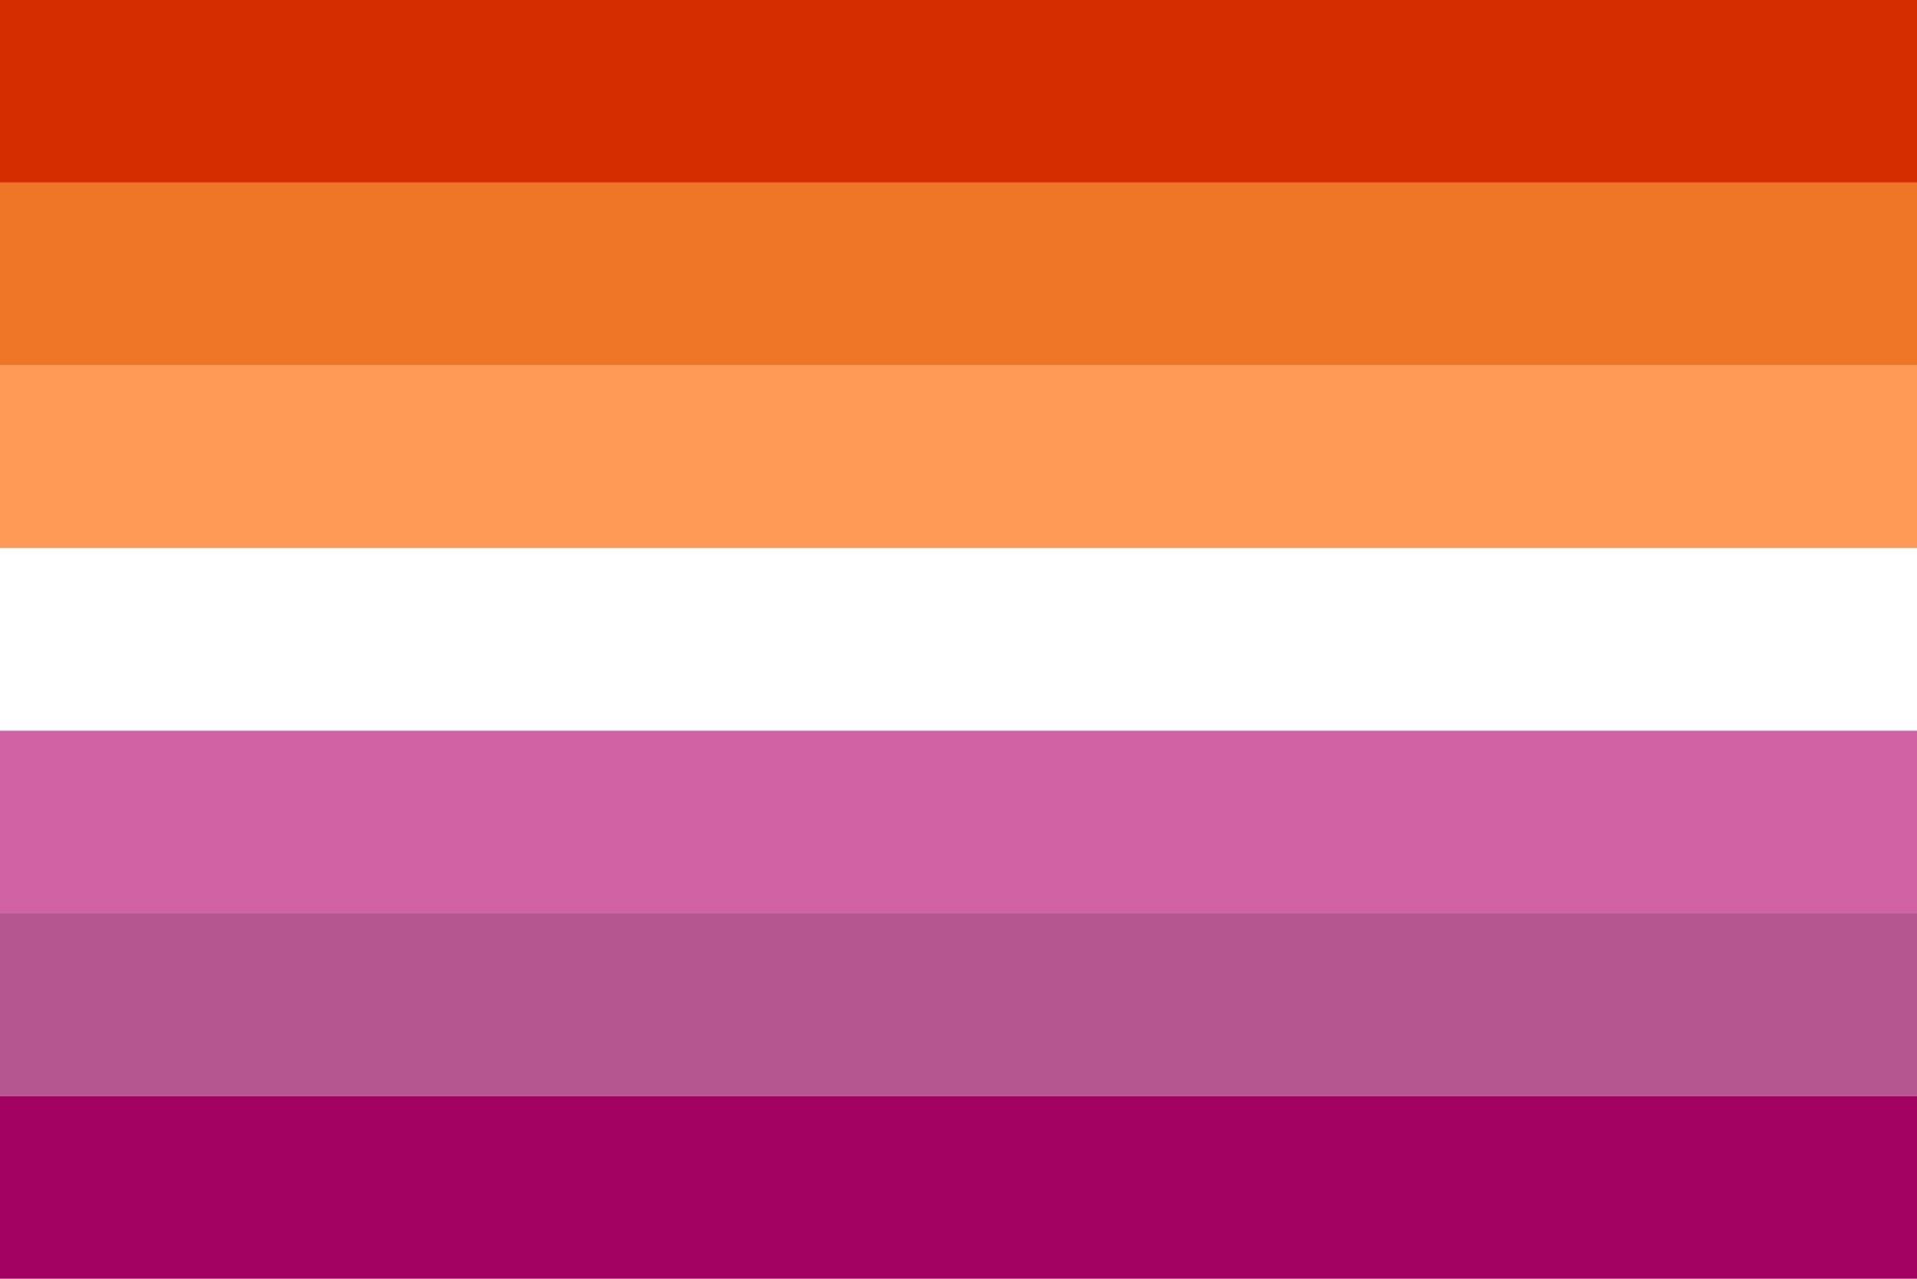
The lesbian flag, affectionately known as the “sunset flag” for its striking resemblance to the fiery tones of twilight, has a beautiful combination of pinks, purples, oranges, and white striped colors.
Outright International explains that each stripe of the sunset lesbian flag holds its own meaning: dark orange = gender non-conformity, orange = independence, and light orange = community. The white stripe = diverse connections to womanhood, pink = serenity and peace, dusty pink = love and sex, and purple rose = femininity.
Earlier versions of lesbian flags, like the “lipstick Lesbian” flag created in 2010, featured shades of pink with a kiss mark in the corner. While it resonated with some, many felt it was too narrowly focused on feminine lesbians, leaving others in the community feeling excluded. By 2018, the updated sunset gradient was adopted by many as a more inclusive representation of lesbian identity.
While not everyone feels comfortable flying a full-sized flag, the sunset colors can be incorporated into subtle pride signals. Think shoelaces, rings, bracelets, nail art, or even a carefully curated outfit featuring those unmistakable tones

10. The U-Haul
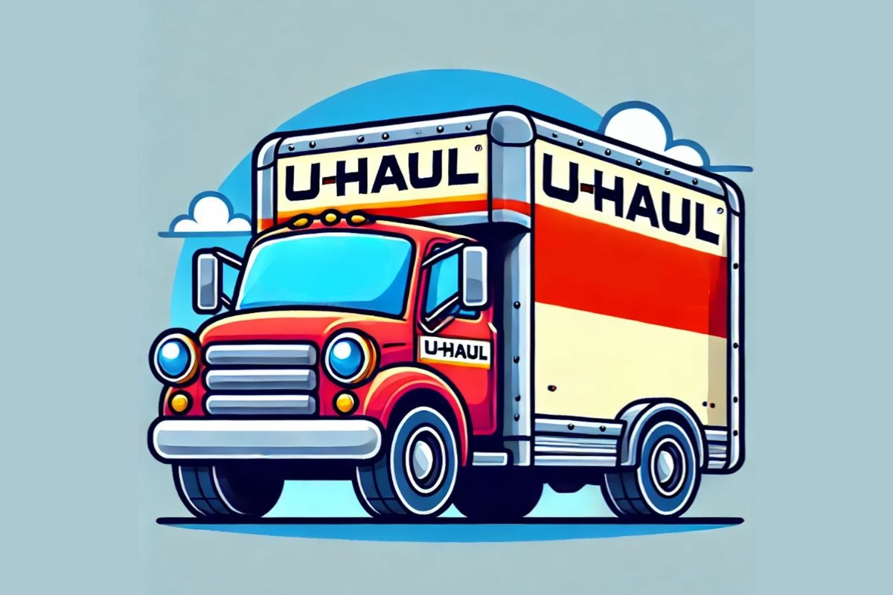
The U-Haul stereotype gained traction after lesbian comedian Lea DeLaria made a joke about how lesbians form connections quickly, deep and often unencumbered by the slow pace of traditional dating.
Now, the U-Haul lesbian slang is immortalized in memes, referenced in stand-up comedy, and proudly displayed on stickers and Pride merchandise. But before you slap that U-Haul logo on your Pride flag, it’s worth noting that U-Haul has donated to his presidential campaign.

11. Carabiner Keychains
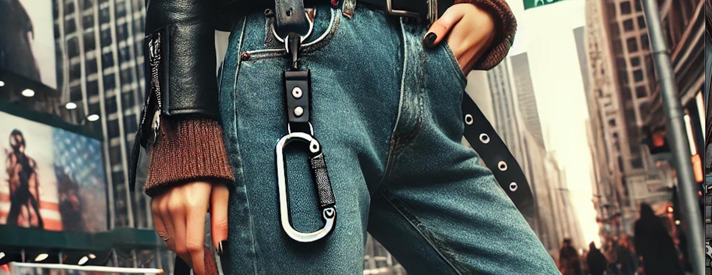
The carabiner’s roots stretch back to World War II, when women entered the industrial and blue-collar workforce in unprecedented numbers. Carabiners became a tool for these trailblazing women and symbolized their entry into traditionally male-dominated spaces. But it wasn’t just about utility; it marked a shift in gender roles and societal expectations, with women proving their strength, adaptability, and grit.
After the war, the carabiner quietly transitioned from factory floors to everyday life. By the 1970s, during the height of the feminist movement, it was embraced by women rejecting traditional notions of femininity. Feminists, and especially lesbians, opted for practical, functional accessories over delicate, decorative ones.
And in 2024 (a year I’m officially calling “the year of the lesbian”) the carabiner had a sapphic renaissance. It’s particularly beloved by mascs and chapstick lesbian types.
It’s also a jab at women’s fashion which often gives us tiny, useless or just no pockets. But the carabiner can hold your keys, chapstick, or even a reusable water bottle.

12. Symbols of Feminism
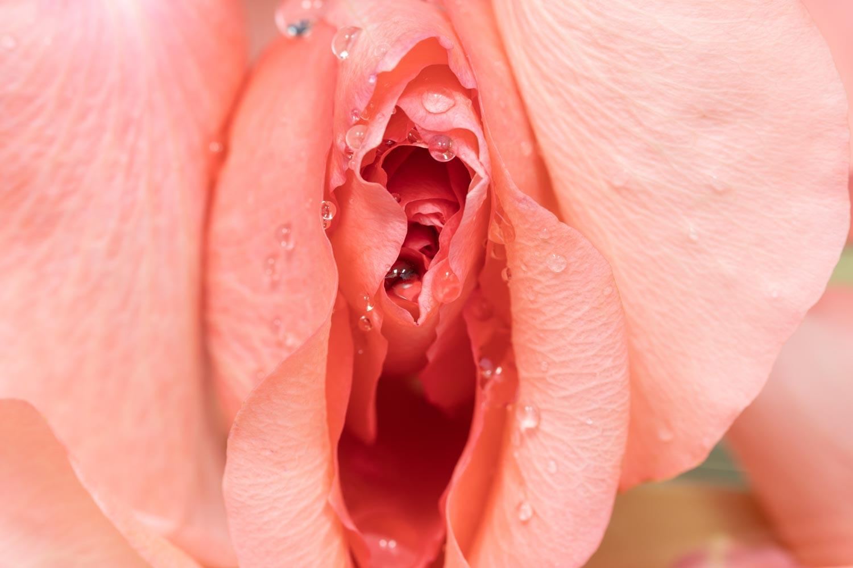
Take peaches, oysters, flowers, and other symbols of our vulva that we’ve been trained to be ashamed of. Georgia O’Keeffe’s now-iconic flower paintings are one of the most famous connections between nature and the female form.
For too long, women’s bodies have been objectified, shamed, and hidden. Embracing vulva-inspired imagery is a way of taking that narrative back. It echoes the feminist movements of the ’60s and ’70s, when women reclaimed their bodies, sexuality, and power. It’s a rejection of societal shame and an embrace of self-love, strength, and pleasure.

13. Monocle
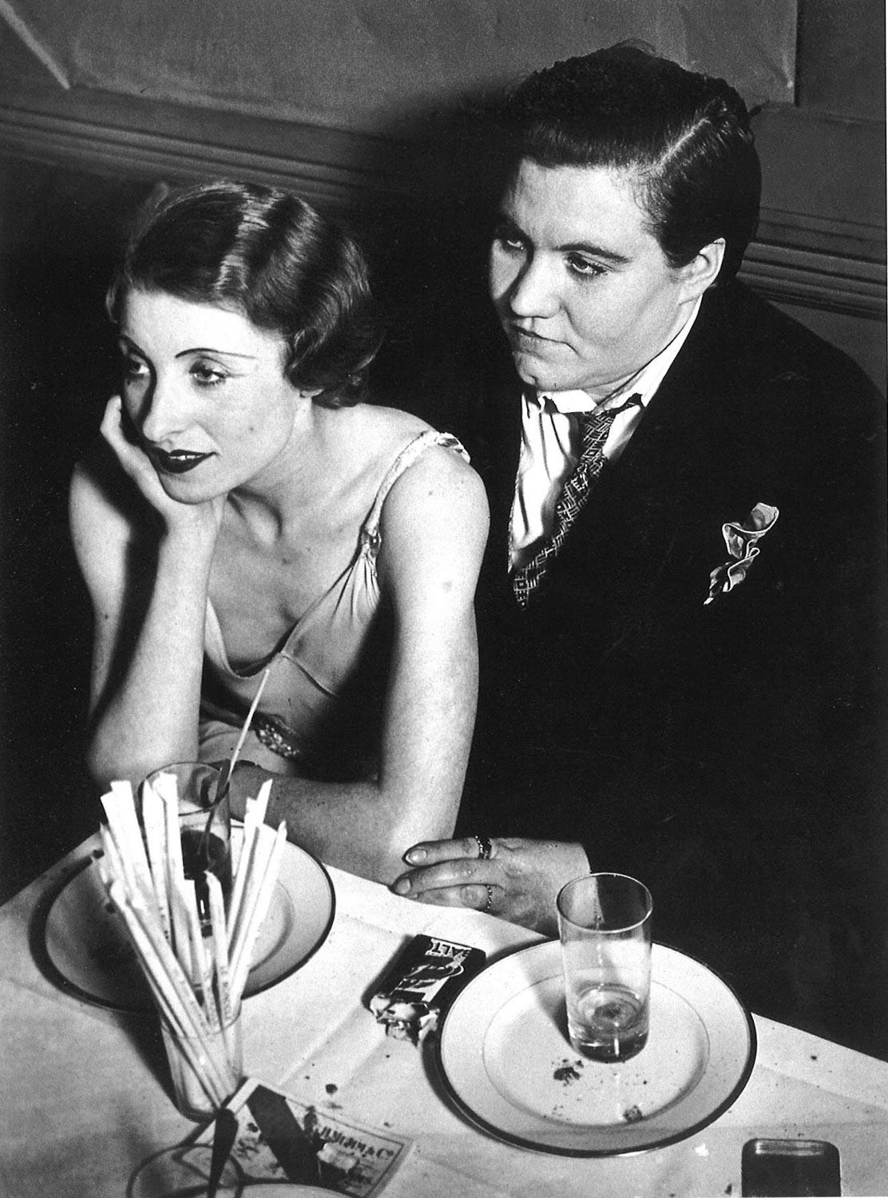
Brassaï, Lesbian Couple at Le Monocle, 1932.
Cleveland Museum of Art
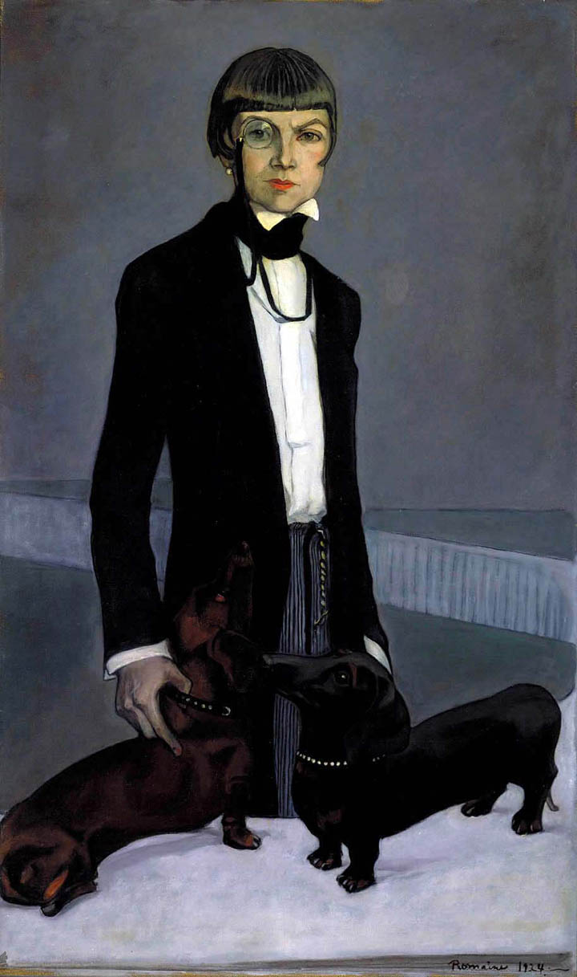
Romaine Brooks, Una, Lady Troubridge. Oil on canvas, 1924. Smithsonian American Art Museum
Historically, many lesbians used the monocle to discreetly signal their sapphic preferences, according to A Short History of Queer Women and Dressing Dykes.
Initially, a fashion piece associated with aristocratic men during the 18th century through 1920s, trailblazed by Antiquarian Philipp von Stosch.
Then, during the Roaring 20s, women enjoyed more freedom and gained more rights (Suffrage Movement), and even British Vogue was led by queer women at the time. At the same time, the historic lesbian club in Paris, Le Monocle, became one of the first lesbian clubs in the city; a safe space where queer upper-class women could freely express themselves. It boomed from through 1940s until the Nazis invasion of France. Despite its closure, Le Monocle undeniably left a legacy as a symbol of early lesbian visibility.
This TikTok by Dressing Dykes highlighted an ad from the lesbian nightclub Damenklub Violetta in Berlin, promoting an event called Monokelfest in 1928, where “every lady gets a monocle for free.” Highlighting the expanded link between the monocle symbol and sapphic pride, which is spreading beyond Paris, showcasing its wider cultural significance in queer communities.

The great big lesbian dictionary
BLOG
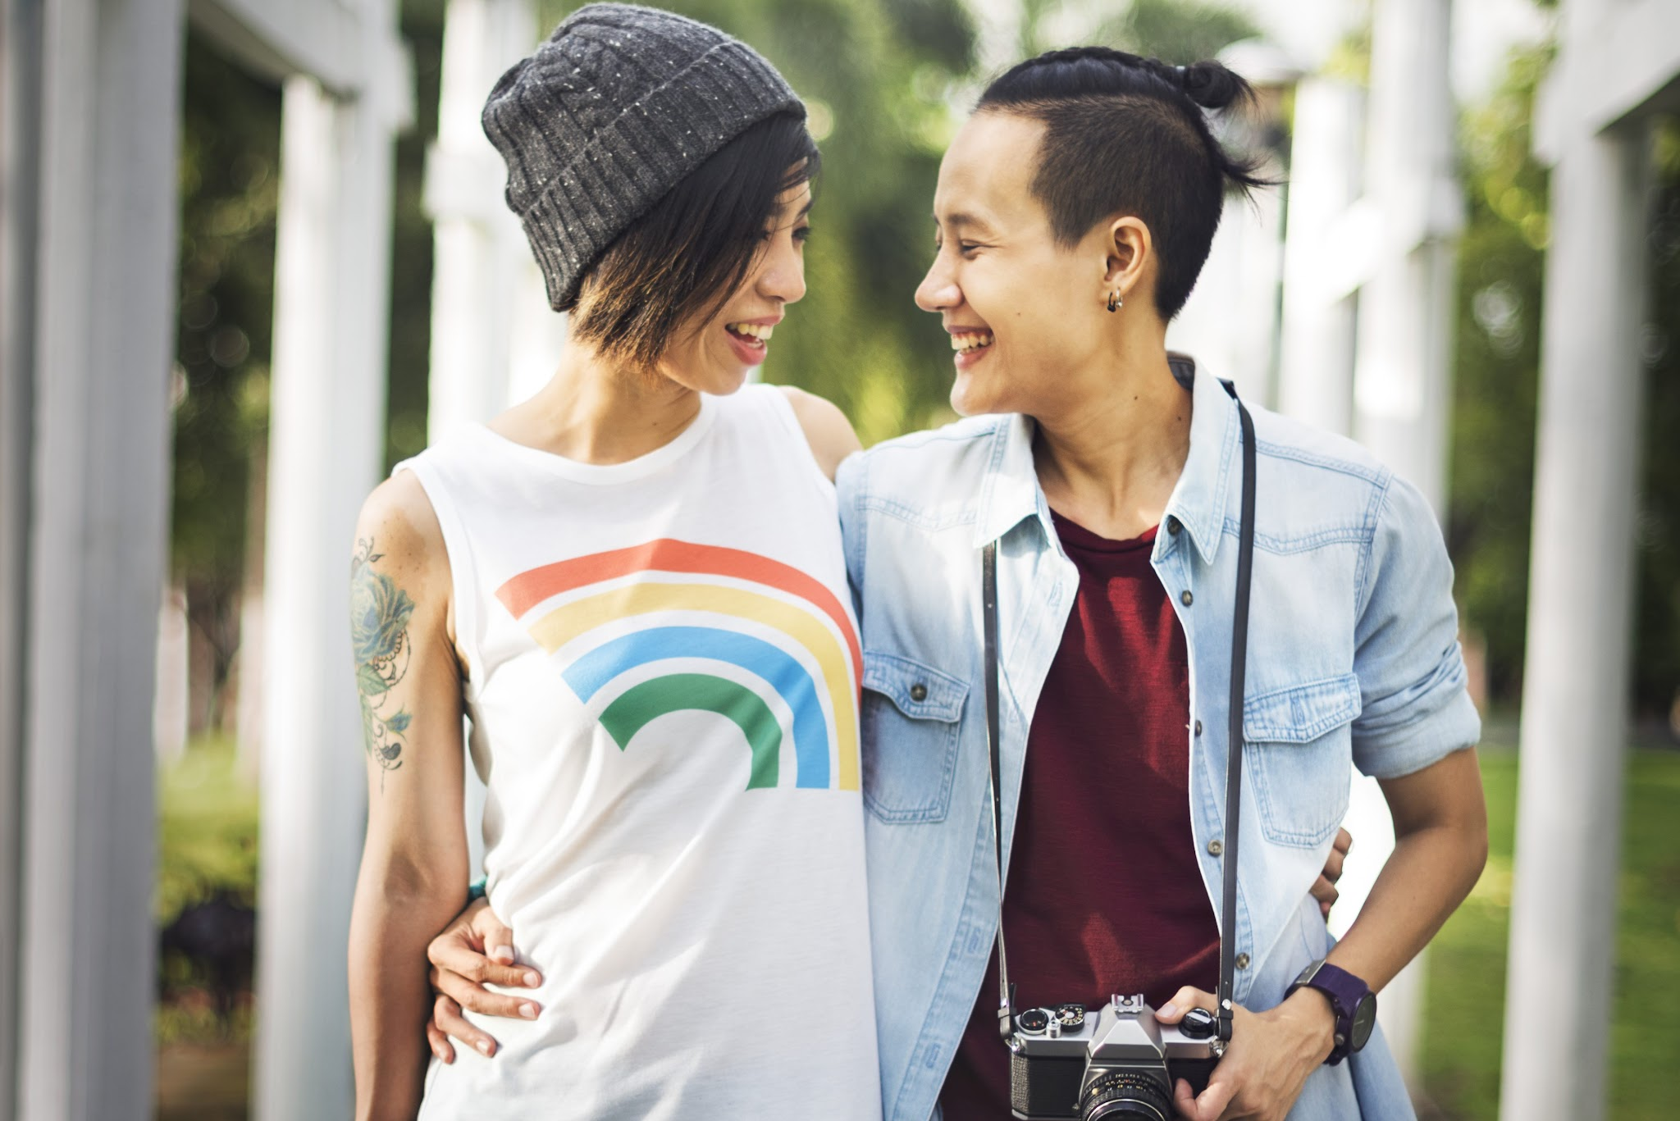

Ever been clam slammed while hitting on a stud? Decode lesbian lingo with DIVA’s handy lesbian lexicon

Have you ever been clam shammed when hitting on a stud? Or do you know a hasbian who succumbed to the golden penis? What do these terms mean? The answers are here in The Great Big Lesbian Dictionary, the oracle of lesbian lingo.

Andro/Androgyny/Androgynous
A lesbian who is neither butch nor femme, but may appear as both. A gender fluid butterfly. Might also go by: gender fluid, gender queer.

Baby Dyke
A young, newbie lesbian – often accompanied by drama.

Beard
A person of the opposite sex who marries or dates a queer who is in the closet in order to hide their homosexuality.

Beersexual
A girl who will only engage in lesbian activities when under the influence. Often seen in television shows and often happens between close girl-friends.

Bicurious
A straight girl who wants to indulge her lesbian fantasies. (Occasionally, a lesbian who wants to indulge her hetero fantasies.)

Bisexual
A girl or guy who likes both sexes. Might also go by: Hovis (Best of Both).

Boi
A multitude of meanings – a boyish lesbian/a soft butch/an actual boy who associates with queer friends.

Bottom
Someone who is submissive in bed.

Bulldagger
A really butch woman.

Bulldyke
The most masculine of all butch lesbians.

Butch
A lesbian with masculine appearance. Can be identified by their short hair, shirts (w/ popped collar) and their "gentlemanly" manners.

Chapstick lesbian
An "in-betweeny" lesbian. Neither identifies as butch or femme, usually in between. A lesbian who wears chapstick, not lipstick. Might also go by: Stem.

Clam Slammed
An annoying experience to have – the lesbian example of cock blocking.

Closet
Queers who are not yet out are said to be "in the closet", hiding.

Coming out
To exit the closet and reveal your sexuality.

Dieseldyke
A super masculine lesbian often associated with trucks/heavy machinery/plaid shirts.

Drag King
A women who dresses to look like a man, often for performance. Think Ivan from The L Word.

Dyke
Another word for lesbian – sometimes derogatory when used by straight people but reclaimed by the international Dyke March lesbian visibility movement.

Femme
A feminine lesbian. Identifying traits are often painted nails, make-up and "girly" clothes.

Friendcest
The phenomenon of sleeping with several (if not all) of the people in your friend circle. I.e. you've slept with your best friend's ex, her ex-girlfriend and her current girlfriend. Often resulting in drama.

Gayborhood
A habitat where the majority of people are queer – can be a club/pub/café, shops, a town/city e.g. Brighton. Often identified by rainbow flags adorning the area.

Gaydar
Gay + Radar. The intuitive ability to recognise if another person is gay or not.

Gender Queer
The limitless fluidity of gender. Feeling like you're both male and female, or indeed, neither. Might also go by: androgynous.

Golden Penis
Neanderthals who believe that they can cure a girl of her lesbianism with their golden penis.

Gold Star
A lesbian who has never had sexual relations with a man. (Controversial: implies a lesbian heirarchy of purity.)

Hasbian
A long-term lesbian who returns to Dicksville after being in Lesbo-Land for some time (often derogatory).

Lesbian
A woman who is sexually and emotionally attracted to other women.

LGBTQQIA+
The way in which the queer community accepts and includes everyone.

Lipstick Lesbian
A really, really, really feminine lesbian.

Lipstick Mafia
The lesbian equivalent of the "Uncle Sam" WW1 recruitment poster. They want you in their circle, and they've got your back.

Lone Star
Someone who has only slept with one person in their life.

Malesbian
Harmless but slightly creepy straight guy who thinks he is a lesbian. Often misunderstood.

Marble
A woman who maintains her heterosexual marriage while recognising that she is actually gay. (MARried But LEsbian.)

The Muffia
They wear business suits, they have a lot of money and they make things happen. Think Bette from The L Word. Always intimidating, but very sexy.

Outed
When someone announces against your will that you are queer, they have outed you.

Packing
When a lesbian wears a strap-on under their clothes to give the impression that there is "something else" there. Socks can also be used.

Partner
The word used to refer to your significant other, may replace "girlfriend" as the relationship becomes more serious.

Pillow Princess
A lesbian who only likes to receive during sex, she never reciprocates.

Poppa
An underage lesbian.

Pride
Being proud to be gay! Or, Gay Pride events, celebrations and parties! (Coined in the late 60s to challenge the notion that the natural response of queers to our sexuality should be shame.)

Queer
The once derogatory term to include all LGBTQQIA+ people. Reclaimed in the 90s, both on the street and in academia.

Saturday Night Lesbian
A girl who is only gay at the weekends.

Saysbian
A fake lesbian. Someone who says they're a lesbian, but only seems to have sex with men.

Scissoring
What men think lesbians do in bed.

Soft butch
The soft butch is like a Creme Egg; they appear to have a hard exterior but are soft on the inside.

Sporty Dyke
Dress like sportswomen and often play sport. Think, Dana from The L Word.

Stem
A lesbian floating between the brackets of "stud" and "femme". Might also go by: chapstick lesbian.

Stone Butch
A lesbian who doesn't like to be touched in a sexual way, always preferring to give than receive. Often found with a "pillow princess".

Stud
A dominant lesbian, usually butch.

Top
Someone that is dominant in bed.

Trysexual
A girl who will try anything once.

U-haul Lesbian
Often used in lesbian jokes, a U-Haul lesbian moves in with you pretty quickly. (From the American removals company.)

Vagitarian
A code word for lesbian.

Vanilla
Non-kinky, non-risqué sex. Plain and simple intercourse.

Only reading DIVA online? You're missing out. For more news, reviews and commentary, check out the latest issue. It's pretty badass, if we do say so ourselves.

divadigital.co.uk // divadirect.co.uk

Post navigation
PREVIOUS

