# Tips

* Height/width can be set in CSS using the **calc()** function:
  + example: width: calc(100% - 100px);
* Resizing of browser window can sometimes mess up sizing/positioning of Dojo **BorderContainer** subpanels, when they are not currently visible. To fix, use BorderContainer **resize**() function:
  + dijit.byId(className + **"MediaBC"**).**resize**();
  + *For this example, code is applied on tab change*
* Accessing superclass methods:
  + Usually this is in **Dojo** [*if in a* ***return declare()*** *section*]
    - in which case, can use **this**.inherited(***arguments***) in method override to call superclass method (literal word "arguments")
  + otherwise, would use **super.<*methodname>*()**
* To get parameter names of an Object, e.g.: **Object.keys**(<object>)
* To access a JS variable using a string representation of the name, use **eval**(name)
* Chrome version updates can affect **CORS** behavior. Try this setting in WebStorm **preferences**:
  + **Build, Execution, Deployment > Debugger**: Turn on **Allow unsigned requests**
* To get rid of **CORS** error (in Chrome), right-click the  icon in the upper browser panel, select **Options**, and enter the URL pattern in the box. For example:
  + [https://alaskafisheries.noaa.gov/*](https://alaskafisheries.noaa.gov/*)
* Use Jscript .**width()** and .**height()** methods to get actual height of an HTML element
  + Example: **$(getEl("photoContainer")).width()**
  + ( **.style.width** doesn’t always work )
* **No property/method for getting list of tables in a map service? !!**
* [**Define color name (or other variable) in CSS:**](https://stackoverflow.com/questions/1875852/how-can-i-define-colors-as-variables-in-css)

[CSS Variables](http://www.w3.org/TR/css-variables/).

**Example CSS file**

:root { --main-color:#06c; }

#foo { color: var(--main-color); }

* Other HTML spacers:
  + **&nbsp;** for single space
  + **&ensp;** for 2 spaces.
  + **&emsp;** for 4 spaces.
* To handle events like button clicks inside of Dojo modules, use “dojo/dom” and on(dom.byId(*button ID*), “click”, *callback function*(evt))
  + (see **test_Dojo_addTab.html** on Macbook)
  + Or use JS **addEventListener**() method
    - Example: document.getElementById("myBtn").addEventListener("click", displayDate);
* By default, the **this** object in an event handler points to the DOM object triggering the event. To specify a different **this** object (say *thisObject*), add “.bind(*thisObject*)” to the end of the function name.
  + For example, to use the current module’s current **this**, then something like:
    - **this**.**queryTask**.on(**"complete"**,**this**.checkData.bind(**this**));
    - **[QueryBasedPanelWidget,** runQuery **function]**
  + (instead of:
    - **this**.**queryTask**.on(**"complete"**,**this**.checkData);
* **To find class name and other HTML element info, right-click object in browser (Chrome, anyway), and select Inspect**
* 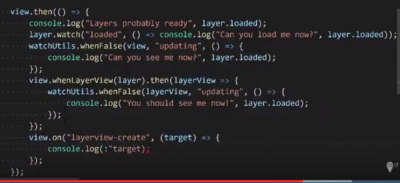
* Quick Tip: ArcGIS API 4 for JS - When stuff is ready?
* Create CSS class in code:

var sheet = document.createElement('style')

sheet.innerHTML = "div {border: 2px solid black; background-color: blue;}";

document.body.appendChild(sheet);

* If working in a SceneView, **polygons** are only supported when their vertices are defined in **clockwise** order.
* When using SceneView, WebStorm brings up this error:

GET http://localhost:63342/FDFA6052-1C12-4655-B658-0DBF2414422D/214/aHR0cDovL2pzLmFyY2dpcy5jb20vNC4zL2Vzcmkvd29ya2Vycy9tdXRhYmxlV29ya2VyLmpz 404 (Not Found)

But if you run just by opening index.html, it runs fine and doesn’t generate the error