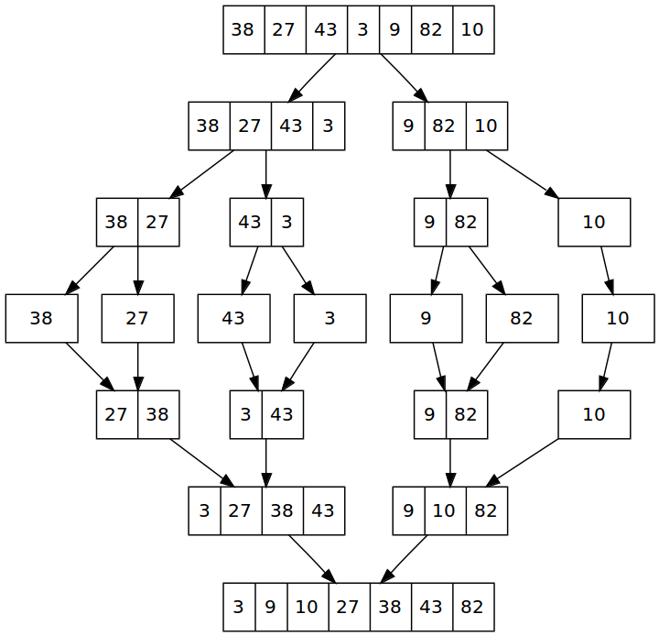
James Patrizi
12-7-2017
Final Project Writeup – EECS 338

The final project is to do a comparison in run time with a multithreaded merge sort implementation versus a normal merge sort implementation. The purpose of merge sort is that it is a divide and conquer algorithm that divides an input array in two halves, calls itself for the two halves and the merges the sorted halves. This process is shown from the diagram on the left. It then outputs a sorted array. This is one of the many sorting algorithms. The reason I am doing this, is because I wanted to do this comparison for a multi-threaded vs normal solution’s computation time. I also have not taken algorithms (and will likely not be allowed to take it during my last semester, as I am a CE) so this will be a great learning experience as well as study prep for interviews. I ended up using OpenMP for my thread management. I worked on my local machine which had a 4 core/ 4 thread capacity. NOTE the attached programs have their printf loops commented out to save time. To verify the array is sorted correctly, uncomment and recompile. If needing to recompile openmp.c, remember to add the -fopenmp compile option.

Files:
mergev2.c – normal merge sort implementation, provide array length arg
openmp.c – openmp merge sort implementation, provide array length and thread number args

Structures:
int *randomish_array(int n); - randomize array of n length. Note this uses the heap memory with malloc instead of standard stack because after > 2000000, the stack runs out of memory and you have seg fault issues.
void merge(int arr[], int l, int m, int r) – standard merge function that sorts array using the middle variable to breakup where what data is put into the respective Left and Right temporary arrays.
void mergeSort(int arr[], int l, int r) – mergeSort start where it calls itself until there is only one element in the array. Then, all the subarrays are merged until the full array is constructed. l is for left index and r is right index of the sub-array of arr to be sorted.
struct timeval start_time, stop_time, elapsed_time; // timers – timers used before and after first mergeSort() is called in main().

Sample Output(after verification that array is printing out in sorted order):

mergev2.c

No args
jim@jim-MacBookPro:~/EECS338_Final$ ./a.out
Usage is ./a.out <# of random numbers to Sort>

1 arg with 1 million

jim@jim-MacBookPro:~/EECS338_Final$ ./a.out 1000000
Total time was 0.249888 seconds.

1 arg with 10 million

jim@jim-MacBookPro:~/EECS338_Final$ ./a.out 10000000
Total time was 2.806218 seconds.

openmp.c

jim@jim-MacBookPro:~/EECS338_Final$ ./a.out 1000000
Usage is ./a.out <# of random numbers to Sort> <# of threads>
jim@jim-MacBookPro:~/EECS338_Final$ ./a.out 1000000 1

Total time was 1.857789 seconds.
jim@jim-MacBookPro:~/EECS338_Final$ ./a.out 1000000 2

Total time was 1.091876 seconds.
jim@jim-MacBookPro:~/EECS338_Final$ ./a.out 1000000 3

Total time was 1.057194 seconds.
jim@jim-MacBookPro:~/EECS338_Final$ ./a.out 1000000 4

Total time was 1.052949 seconds.
jim@jim-MacBookPro:~/EECS338_Final$ ./a.out 10000000 1

Total time was 19.755961 seconds.
jim@jim-MacBookPro:~/EECS338_Final$ ./a.out 10000000 2

Total time was 11.275280 seconds.
jim@jim-MacBookPro:~/EECS338_Final$ ./a.out 10000000 3

Total time was 10.768983 seconds.
jim@jim-MacBookPro:~/EECS338_Final$ ./a.out 10000000 4

Total time was 10.523926 seconds.

Number of Threads |  | int Array Size | int array size | int array size | int array size | int array size
 |  | 100000 | 1000000 | 10000000 | 100000000 | 1000000000
 | Run time | Time(s)
1 |  | 0.085399 | 0.916745 | 9.716803 | 98.612228
2 |  | 0.060734 | 0.546886 | 5.685945 | 65.589226 | 1192.207319
3 |  | 0.069057 | 0.540254 | 5.431459 | 64.070242
4 |  | 0.059828 | 0.526584 | 5.390158 | 105.678678
Normal Merge Sort |  | 0.048192 | 0.505944 | 5.72869 | 63.690985 | 735.111464

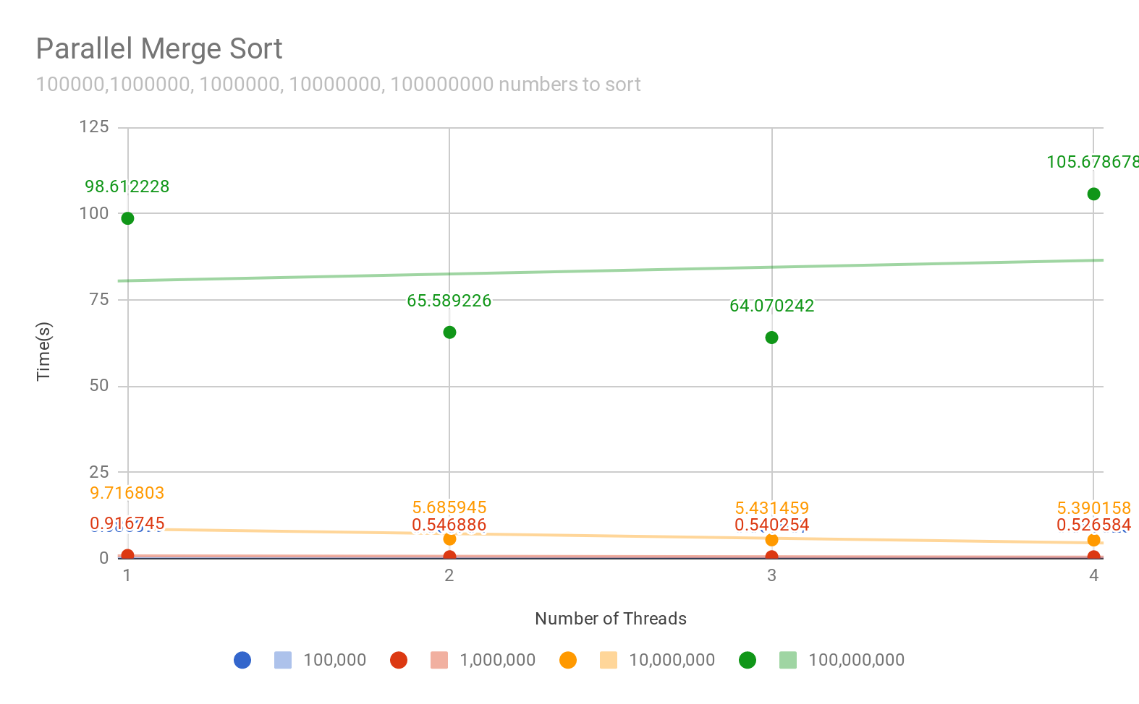

From my findings, the number of threads can not help the computation compared to normal merge sort, it just takes too long. But this might be perhaps writing the openmp.c program wrong, ergo I am doing the parallel work in the wrong place. What is promising is when I compare the computation time of the openmp.c to just itself with the same data set, but increasing threads, it typically can speed up performance as shown in the above sample output and data series. Further testing and tweaks will be required to figure out what went wrong with the parallel computation, as the parallel computation should be faster than typical merge sort. Perhaps running on the HPCC will be the next step, or doing thread control myself with pthreads.

