The early endeavors of establishing a gateway between the Old World to the New World lead to renewed communion between Europeans and Native Americans, both healthy and unhealthy commerce, and profound exploration of Earth’s resources and geography (carried out predominantly by Europeans). John White was one of the early seafaring voyagers from England scouting for a northwest passage to Asia, and possibly precious metals. White was a part of one of the many failed expeditions to the Americas, in May 1577. He sailed on the ship “Aid,” and upon returning from the expedition he brought back many of his own artistic drawings depicting the lands and people encountered. In April 1585, White was once again in the English exploring boat, now sponsored by Sir Walter Raleigh. This time the ill-fated settlement of Roanoke Island was established. The settlement dissipated owing to the alien environments and peoples that the English could not yet adapt to. And, the expedition was deserted in June 1586. However, these early expeditions gave Britain insight into the opportunities that the Americas held. Another attempt was made in 1587. An expedition, that John White was once again a part of, destined to colonize around Chesapeake Bay. It failed when the journey halted at Roanoke, then White returned to England, and didn’t come back because of the imminent war with Spain.

In 1590 John White’s Relief Expedition was launched. They found evidence that the colony was meddled with, being obviously pillaged, and possibly uprooted by Native Americans. The chronology of the expedition is as follows:

* March 20th, 1590 – The expedition dispatches from Plymouth
* April 4th, 1590 – Passes East Ile of the Canaries
* April 9th, 1590 – Departs from Grand Canary
* Last of April, 1590 – Passes Dominica
* May 14, 1590 - Departs from Mona
* May 26, 1590 – Passes between Jamaica & Cuba
* August 17, 1590 – Reaches Roanoke
* October 2nd, 1590 – Passes S. Michaels Island
* October 24th , 1590 – Arrives Plymouth

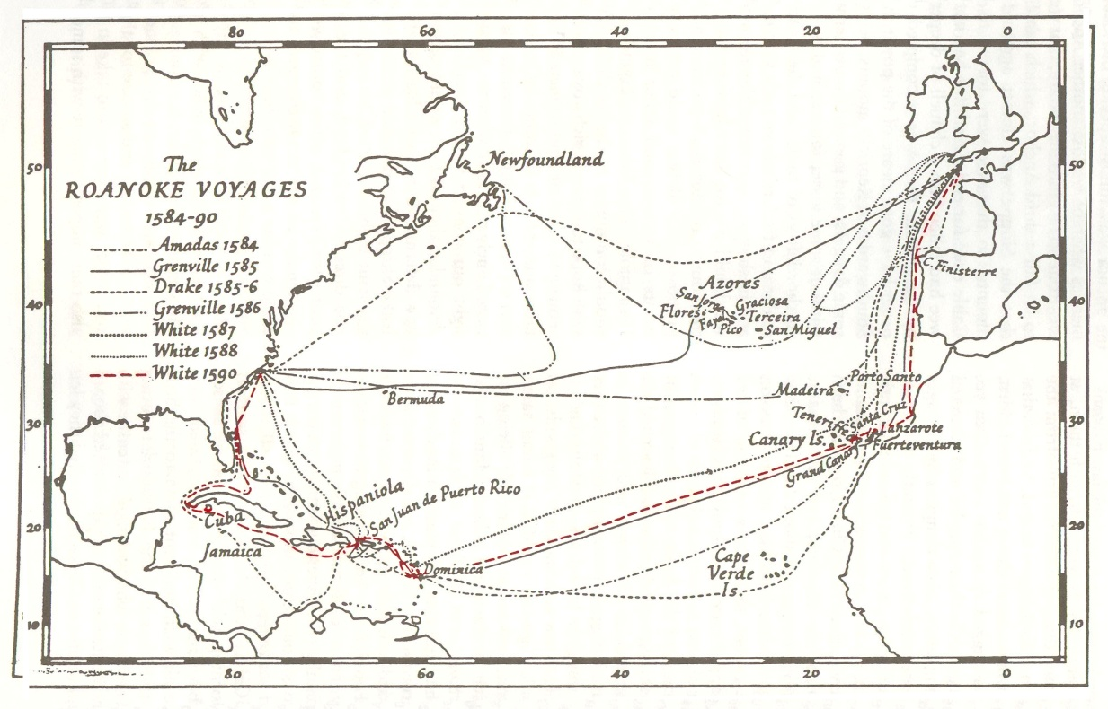

Later in December 1606, a new permanent colony was launched. The results were disastrous to the health of the English colonists. Of the 140 men, only half made it through the first 6 months. Though the Jamestown settlement was built, and the Englishmen attempted to maintain their colony. However, grave problems continued to arise. George Percy explains how day after day their men died, dwindling their numbers. New leaders were crudely selected to replace those who passed away. Later a better foothold was made, and interactions between Native Americans increased. The Natives were probably extremely curious and speculative of the newcomers, watching their movements with interest. Mainly, the customary way of life in 1625 Virginia was very harsh. A very low percent of people made it past age 39.

Spanish involvement in the Americas was primarily of unhealthy commerce. The Conquistadores main purpose was to capture their own colonies in self-interest of Spain, and convert the land to Christianity. This was typically violent, and unjust towards the Natives; though the Native Americans were helpless under the Europeans advanced arms. In the eyes of the conquering Spanish, the Natives were seen as an inferior race. Bartolome de Las Casas explains how the Conquistadores were indiscriminate in targeting the Natives. The Europeans often behaved deceivingly in their own self-interest, displaying degrading and racist behaviors in the end.