Wei Chun Tang

Professor Hayes

WDD 230

30 March 2021

**Temple Inn & Suites Site Plan**

**Site Purpose:**

The purpose of this site is to help people who come around the globe find Inns and suites near temples of The Church of Jesus Christ of Latter-day Saints. We also want to introduce some information and beliefs about the temples nearby and provide the services if the customers want to understand more about temples. Finally, we want to let those who come to visit feel comfortable and know that they can get a comfortable place while they come visit.

**Target Audience:**

The target audience has two different groups. The first group is those who come to visit the temple normally, for example, temple patrons, missionaries, and youth groups. The second group is some people that reserve temple to do some special activities such as weddings and temple participants on travel.

**Site Map:**

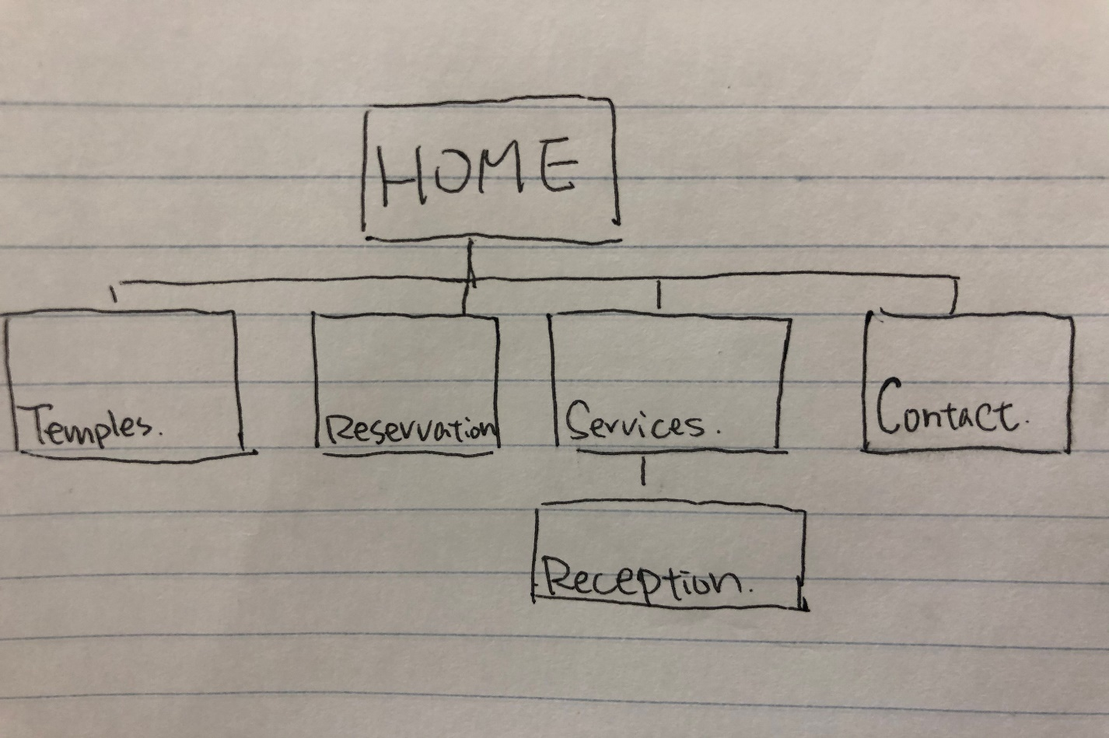

**Color Scheme:**

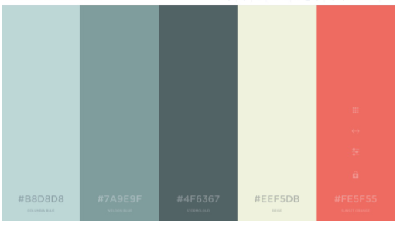

**Typography:**

**Font:**

'Dancing Script',

       'Josefin Slab',

       'Saira Condensed',

        'Potta One',

|  |  |  |  |  |
| --- | --- | --- | --- | --- |
| **Site Header** | 'Dancing Script' | **25px** | **Color: white** | **title** |
| **Navigation** | Saira Condensed | **20px** | **Color: white** | **temple** |
| **Header/footer** | Potta One | **25px / 15px** | **Color: white** | **temple** |
| **Temple name h1** | 'Dancing Script' | 50px; | **Color: black** | **temple** |
| **Temple info p** | Saira Condensed | **10px;** | **Color: black** | **temple** |

**Home Wireframe:**