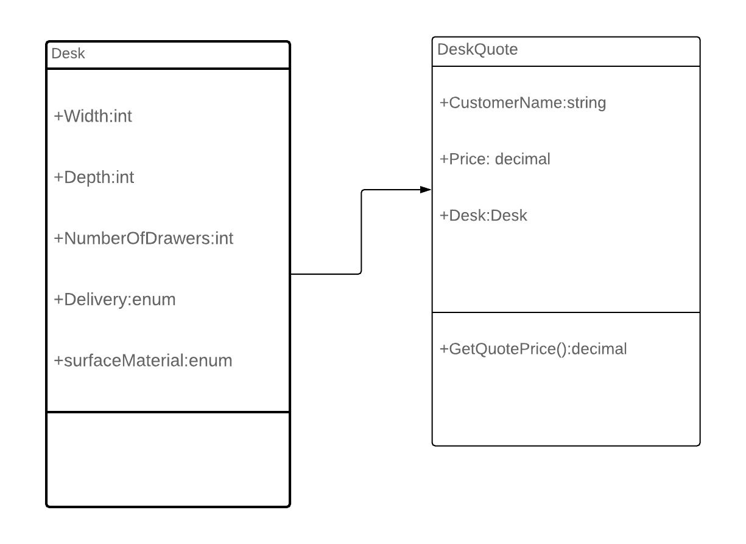

|  |  |
| --- | --- |
| Int base = 200;  Int surfaceCost =0;  SurfaceArea =width * depth;  If SurfaceArea > 1000;  SurfaceCost += SurfaceArea – 1000;  drawerCost = numberOfDrawers * 50;  materialCost = 0  Switch (surfaceMaterial)  { case Oak:  materialCost += 200;  break;  case Laminate:  materialCost += 100  break;  case Pine:  materialCost += 50;  break;  case Rosewood:  materialCost+= 300;  break;  case Veneer:  materialCost += 125;  break; } | shippingCost = 0;  If SurfaceArea < 1000  ShippingCost +=60;  If SurfaceArea> 1000 && SurfaceArea<2000  ShippingCost +=70;  If SurfaceArea<2000  ShippingCost +=80;  Switch(DeliveryDay)  Case 3Day;  Break;  Case 5day  ShippingCost -=20;  Case 7day  If SurfaceArea < 1000  ShippingCost-30;  Case 14day  ShippingCost = 0;  totalPrice = base + surfaceCost + drawerCost + materialCost+shippingCost; |
|  |  |