Square Pacmen. X:= half the base of the triangle cutout from the unit square centered at 0.5+0.5i. Tolerance is 10^(-4). Function is h(z)=[Re(z)]^2 on boundary.

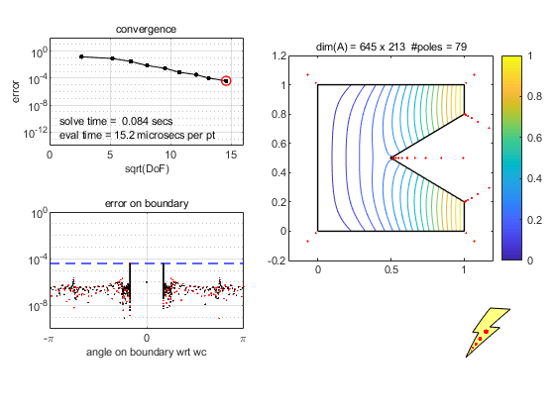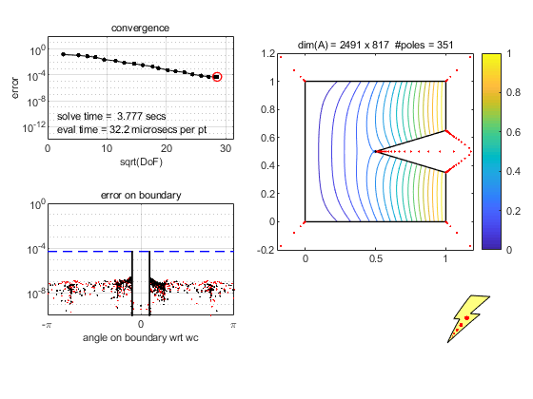

X=0.3 X=0.2

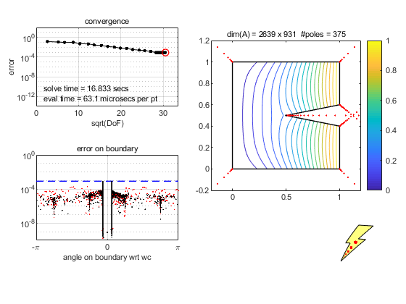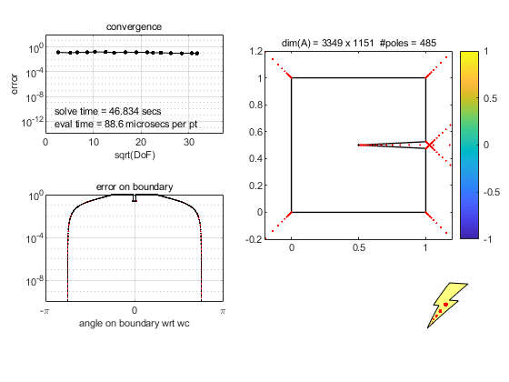

X=0.1 (Laplace failure) X=0.01 (Contour not rendered)

Circle Pacmen.