KHU EIT MK 2.5 Calibration Procedure and System Check

This document is supposed to be used in conjunction with the manual given by Kyung Hee, which describes the cabling setup etc. This guide is more of a best practice guide, and what to look for to check that the calibration is OK and how to check the system is connected fine.

# System Check – or what to do when you get “Total Ch: 0” errors

### First Sanity Check:

Is it even connected properly? Select “Devices and printers” from the start menu and you should have USBXpress device listed under unspecified devices

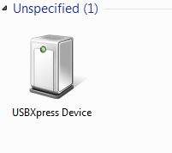

If that is OK then the next thing to do is check the IMM connection! If it is not, check the power to the DSP – is the light on at the back? (you will have to take the back of the case to see) Change the USB cable, check the power cable, restart the PC, try on another computer etc. etc.

## Check IMMs are recognised by the system

1. From the KHU software, select window > Engineer Control Dialog

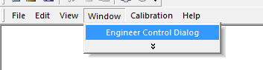

1. On this dialogue hit USB Check, and the box to the left should change from 0 to 1.
2. Next hit Port Open, and the box should read Port Open

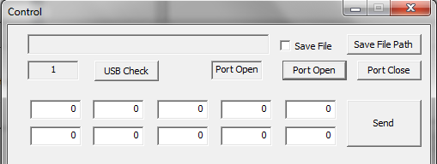

1. Next, with all 10 boxes with 0s in, hit send. This checks the communication is OK. The response should be: 129 and a load of zeros.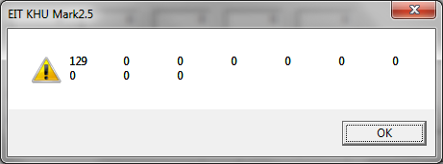
2. If that checks out, change the top left box to 2 and hit send like so: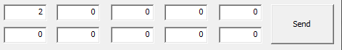
3. **And you should get the following response**

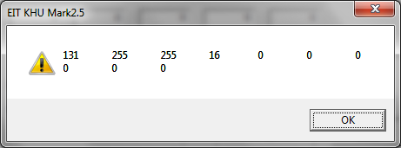

A little explanation:

131 is the response of the controller 129+2 (the command sent)

The next first two columns represent what channels of the digital backplane have IMMs in them as a binary number (1 for detected, 0 for undetected). The backplanes are split into 2 groups of 8, with the second column representing 1-8, and the third number representing 9-16. The response from each of the two groups is 25510 = 111111112, meaning an IMM was detected in each channel of the both groups. This is good. For example 19110 =101111112 means that an IMM was not detected in the 7th channel of that group. This is bad.

The next number are the total number of connected channels (i.e. ones with IMMs in them), which should be 16.

The final number is the total number of unconnected channels, and should be 0.

Summary:

|  |  |  |  |  |
| --- | --- | --- | --- | --- |
| 131 | 255 | 255 | 16 | 0 |
| System response | Group 1 connected IMMs | Group 2 connected IMMs | Total IMMs connected | Total unconnected channels |

## What to do if you don’t get this!

The connections between the IMMs and the digital backplane are likely slightly loose. Take apart the system and rebuild it.

# Calibration

You have to do each of these steps for each frequency. The steps for this are pretty well documented in the proper manual.

## Order

The order in which you should perform the calibration is:

1. Output Impedance
2. DC Offset
3. Output Impedance
4. Amplitude
5. Voltmeters – Close the software afterwards. Known bug!

## Notes on cables

* Use the cables you are going to record with, i.e. the ones that will eventually be connected to the electrodes.
* Use the gold adaptors in the holes for the resistor phantom and the blue calibration channels to give something to crocodile clip on to.
* Use a short cable to connect the centre of the resistor phantom to the channel 1 or ground for amplitude and voltmeter calibration. Make sure this cable has good connection and low impedance
* The old KHU cables from the KHU MK1 and other systems, often had a resistor in the connector. So if you are using and old cable, unsolder this from the connector first

## What to check – did it calibrate OK?

The results of all of the calibrations are stored in the folder “1234” in the folder “Calibration” found in the same folder where the KHU software is stored. Within the Calibration folder look for separate folders for Amplitude, DCOffset, OutputImpedance and Voltmeter tests, as well as subfolders for each frequency.

### Output Impedance

Choose the folder corresponding to the frequency you are calibrating at, and look at the files in Log > Zout. You should see something like this:

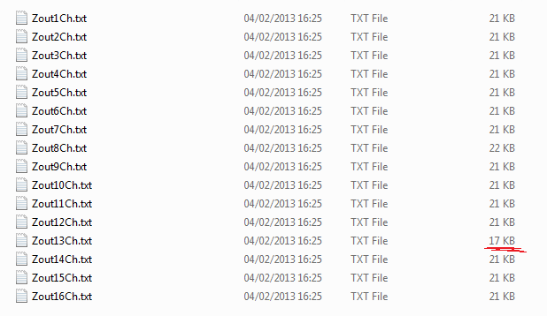

With a separate text file for each IMM. The first sanity check is the file size, every test is doing exactly the same thing with the same number of results, so the files should roughly be the same size. Channel 13 had a problem with the connection during this test, and this is shown by the smaller file size of 17KB as instead of 16bit numbers the results were “INF”.

Open up of these files and scroll down to the very bottom line and if all is well you should see: MaxZout: 1e+009.

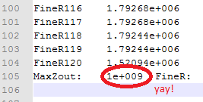

i.e. that the maximum output impedance was measured to be 1 MΩ. Check this for all channels before moving on.

#### If you don’t get this

Check the connections are ok, it’s usually something simple like the cables aren’t connected ok or the cable is broken. Occasionally, you might not reach an output impedance that is exactly 1MΩ but after performing the DC offset calibration and repeating this output impedance calibration can give you the correct result. If not – swap the IMMs around and see if it is consistent with the channel or the IMM.

### DC Offset

Check the DCOffset.txt in the folder corresponding to the frequencies you are interested in. What you are looking for are similar values, and only small changes – the fuzzy logic is less than 25ish with certainly no 3 digit changes.

### Amplitude

Look for the file Amplitude.txt in the folder corresponding to your frequency of interest. The first value should be 1, and the remaining values should be closed to 1, as this indicates only small adjustments to the current levels were needed. This is very sensitive to the connection to the centre of the resistor phantom, so make sure this cable is OK

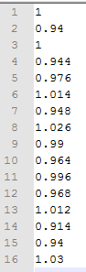

### Voltmeter Calibration

The best way to check this is correct is to collect a few test frames on the resistor phantom, and compare the results with the simulation/expected results. CLOSE THE SOFTWARE AFTER VOLTMETER CALIBRATION. There is a known bug which means you can’t start scans after running that dialogue.

**YOU MUST USE THE CORRECT SIMULATED VOLTAGES.**

The voltmeter gives the correction factors to convert from the demodulated digital values to the simulated values (in either mV or V, or anything you choose) and to give a phase angle of 0. *This includes the gain correction*. Thus, if you change the gain in the protocol, you must recalibrate the voltmeters. If you change the current injection, you must first change the simulation to represent the new current level, then create a new file with the expected values, then recalibrate the voltmeters.

#### Making new simulated voltages

The model of the resistor phantom can be found in circuitlab:

<https://www.circuitlab.com/circuit/m5cv9k/khu-resistor-phantom/>

or as a OrCAD file in the technical folder of eit-nas.

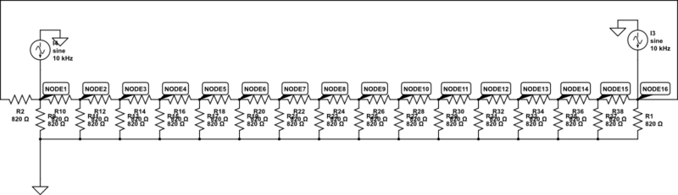

In this model each node represents the differential voltage between the two channels, i.e. what is measured by the system. These do not change with different protocols. So what you are interested in changing is the two current sources. These in the above picture, ch1 is the source and ch16 is the sink. The source is set to 1000uA and the sink is set to -1000uA. Change the amplitudes and the positions which match the protocol you are using, and then simulate the resulting voltages.

To get the simulated voltages into matlab to check:

1. On circuit lab, switch to the simulate panel and choose “time domain”
2. Hit “Run Time-Domain Simulation” an d you should get something pretty like this: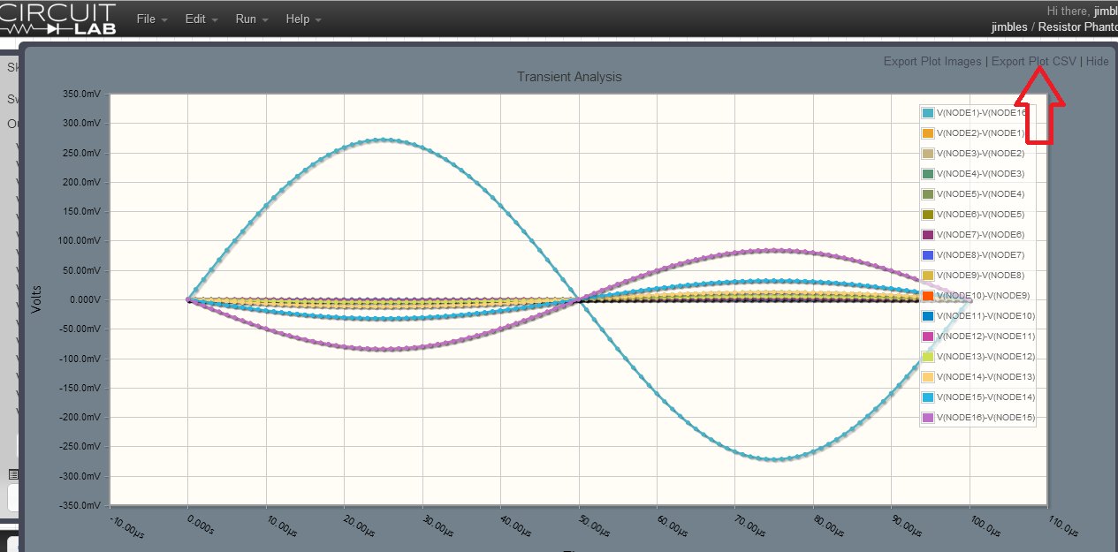
3. Hit Export Plot CSV and copy the text in the box that pops up to the clipboard
4. In matlab, type uiimport and then select “clipboard”, make sure comma is selected as the delimiter
5. The format of this data is then:

|  |  |  |  |
| --- | --- | --- | --- |
| Time | Chn1 | Chn2 | Chn etc. |

1. So to find the correct voltages for calibration find the max in each channel: max(data(:,2:end))
2. Do this for every current injection you have in your protocol
3. Make a text file in the same format as the others e.g. 2Dneighboring_mV.txt where each column is an injection pair, with a row for each channel.

# Building the system

1. Attach all the IMMs to the digital backplane
2. Holding the backplane in one hand with the IMMs vertically, align the bottom connection of analogue front plane with lowest row of 8 IMMS with the other
3. Push the IMMs together ensuring all the connectors are aligned and snapped together. This can be tricky!
4. Push the whole system together above each IMM connection with the palms of your hands
5. Attach the DSP module, check that the USB connector is parallel to the plane of the IMMs and that the pin numbers connectors on the backplane and the DSP board are matching.
6. Test the power levels are correct before connecting the system
7. Connect the power cable and test that all IMMs are recognised.
8. Unplug the power and put system in case
9. The PCB standoffs required are as followed
10. Correct PCB standoff sizes:

Front of case

10mm

Analogue backplane – 2mm

45mm

30mm

30mm

7mm

Digital backplane – 2mm

25mm (this one is optional)

7mm

Back of case