**32 Channel KHU Mark 2.5 Power Supply**

1. **Power Supply Requirements for the 32 channel KHU Mark 2.5 system:**

|  |  |  |  |
| --- | --- | --- | --- |
|  | **Digital backplane** | **Analog backplane** | **DSP** |
| **Voltage (V)** | 3.3 | +5, -5 | 5 or 7 |
| **Current (A)** | 8 to 9 | 3 to 4 | 0.15 to 0.2 |

1. **Problems with the old power supply:**

* It was primarily designed for the 16 channel system hence it was unable to meet the specifications of the 32 channel system
* Since the system is power intensive, the heat dissipation is quite high. As no fans or any cooling mechanisms were included in the design, it resulted in components failure and poor performance.

Thus, the power supply had to be redesigned, building on the design of the older one.

1. **Power supply design**

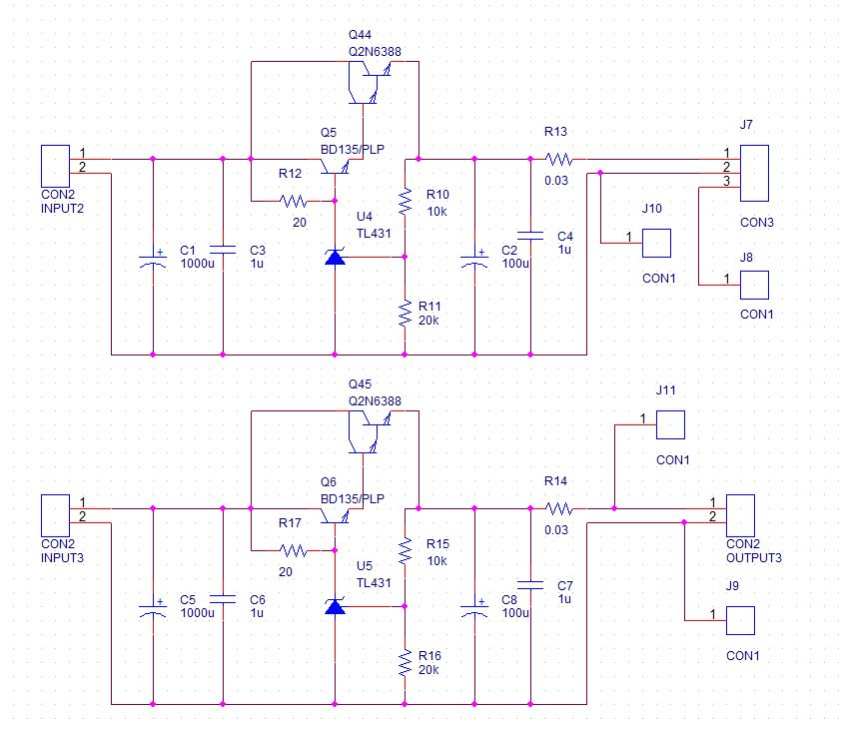

Figure 1: 3.3V digital power supply

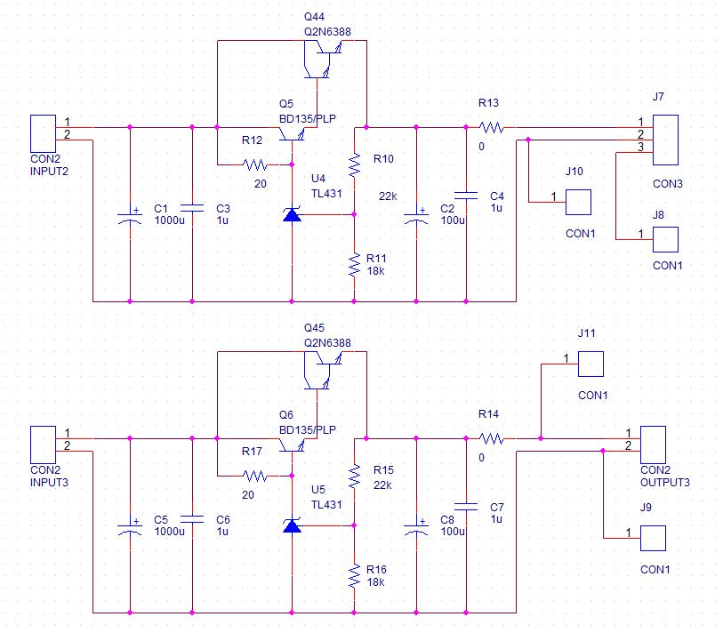

Figure 2: +/- 5V analog power supply

Same switching mode power supply (SMPS) modules used in the previous design were used in this new design as well. ECM100US07 (7V, 100W) is used to supply the digital backplane and the DSP, ECM100US09 (9V, 100W) is used for the analog backplane and ECM100US12 (12V, 100W) for the fans in the power supply case as well as the KHU system case.

Figure 1 and 2 show the circuits to regulate the outputs from the SMPS to meet the requirements for the system. The design is essentially similar to the older one with the exception of the capacitors and the transistors used. In order to meet the required amperage, transistors BD135 and 2N6388 were used in darlington pair configuration. 2N6388 is a single chip darlington transistor in itself.

Figure 1 and 2, which are for the digital and analog supply respectively, differ only in the value of resistors used. Two circuits in figure 1 are used in parallel to provide the higher amperage for the digital supply, hence the 0.03 ohm, 3W resistor is included at the output to balance the current. The circuits in figure 2 should be connected in series in order to obtain the +5V, GND and -5V required for the analog supply. As evident from the circuit, this is achieved by connecting J10 to J11 and J8 to J9.

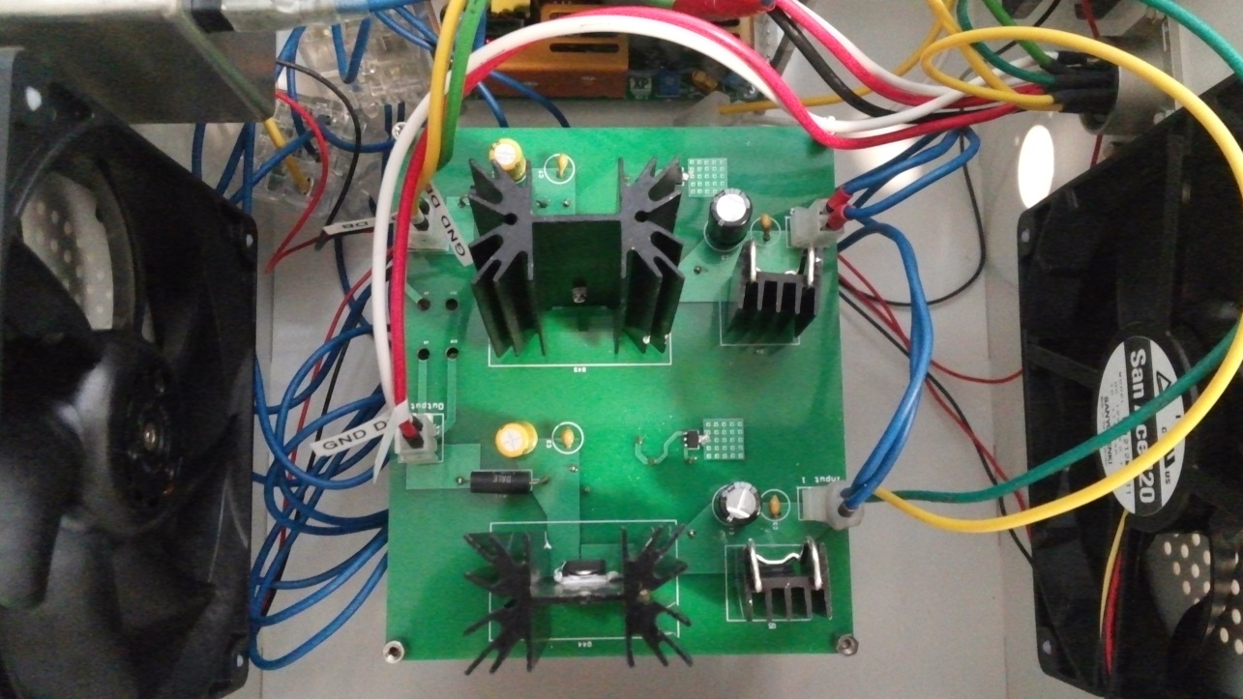

Figure 3: Circuit board for 3.3V supply

The layout for the circuit board has been designed to suitably accommodate the components which include large heatsinks for 2N6388, and to provide ample space for the high current path.

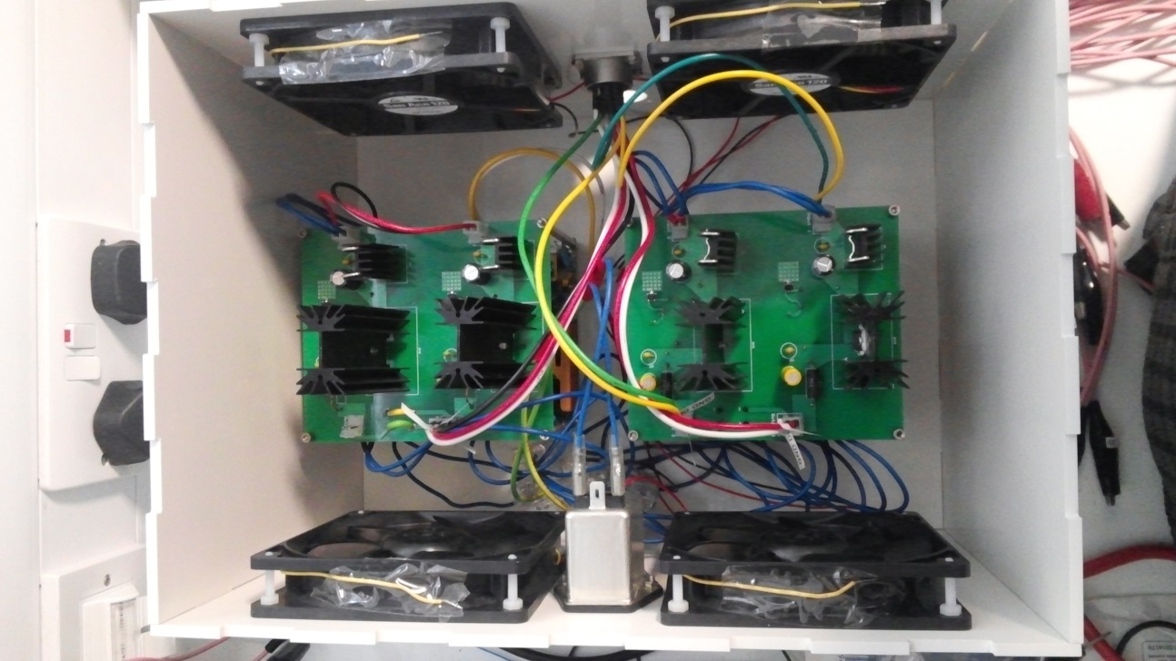

Figure 4: The power supply in its entirety

Two ECM100US07 modules are used to power the digital supply and two ECM100US09 modules are used to power the analog modules. One ECM100US07 is used to power the DSP. The outputs of ECM100US07 are adjusted to be 6.5 V and outputs of ECM100US09 are adjusted to be 8.5V using the potentiometer in the modules. This is done in order to reduce the power dissipation at the transistors.

Four fans are used for cooling the power supply as seen in figure 4. The fans are rated at 12 V, 0.13 A each. ECM100US12 is used to power the fans.

1. **Comparisons with old power supply**





Figure 5: Comparison between old and new PSU when KHU system is idle





Figure 6: Comparison between old and new PSU when KHU system is scanning

The performance of the new power supply shows significant improvement over the old one as shown by figure 5 and 6. This data was collected from the +5V and GND pin on one of the analog backplanes for the 32 channel system.