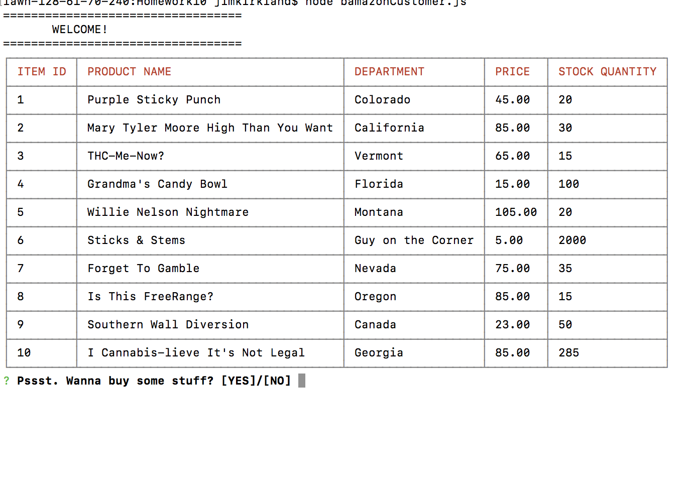

YOU ARE GIVEN THE MAIN MENU UPON LAUNCHING THE APP

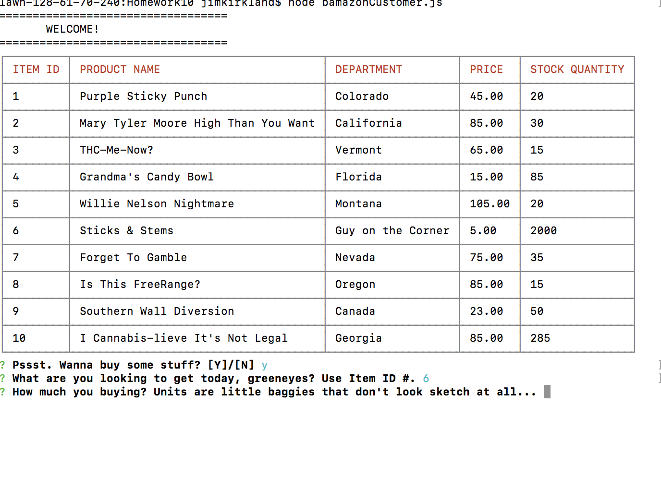
MAKE YOUR CHOICES AND UNIT SELECTIONS...

AFTER MAKING A CHOICE AND GETTING TO CHECKOUT THERE IS FINAL CONFIRMATION...

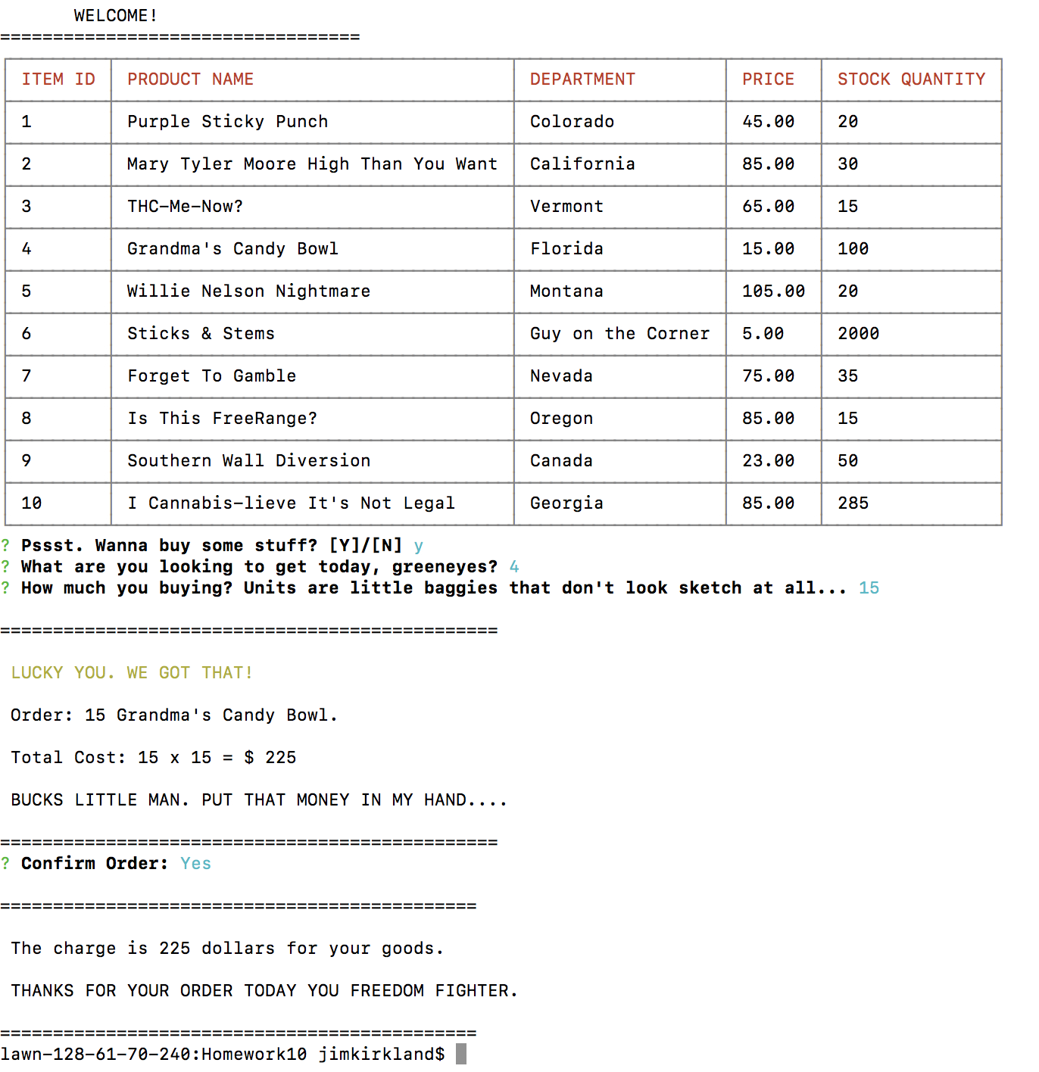

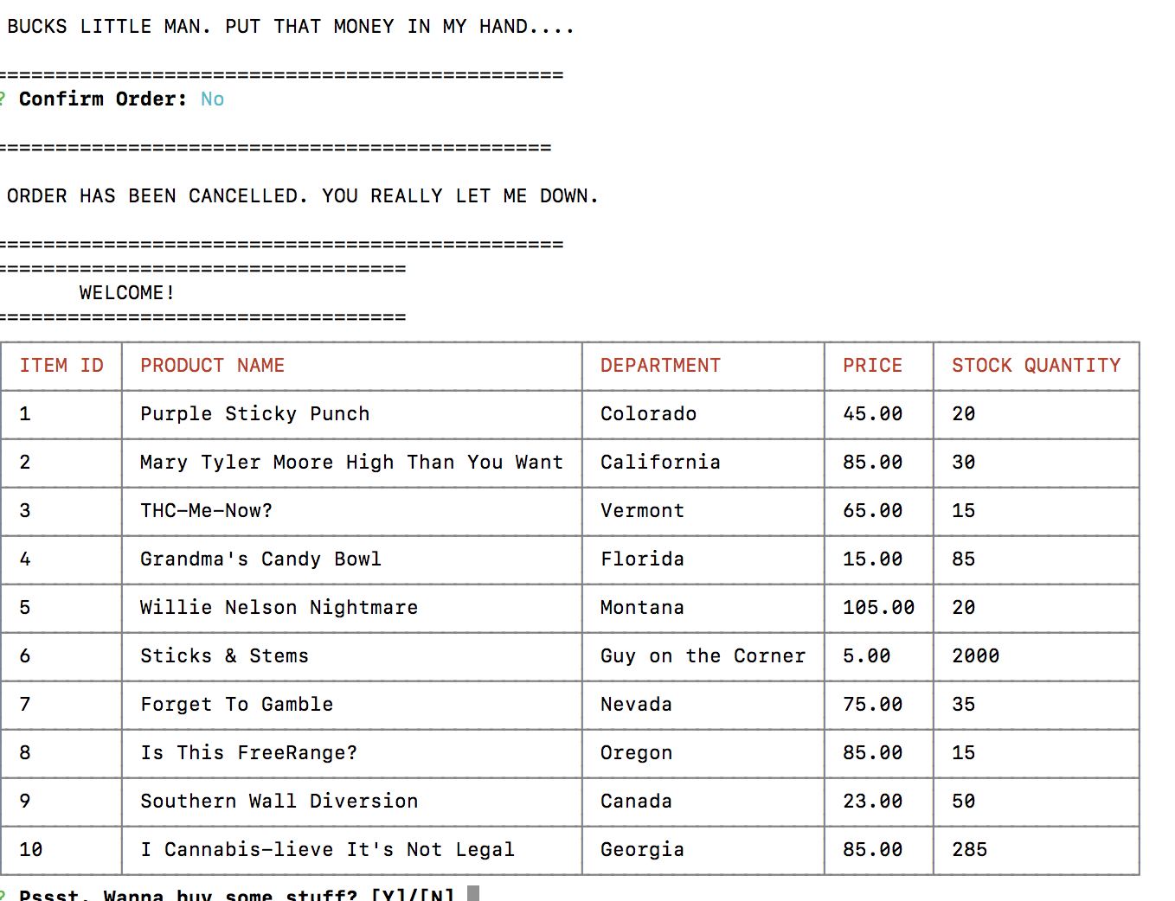
IF YOU DON'T CONFIRM THE ORDER – YOU ARE SENT BACK TO THE MAIN MENU.

