Shithead Ideas & Questions

How many players?
- Programming-wise we can have as many as we like but the issue is how to display all the cards on the screen?
- Would you just have a row of opponents up cards? Below is a sketch of a possible screen layout with 3 opponents.
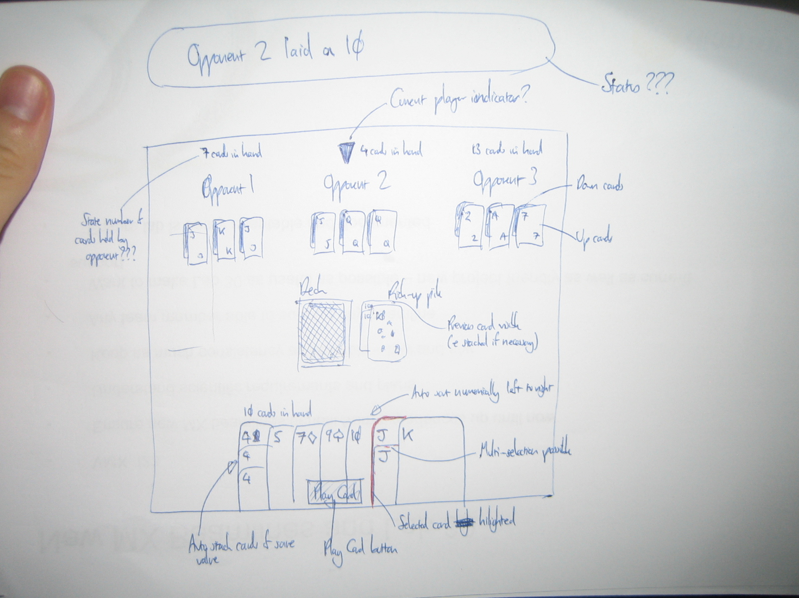
- Along the bottom are your cards in your hand, auto arranged into numerical order, and auto-stacked into same-number-groups (to save screen space when you have loads of cards)
- An alternative is to make the game just have one computer opponent, a bit like the blackjack game
- Is it important to see all opponents cards on screen at the same time?
- Do you only need to see the next players hand?
- Is there a relationship between the number of decks to use and the number of players?
- Bare in mind the more cards used, the harder it is to display your current hand clearly

Invasion
- I was thinking, to keep invasions fast, if an invasion is possible (ie the pile has two 4's, and you have two 4's in your hand) then an 'Invasion' button will appear by your hand. Hitting it will lay the appropriate cards for an invasion. This would mean in multiplayer whoever notices and hits the invasion button first, gets the invasion

Magic Cards
- Which are the magic cards?
- I remember:
2 – 'Reset' pile back to 2 without burning the pile. Can be played at any point
7 – Next card played must be of a lower value than 7. Only played in order
8 – See thru, pile maintains value of previous non-8 card. Can be played at any point
10 – Burns pile. Can be played at any point. Player plays again after burn
- Am I missing any? Did I get the values and rules correct?
- Can a player play a 7 on a 7???

Start of Play
- All the cards would be laid out as in the sketch
- Whoever has a 3 starts the game, and their 3 is auto dealt, and the next player (clockwise??) is given their turn. If multiple players have a 3 then the starter is chosen at random.

Players Turn
- Players will be allowed to place a card with a value >= the current pile top card or a valid magic card
- Invalid cards in your hand could be 'greyed out' to make it clearer what your options are?
- Players select the card/s they want to play by clicking on it (highlighting it) and then hitting a 'play card/s' button – this avoids the wrong card being played if accidentally clicked on
- Players will be able to select multiple cards of the same value by clicking on the cards they wish to play, then selecting the 'play cards' button.
- If play is not possible, should the pile be picked up automatically or should they have to do something to acknowledge that they have to pick up?
- After a play, cards from the deck are auto-picked-up to ensure you always keep a hand of at least 3 cards
- After a pick-up, whose go is it?
- Should the number of cards held by an opponent by visible on the screen?
- If a player burns the pack, do they get another go?
- How should the pile be displayed to make it clear if there is:
a) multiple cards of the same value placed
b) the value of card underneath if an 8 (or multiple 8s) are played?
- On my sketch I have shown the previous card/s under the top card (and stacked if applicable – ie to show the build up to an invasion)
- A status text could be displayed at the top tracking play?

AI Card Decisions
- What kind of rules should the computer follow?
- Should it always lean towards getting rid of cards – ie if holding 3 tens should it play all 3 to get rid of them?
- Is there a preference to magic cards? Ie would you always play a 2 before a 10 to increase the pile size for other players?
- Should the computer work through their cards lowest to highest or go high to try to make things harder for the next player?
- Do aces have a preference over magic cards?

