Shthead Ideas & Questions

How many players?
- Programming-wise we can have as many as we like but the issue is how to display all the cards on the screen?
- Would you just have a row of opponents up cards? Below is a sketch of a possible screen layout with 3 opponents. Yeah, I think the ‘endgame’ cards are fine like that.
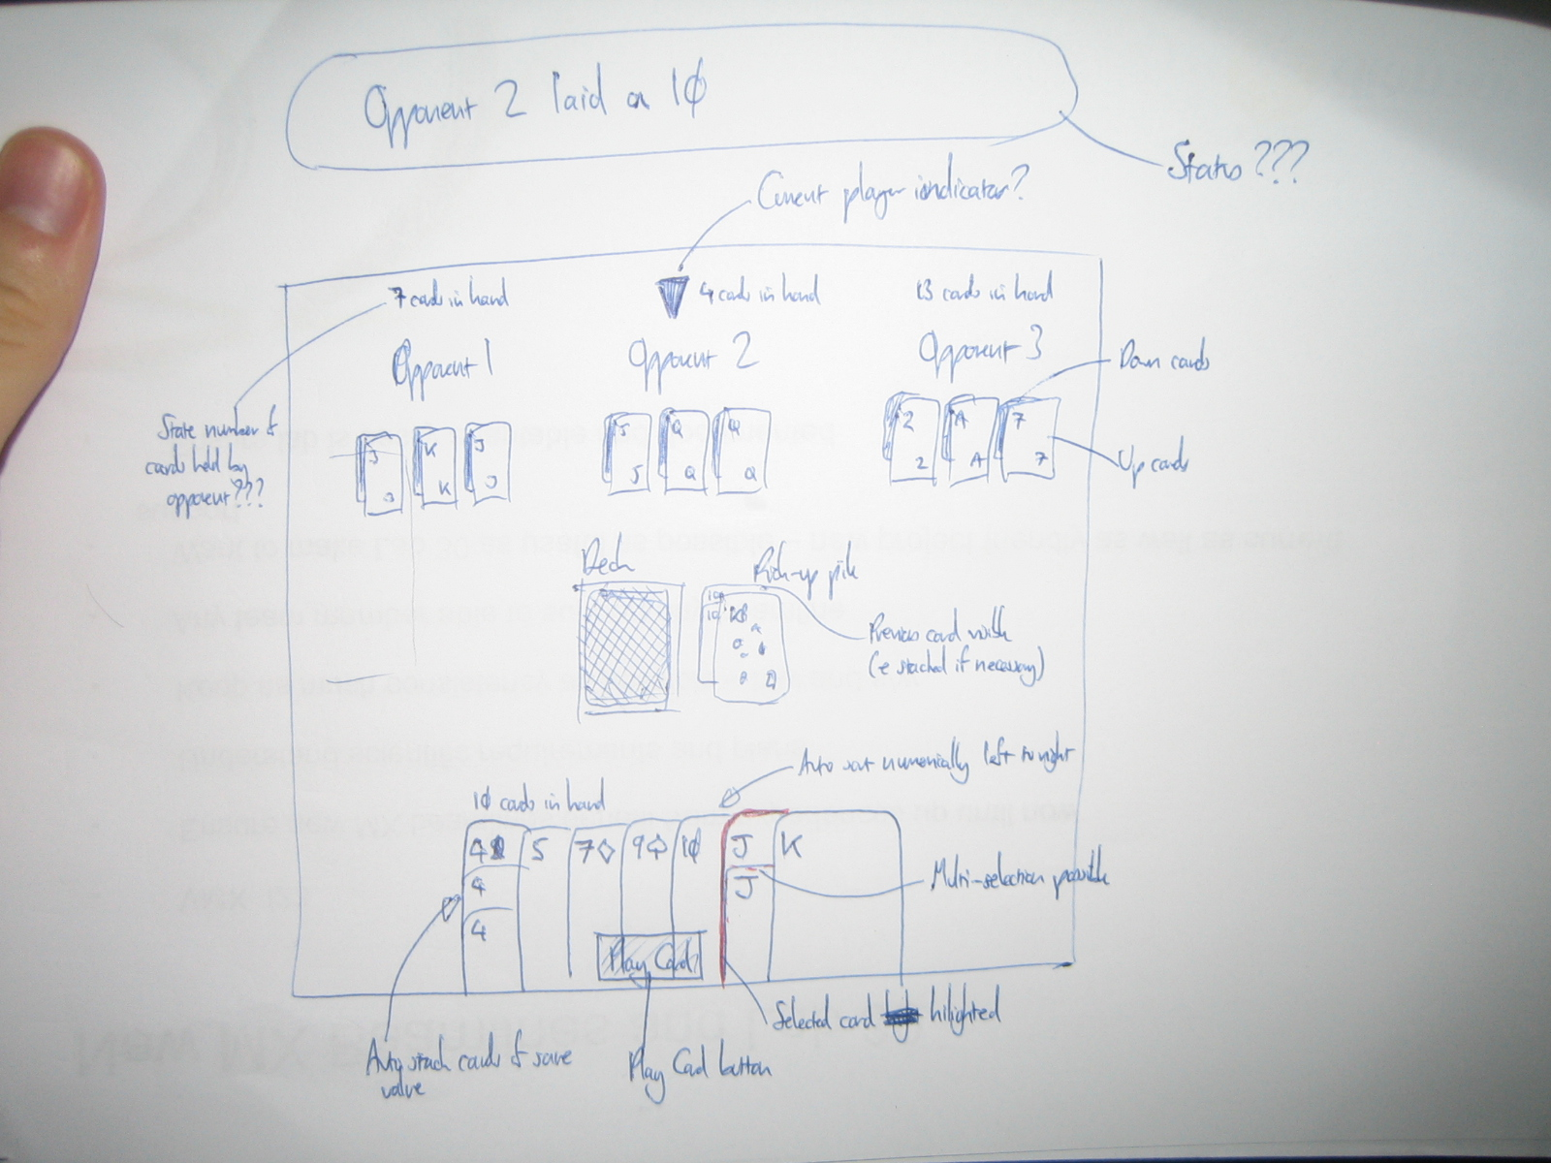
- Along the bottom are your cards in your hand, auto arranged into numerical order, and auto-stacked into same-number-groups (to save screen space when you have loads of cards)
- An alternative is to make the game just have one computer opponent, a bit like the blackjack game – I can see why this would make it simpler, although I think it would take something from the game. Are you familiar with Hearts? That is a similar ‘judgement based’ game, which was made into a good computer game. How did they do that?!
- Is it important to see all opponents cards on screen at the same time? If you mean the face up cards that come into play in the ‘endgame’ then I would say yes… you sometimes think 2 or three turns ahead in the ‘endgame’… i.e. if you have an Ace and a King, the next guy only has an 8, the next only has a King, you would play your Ace to ‘screw them’.
- Do you only need to see the next players hand? Do my answers above cover this? You should see everyone’s faceup ‘endgame’ cards, but not their face down ‘in hand’ cards
- Is there a relationship between the number of decks to use and the number of players? Yeah so you would want 2 decks for 5 or 6 players ideally. Otherwise the first phase of the game is over after about one round of play.
- Bare in mind the more cards used, the harder it is to display your current hand clearly. Yeah I can see this. But as above it’s a case of the first phase of the game being over almost straight away.

Invasion
- I was thinking, to keep invasions fast, if an invasion is possible (ie the pile has two 4's, and you have two 4's in your hand) then an 'Invasion' button will appear by your hand. Hitting it will lay the appropriate cards for an invasion. This would mean in multiplayer whoever notices and hits the invasion button first, gets the invasion. Yeah this could work. I guess it’s not going to be a very common occurrence anyway.

Magic Cards
- Which are the magic cards?
- I remember:
2 – 'Reset' pile back to 2 without burning the pile. Can be played at any point
7 – Next card played must be of a lower value than 7. Only played in order
8 – See thru, pile maintains value of previous non-8 card. Can be played at any point
10 – Burns pile. Can be played at any point. Player plays again after burn
- Am I missing any? Did I get the values and rules correct? Yep, 100%.
- Can a player play a 7 on a 7??? Yes, you can. This just means the next player then has to play a 7 or lower. Or a magic card.

Start of Play
- All the cards would be laid out as in the sketch.
- Whoever has a 3 starts the game, and their 3 is auto dealt, and the next player (clockwise?? – Yeah I’d say clockwise) is given their turn. If multiple players have a 3 then the starter is chosen at random. It’s the player to the left of the dealer with a 3 in the game we play. If no one has a 3 it moves onto a 4, then a 5 etc. This may not work without a ‘dealer’ as such though.

Players Turn
- Players will be allowed to place a card with a value >= the current pile top card or a valid magic card
- Invalid cards in your hand could be 'greyed out' to make it clearer what your options are? Yeah that could work. Or invalid cards could just not ‘stick’ to the deck, and be dragged back to your hand? This would be similar to hearts on windows OS’s for example.
- Players select the card/s they want to play by clicking on it (highlighting it) and then hitting a 'play card/s' button – this avoids the wrong card being played if accidentally clicked on. As above. Could it be a drag and drop type process where invalid cards just don’t ‘stick’ to the deck? I think the use of button’s generally spoils the illusion of a real game of cards. You’d still have to highlight multiple cars I guess. But then I don’t have any idea how difficult these things are from a technical POV!
- Players will be able to select multiple cards of the same value by clicking on the cards they wish to play, then selecting the 'play cards' button.
- If play is not possible, should the pile be picked up automatically or should they have to do something to acknowledge that they have to pick up? I would personally say it should just automatically move into their hand, with maybe a message sound to indicate that this has happened?
- After a play, cards from the deck are auto-picked-up to ensure you always keep a hand of at least 3 cards. Yep, that’s good.
- After a pick-up, whose go is it? It’s the next person in sequence after the person who picked up. If it’s the deck being ‘burned’, ie with a 10, or alien invasion (4 of a kind) then it’s the person who burned the deck to play again.
- Should the number of cards held by an opponent by visible on the screen? Yes, as in the real game I would say the number of cards they have is important to know, for tactical reasons.
- If a player burns the pack, do they get another go? Answered above.

- How should the pile be displayed to make it clear if there is:
a) multiple cards of the same value placed
b) the value of card underneath if an 8 (or multiple 8s) are played?

What about a system were the last 3 or 4 are visible layered over each other, with a growing pile beneath? So only cards of significance are displayed on top of the pile. So if there were 3 of a kind you could display those three as being visible on top, with a pile beneath. If there’s only one card of significance (ie the top one) then this is the only one that needs to be displayed. If there was a card followed by 3 8s, then it would be necessary to have the top 4 visible.

- On my sketch I have shown the previous card/s under the top card (and stacked if applicable – ie to show the build up to an invasion) – Yeah I think this is basically what I mean. So just the one’s that have a bearing on the next turn need to be displayed, to a max of 4 cards I guess.
- A status text could be displayed at the top tracking play? Ideally it would be better if it was just done through visuals without the need for explanatory notes I think!

AI Card Decisions

- What kind of rules should the computer follow?
- Should it always lean towards getting rid of cards – ie if holding 3 tens should it play all 3 to get rid of them? I guess you want them to play in a realistic way. Is there a way you could get them to hold the cards, ie to use the min needed (one ten) and hoard the others?
- Is there a preference to magic cards? Ie would you always play a 2 before a 10 to increase the pile size for other players? Yes, I would. The 2 is used to set it up for someone else to take a beating!
- Should the computer work through their cards lowest to highest or go high to try to make things harder for the next player? Generally you would play low to high and only make things hard for the next player once the pack gets to a certain size. Is this possible? Change the way the comp plays once the pack gets to a certain size, so they start trying to be more aggressive against the opponents?
- Do aces have a preference over magic cards? Well you can’t play an Ace on a 7 for example, so they would be slightly weaker to me.

